**Python Assignment-4**

**Answers with their output**

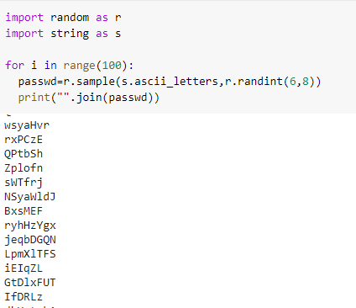

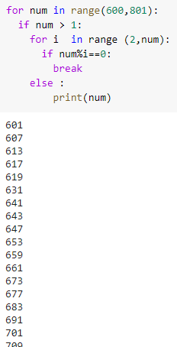

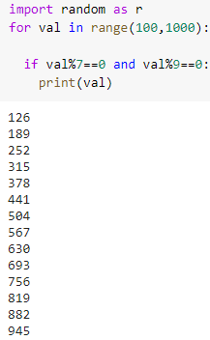

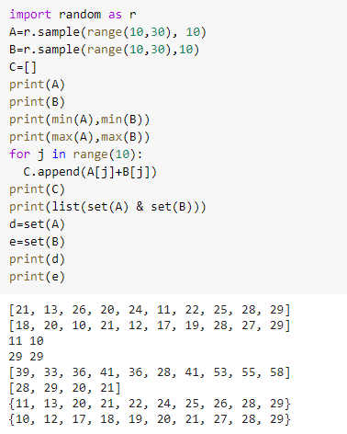

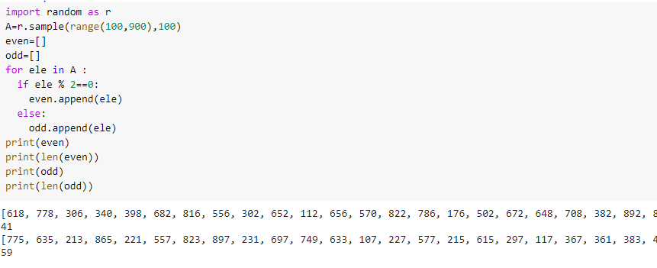

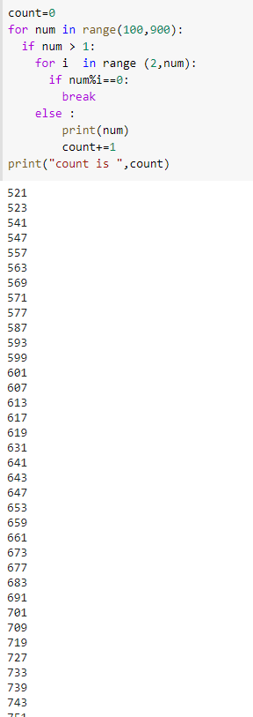

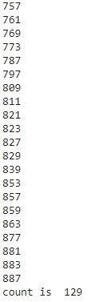

**Sir codes are working fine you may check them . output pasted here is truncated .**

**I could not paste it as whole . So sir please check my assignment .**

**Thank you**