**Don Bosco Institute of Technology, Mumbai - 400070**

**Department of Information Technology**

**Date: 25/05/2020**

**TEAM MEMBERS:**

|  |  |
| --- | --- |
| Name | Roll. No. |
| Kartik Gowda | 22 |
| Kritika Chatterjee | 04 |
| Vardan Sharma | 52 |

**Title: Soil Moisture Monitoring System**

**Problem Description:**

Agriculture plays a vital role in the development of agricultural countries. Some issues concerning agriculture have been always hindering the development of the country. Thus, the only practical solution to this issue is smart agriculture based on modernizing current traditional methods of agriculture.

The soil moisture content will be measured by using Capacitive Soil Moisture Sensor. In addition, our preference is DHT11 Humidity Temperature Sensor for measuring air temperature and humidity.

You can monitor all this remotely via Thingspeak Server online from anywhere in the world.

**Detailed Description of Sensors:**

**1) Soil Moisture Sensor:** This is an **analog capacitive soil moisture sensor** which measures soil moisture levels by **capacitive sensing**. This means the capacitance is varied on the basis of water content present in the soil. You can convert the capacitance into voltage level basically from 1.2V minimum to 3.0V maximum. The advantage of Capacitive Soil Moisture Sensor is that they are made of a **corrosion-resistant material** giving it a long service life.

**2)Humidity and Temperature Sensor (DHT11):** The **DHT11** is a basic, ultra-low-cost digital temperature and humidity sensor. It uses a capacitive **humidity sensor** and a **thermistor** to measure the surrounding air. It spits out a digital signal on the data pin. It’s fairly simple to use, but requires careful timing to grab data. The only real downside of this sensor is you can only get new data from it once every 2 seconds. So, when using the library, sensor readings can be up to 2 seconds old. In this project, we will use this sensor to measure the air temperature and humidity.

**Implementation:**

The Soil Moisture Monitoring System was implemented using Arduino IDE, NODE MCU and ESP8266 board.

**Results:**

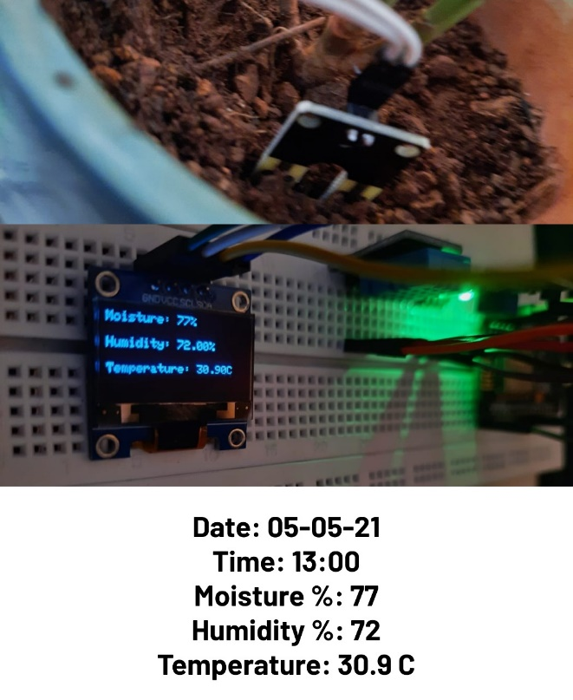 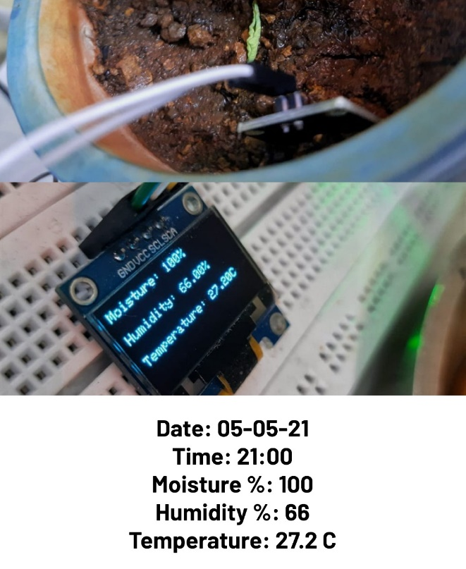

**Conclusion:**

1. Soil Moisture Monitoring System was implemented using NODE MCU ESP8266.
2. The data was visualized on Thingspeak as well as on the OLED display.
3. The data received was stored in Thingspeak.