retrieval component :- (context_relevancy and context_recall) generative component:- (faithfulness and answer_relevancy)

1 Raga’s implementation.

2 Experiment with different matrix.

3 Alternative of raga’s.

4 langsmith alternative evaluation.

**Ragas:-**

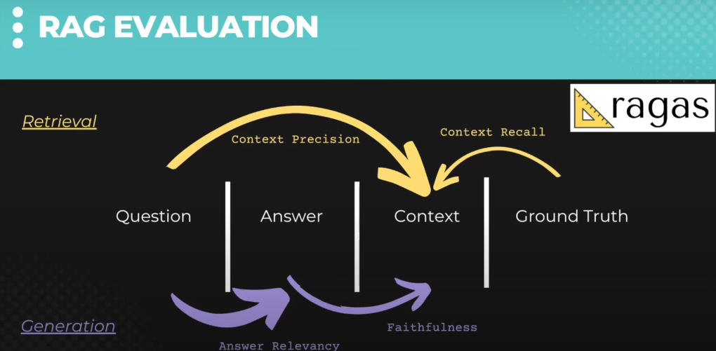

**Faithfulness**

This measures the factual consistency of the generated answer against the given context. It is calculated from answer and retrieved context. The answer is scaled to (0,1) range. Higher the better.

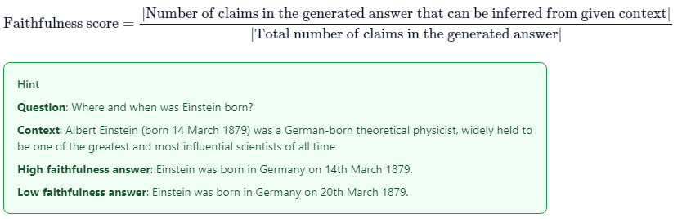

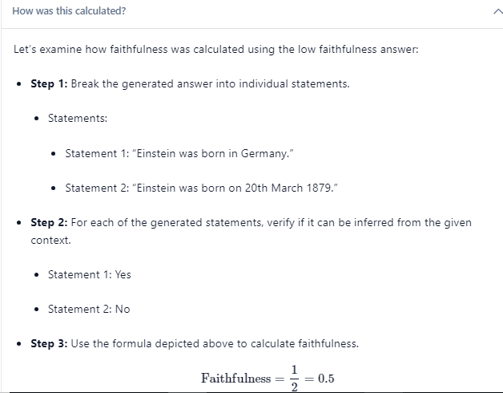

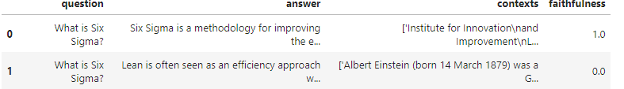

# Answer Relevance

The evaluation metric, Answer Relevancy, focuses on assessing how pertinent the generated answer is to the given prompt. A lower score is assigned to answers that are incomplete or contain redundant information. This metric is computed using the question and the answer, with values ranging between 0 and 1, where higher scores indicate better relevancy.



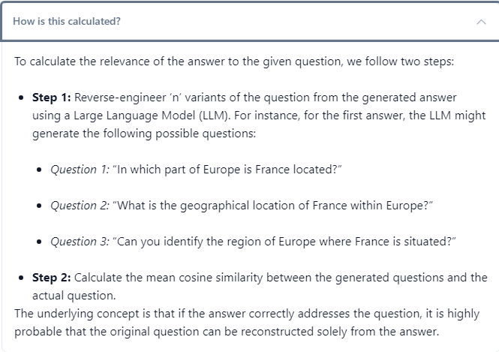

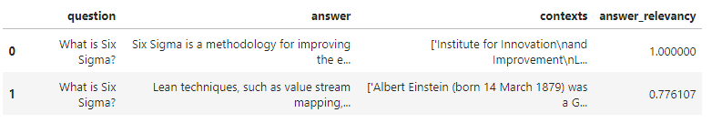

# Context Precision

Context Precision is a metric that evaluates whether all of the ground-truth relevant items present in the contexts are ranked higher or not. Ideally all the relevant chunks must appear at the top ranks. This metric is computed using the question and the contexts, with values ranging between 0 and 1, where higher scores indicate better precision.

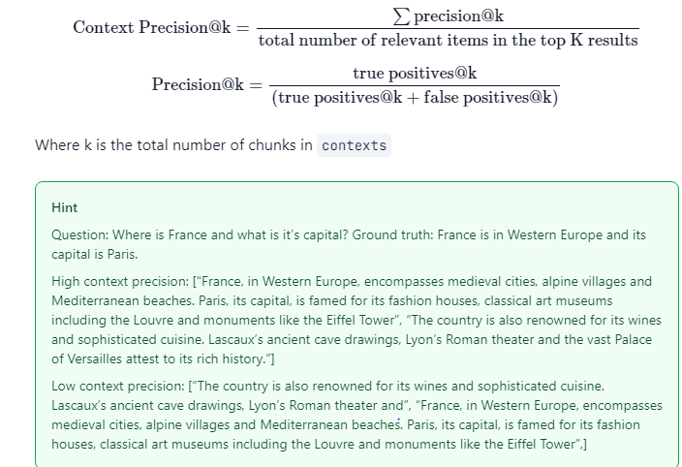

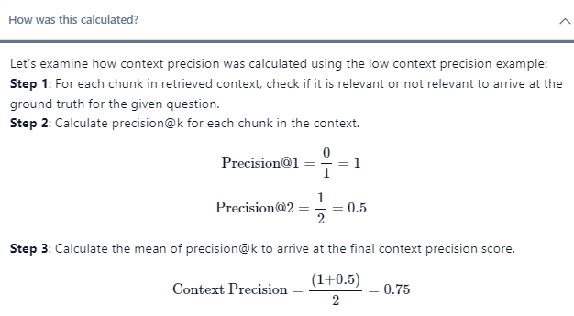

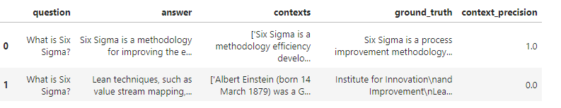

# Context Recall

Context recall measures the extent to which the retrieved context aligns with the annotated answer, treated as the ground truth. It is computed based on the ground truth and the retrieved context, and the values range between 0 and 1, with higher values indicating better performance.

To estimate context recall from the ground truth answer, each sentence in the ground truth answer is analyzed to determine whether it can be attributed to the retrieved context or not. In an ideal scenario, all sentences in the ground truth answer should be attributable to the retrieved context.

