A Project Report on

Fresh Mart: Online Vegetable Market

Undertaken At
Binary Developer

Submitted in fulfilment for the award of degree in
Master of Computer Applications
[Batch: 2024-2026]

Submitted by
Nakum Kartik J [240823064]

Under the guidance of
Mr. Shrey Shah [Internal Guide]
Mr. Visal Chuhan [External Guide]

Department Head
Dr. Divyesh Gohel

Submitted to


Declaration of Authenticity and Originality

I hereby declare that the project titled “Fresh Mart” is a result of my own efforts and original work.
The work presented in this report is original and has been developed by me specifically for this academic requirement.
This project has not been submitted, either in part or in whole, for any other degree or diploma to this or any other University or Institute.
The source code, database design, and diagrams included in this report are based on my own development using the MERN (MongoDB, Express.js, React, Node.js) stack.
I have duly acknowledged all the sources of information, libraries, and tools used during the development of this system.

[Nakum Kartik J] [240823064]

Acknowledgment

I would like to express my deepest appreciation to all those who provided me the possibility to complete this project. A project of this nature is never the work of a single individual; it is the culmination of the efforts, guidance, and support of many.
First and foremost, I would like to thank my project guide [Guide Name] for their invaluable guidance, constant encouragement, and technical support throughout the development of the Fresh Mart project. Their insights into the MERN Stack and system analysis were instrumental in making this project a success.
I also extend my sincere gratitude to the [Department Name] and [College/Institute Name] for providing the necessary infrastructure and resources required for this research and development.
A special thanks to my family and friends for their continuous support and patience during the completion of this work. Their belief in my abilities kept me motivated during the challenging phases of coding and system integration.
Lastly, I want to thank the developers and the open-source community behind React, Node.js, and MongoDB for providing such powerful tools that allowed me to build a modern and scalable online vegetable market.
[Nakum Kartik J] [240823064]

Abstract

The FreshMart: Online Vegetable Market is a comprehensive e-commerce solution designed to bridge the gap between traditional agricultural markets and modern consumers. Developed using the MERN Stack (MongoDB, Express, React, and Node.js), this project aims to provide a seamless, transparent, and efficient platform for purchasing fresh and organic vegetables online.
The system addresses the common challenges of traditional shopping, such as time constraints, price inconsistency, and lack of product tracking. For customers, the application offers features like advanced product filtering, a personalized wishlist for saving favorite items, a streamlined shopping cart, and a real-time order tracking system that monitors stages from 'Pending' to 'Delivered'.
For administrators, FreshMart provides a robust management dashboard to control inventory, monitor sales analytics through graphical representations, and manage the order lifecycle with secured status locking mechanisms. By automating stock validation and ensuring data integrity, the system minimizes human error and maximizes operational productivity. Ultimately, FreshMart represents a significant step towards digitalizing the local vegetable trade, ensuring that freshness and quality are just a few clicks away for the end-user.

Company Details

Company Name | Binary Developer
Technologies | PHP, Android Developer, React.js, Web Designer
Address | 210, Khodiyar Complex, Oop.Khodiyar Temple, Aerodrome Road, Jamnagar-361001.
Website | www.binarydevelopers.com
Email | info@binarydevelopers.com
Contact Number | +91 9824228575

Project Detail

Project Title | Fresh Mart
Operating system | Windows 11
Hardware Used | I5 Processor, 8 GB RAM
Software Tools | Visual Studio Code, Google Chrome
Frontend | React.js
Backend | Node.js and Express.js
Database | MongoDB
Project Duration | 4 months

1. Project Profile.......................................................................................................................................................................................1
1.1 Introduction ................................................................................................................................ ..................................................1
1.2 Objectives.................................................................................................................................... ..................................................2
1.3 Key Impacts and Benefits ........................................................................................................... .....................................................3
1.4 Description.................................................................................................................................. ...................................................4
1.5 Key Features ................................................................................................................................ ..................................................5
1.6 System Requirements (Hardware, Software) .............................................................................. ....................................................6
2. About the Tools....................................................................................................................................................................................7
3. System Analysis................................................................................................................................ ....................................................9
3.1 About Existing System................................................................................................................. ....................................................9
3.2 Feasibility Study........................................................................................................................... .................................................10
3.3 Limitations of Existing System....................................................................................................... .................................................12
3.4 Scope of Proposed System........................................................................................................... ..................................................13
3.5 Limitations of Proposed System.................................................................................................... .................................................14
3.6 Targeted User................................................................................................................................................................................15
3.7 Project Module..............................................................................................................................................................................16
4. System Design.................................................................................................................................... ................................................18
4.1 Use Case Diagram...........................................................................................................................................................................18
4.2 Activity Diagram.............................................................................................................................................................................20
4.3 Class Diagram.................................................................................................................................................................................21
4.4 Database Diagram...........................................................................................................................................................................22
4.5 Data Dictionary...............................................................................................................................................................................23
4.6 Screenshots....................................................................................................................................................................................25
5. Agile Documentation...........................................................................................................................................................................33
5.1 Project Charter...............................................................................................................................................................................33
5.2 Roadmap.......................................................................................................................................................................................33
5.3 User Story......................................................................................................................................................................................34
5.4 Release Plan...................................................................................................................................................................................34
5.5 Sprint Backlog............................................................................................................................................................................... 34
5.6 Agile Test Plan................................................................................................................................................................................34
6. Future Enhancement...........................................................................................................................................................................35
7. Conclusion..........................................................................................................................................................................................36
8. Bibliography & References................................................................................................................................ ................................. 37
- Project Profile

1.1 Introduction

Fresh Mart: Online Vegetable Market is a full-stack web-based e-commerce platform designed specifically for the online buying and selling of fresh vegetables and fruits. In the modern digital era, traditional vegetable markets face numerous challenges such as long queues, limited operating hours, lack of price transparency, and the inconvenience of physical travel. This project addresses these pain points by providing a seamless, user-friendly online marketplace where customers can browse, select, and order fresh produce from the comfort of their homes.

The application is built using the MERN stack — MongoDB, Express.js, React.js, and Node.js — which ensures a robust, scalable, and maintainable architecture. The frontend is developed in React.js with a responsive design that works smoothly across desktops, tablets, and mobile devices. The backend REST API is powered by Node.js and Express.js, and data is persistently stored in MongoDB.

The platform serves two main user groups: regular customers who can register, log in, browse products, manage their cart and wishlist, place orders, and track their purchase history; and administrators who can manage products, categories, users, and orders through a dedicated admin panel.

1.2 Objectives

The primary objective of the Fresh Mart project is to provide a seamless and efficient digital platform for consumers to purchase fresh, organic vegetables directly from local sources. The specific objectives are as follows:

• To Provide 100% Organic Products: To create a dedicated marketplace for chemical-free and farm-fresh vegetables to promote a healthy lifestyle.
• User-Friendly Interface: To develop an intuitive and responsive web application using React.js that allows users to easily browse categories, search for products, and manage their shopping cart.
• Automated Stock Management: To implement a real-time inventory system that automatically reduces product stock once an order is placed and notifies users when items are sold out.
• Secure Authentication: To provide a safe environment for users through secure registration and login processes, including password encryption and OTP verification via email.
• Efficient Order Tracking: To allow customers to view their order history and track the current status of their purchases (Pending, Shipped, Delivered) in real-time.
• Centralized Admin Control: To empower the administrator with a comprehensive dashboard to manage products, categories, registered users, and order fulfilment efficiently.
• Enhanced Customer Support: To facilitate direct communication between users and administrators through a dedicated contact system for inquiries and feedback.

1.3 Key Impacts and Benefits

The implementation of Fresh Mart brings significant advantages to both the end-users and the business administrators. The key impacts and benefits are detailed below:

For Customers (Users):

• Access to Pure & Organic Food: Users can easily access 100% fresh and organic vegetables, reducing the consumption of pesticides and promoting better health.
• Convenience & Time Saving: The platform eliminates the need to visit physical markets. Customers can order from home at any time using a responsive and fast interface.
• Enhanced Security: With Email OTP verification and encrypted passwords, user data and accounts are protected against unauthorized access.
• Real-time Availability: Customers can see the exact stock status. The "Sold Out" labels prevent users from ordering items that are unavailable, ensuring a transparent shopping experience.
• Seamless Tracking: The order tracking bar allows users to monitor their purchase progress from "Pending" to "Delivered" status.

For Administrators (Business Owners):

• Automated Inventory Management: The system automatically handles stock reduction during purchases, reducing the manual effort required to manage the inventory.
• Data-Driven Decisions: The integrated Dashboard Analytics (using Recharts) provide visual insights into total sales and monthly revenue, helping the admin plan business growth.
• Centralized User Control: Admins can easily manage the database of registered users and oversee all customer queries from a single interface.
• Scalability: Built on the MERN stack, the system is highly scalable, allowing the business to add more product categories and handle a larger number of orders as the customer base grows.
• Streamlined Operations: Features like dynamic category management and order status updates ensure that the business operations are professional and error-free.

1.4 Description of the Project
Fresh Mart is a comprehensive e-commerce platform designed using the MERN (MongoDB, Express.js, React.js, and Node.js) stack, aimed at bridging the gap between local organic farms and urban consumers. The system provides an end-to-end shopping experience, starting from secure registration to final delivery tracking.
The project is divided into two major modules: the Customer (User) Module and the Administrator Module.

Customer Module:
This module focuses on providing a smooth and secure shopping experience.
• User Authentication: Users sign up with an email and phone number. To ensure authenticity, a 4-digit OTP (One Time Password) is sent to their email using EmailJS.
• Product Interaction: Customers can browse fresh vegetables and fruits through dynamic categories. The system includes a real-time search function and a Wishlist feature to save favourite items.
• Shopping Cart & Checkout: The cart is synchronized with the backend database, ensuring that items are saved across sessions. During checkout, users provide shipping details and choose their payment method (currently Cash on Delivery).
• Order Tracking: After placing an order, users can monitor the status through a visual tracking bar that moves from 'Pending' to 'Delivered'.

Administrator Module:
This is the back-office of the system, designed to give the business owner full control.
• Analytics Dashboard: The dashboard features visual data representations using Recharts, showing total earnings, order counts, and registered user statistics.
• Inventory Management: Admins can add new products with images, set prices, and manage stock levels. If a product’s stock reaches zero, the system automatically marks it as "Sold Out" on the user side.
• Order Fulfilment: Admins have the authority to update order statuses as they are processed, shipped, or delivered. They can also cancel orders if necessary.
• User & Category Control: Admins manage the platform's structure by adding/editing categories and supervising the registered user database.

1.5 Key Features
The Fresh Mart system is developed using advanced technologies and a user-friendly design. Its major features are described below:

User Interface and Experience (UI/UX):

• Responsive Design: The website works smoothly across all devices, including mobile phones, tablets, and desktop computers.
• Dynamic Product Search: Users can quickly search for any product by name using the search bar.
• Interactive Notifications: The system uses SweetAlert2 to display professional dialog boxes for order success messages, errors, and alerts.

Security and Authentication:

• OTP Verification: During new user registration, a 4-digit OTP is sent to the user’s email via EmailJS to verify the account.
• Secure Password Hashing: User passwords are securely stored in the database using the bcryptjs library for encryption.
• Role-Based Access Control: The system differentiates between “User” and “Admin” roles and secures the admin panel accordingly.

Shopping and Order Management:

• Persistent Shopping Cart: The user’s cart is linked to the database, ensuring that cart items remain saved even after logout.
• Wishlist Functionality: Customers can save their favorite products in a wishlist for future reference.
• Real-Time Stock Management: Once an order is placed, the product stock is automatically reduced from the backend. When stock is exhausted, a “Sold Out” label is displayed on the product.
• Visual Order Tracking: Users can view their order status (from Pending to Delivered) through a visually appealing tracking bar.

Powerful Admin Control:

• Analytics Dashboard: The admin can view sales data and stock status in graphical form using Recharts.
• Inventory Control: The admin can add new products and categories, edit existing ones, or remove items from stock.
• Order Fulfilment Management: The admin can update order statuses and efficiently manage customer inquiries through the contact system.

1.6 System Requirements (Hardware, Software)

1. Hardware Requirements
• Processor: Intel Core i3 or higher (5th generation or above)
• RAM: 8GB RAM or more (recommended for MERN Stack)
• Storage: 256GB SSD or more (for fast data read/write)
• Display: 1920 × 1080 resolution or higher
• Internet: High-speed stable internet (for API and cloud database connectivity)

2. Software Requirements
• Operating System: Windows 10/11
• Recat.js: Version 19.2.3 or later
• Node.js: Version 22.22.0 or later
• Experss.js: Version 5.2.1 or later
• Database: MongoDB (NoSQL Database)
• Code Editor: Visual Studio Code or similar
• API Testing: Postman
• Package Manager: npm (Node Package Manager) 11.1.0

2 About the Tools

React.js

• Component-Based Architecture: React divides the entire website into small, independent components such as Navbar, Product Card, and Wishlist. This modular structure makes the codebase easier to manage, reusable, and simple to maintain or enhance in the future.
• Virtual DOM: The Virtual DOM is one of Reacts most powerful features. When a user clicks on the heart icon or adds an item to the cart, react updates only the specific component instead of reloading the entire page. This significantly improves application speed and performance.
• State Management: React hooks such as use State and use Effect are used to manage real-time data for features like the Wishlist and shopping cart, ensuring smooth interactions and a responsive user experience.

Node.js & Express.js (The Backend Framework)

• High Performance: Node.js runs on Google Chrome’s V8 engine, enabling it to handle thousands of concurrent user requests efficiently.
• RESTfulAPIDevelopment: Express.js is used to build secure RESTful API routes that act as a bridge between the frontend and the database, ensuring smooth and reliable data communication.
• Middleware & Security: Express middleware is implemented to protect user authentication, authorization, and order status management, enhancing application security.

3. MongoDB & Mongoose (The Database & ODM)

• NoSQL Flexibility: MongoDB stores data in a JSON-like format, making it ideal for handling products such as vegetables that contain varying attributes like weight and units.
• Data Modelling with Mongoose: Mongoose defines schemas to ensure data consistency and correct structure before saving information to the database.
• Scalability: MongoDB is highly scalable and capable of maintaining performance even as the number of users and data volume grows in the future.

4.Mongoose
Mongoose is an Object Data Modeling (ODM) library for MongoDB and Node.js. It provides a straightforward schema-based solution for modeling application data, with built-in type casting, validation, query building, and business logic hooks. All database models in this project (User, Product, Order, Cart, etc.) are defined using Mongoose schemas.

5. SweetAlert2 & React Icons (UI/UX Tools)
• Professional Feedback: SweetAlert2 transforms standard browser alerts into visually appealing, animated dialog boxes, enhancing user interaction.
• Visual Communication: React Icons such as FaHeart and FaShoppingCart improve visual clarity and make the application more engaging.
• Customization: These tools allow full customization of colors, icons, and messages to match the brand identity, such as the green theme used in the application.

3. System Analysis

3.1 About Existing System

At present, the process of buying and selling vegetables is primarily based on the traditional physical market system. In this system, customers are required to visit the market in person to purchase vegetables. Although this traditional method has been in practice for many years, it involves several limitations and challenges.

Working of the Existing System

• Physical Presence: Customers must visit crowded local markets in person to purchase fresh vegetables.
• Price Comparison: Customers need to visit multiple vendors or stalls to inquire about prices and manually compare them to find the best option.
• Cash Transactions: Most transactions are conducted in cash, which makes maintaining accurate financial records difficult.
• Lack of Information: Customers do not have prior knowledge about product availability or stock levels until they physically reach a particular shop or vendor

Challenges in the Existing System

• Time Consumption: A significant amount of time is spent traveling to the market and selecting products, which is inconvenient in today’s busy lifestyle.

• Lack of Transparency: There is no price consistency, as different customers are often charged different prices for the same products.

• Difficulty in Record Keeping: For vendors, maintaining daily sales records, profit calculations, and stock details manually is tedious and error-prone.

• Freshness and Quality Issues: Customers are often unaware of how fresh the vegetables are, and prolonged exposure in open markets can reduce product quality.

• Stock Management Problems: Vendors lack real-time stock information, leading to situations where products are unavailable despite demand or excess stock goes to waste.

3.2 Feasibility Study
Before developing a project, it is essential to analyze its practicality and chances of success. The feasibility study conducted for the FreshMart project is divided into the following main sections:

1. Technical Feasibility
This study examines whether the required technology and technical resources are available to develop the project.
• MERN Stack: The project is developed using React.js, Node.js, Express.js, and MongoDB. These are modern, open-source technologies widely used for building scalable and reliable e-commerce platforms.

• Scalability: The system is highly scalable, meaning it can be easily expanded in the future to accommodate an increasing number of users without affecting performance.

• Development Tools: Powerful tools such as Visual Studio Code, Postman, and Git are used, which help speed up development while ensuring accuracy and version control.

2. Economic Feasibility
This analysis focuses on the project’s cost and the benefits it delivers (Cost-Benefit Analysis).
• Low Initial Cost: Since the project is based on open-source technologies, there are no additional software licensing costs.

• Efficiency: The system is paperless, which significantly reduces administrative expenses. Using a digital database instead of manual record keeping results in long-term financial savings.

• Market Potential: The online vegetable market is rapidly growing, indicating that the project has strong potential to be economically viable and profitable.

3. Operational Feasibility
This section evaluates how easily users can operate and adapt to the system once it is implemented.
• User-Friendly Interface: The user interface is designed to be simple and intuitive. Users can place orders and manage their Wishlist with just a few clicks.

• Admin Control: The admin dashboard allows efficient management of stock and orders without requiring advanced technical training.

• Problem Solving Capability: By addressing traditional market issues such as crowding and time consumption, the system is expected to gain quick acceptance among users.

4.Legal and Schedule Feasibility

• Legal Feasibility: The project ensures the security of customer data and complies with applicable legal and regulatory requirements.

• Schedule Feasibility: The project can be completed within the defined timeline, as each module has been carefully planned and scheduled.

3.3 Limitations of Existing System
The traditional vegetable market operates largely on manual processes, which results in several limitations. These challenges create difficulties for both customers and vendors. The major limitations are as follows:

1. Time and Effort Intensive
In the existing system, customers must spend valuable time visiting physical markets. Traffic congestion, overcrowding, and moving between multiple vendors to find quality vegetables require significant effort, making this approach inconvenient in today’s busy lifestyle.

2. Lack of Price Transparency
In traditional markets, vegetable prices are not standardized. Different vendors charge different prices for the same product. Since there is no centralized system for price comparison, customers often end up paying higher prices.

3. Uncertainty of Inventory and Stock
Customers only discover product availability after reaching the market. Often, after traveling long distances for specific vegetables, they find that the items are out of stock. Vendors also lack real-time stock update mechanisms.

4. Difficulty in Record Keeping
Maintaining sales records manually is highly challenging. Tracking daily income, identifying best-selling items, and monitoring wastage accurately becomes difficult, which hinders long-term business planning.

5. Lack of Order Tracking
When customers place orders via phone, they have no visibility into the order status, such as whether it is being prepared or is out for delivery. This creates communication gaps between customers and vendors.

6. Geographical Limitations
The existing system is restricted to customers who can physically visit the store. Due to the absence of a digital presence, vendors are unable to expand their business to a wider geographical area.

7. Payment Constraints
Traditional markets mainly rely on cash transactions. The lack of digital payment options and credit record management can be inconvenient for many customers.

3.4 Scope of Proposed System
The Fresh Mart: Online Vegetable Market system is designed not only to sell vegetables but also to digitalize and bring transparency to the entire buying and selling process. The scope of the proposed system can be understood through the following points:

1. 24/7 Online Availability
The proposed system removes time constraints by allowing customers to browse products and place orders at any time, day or night, according to their convenience. This feature is especially beneficial for working professionals and busy individuals.

2. Wide Product Range and Advanced Filtering
The system organizes various types of vegetables, fruits, and organic products into well-defined categories. Customers can use search and filtering options to quickly find products that match their needs within seconds.

3. Real-Time Order Tracking
One of the most important aspects of the system is order transparency. After placing an order, customers can view the live status of their order, such as Pending, Processing, Shipped, and Delivered. This enhances trust between customers and vendors.

4. Efficient Inventory Management
For administrators, the system simplifies stock management. Whenever a product is sold, the quantity is automatically updated in the database. Products that are unavailable are displayed as “Out of Stock,” preventing incorrect or failed orders.

5. User Preferences and Wishlist
The system allows customers to save their favourite products in a Wishlist. This data can later be used to provide personalized offers or discounts based on user preferences, helping to increase customer engagement and business growth.

6. Future Scalability
The scope of this project is not limited to current requirements. There is significant potential to enhance the system in the future with features such as:
- Payment Gateway Integration: Online payments via UPI and debit/credit cards.
- Delivery Boy Application: Separate login and real-time location tracking for delivery personnel.
- Subscription Model: Weekly or monthly subscription plans for regular vegetable delivery.

7. Data-Driven Decision Making
Administrators can access detailed sales reports to analyse demand patterns. By understanding which vegetables are in high or low demand, better inventory planning and business decisions can be made.

3.5 Limitations of Proposed System
Every new system, along with its advantages, also has certain limitations. While the FreshMart system resolves many issues associated with traditional vegetable markets, it still has some internal and external limitations, which are described below:

1. Internet Dependency
The system is entirely based on an online platform, which means both customers and administrators must have a stable internet connection. Without internet access, customers cannot place orders, and administrators cannot process them.

2. Lack of Physical Inspection
Vegetables are perishable items, and customers generally prefer to physically inspect them to check freshness and quality. In the proposed system, customers must rely solely on product images and descriptions, which may sometimes create hesitation or dissatisfaction.

3. Delivery Lead Time
In traditional markets, customers can purchase items and take them home immediately. However, in this system, order processing and delivery require additional time. For urgent needs, this system may not always be the most suitable option.

4. Requirement of Basic Technical Knowledge
Although the system interface is designed to be user-friendly, users must possess basic knowledge of operating a smartphone or computer. Individuals unfamiliar with technology may face difficulties while using the system, especially during initial usage.

5. Risk Associated with Perishable Items
Vegetables spoil quickly if not handled properly. Delays in delivery or improper temperature control during transportation may result in reduced product quality by the time it reaches the customer.

6. Current Payment Limitations
In the current version of the system, online payment options may be limited if a payment gateway has not yet been integrated. Customers may have to rely on Cash on Delivery (COD), which can be inconvenient for large or frequent transactions.

7. Data Storage and Security Concerns
All system data is stored in a cloud-based database such as MongoDB. In the event of server downtime, data access may be temporarily affected. Although modern security mechanisms are implemented, digital platforms always carry some level of cybersecurity risk.

3.6 Targeted Users

The Fresh Mart system is designed for users who prefer modern, digital shopping methods over traditional purchasing practices. The primary targeted users of this project are as follows:

1. Busy Professionals
In today’s fast-paced lifestyle, working professionals often lack the time to visit markets and select vegetables personally. For such users, Fresh Mart provides a convenient platform where they can place orders anytime from their home or workplace, helping them save valuable time.

2. Homemakers
Homemakers who are conscious about the quality and pricing of daily fresh vegetables benefit greatly from this system. Fresh Mart offers transparency in pricing, allowing them to compare products easily and save preferred items in a Wishlist for future purchases.

3. Senior Citizens
For many senior citizens, visiting crowded markets and carrying heavy bags can be physically challenging. Through this system, they can conveniently place online orders and receive fresh vegetables directly at their doorstep.

4. Local Retailers and Vendors
This project is not only beneficial for customers but also for small-scale retailers who wish to digitize their business operations. Using the admin panel, vendors can efficiently manage inventory, monitor sales, and streamline order processing.

5. Tech-Savvy Generation
The younger generation, which is comfortable with online shopping and mobile applications, forms a major user base for this platform. Features such as an attractive user interface, easy navigation, and real-time order tracking appeal strongly to these users.

6. Institutional Buyers
Small restaurants, cafés, and hotel owners who require fresh vegetables in bulk on a daily basis can use this platform to place direct orders and fulfill their business requirements efficiently.

3.7 Project Module

To simplify the functionality and management of the Fresh Mart system, it is primarily divided into two main modules: the User Module and the Admin Module. These modules are interconnected through APIs and a centralized database to ensure smooth data flow and system coordination.

1. User Module
The User Module is designed for general customers with the primary goal of providing a smooth and user-friendly shopping experience.
• Registration & Authentication: New users can create an account and securely log in to the system using authentication mechanisms.

• Product Browsing: Customers can browse a wide range of fresh vegetables categorized systematically and view detailed information such as price, weight, and product descriptions.

• Wishlist Management: Users can save their favourite products to a Wishlist using the “heart” icon, allowing quick access to preferred items in the future.

• Shopping Cart: Customers can add products to the cart, increase or decrease quantities, and view the total bill before placing an order.

• Order Tracking: After placing an order, users can track the live status of their order, such as Pending, Processing, Shipped, and Delivered.

2. Admin Module
The Admin Module is intended for the store owner or system administrator, who has complete control over system operations.

• Admin Dashboard: A centralized dashboard that displays key analytics such as total orders, total sales, and registered customers using graphical representations.

• Inventory Management: The admin can add new products, update existing product details, or mark items as Out of Stock when inventory levels are low.

• Order Lifecycle Management: The admin has the authority to update order statuses. Orders can be marked as Processing once packed and shipped once dispatched.

• User Management: The admin can view and manage registered users and their account details.

• Security & Validation: The admin ensures data integrity by validating inputs and maintaining secure transaction processing across the system.

4. System Design

4.1 Use Case Diagram

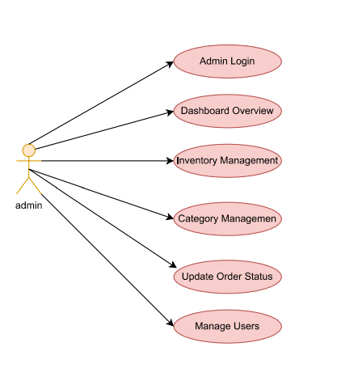

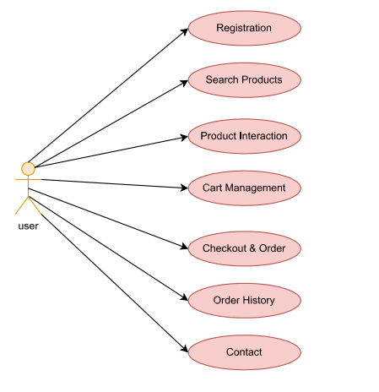

4.2 Activity Diagram

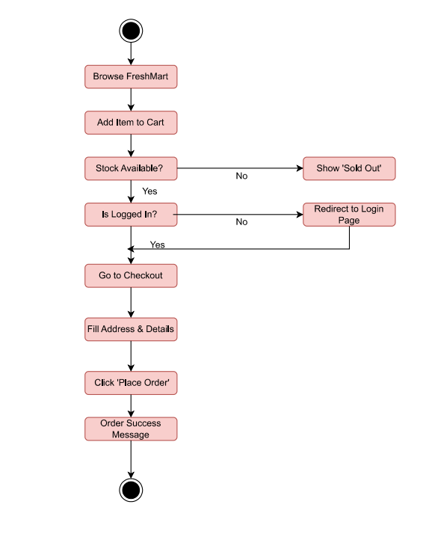

4.3 Class Diagram
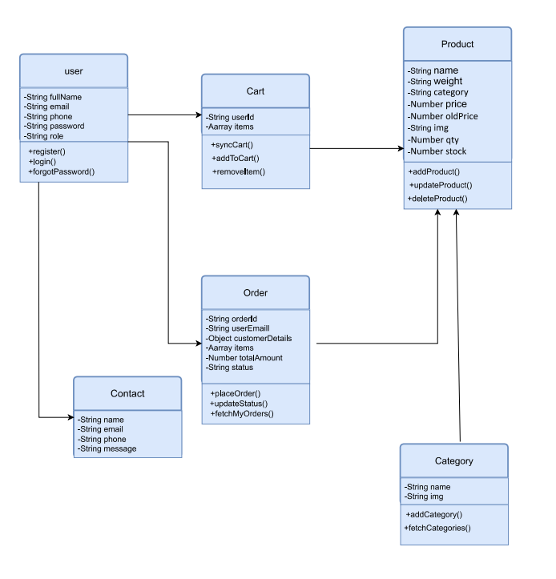

database Diagram
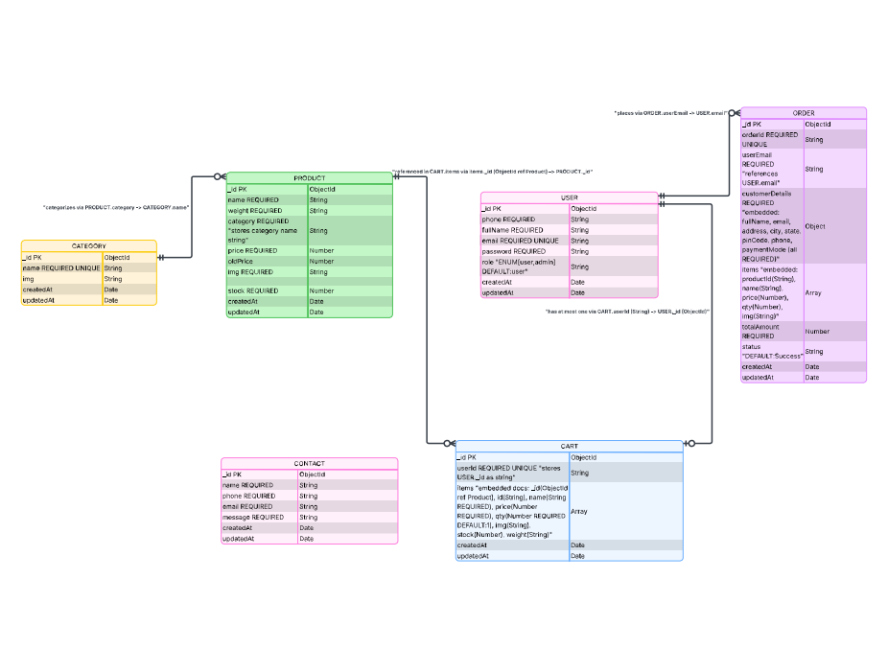

4.5 Data Dictionary

1: User
Field Name | Data Type | Key | Description
FullName | String | Required | Full name of the user
email | String | Unique | Email for login (Unique)
phone | String | Required | Contact number of the user
password | String | Required | Encrypted password
role | String | Default:'user' , Enum: [user  , admin] | User role (Default: "user")

2: Product
Field Name | Data Type | Key | Description
name | String | Required | Name of the vegetable
weight | String | Required | Unit of weight (e.g., 500g, 1kg)
category | String | Required | Category name (e.g., Root, Leafy)
price | Number | Required | Current selling price
oldPrice | Number | Optional | Original price (before discount)
qty | Number | Default: 1 | Add qty
img | String | Required | URL/Path of the product image
stock | Number | Required | Available quantity in inventory

3: Order
Field Name | Data Type | Key | Description
orderId | String | Unique | Unique order tracking ID
userEmail | String | Required | Email of the person who ordered
customerDetails | Object | Required | Embedded: fullName,email,address, city, state, pinCode, phone
items | Array | Required | List of products (ID, name, qty, price)
totalAmount | Number | Required | Final bill amount paid
status | String | Default: ' Success' | Current status (Default: "Success")

4: Cart
Field Name | Data Type | Key | Description
orderId | String | Required | Email of the cart owner
items | Array | Required | Array of cart items: name, price, qty, img,stock

5: Category
Field Name | Data Type | Key | Description
name | String | Unique | Category name (e.g., Vegetables, Fruits)
image | String | Optional | Category image stored as Base64 string

6: Contact

Field Name | Data Type | Key | Description
name | String | Required | Name of the person contacting
email | String | Required | Email for reply
phone | String | Required | Contact number
message | String | Required | Message/Query details

Screenshots

Admin side image
1.Login Page:
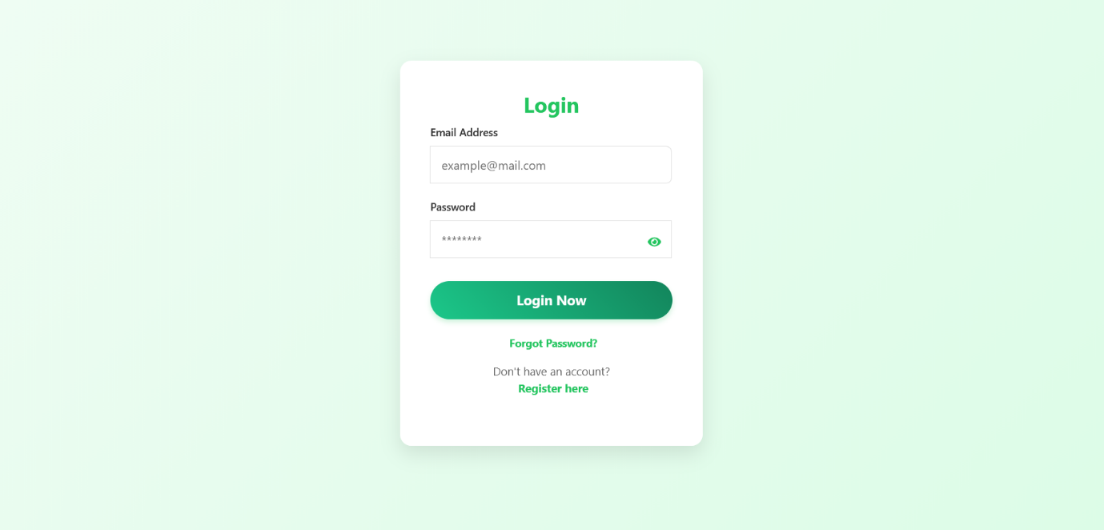

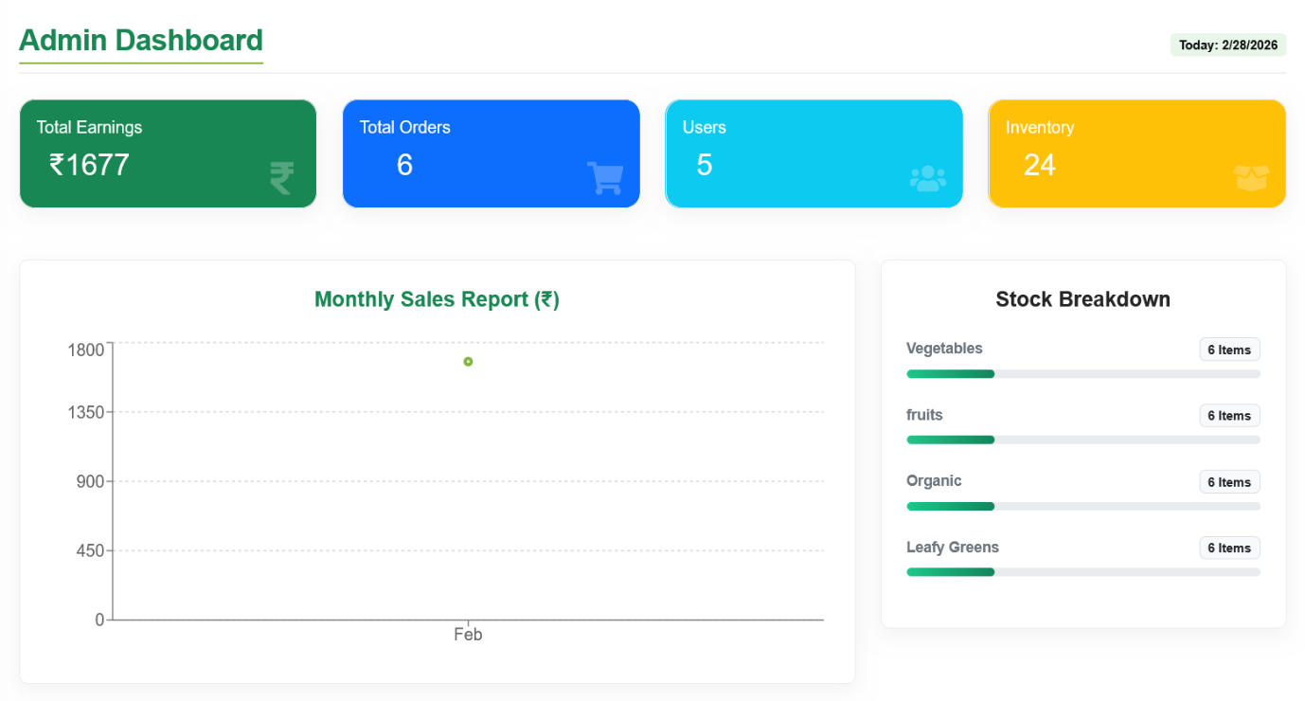
2.Admin Dashboard page:

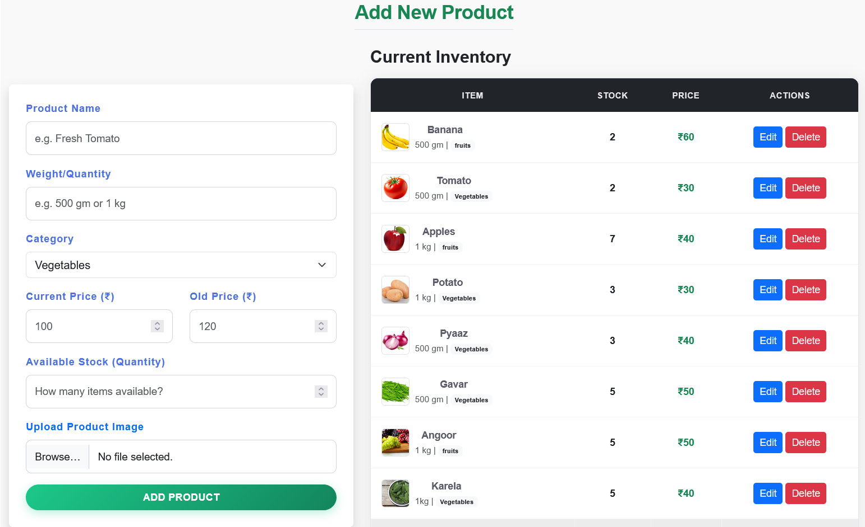
3.Add New Product page:

4.Customer Order Management page:
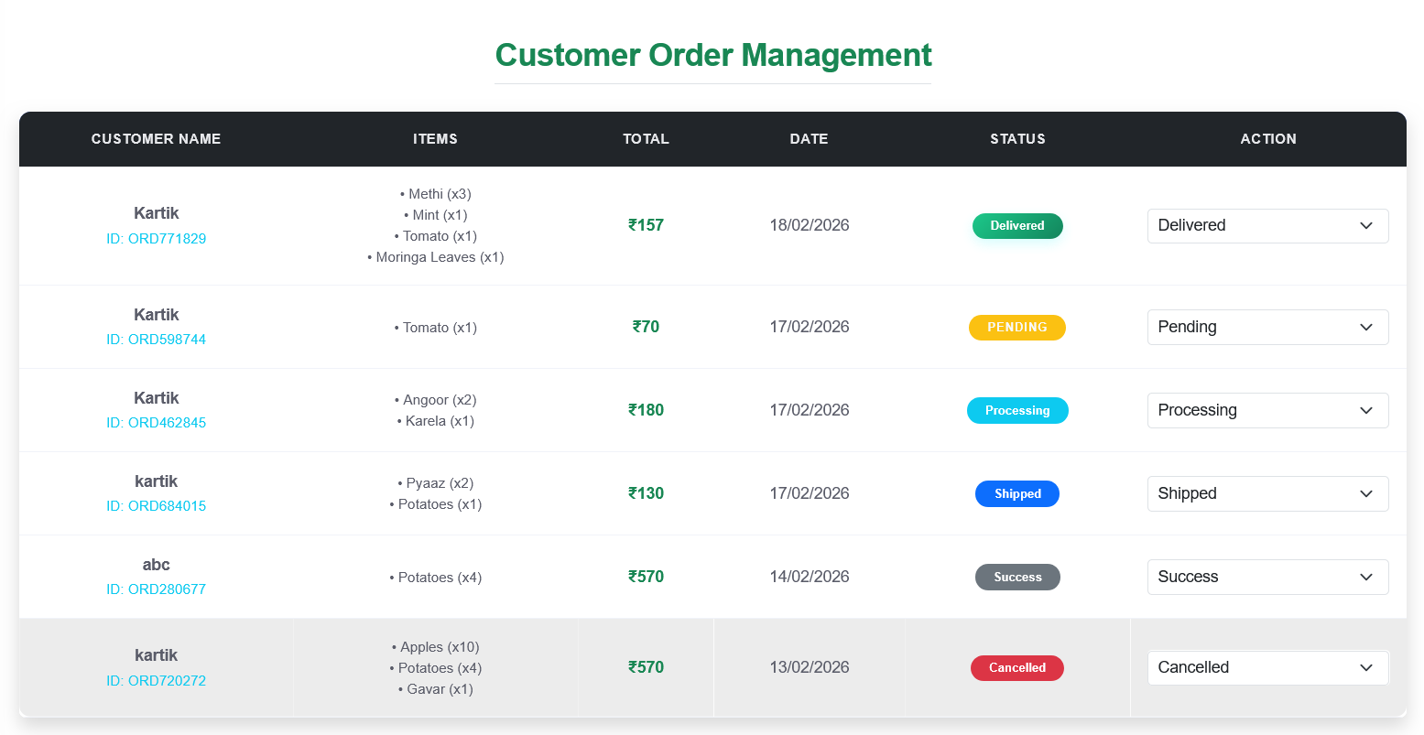

5.Category Management page:
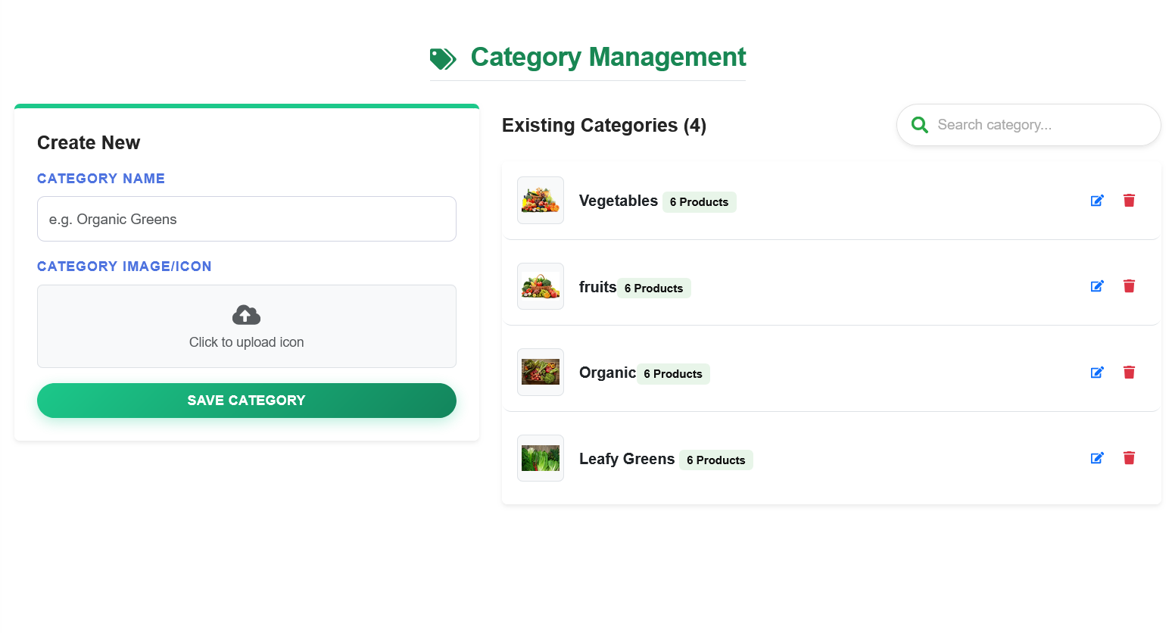

6.User Management page:
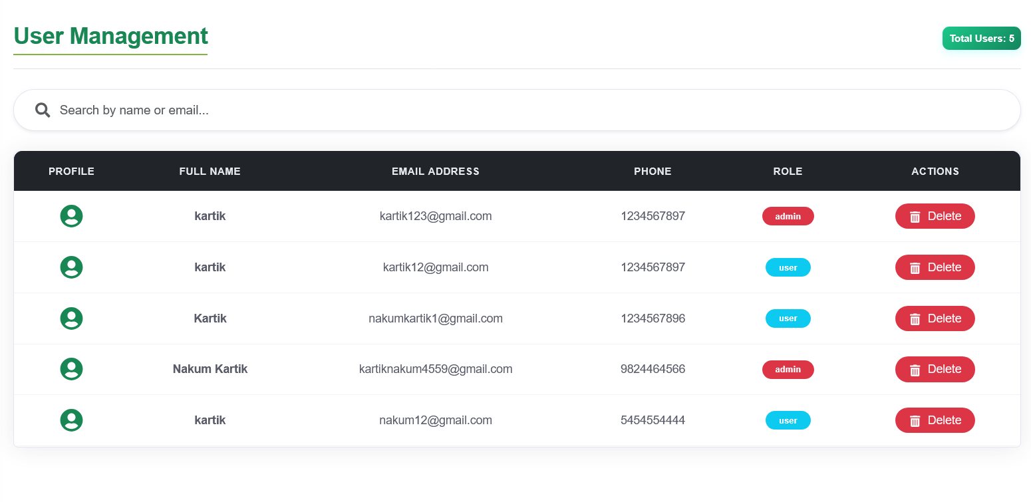

User side Image

1.Home page:

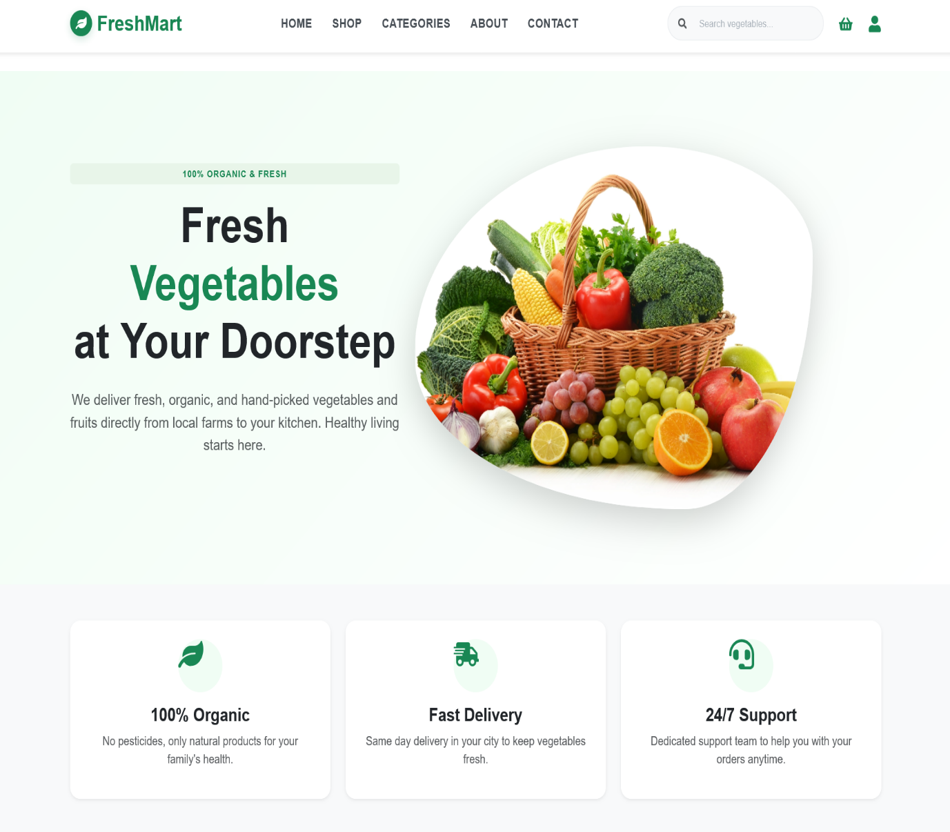

2.Shop Page:
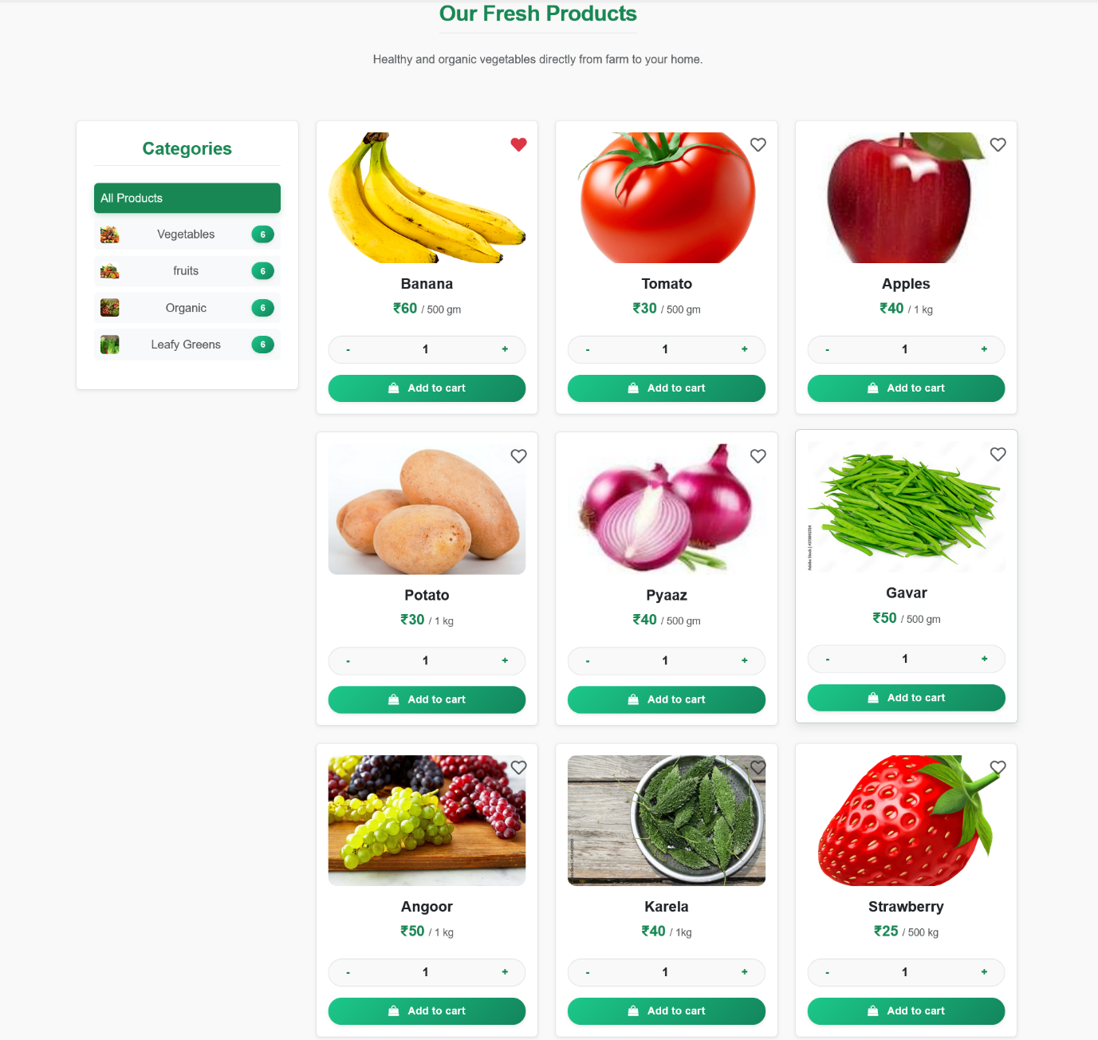

3.Cart page:
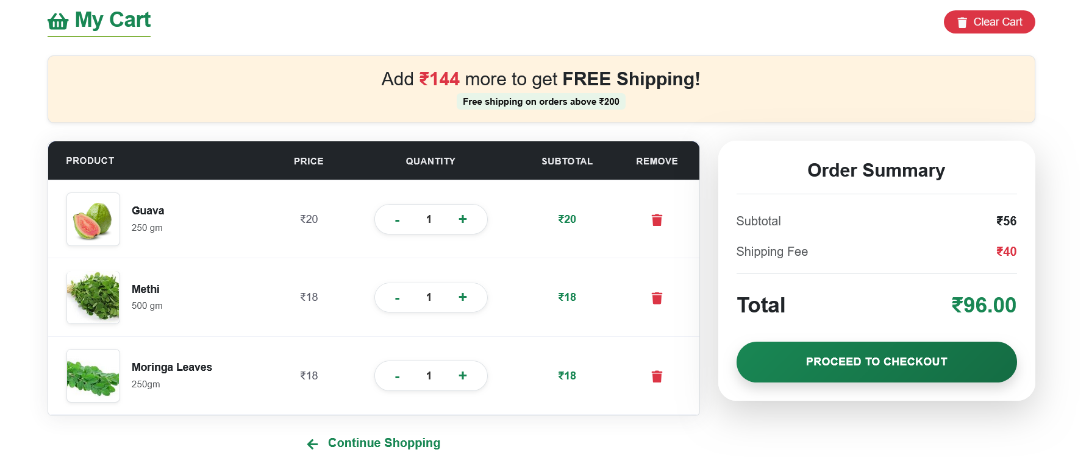

4.Checkout Page:

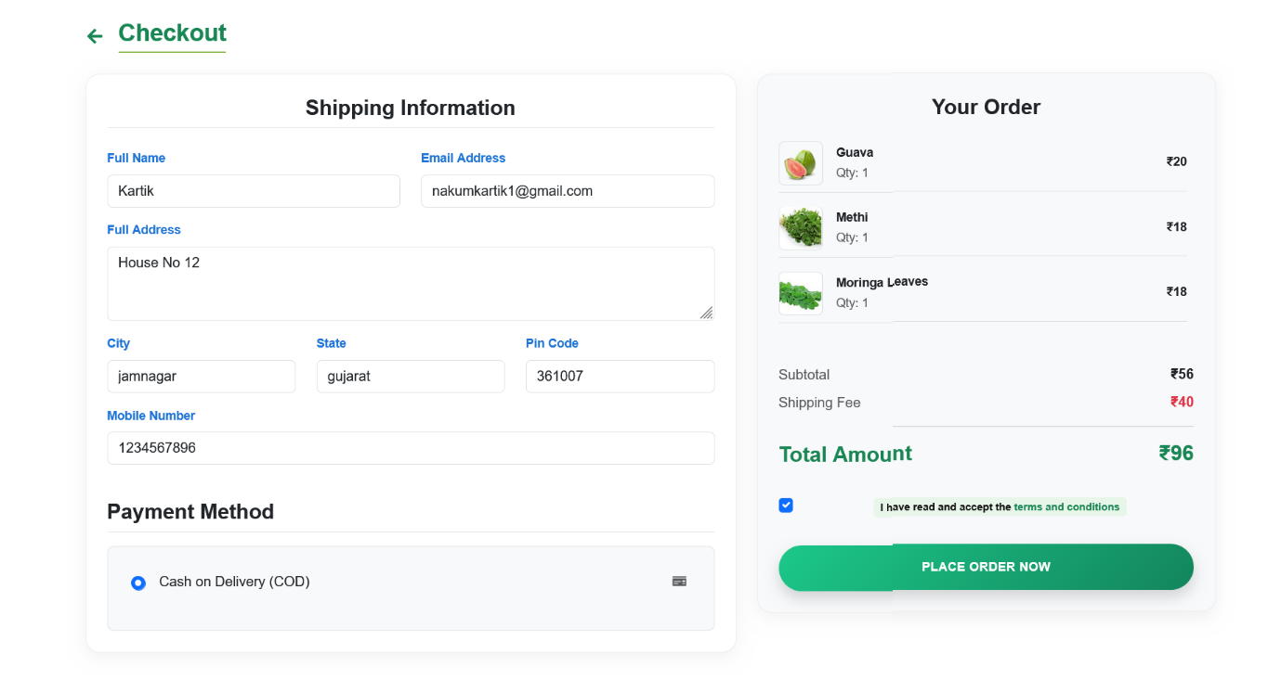

5.Orders History page:

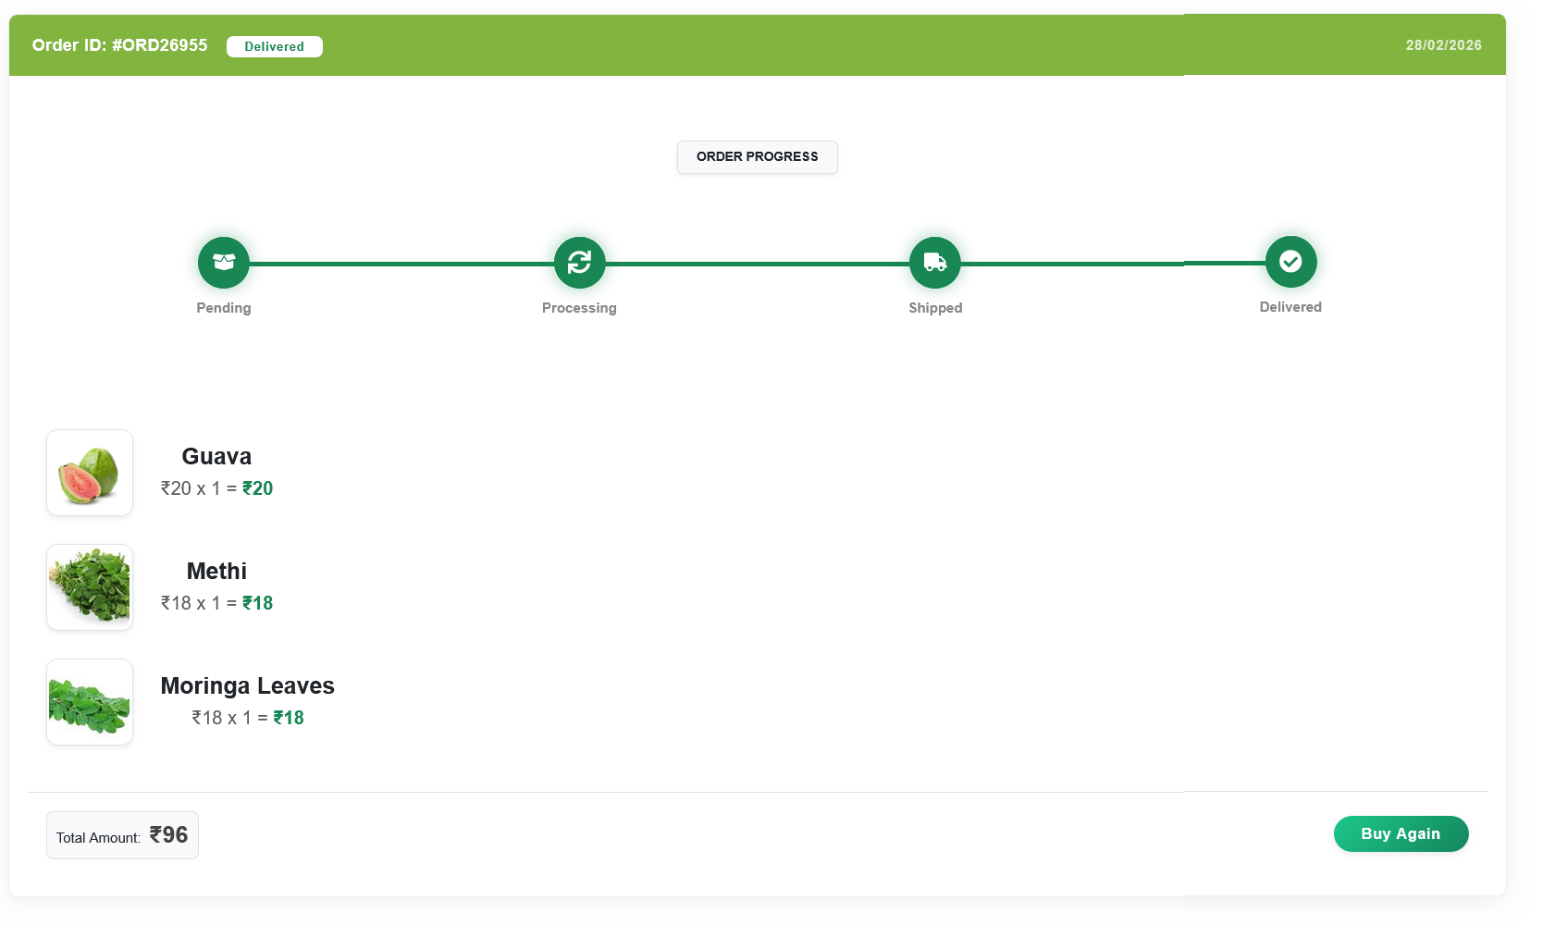

6.Contact page:

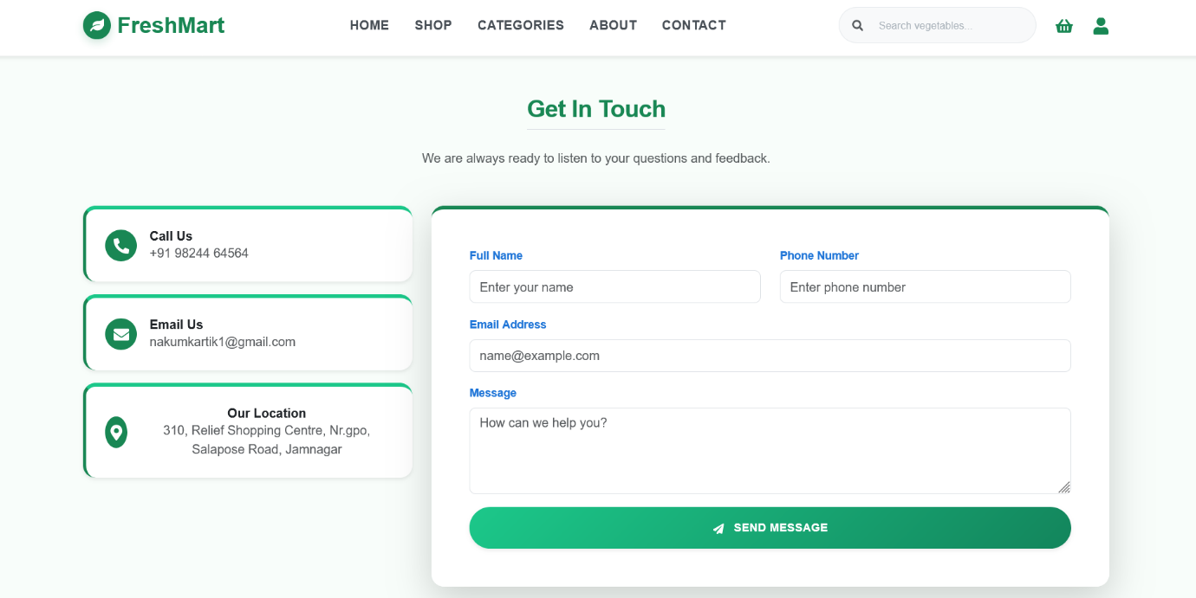

5. Agile Documentation

5.1 Project Charter

• Purpose: This document defines the primary objectives of the project. The main purpose of this project is to eliminate the problems of the traditional vegetable market by using digital technology.

• Vision: To provide a reliable platform that delivers fresh and organic vegetables directly to customers’ homes.

• Scope: The scope of the project includes basic functionalities such as user profile management, inventory control, and order processing.

• Success Criteria: The project will be considered successful when the system is capable of securely accepting orders and efficiently managing them through the admin panel.

5.2 Roadmap

• Strategy: The roadmap represents the long-term development plan of the project. It illustrates how the project will progress through different phases.

• Milestones: The target is to complete database design in the first month, core features such as Cart and Wishlist in the second month, and testing in the third month.

• Adaptability: The roadmap is flexible and can be modified during development as per project requirements.

• Goal: The ultimate goal is to launch a bug-free and user-friendly Fresh Mart platform.

5.3 User Story

• Customer Perspective: “As a customer, I want to view different categories of vegetables so that I can quickly find products according to my preference.”

• Admin Perspective: “As an admin, I want to update new products and their prices so that customers always receive the latest information.”

• User Experience: User stories ensure that development is always carried out with a focus on user convenience and usability.

• Acceptance Criteria: A user story is considered complete only when it functions according to user expectations.

5.4 Release Plan
• Phased Launch: Instead of launching the entire project at once, it is released in different versions.

• Version 1.0: This release includes essential features such as login, product display, and order placement.

• Incremental Updates: Future releases are planned to include advanced analytics and payment gateway features.

• Feedback Integration: User feedback is collected after each release and improvements are made accordingly.

5.5 Sprint Backlog

• Short-Term Goals: The sprint backlog contains a list of tasks that must be completed within the next 2 to 4 weeks.

• Prioritization: Features that are most critical for business (e.g., “Add to Cart”) are prioritized in the initial sprint.

• Daily Tracking: Task progress is tracked under categories such as To-Do, In-Progress, and Done.

• Resource Allocation: Each developer is assigned specific tasks based on their skills during the sprint.

5.6 Agile Test Plan

• Continuous Testing: Testing is performed not only at the end but continuously during each sprint.

• Types of Testing: This includes unit testing for individual functions and integration testing between the frontend and backend.

• Bug Management: If any issue is identified, it is immediately fixed and retested to maintain quality.
• User Validation: Final testing focuses on ensuring that the system is user-friendly and easy to use.

6. Future Enhancements
No software project is ever completely finished; there is always scope for improvement based on time, technology, and user requirements. To make the Fresh Mart system more efficient and customer-centric in the future, the following enhancements can be implemented:

1. Payment Gateway Integration
The current system may have limitations in online payment options. In the future, secure payment gateways such as Razorpay, Stripe, or PayPal can be integrated, allowing customers to make payments directly using UPI, debit cards, or credit cards.

2. Delivery Boy Application (Delivery Module)
To improve delivery accuracy and efficiency, a separate login panel or mobile application can be developed for delivery personnel. Through this module, delivery boys can view assigned orders, track customer locations, and provide real-time delivery confirmation after successful order completion.

3. Artificial Intelligence and Machine Learning (AI & ML Implementation)
Artificial Intelligence can be used to analyse customer purchasing behaviour. Based on this analysis, personalized product recommendations can be provided to users, which can significantly enhance user experience and increase sales.

4. Voice Search and Multilingual Support
To make the system more user-friendly for general users and senior citizens, a voice search feature can be introduced. Additionally, providing multilingual support (such as Gujarati and Hindi) will help reach a wider audience and improve accessibility.

5. Slot-Based Delivery System
Customers can be given the option to select their preferred delivery time slots. This feature will improve customer satisfaction and help in better logistics and delivery management.

6. Subscription Model
For customers who require regular delivery of vegetables on a daily or weekly basis, subscription plans can be introduced. This will reduce the need for repeated ordering and ensure a steady source of revenue for the business.

7. Real-Time Chat Support
To resolve customer issues quickly, a live chat or chatbot feature can be added. This will enable 24/7 customer support and improve overall customer satisfaction.

7. Conclusion

The successful development of the FreshMart: Online Vegetable Market project demonstrates how modern technology can bring revolutionary changes to traditional business models. The primary objective of this project was to reduce the gap between customers and fresh vegetables through a digital platform, and this goal has been achieved successfully

The system has been developed using the MERN Stack (MongoDB, Express.js, React.js, and Node.js), making it fast, secure, and highly scalable. During the development of this project, the following key outcomes were observed:
• Customer Satisfaction: The platform provides customers with freedom from crowded traditional markets and allows them to purchase quality vegetables at transparent prices from the comfort of their homes.

• Efficient Management: With the help of the admin dashboard and inventory management system, vendors can accurately manage stock and orders, significantly reducing the chances of manual errors.

• Technical Learning Experience: This project provided in-depth exposure to various aspects of full-stack development, including API integration, database management, and user interface design.

• Benefits of Agile Methodology: By following the Agile development approach, continuous quality checks and requirement-based changes were easily implemented at every stage of the project.

In conclusion, Fresh Mart is not just an online buying and selling platform but a system that supports and strengthens the vision of Digital India. With future enhancements such as payment gateway integration and AI-based recommendations, the platform can be expanded further. This project has the potential to empower small-scale vendors by providing them with an online platform and helping their businesses reach new heights.

8. Bibliography / References
- React.js Official Documentation — https://reactjs.org/docs
- Node.js Official Documentation — https://nodejs.org/en/docs
- Express.js Official Documentation — https://expressjs.com/
- MongoDB Official Documentation — https://www.mongodb.com/docs/
- SweetAlert2 Documentation — https://sweetalert2.github.io/
- React Reference: https://www.w3schools.com/
- React Reference: https://www.geeksforgeeks.org/

Design & Tools References:

- draw.io (diagrams.net) — For UML Diagrams — https://www.diagrams.net/
- Lucidchart — UML and ER Diagram Tool — https://www.lucidchart.com/
- Postman — API Testing Tool — https://www.postman.com/
- Git & GitHub — Version Control — https://github.com/
- Visual Studio Code — Code Editor — https://code.visualstudio.com/

npm Packages Used:

Package | Version | Purpose
express | ^4.x | Web framework for Node.js
mongoose | ^7.x | MongoDB ODM for Node.js
bcryptjs | ^2.x | Password hashing
cors | ^2.x | Cross-Origin Resource Sharing middleware
dotenv | ^16.x | Environment variable management
react | ^18.x | Frontend JavaScript library
react-router-dom | ^6.x | Client-side routing for React
axios | ^1.x | HTTP client for API requests
sweetalert2 | ^11.x | Popup/notification library

