Data Visualization and Storytelling

Understood the overall architecture of Data Visualization and storytelling as below:

Understand the requirement and then do collect the data points about the requirement.

Until unless we do not get the basic understanding of the requirement and then we have to reach to specific need of the requirement.

After that the data you have collected clean the data and move on to next step by applying the analytics on the data, such as representation of your data collected to a pie chart or bar chart or any other format.

After the analytics phase you should represent your analytics to a more understandable form to your client which will help them to understand your idea and help them to invest in your idea or if it is going to resolve their problem.

So in the first class we were told to create a chair so we come up with a normal chair design. But then when professor told us to draw a comfortable chair then the design was different and more towards building a comfortable chair, from this we can conclude that previously the requirement was generic and now it moves to a more specific requirement which brings us to come up with specific solution instead of generic solution.

The above same understanding we developed with the weather or temperature.

Have got more understanding on Goal of information visualization through the pyramid which follows below

Data 🡪 Wisdom -🡪 Knowledge 🡪 Wisdom

Data is the power:

We went trough a case study which was mesmerizing where London health board was trying to figure out the cause of Cholera and this was the first time where the datascience was used .

Where the health board build bubbles on the map of London , where bubbles were representing the number of cases and they found out that the number of cases are more near water supply which comes out to be cholera is spreading through the water which contains the virus.

So this whole case study was very inspiring about the applications of datascience in solving the real world problems. Data is the power.

Understood the difference between the data visualization and the infographics.

Discussed in brief about the Design Thinking : A 5 stage process

Empathize -🡪 Define 🡪 Ideate 🡪 Prototype 🡪 Test

Empathize – This is where we have to put ourselves in the shoes of our customer or client. And understand about their problem

Define – To convert your empathy into your needs

Ideate – Focus on generating ideas

Prototype- Preliminary model of your idea

Test – To identify if what user is liking and disliking about the product (infographic)

Empathize:

Here to understand what is empathize we come up with a class activity where we were given 4 different types of can opener and their images. After that we were given a matrix where in x axis openers were placed and in the y axis the characteristics were placed and we need to check on the matrix cell where we find that this opener has the these characteristics.

After that we were given 4 different types of users and their categories such as parents, landlord,

Pensioner, backpacker and we have to choose which opener should be given to each one of them.

So overall we understood that different users have their specific different need where we have to align with them and empathize.

Then we came across the 5 Why method and 6 W method and among these we need to choose one method in our team and discuss about the user problem.

So, we choose the 6 w method which includes below

Who?

Why?

What?

When?

Where?

How?

So, we have got our user/client who is john and he is facing the accommodation issue in Heidelberg and discussed the same with the team keeping in mind these 6 W method.

So, we collected the information by conducting the survey. Below are the survey results

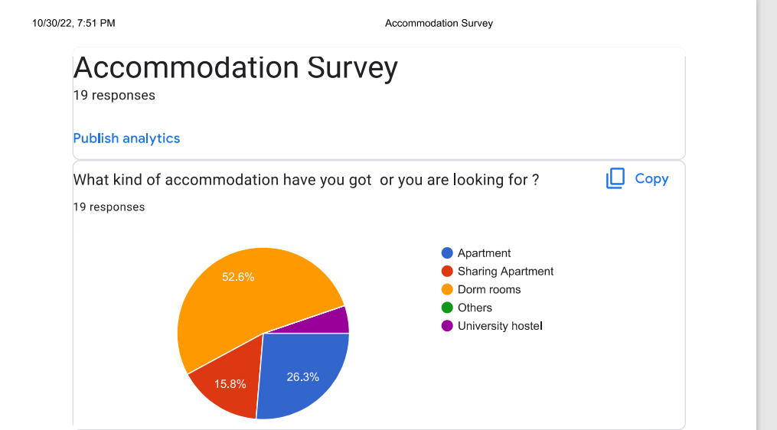

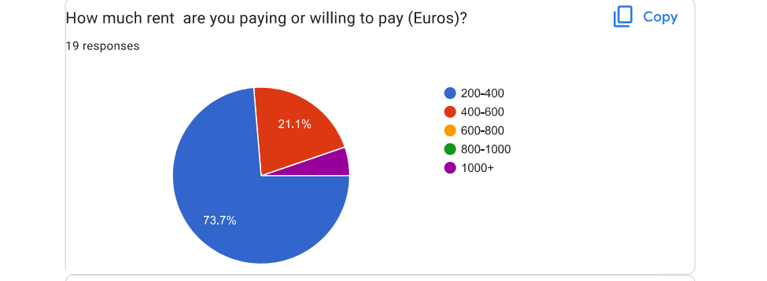

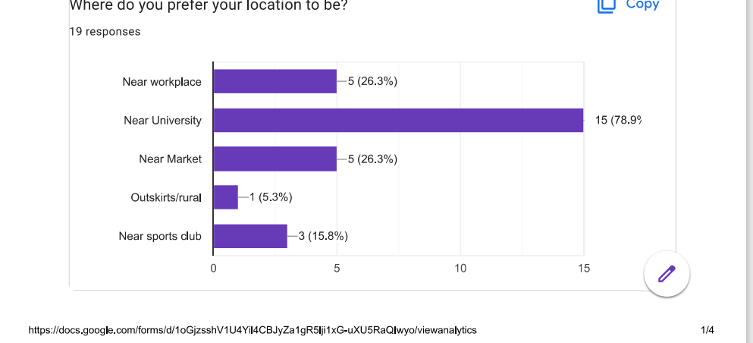

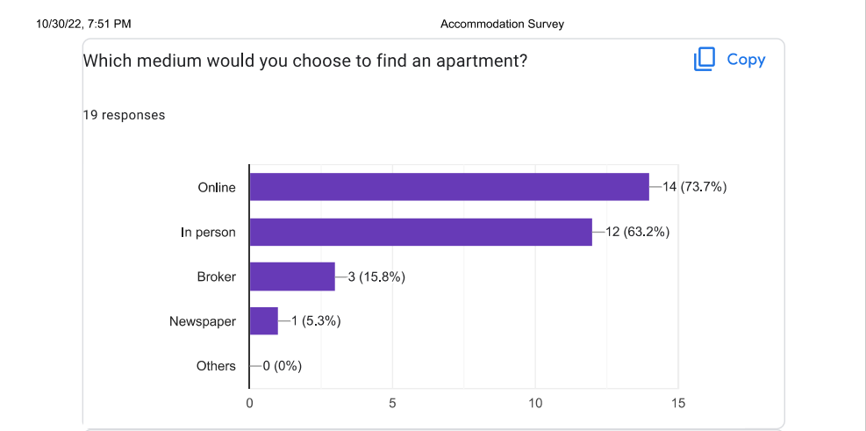

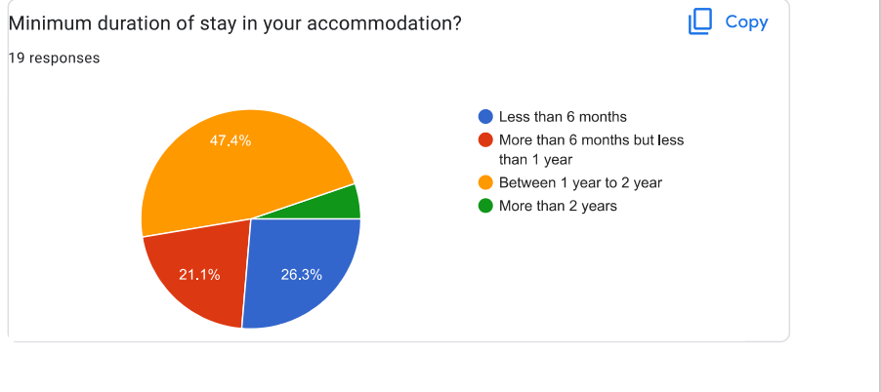

After that we learnt how to develop a persona which consist of user information, user needs and user constraint.

We formed the below persona as given below

Persona of John

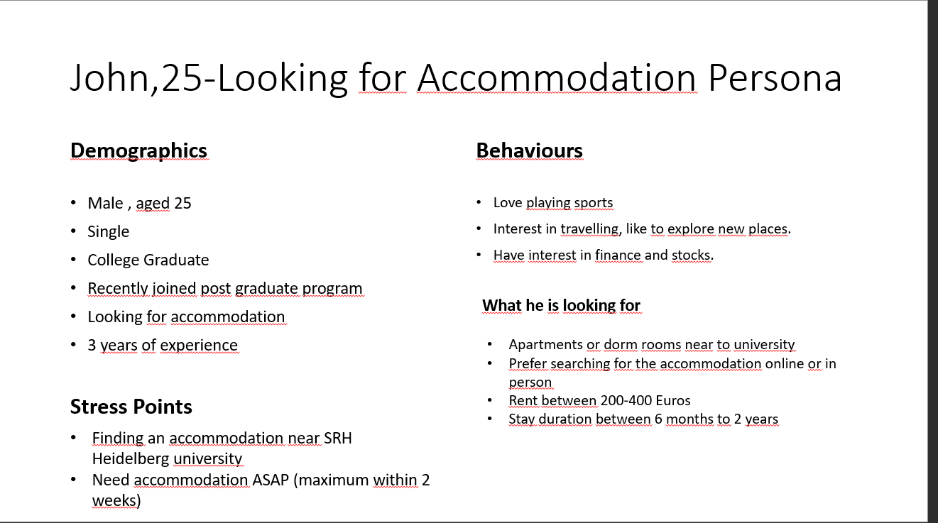

Here John is looking for an immediate accommodation within 2 weeks in Heidelberg and he is having a budget between 200-400 Euros. His preference is near the university

***IDEATE***

We came across the ideate phase where we can choose any method which includes 6-3-5, Brainstorming, Dotmocracy, How-Wow-Now matrix, Lotus Blossom diagram, SWOT Analysis, SCAMPER.

We choose to go with the Dotmocracy method where we come across with many ideas and then voted for the ideas and the ideas which got the highest voting we went with those ideas.

Below is the result of Dotmocracy

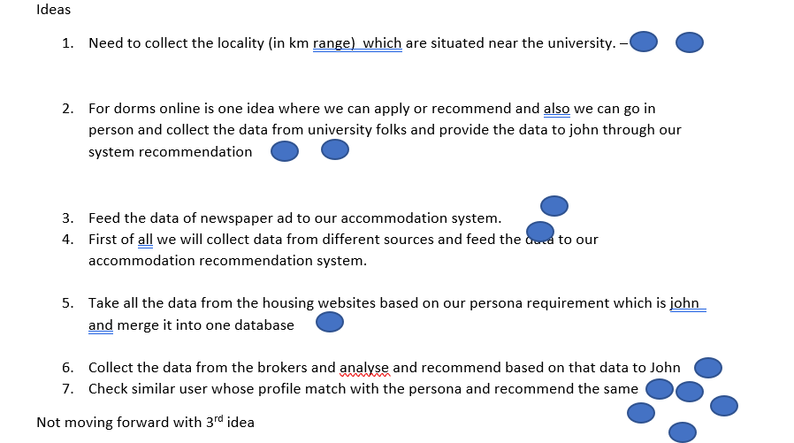

PROTOTYPE

We started creating a prototype for the user to understand our idea and the solution of his problem of getting an accommodation.

Below is the first prototype in the form of wireframe we formed.

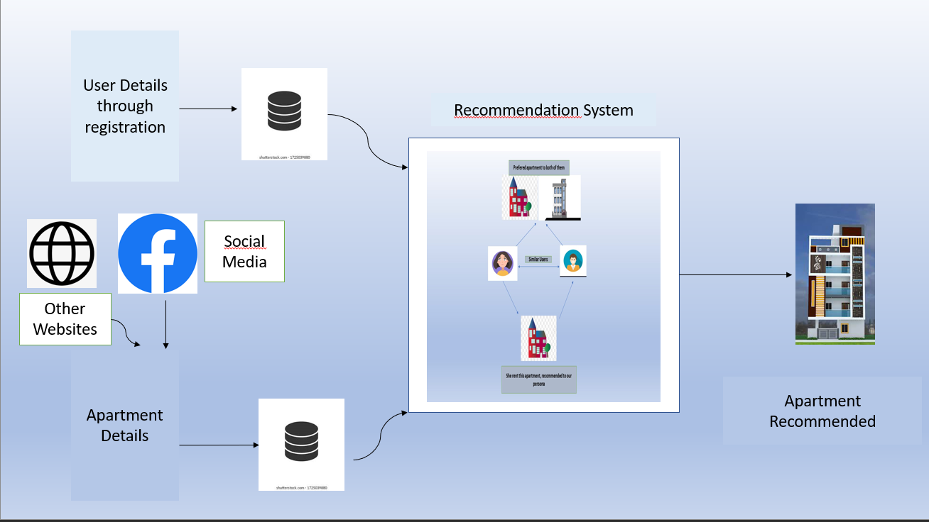

We understood the principle of design by taking the example of google search bar. Where we understood the concept of negative space and why it is an important part of any UX UI design.

Understood the topography of font and when we deliver our message we should be using professional font such as San serif. Every font has its own significance or importance

Using too many fonts is bad in a single design. Also understood the concept of legends used in a visualization and labelling.

Went through the color theory of RGB additive colors and CMYK subtractive color.

In color theory we understood that every color has its own significance , such as green color which resembles growth , blue provides trust.

After that we went through 101 exmaples of infographics in visme and we need to choose one which we think that it is the best infographic according to us and state the reason why we have choose this infographic.

After all these studies we have come up with our first prototype of infographic. As given below.

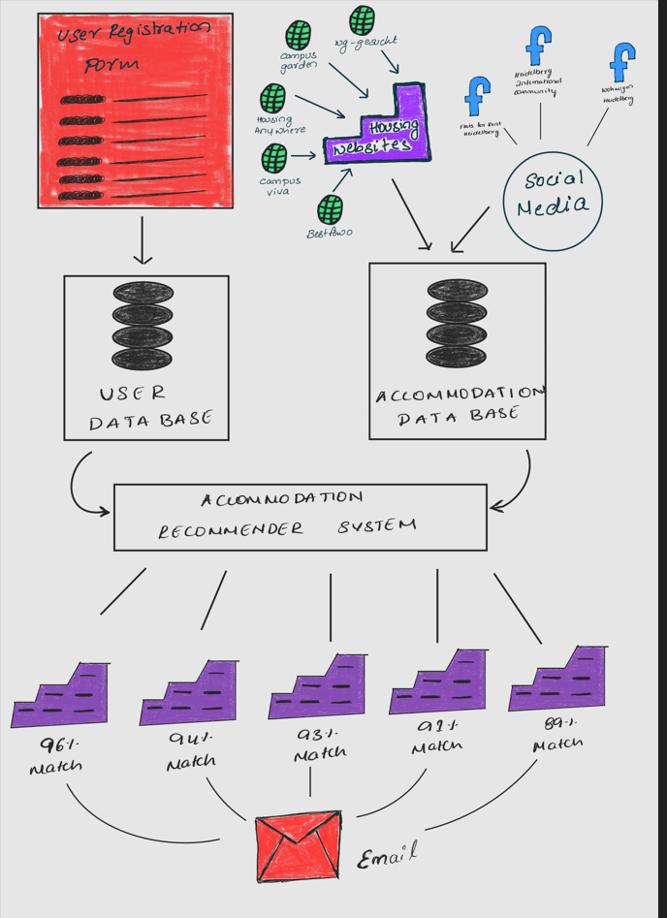

This is a simple version of our prototype of accommodation recommendation system.

After discussion with the user to the pros and cons of this prototype we again went to the ideate phase to make the improvements in this prototype, so we come up with our second prototype model as below.

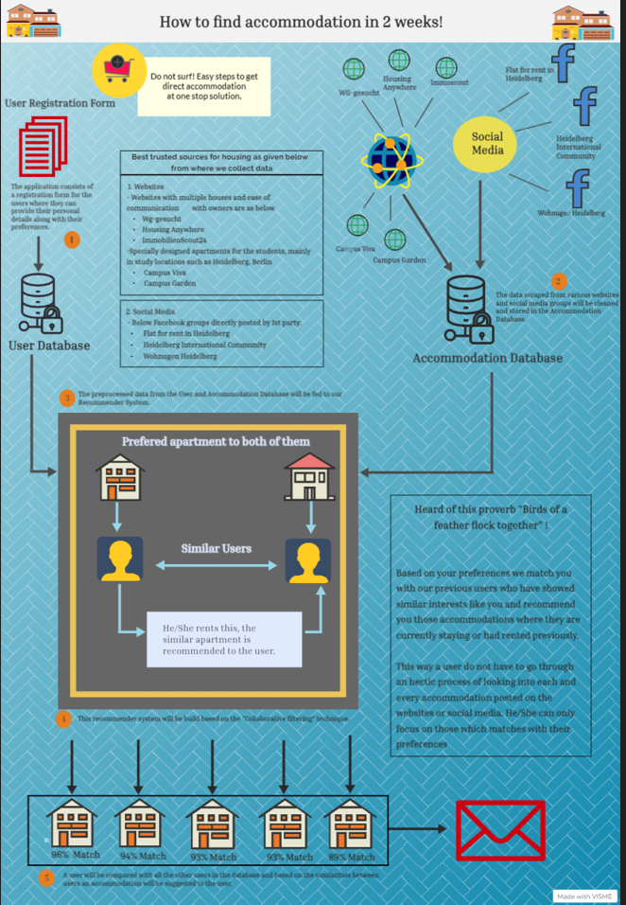

In the second prototype we have given a catchy heading which itself explains what is there in this model such as “How to get accommodation in 2 weeks”.

So, we come up with an idea that we will compare our user persona with the user who already got the accommodation and the persona should match.

We will make user to fill the user registration form where they have to write about their preferences for an accommodation such as budget, location, shared or non-shared apartment etc.

In parallel with this we will collect the information from different housing websites such as wg-gesucht, Housing Anywhere, Immoscout, Campus Viva, Campus Garden. And also, we collect the information of such kind of accommodation which matches with our and the matching user and present in the same location with same budget and is empty from the social media platform such as social media groups in Facebook.

And once there is a match the system will recommend that house/apartment/room to the user with the accuracy of 90% and above matching.

After the presentation of this prototype we have taken few feedbacks from the user and the people in class such as the background should be more dark and text should be in white instead of black, also there are lot of text information in the prototype which is not necessary, so we fixed all these flaws in prototype 2 and come with our final prototype 3 as given below.

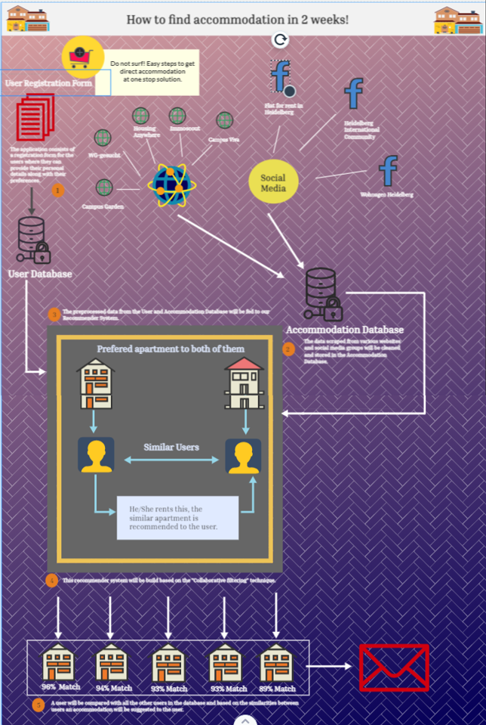

**Prototype 3**

Here in the above prototype you may see that the background color has been changed, text is in now white color and the unnecessary text has been removed from this prototype. So, all these changes is possible in the testing phase where we continuously took feedback and come up with the improvements in this.