* 1. There are 32 columns and 2.2Million rows in the data.

Product_id is 99.75% unique (2160607)

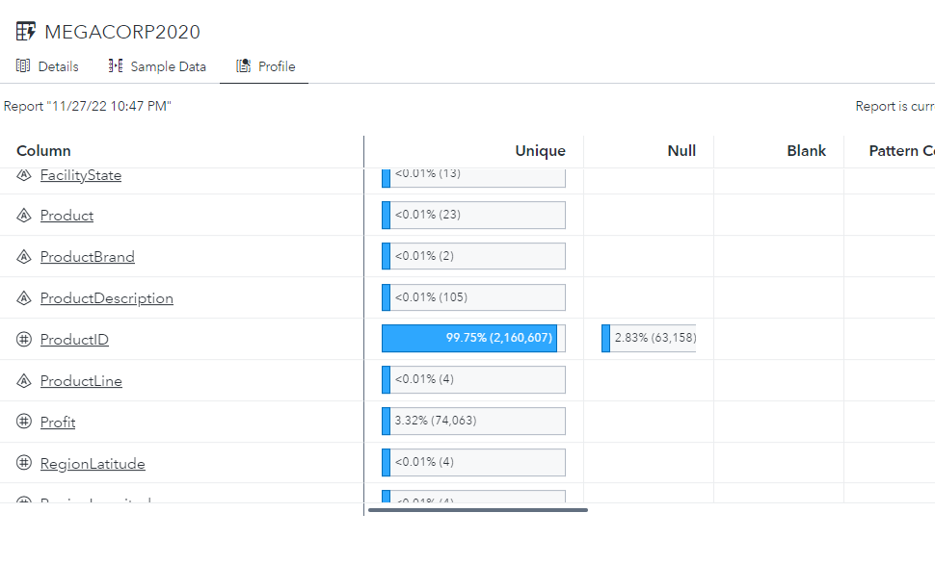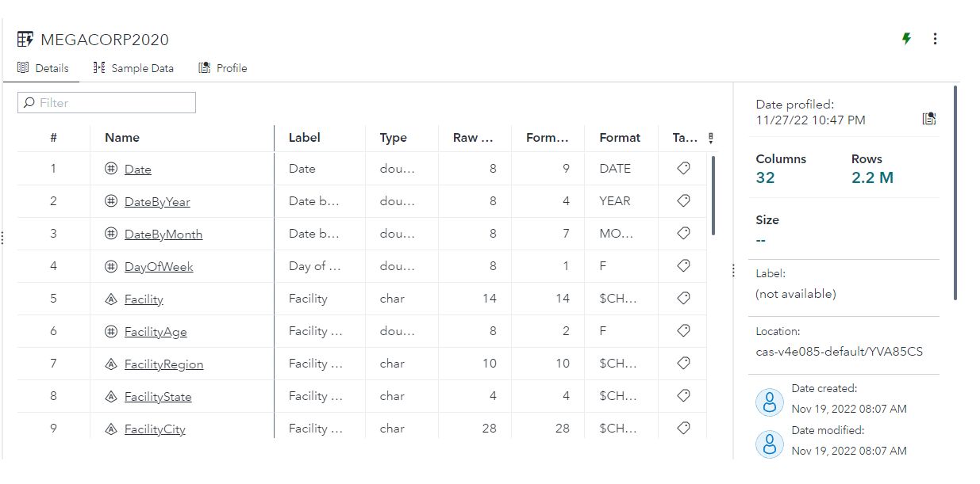

**1.2**

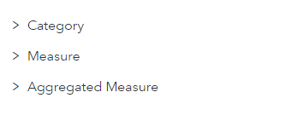

In category we have Date, facility, product, and unit related details.

In Measure we have profit, geographical, age, expenses, and product id details

**1.3**

**A1.3:**

|  |  |
| --- | --- |
| **Data Item Name** | **Format** |
|  |  |
|  |  |
|  |  |
|  |  |
|  |  |

1.4

Day of week, Facility age, unit age should be moved from measure to category

1.5

Default aggregator for **Unit** **Reliability** and **Unit Yield (rate)** both have **sum** but it should be **Average**

**A2.1:**

|  |  |  |  |  |
| --- | --- | --- | --- | --- |
| **Data Item** | **Rename** | **Classification** | **Format** | **Aggregation** |
| **DateOfWeek** |  |  |  |  |
| **Facility Age** |  |  |  |  |
| **Unit Age** |  |  |  |  |
| **Unit Reliability** |  |  | **category** |  |
| **DateOfYear** | **Year** |  |  |  |

**Activity 2.2:**

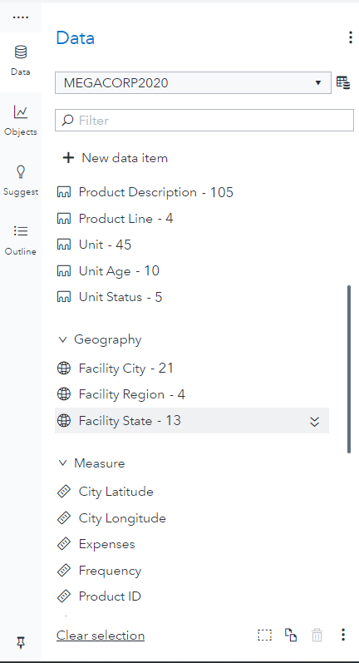

2.3

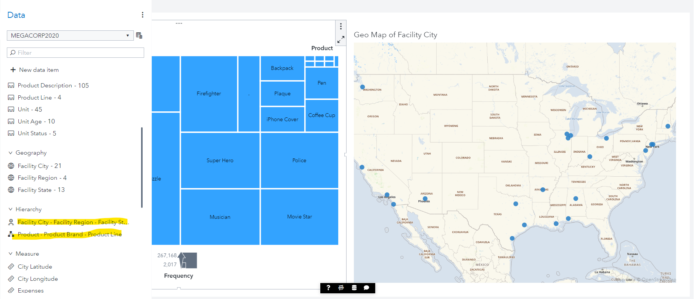

2.4

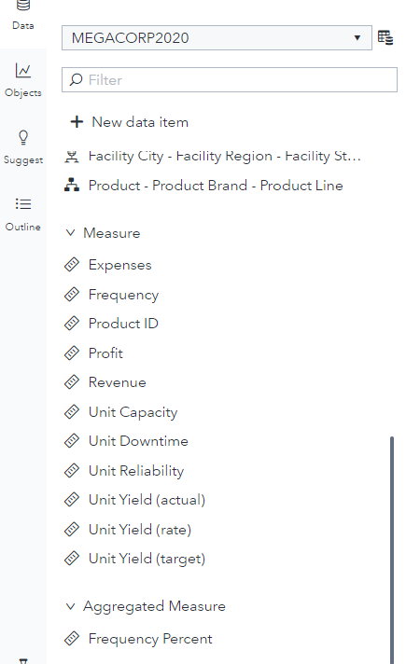

2.5

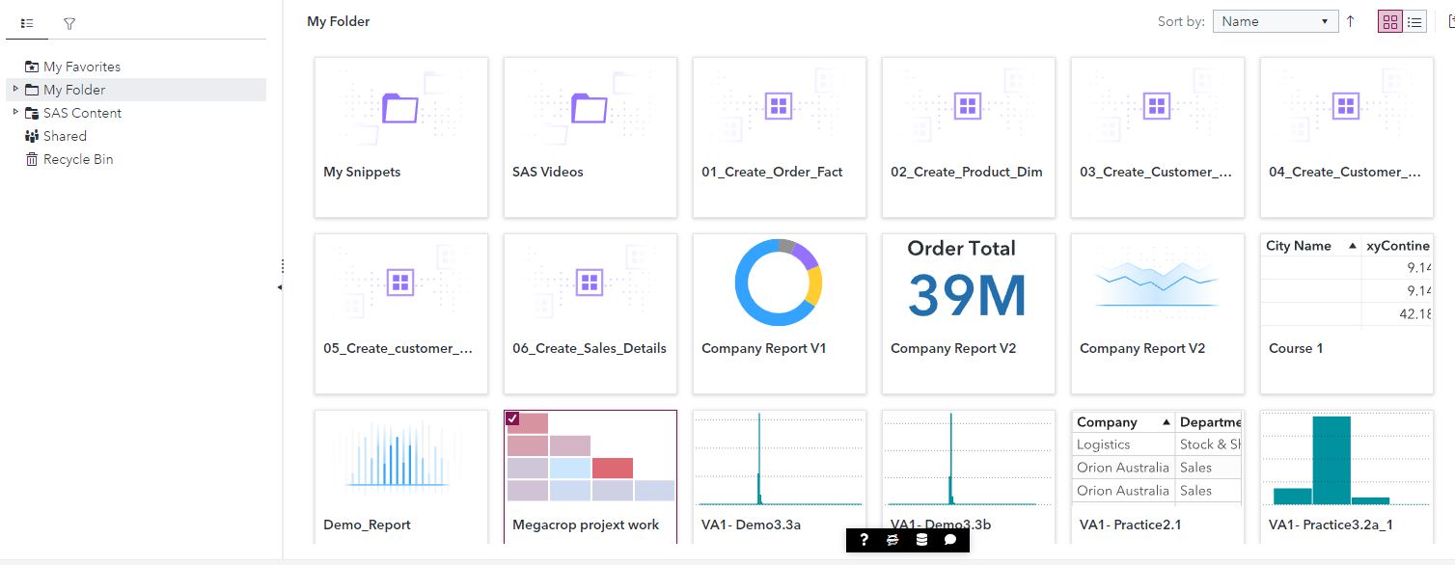

Part3

**Q3.1.1:**

There are 4 regions:

East, West, North & South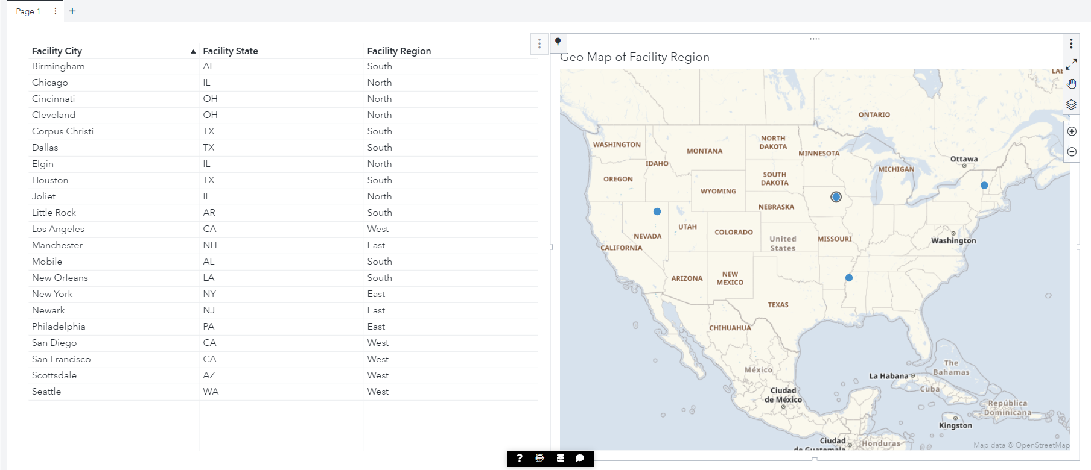

3.1.2

13 state

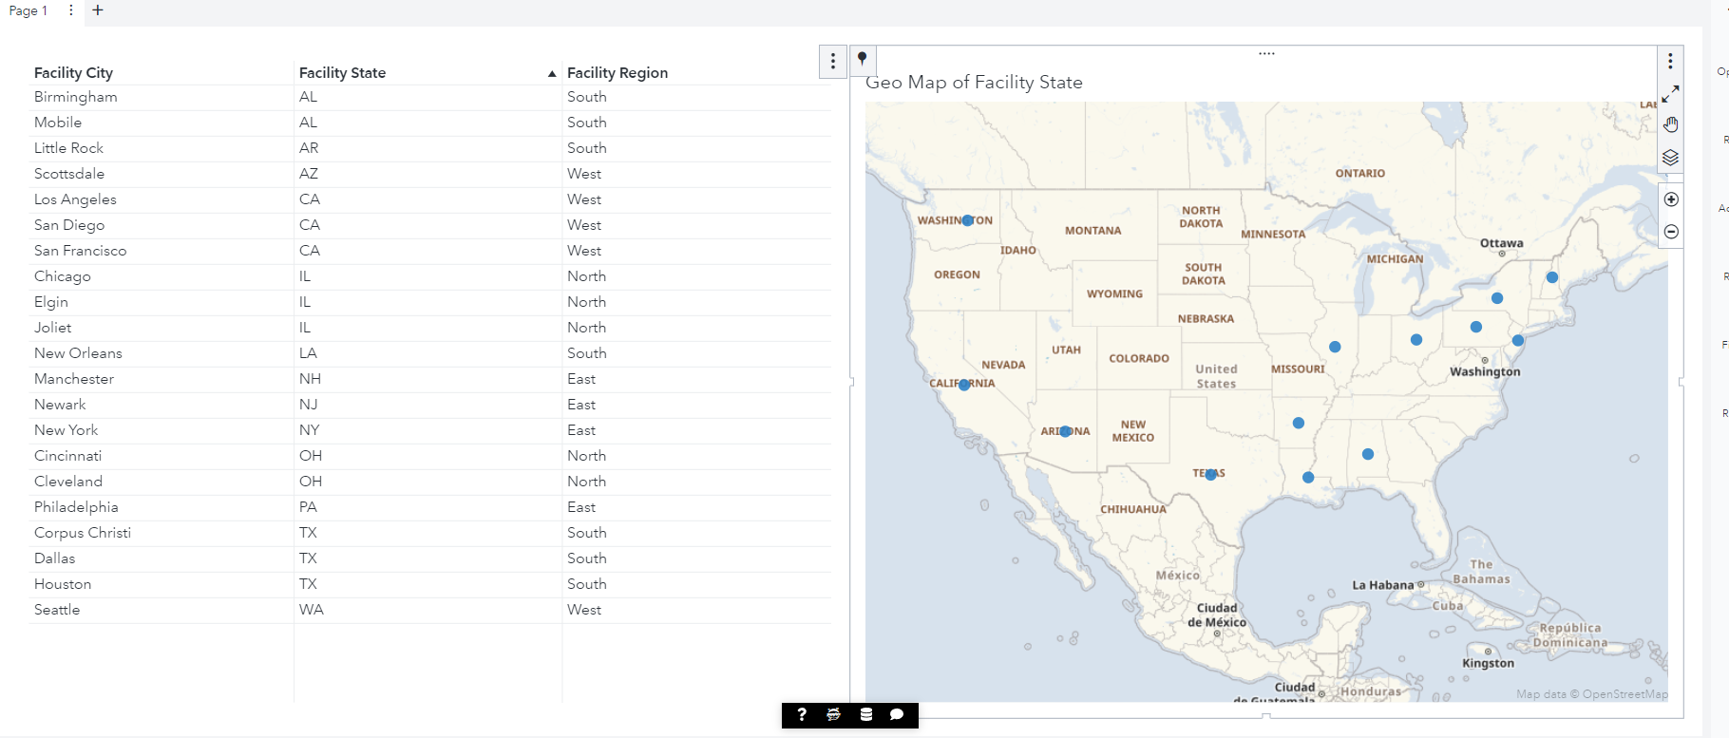

3.1.3

There are 8 states with single facility.

They are: AR, AZ, LA, NH, NJ, NY, PA, WA

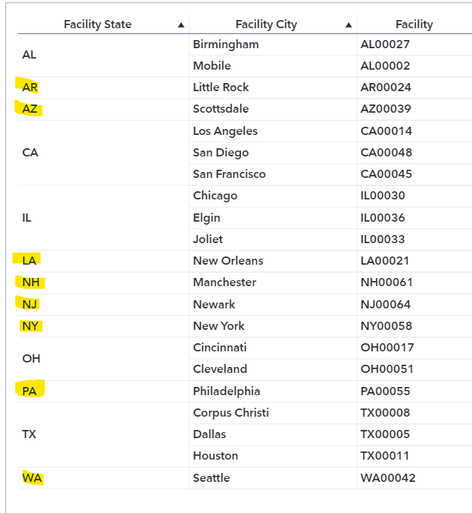

3.1.4

City names are

1. Little Rock (AR)
2. Scottsdale (AZ)
3. New Orleans (LA)
4. Manchester (NH)
5. Newark (NJ)
6. New York (NY)
7. Philadelphia (PA)
8. Seattle (WA)

3.2.1

There is data of 13 years and it ranges from 2008 to 2020

3.2.2

Earliest date is 05/01/2008

Latest date is 04/01/2020

3.3.1

Active has the highest frequency and it is almost have 2165929 of total data i.e., is almost 99% of the total data

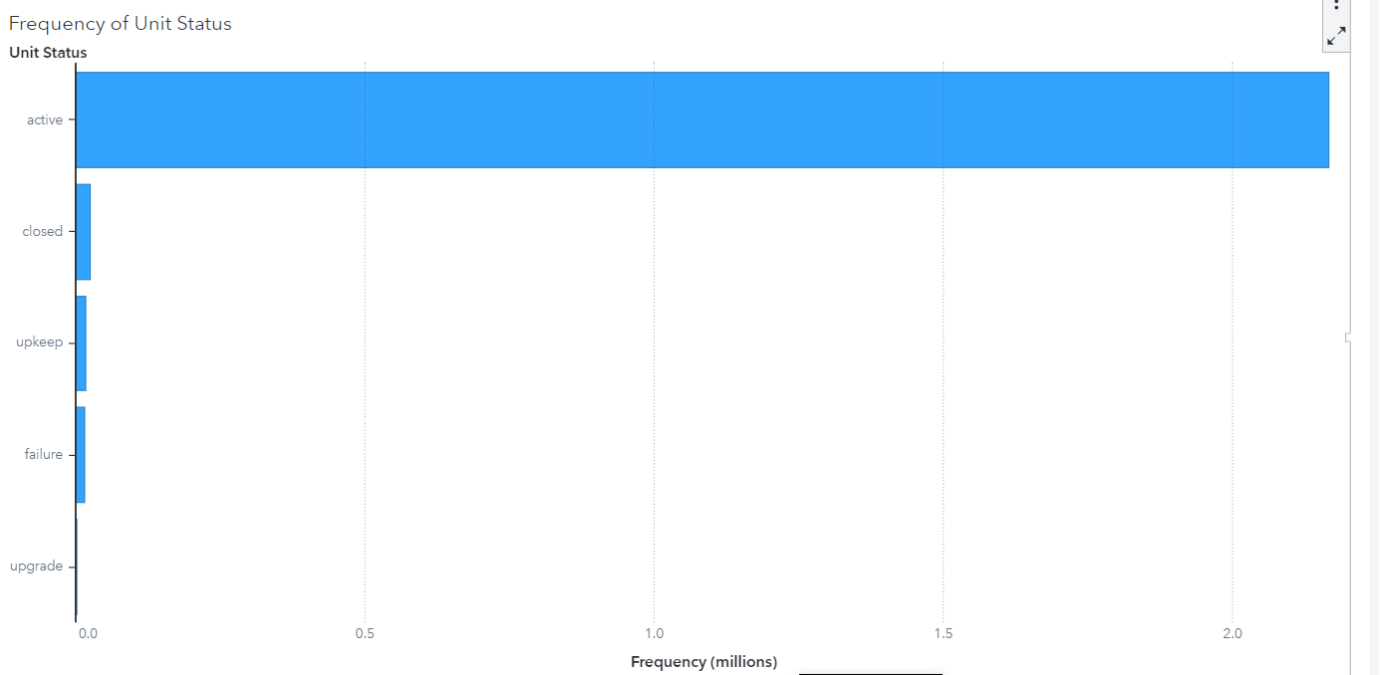

3.3.2

Upgrade is the least frequency and it has 157 of total data.

3.3.3

Second day of the week has the highest

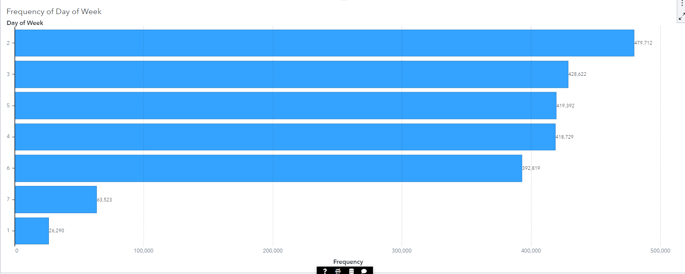

3.3.4

For Sunday the active unit is 44541

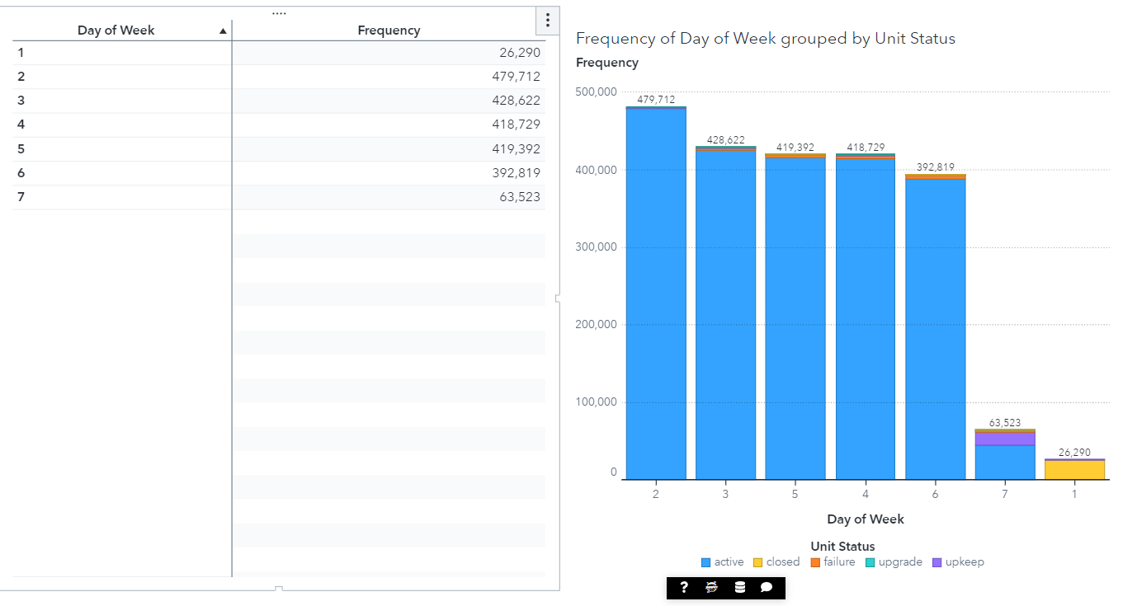

3.4.5

Fourth day of the week has highest failure which is Thursday and it is 4002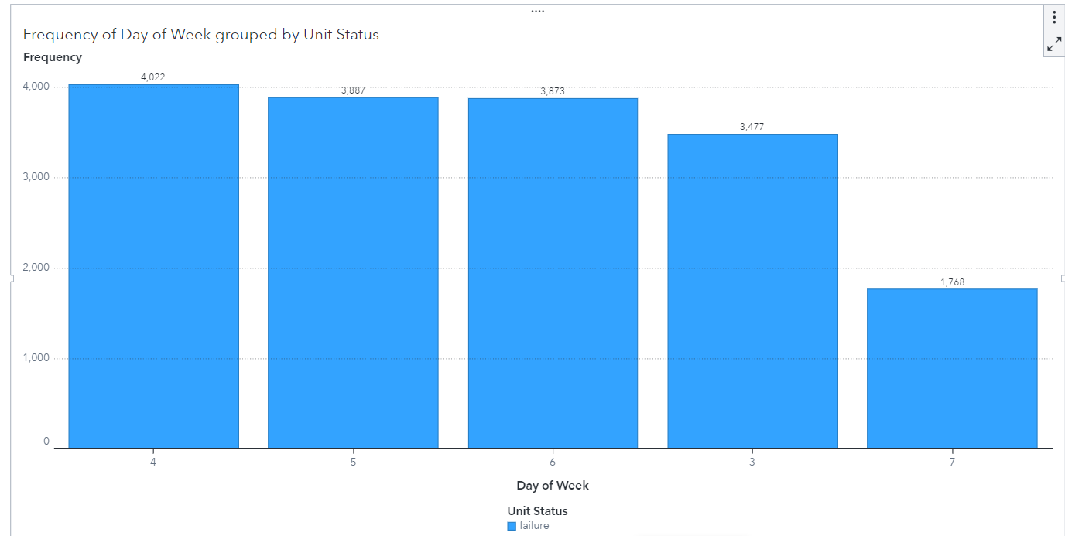

3.4.6

Upgrade and Upkeep both are busiest on Sunday

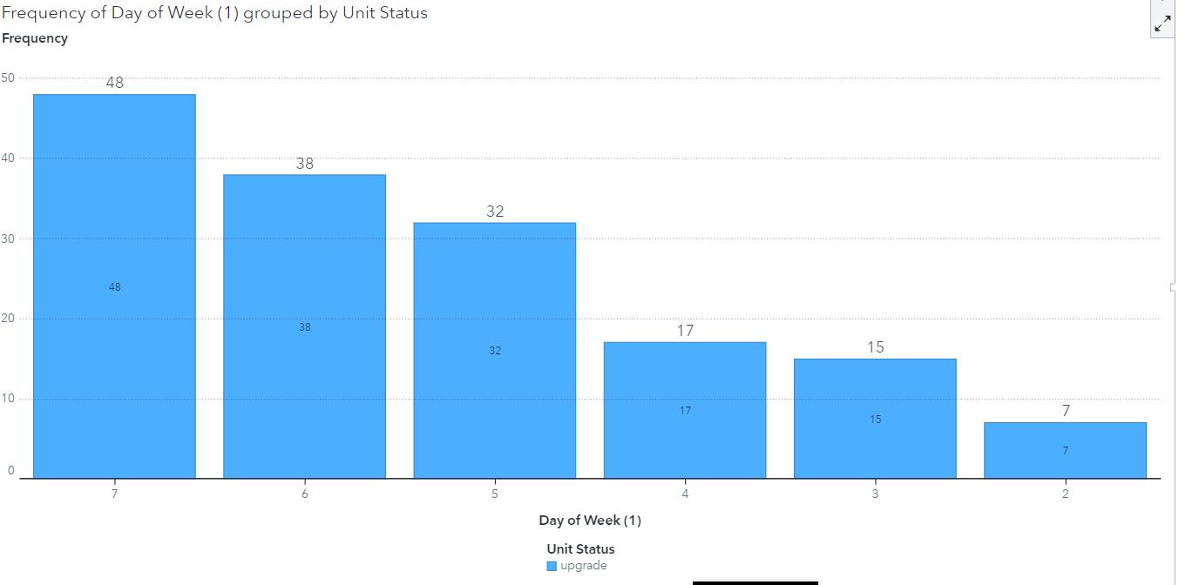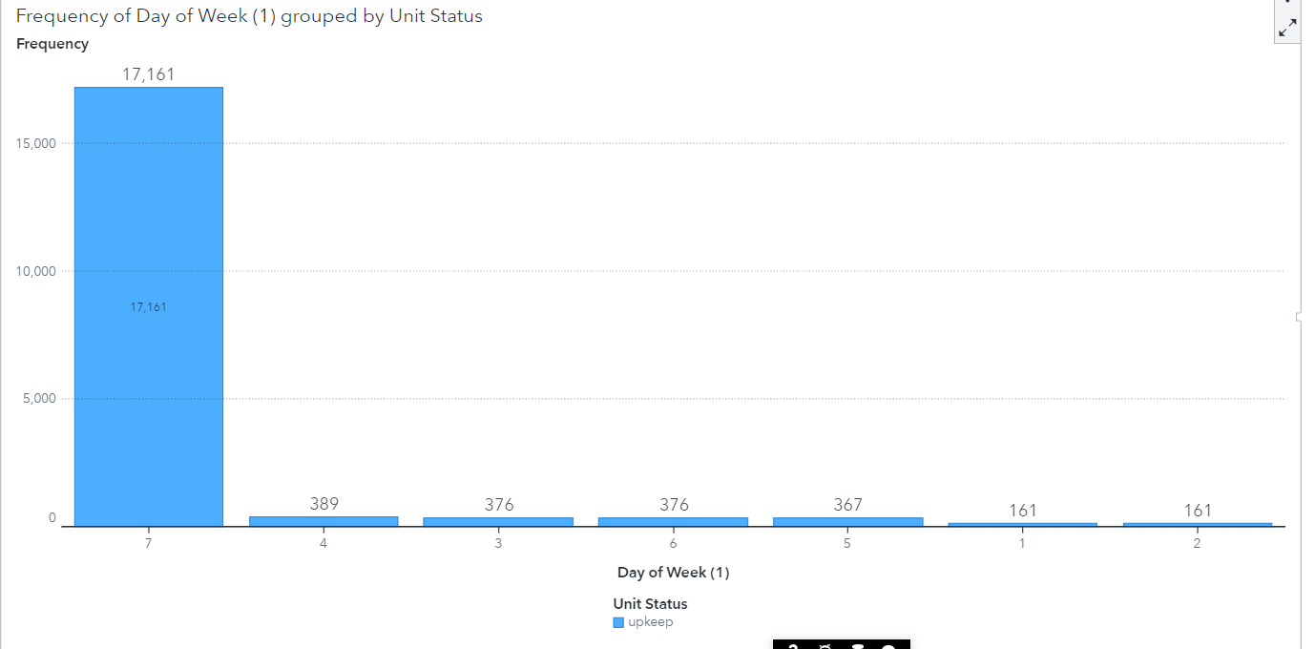

3.4.1

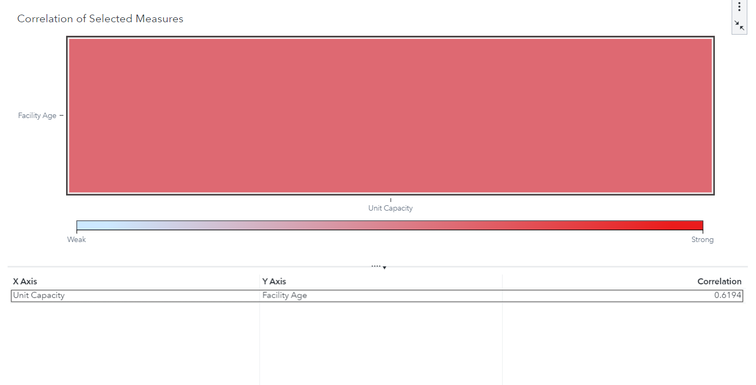

3.4.2

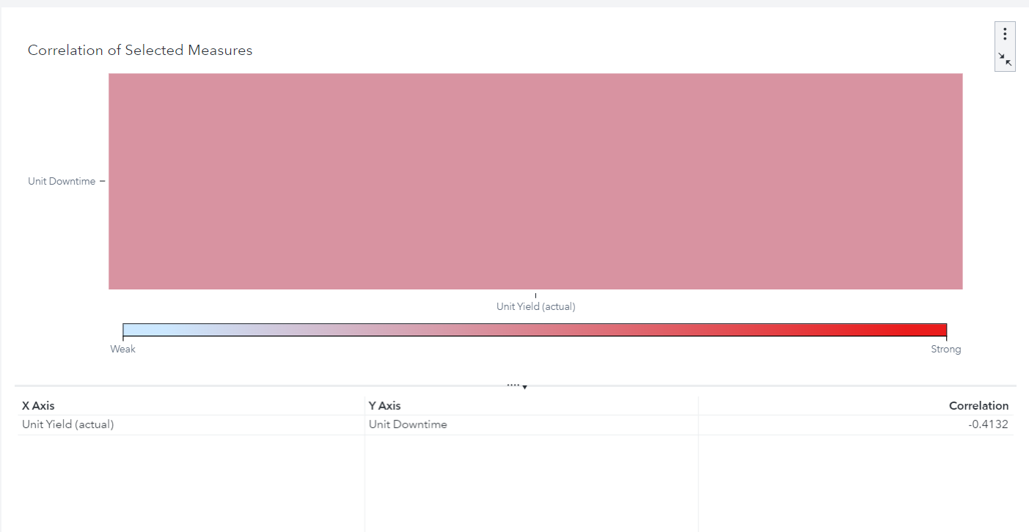

3.4.3

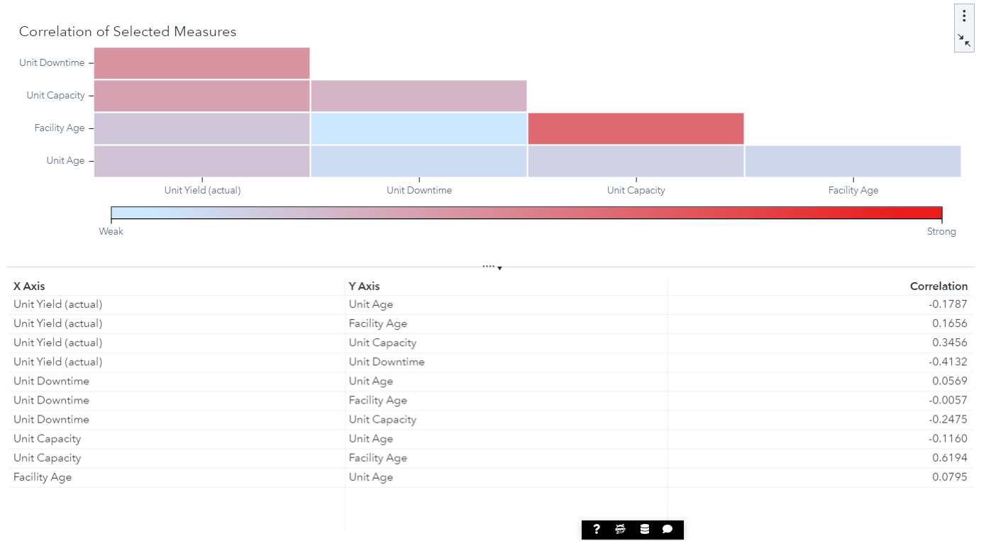

3.5

Unity reliability will get reduces in the 8th year

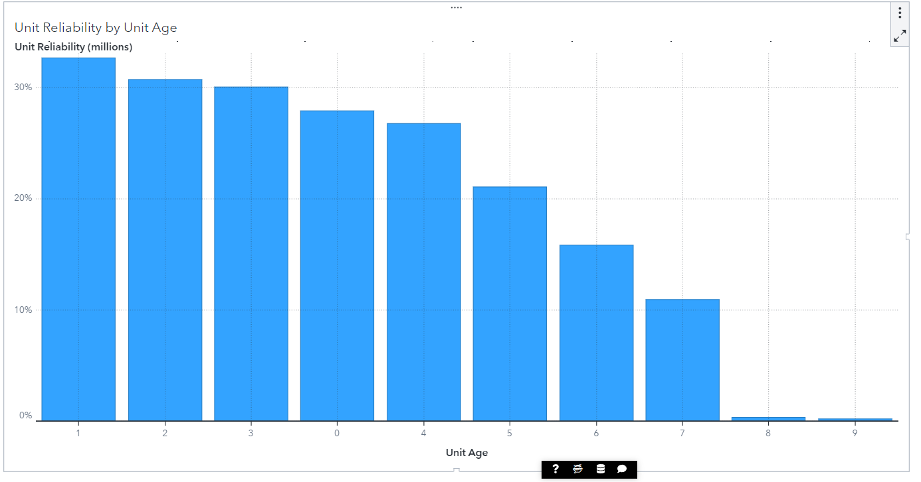

3.6

2017 had the negative

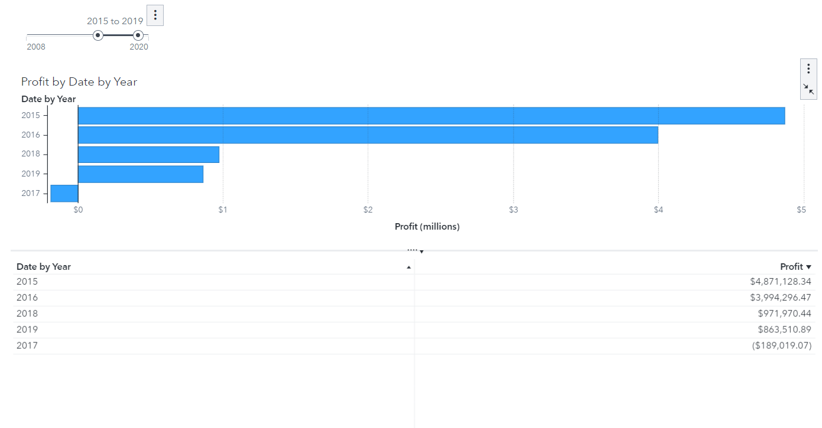

3.6.2

Loss occurred in Toy

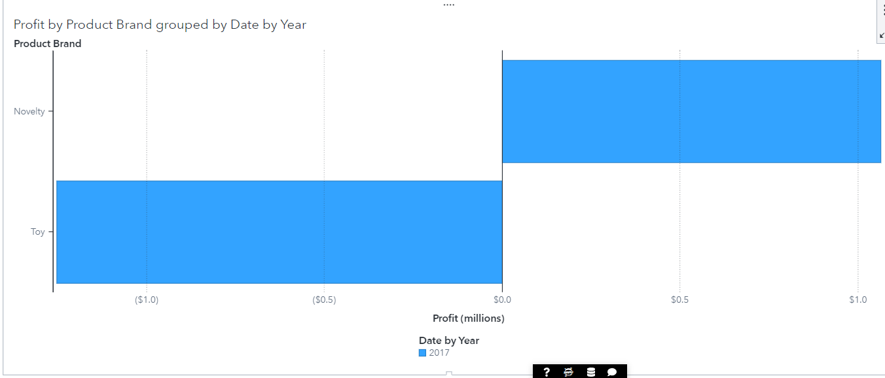

3.6.3

In west

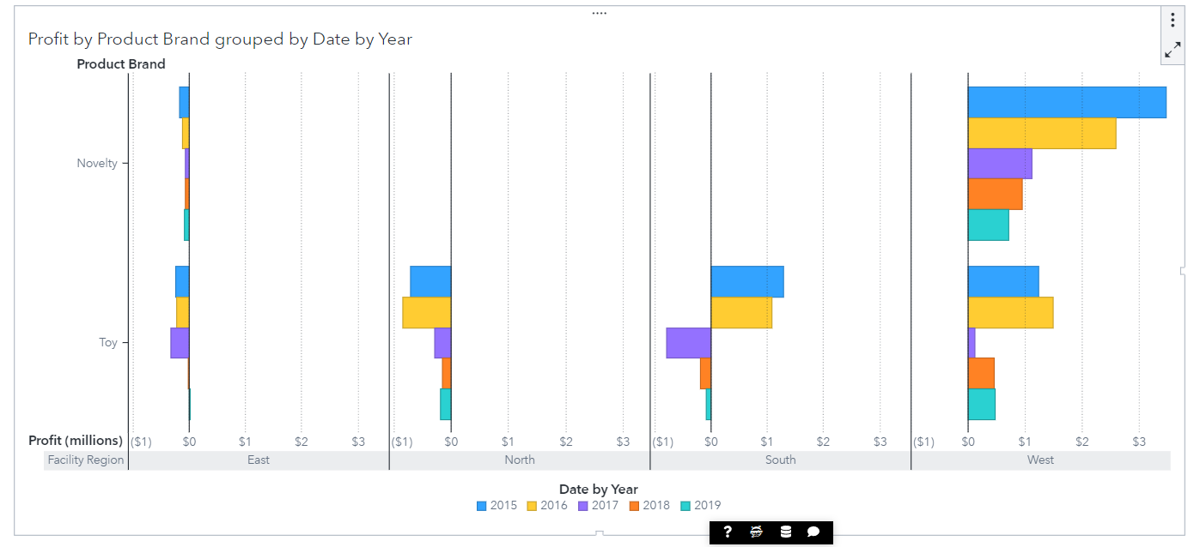

3.6.4

In North

3.7.1

In 2008 AZ state had unit capacity is 865876

3.7.2

In 2020 AZ state had unit capacity is 1680

3.7.3

Total capacity in last five year i.e., between 2015-2019 is 36846168

3.7.4

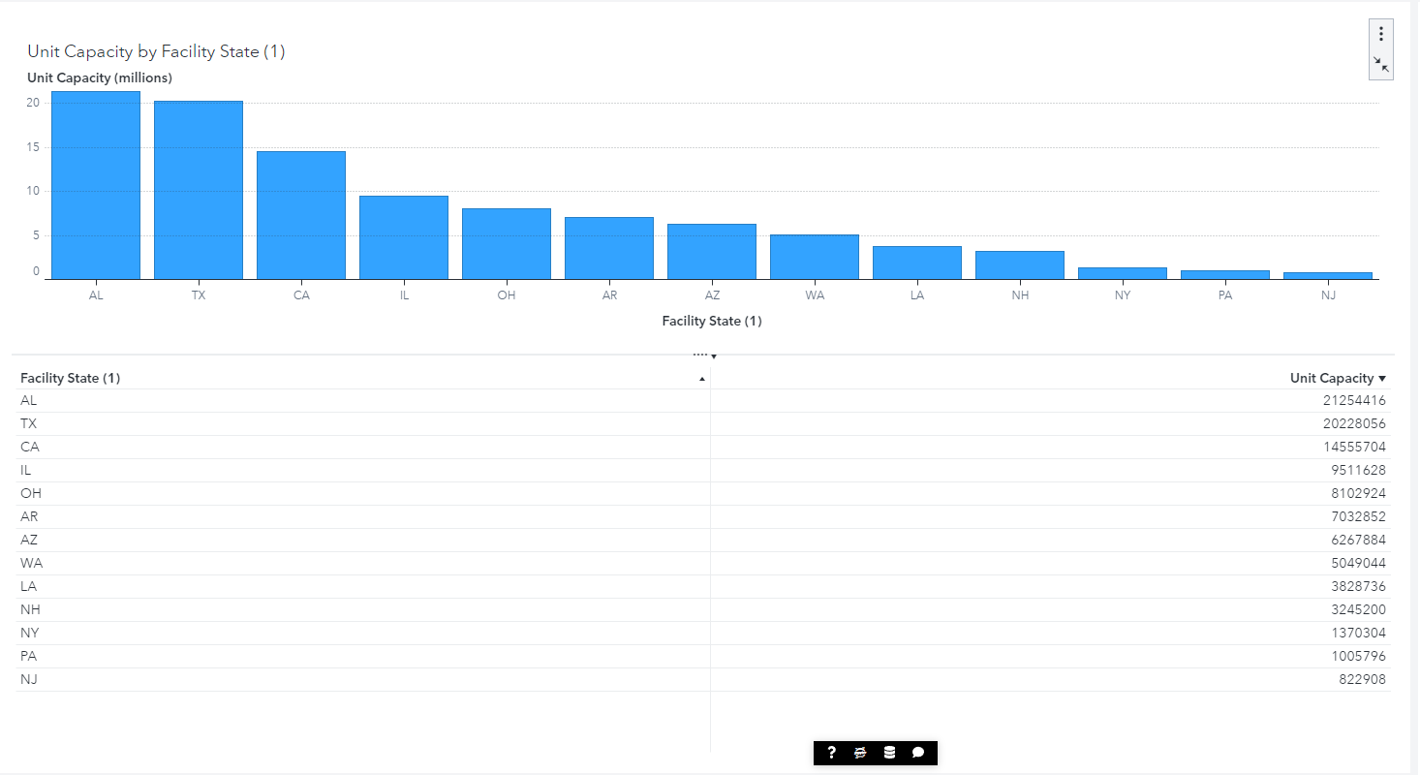

AL state has the highest

3.7.5

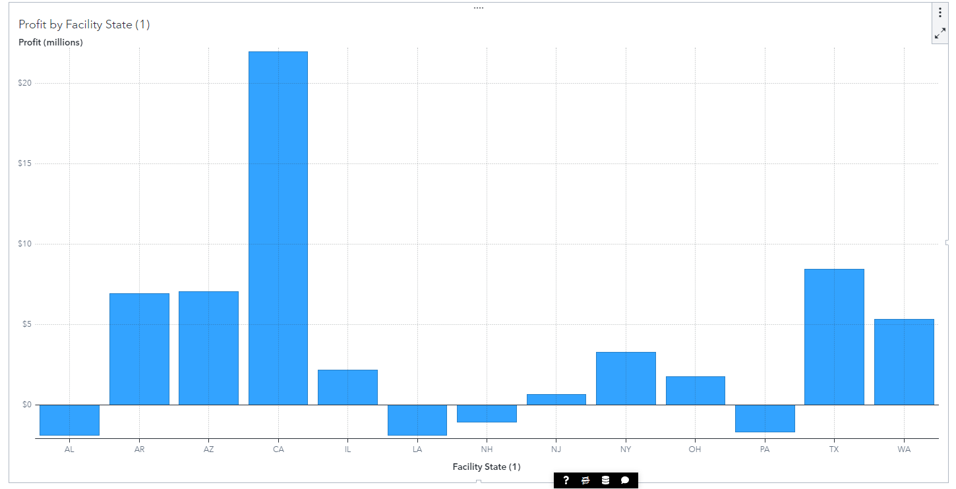

3.7.6

CA is the most profitable state

3.7.7

AL

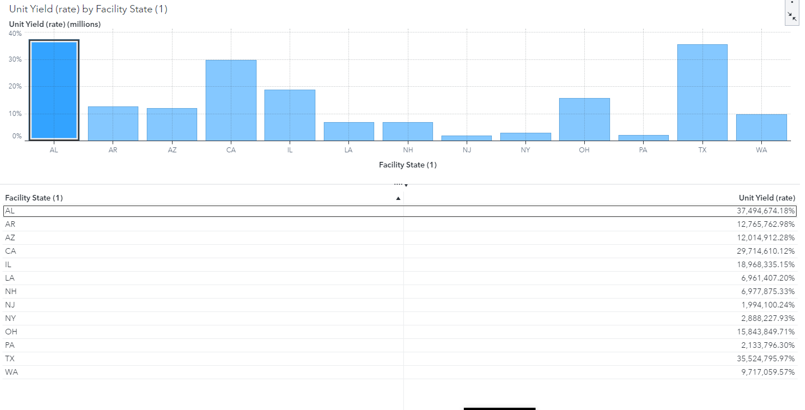

3.7.8

NA, LA, NH & AL

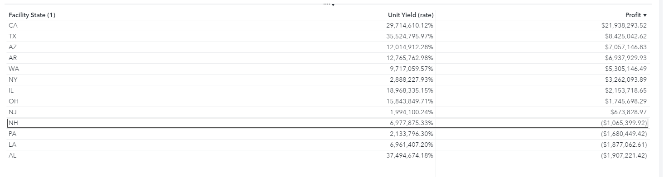

3.8.1

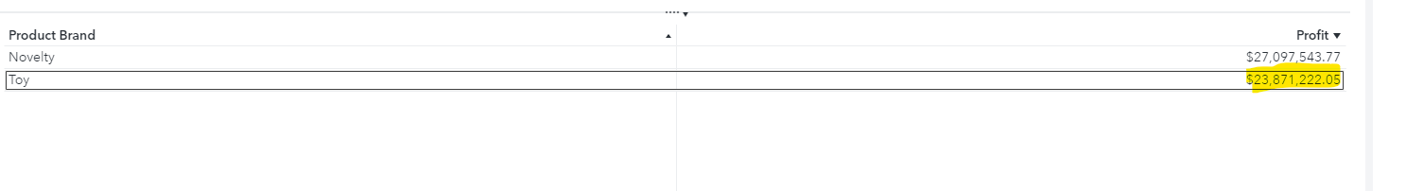

23871222.05

3.8.2

2162114.84

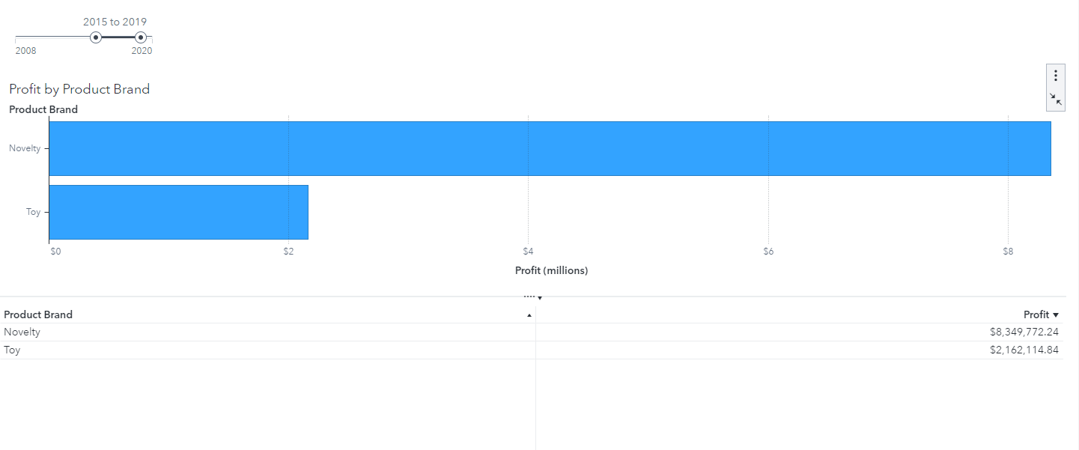

3.8.3

Action Figure and Stuffed Animal

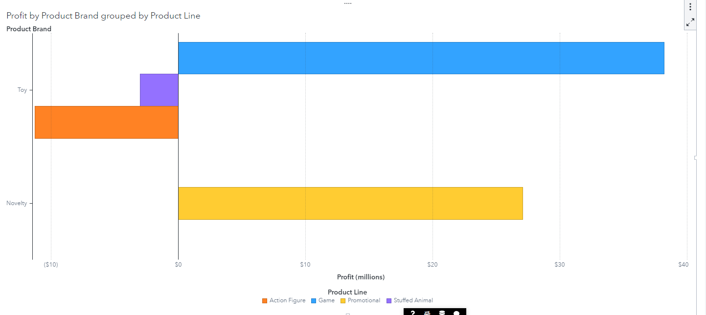

3.8.4

Yes, the losses have increased in last 5 years

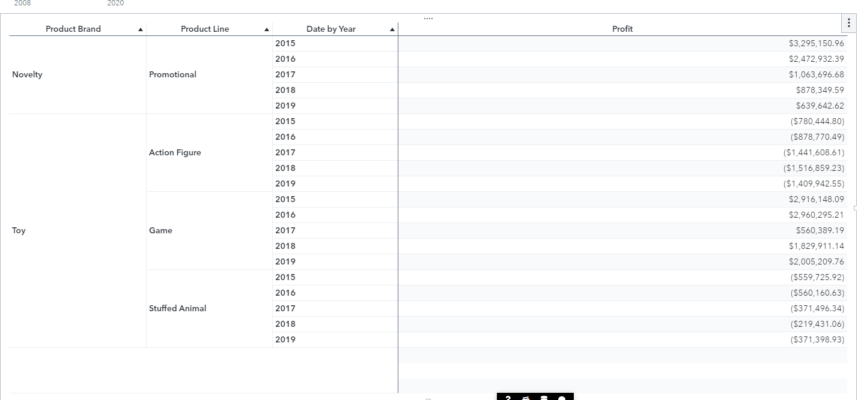

3.9

3.9.1

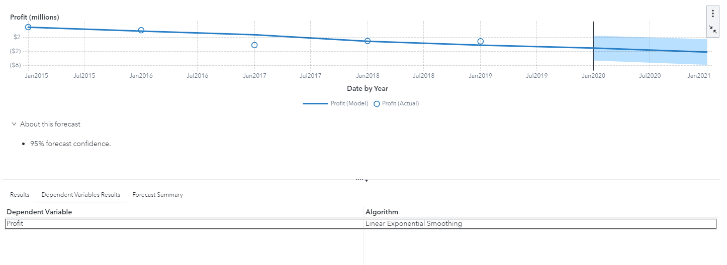

3.9.2

**A3.9.2:**

|  |  |  |
| --- | --- | --- |
| **Product Line** | **Forecast: Gain or Loss** | **Forecast Algorithm** |
| Game | **Loss** | **Simple exponential smoothing** |
| Promotional | **Loss** | **Linear exponential smoothing** |
| Stuffed Animal | **Gain** | **Linear exponential smoothing** |

3.10

3.10.1

Page1

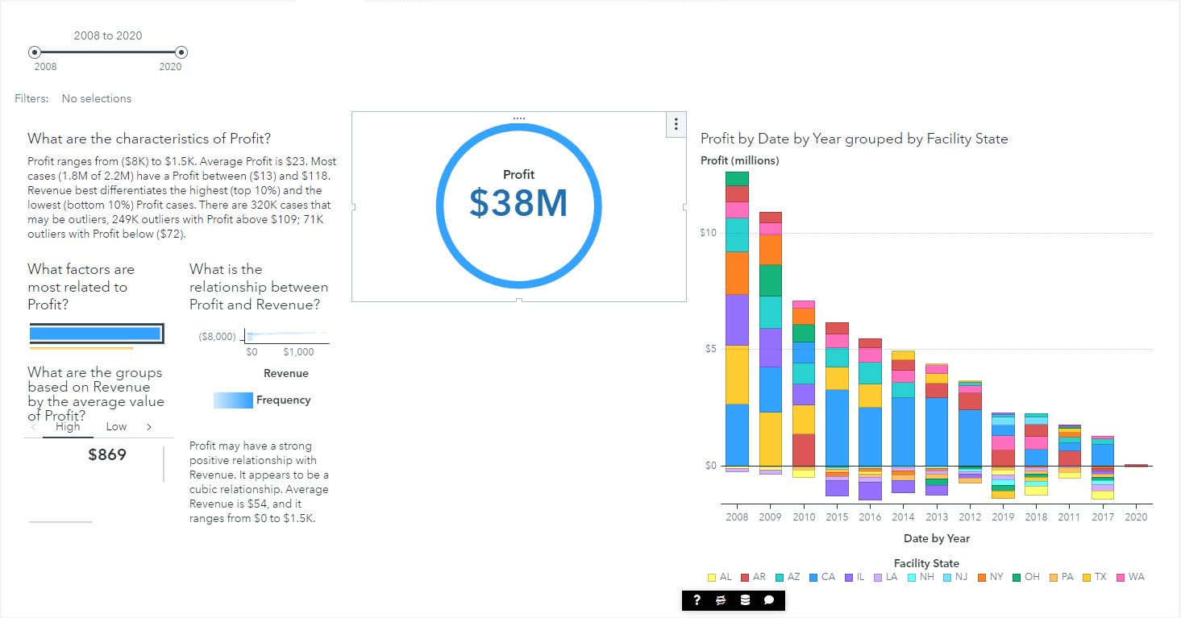

Page 2

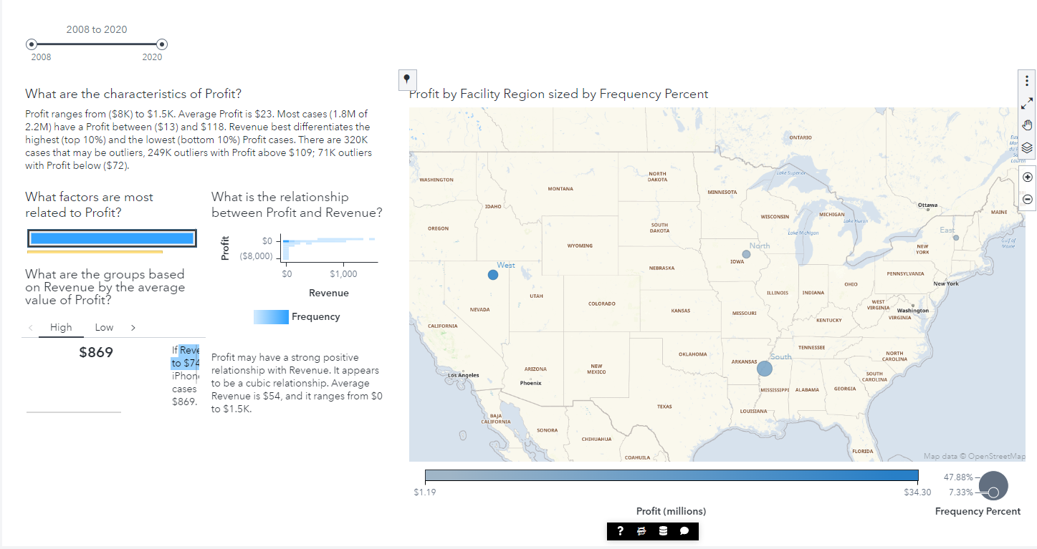

Page3

