Capstone Project Report
MUSIC LIBRARY MANAGEMENT SYSTEM
Project Category: DBMS Capstone Project (Topic 9)
Submitted in partial fulfilment of the requirement of the degree of
BACHELOR OF TECHNOLOGY
In
CSE with Specialization Data Science
at
K.R. Mangalam University
by
Student Name: | Kartik Sharma
Roll Number: | 2501420029
Course/Subject Name: | Database Management Systems (DBMS)
Faculty Name: | Swati Ma’am
Submission Date: | 10 November 2026

Department of Computer Science and Engineering
School of Engineering and Technology
K.R. Mangalam University, Gurugram- 122001, India
INDEX
S.No. | Topic | Page No.
1. | Introduction | 3
2. | Database Schema Design | 4
3. | CRUD Operations | 9
4. | Search, Playlist and Preference Analysis Queries | 15
5. | Indexing | 25
6. | Views | 29
7. | Window Functions | 34
8. | Conclusion | 38

1. Introduction

1.1 Project Overview
A Music Library Management System organizes the information of a digital music collection: artists, albums, tracks and genres, together with the users who listen to the music, the playlists they create and their listening history. In this project the database music_library is designed in MySQL and SQL is used to manage the data, search the library, build playlists and analyse listening preferences.

1.2 Objectives
- Create a database schema to store music tracks, albums, artists and genres.
- Implement CRUD operations to manage music library content and artist information.
- Write SQL queries to search for songs by title, artist or genre, create playlists and analyse music preferences.
- Indexing: create indexes on track titles, artist names and playlist tracks and check their use with EXPLAIN.
- Views: create a track details view and an artist view that simplify common queries.
- Window functions: rank tracks per genre with DENSE_RANK(), find the next track played with LEAD(), calculate a running total of plays per day and the contribution of each track to its album with SUM() OVER (PARTITION BY ...).

1.3 Tools and Report Organisation
The queries were executed on a local MySQL 8.0 server (instance MySQL80) using MySQL Workbench, in the database music_library. For every query the report shows the screenshot of the executed query and its output, the SQL code, and an explanation of what the query does.

2. Database Schema Design
The music_library database consists of nine tables. The core entities are artists, albums, tracks and genres; users, playlists, playlist_tracks and listening_history support playlists and listening analysis; and track_genres links tracks to genres. One artist has many albums, one album has many tracks, a track can belong to several genres, a user owns many playlists, a playlist contains many tracks, and every play of a track by a user is logged in listening_history.
Table | Purpose | Key columns
artists | Artist information | artist_id (PK), artist_name
albums | Albums released by artists | album_id (PK), album_title, release_year, artist_id (FK)
tracks | Individual songs | track_id (PK), track_title, album_id (FK), duration_seconds
genres | Music genres | genre_id, genre_name
track_genres | Links tracks to genres (many-to-many) | track_id, genre_id (composite PK)
users | Listeners of the library | user_id, username
playlists | Playlists created by users | playlist_id (PK), user_id (FK), playlist_name
playlist_tracks | Tracks inside a playlist, in order | playlist_id, track_id (composite PK), position
listening_history | Log of every play | history_id (PK), user_id (FK), track_id (FK), played_at
PK = primary key, FK = foreign key. The screenshots on the following pages show the table list and the structure of the tables with DESCRIBE.

2.1 Listing the Tables of the Database
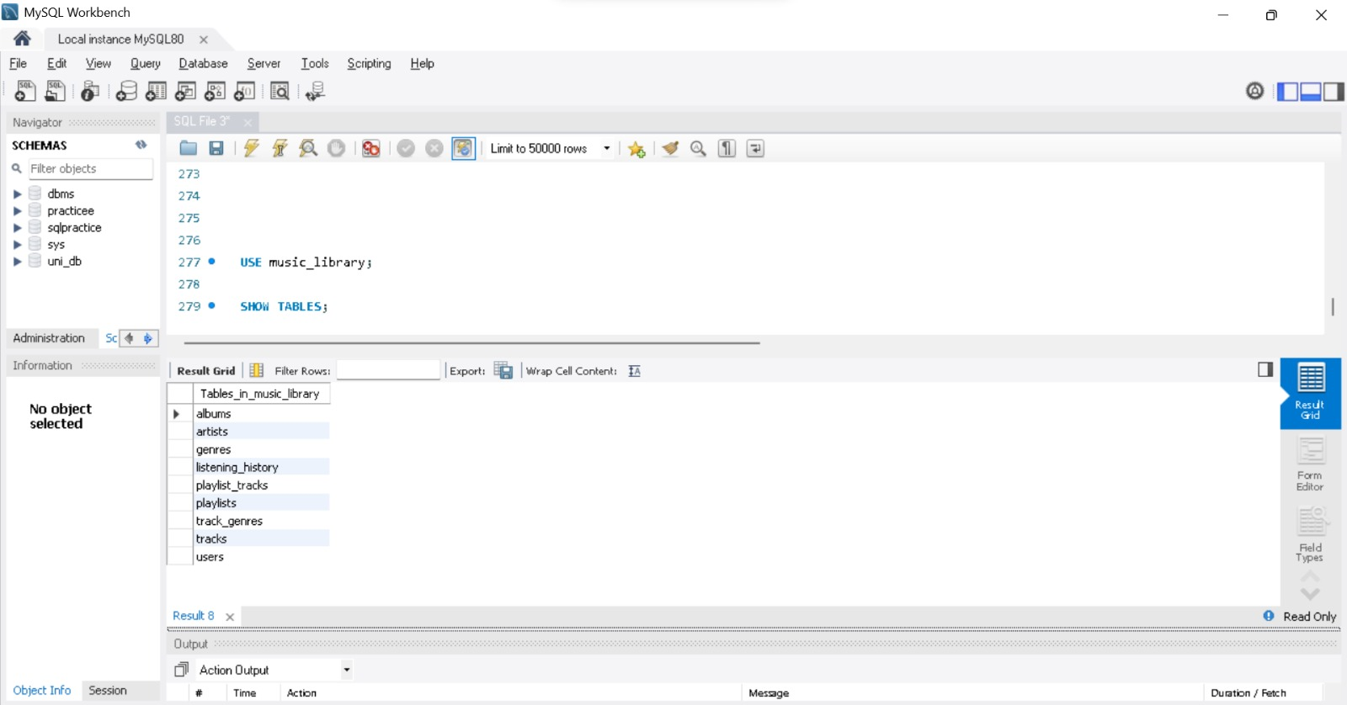
SQL Query:
USE music_library;
SHOW TABLES;
Explanation:
USE music_library selects the database to work in and SHOW TABLES lists every table inside it. The result confirms that the schema contains nine tables: albums, artists, genres, listening_history, playlist_tracks, playlists, track_genres, tracks and users.

2.2 Structure of the artists Table
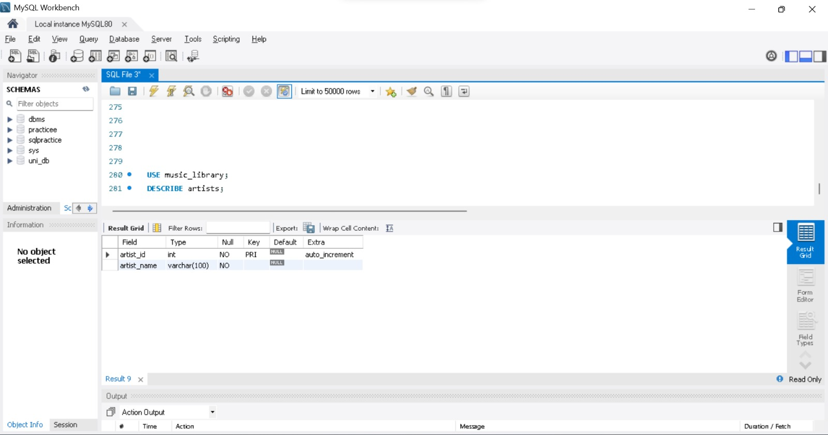
SQL Query:
USE music_library;
DESCRIBE artists;
Explanation:
DESCRIBE shows the structure of a table: column names, data types, whether NULL is allowed, keys, defaults and extra properties. artists has artist_id (INT, primary key, AUTO_INCREMENT) and artist_name (VARCHAR(100), NOT NULL).

2.3 Structure of the albums Table
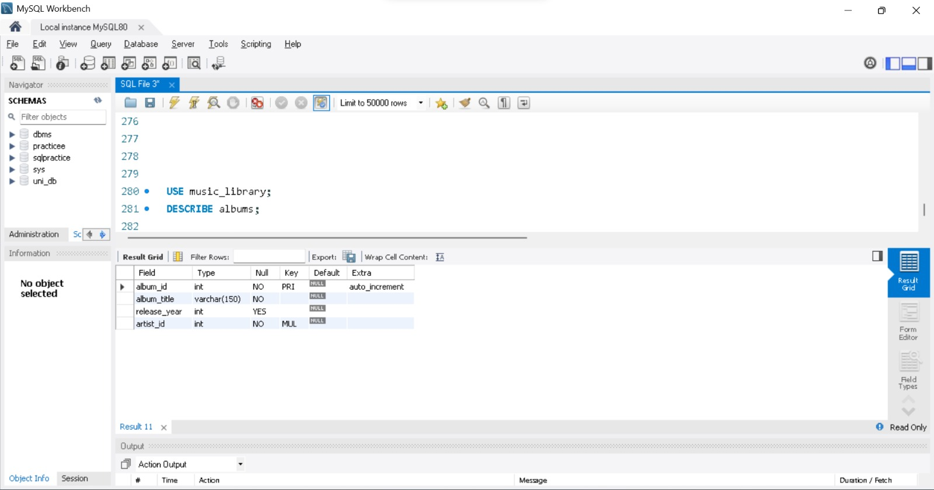
SQL Query:
USE music_library;
DESCRIBE albums;
Explanation:
albums stores album_id (primary key, AUTO_INCREMENT), album_title (VARCHAR(150), NOT NULL), release_year (INT, optional) and artist_id (INT, NOT NULL). The MUL key flag on artist_id shows it is an indexed foreign-key column linking every album to its artist.

2.4 Structure of the tracks Table
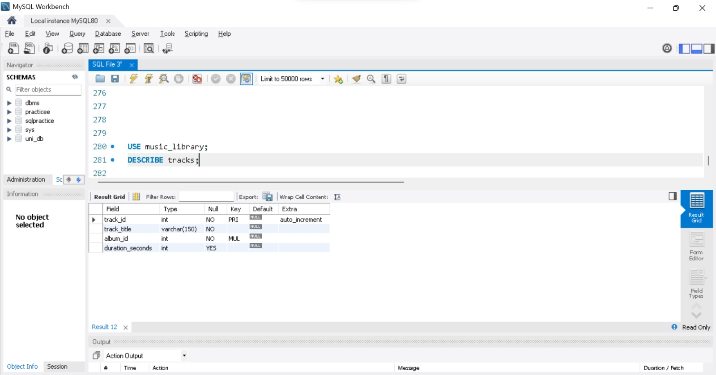
SQL Query:
USE music_library;
DESCRIBE tracks;
Explanation:
tracks stores track_id (primary key, AUTO_INCREMENT), track_title (VARCHAR(150), NOT NULL), album_id (INT, NOT NULL, indexed) which links each track to its album, and duration_seconds (INT, optional) holding the length of the song.

2.5 Structure of the track_genres Table
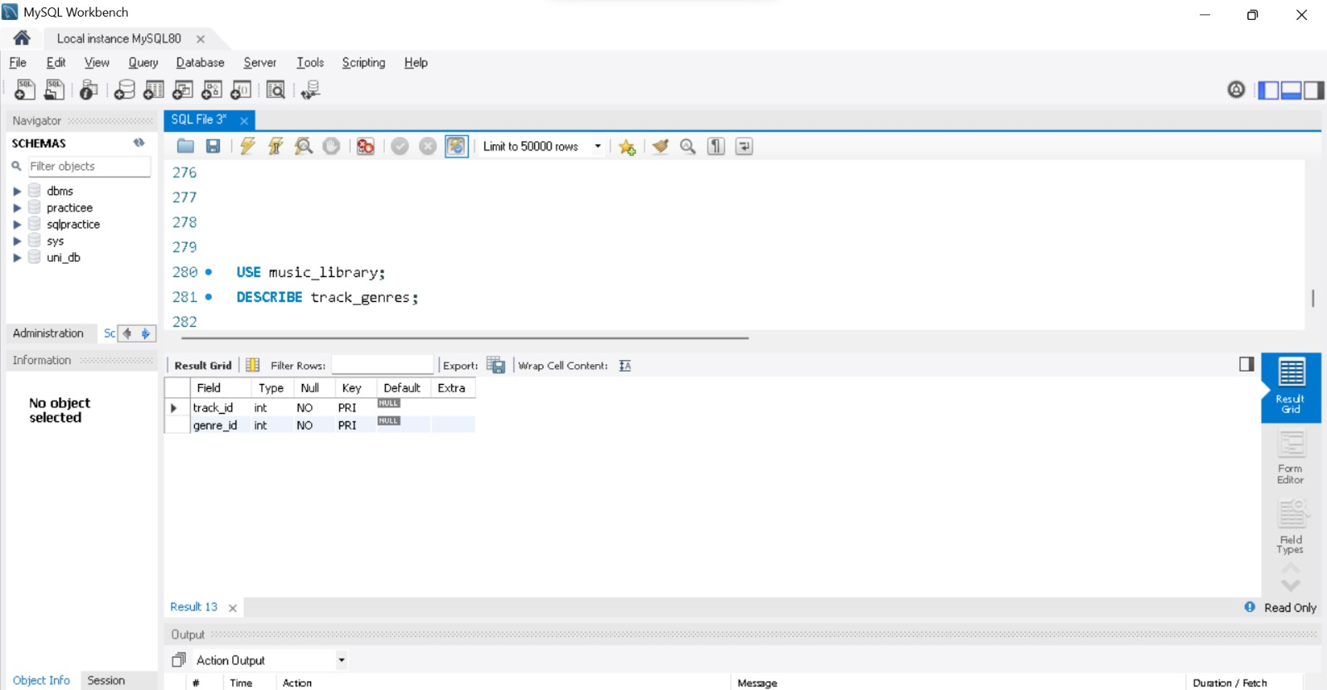
SQL Query:
USE music_library;
DESCRIBE track_genres;
Explanation:
track_genres is a junction table that resolves the many-to-many relationship between tracks and genres. Both track_id and genre_id are marked PRI, i.e. together they form a composite primary key, so the same track can be tagged with several genres but the same pair can never be stored twice.

2.6 Structure of the playlists Table
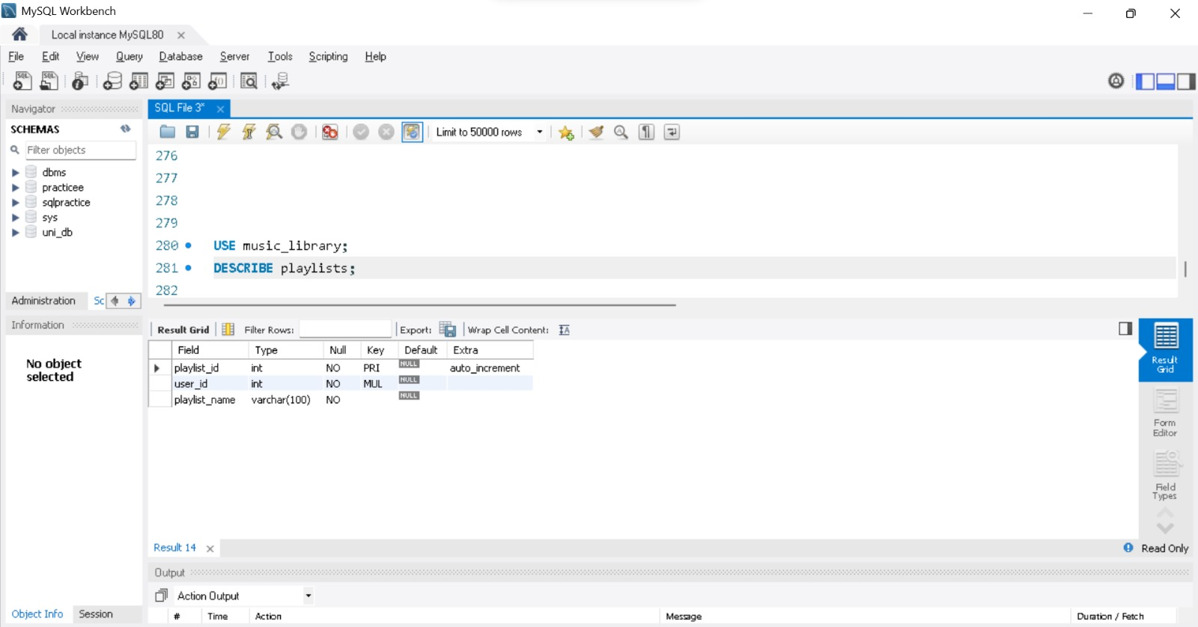
SQL Query:
USE music_library;
DESCRIBE playlists;
Explanation:
playlists stores playlist_id (primary key, AUTO_INCREMENT), user_id (INT, NOT NULL, indexed) which identifies the owner of the playlist, and playlist_name (VARCHAR(100), NOT NULL).

2.7 Structure of the playlist_tracks Table
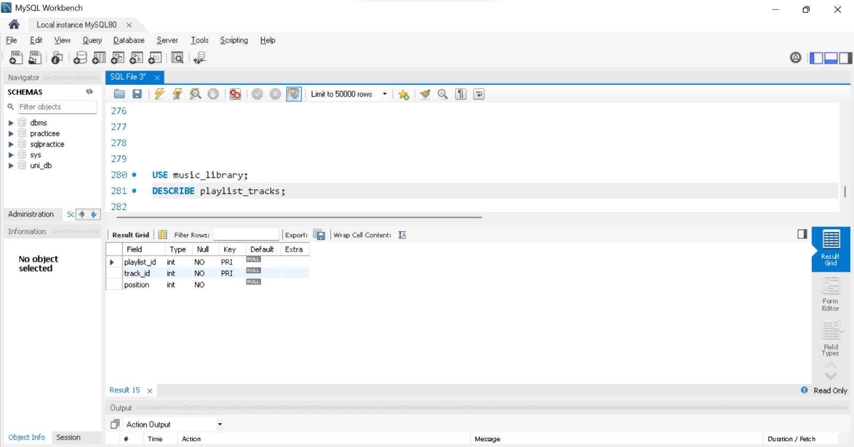
SQL Query:
USE music_library;
DESCRIBE playlist_tracks;
Explanation:
playlist_tracks links playlists to tracks. playlist_id and track_id form a composite primary key, and position (INT, NOT NULL) stores the order of a track inside its playlist.

2.8 Structure of the listening_history Table
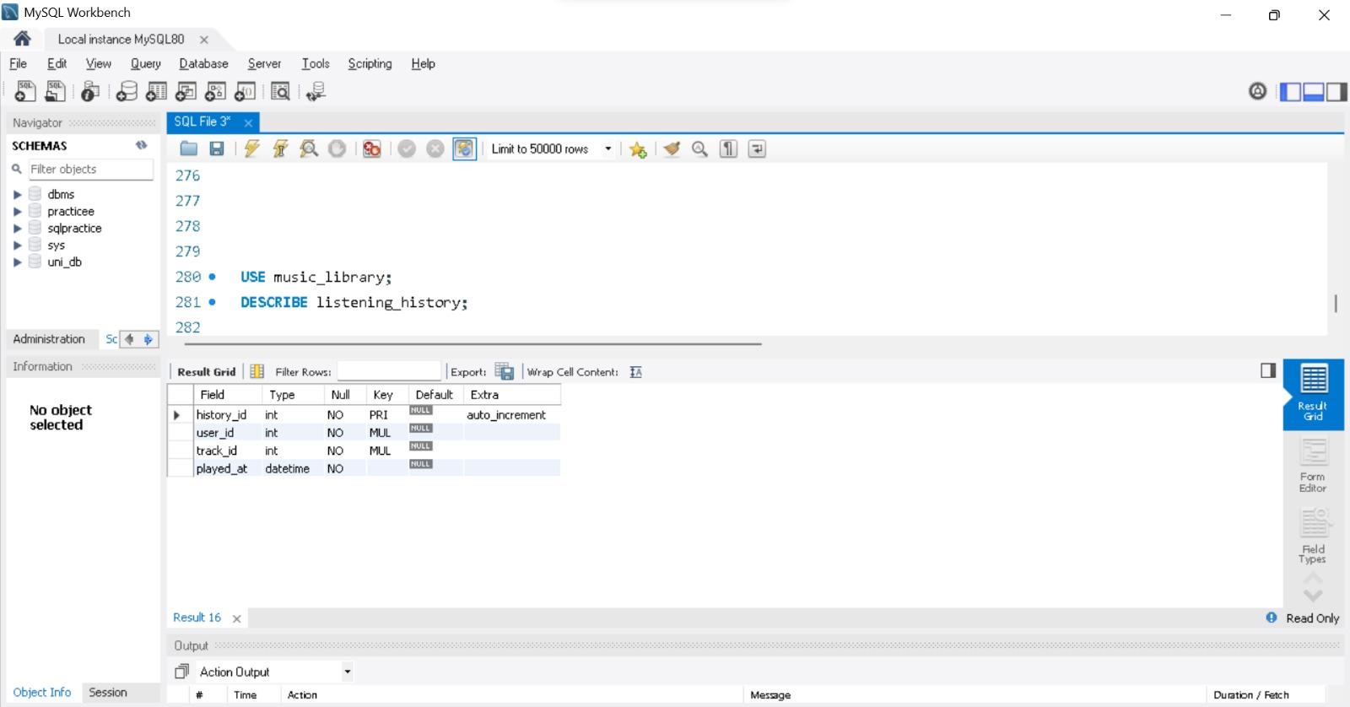
SQL Query:
USE music_library;
DESCRIBE listening_history;
Explanation:
listening_history records every play: history_id (primary key, AUTO_INCREMENT), user_id and track_id (both INT, NOT NULL, indexed foreign keys) and played_at (DATETIME, NOT NULL), the moment the track was played.

3. CRUD Operations

3.1 Create: Inserting a New Track
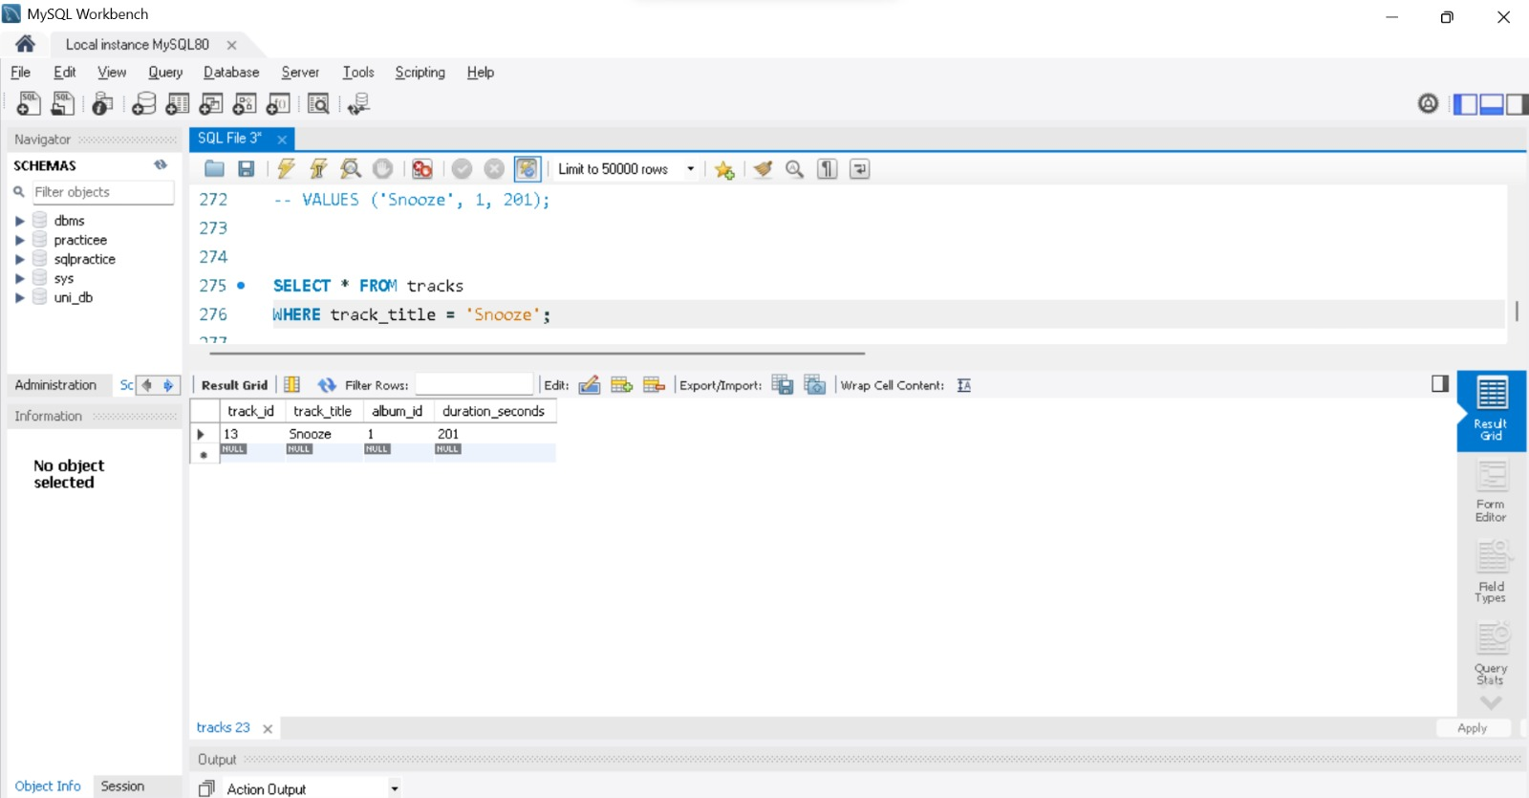
SQL Query:
INSERT INTO tracks (track_title, album_id, duration_seconds)
VALUES ('Snooze', 1, 201);

SELECT * FROM tracks
WHERE track_title = 'Snooze';
Explanation:
INSERT INTO adds a new row to tracks. The track_id is generated automatically (AUTO_INCREMENT), so only the title, the album and the duration are supplied.
The SELECT that follows verifies the insert: the new row is returned with track_id 13, title Snooze, album_id 1 and a duration of 201 seconds.

3.2 Row Count of Every Table After the Insert
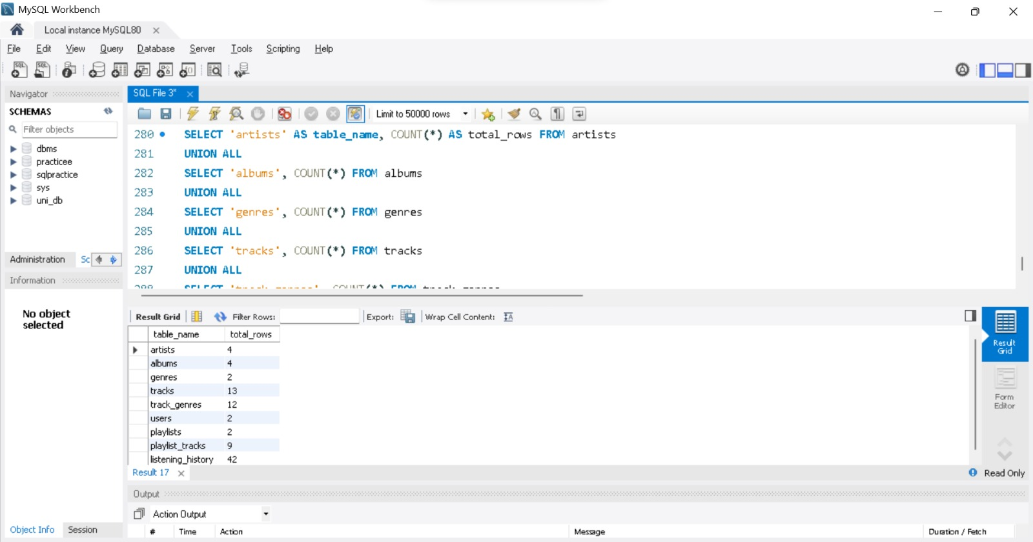
SQL Query:
SELECT 'artists' AS table_name, COUNT(*) AS total_rows FROM artists
UNION ALL
SELECT 'albums', COUNT(*) FROM albums
UNION ALL
SELECT 'genres', COUNT(*) FROM genres
UNION ALL
SELECT 'tracks', COUNT(*) FROM tracks
UNION ALL
SELECT 'track_genres', COUNT(*) FROM track_genres
UNION ALL
SELECT 'users', COUNT(*) FROM users
UNION ALL
SELECT 'playlists', COUNT(*) FROM playlists
UNION ALL
SELECT 'playlist_tracks', COUNT(*) FROM playlist_tracks
UNION ALL
SELECT 'listening_history', COUNT(*) FROM listening_history;
Explanation:
Nine SELECT COUNT(*) queries are combined with UNION ALL so that the row count of every table appears in a single result set.
The result shows 4 artists, 4 albums, 2 genres, 13 tracks, 12 track-genre links, 2 users, 2 playlists, 9 playlist entries and 42 listening-history rows. The track count is 13 because the new track Snooze was added in the previous step.

3.3 Read: Selecting Tracks with a Condition
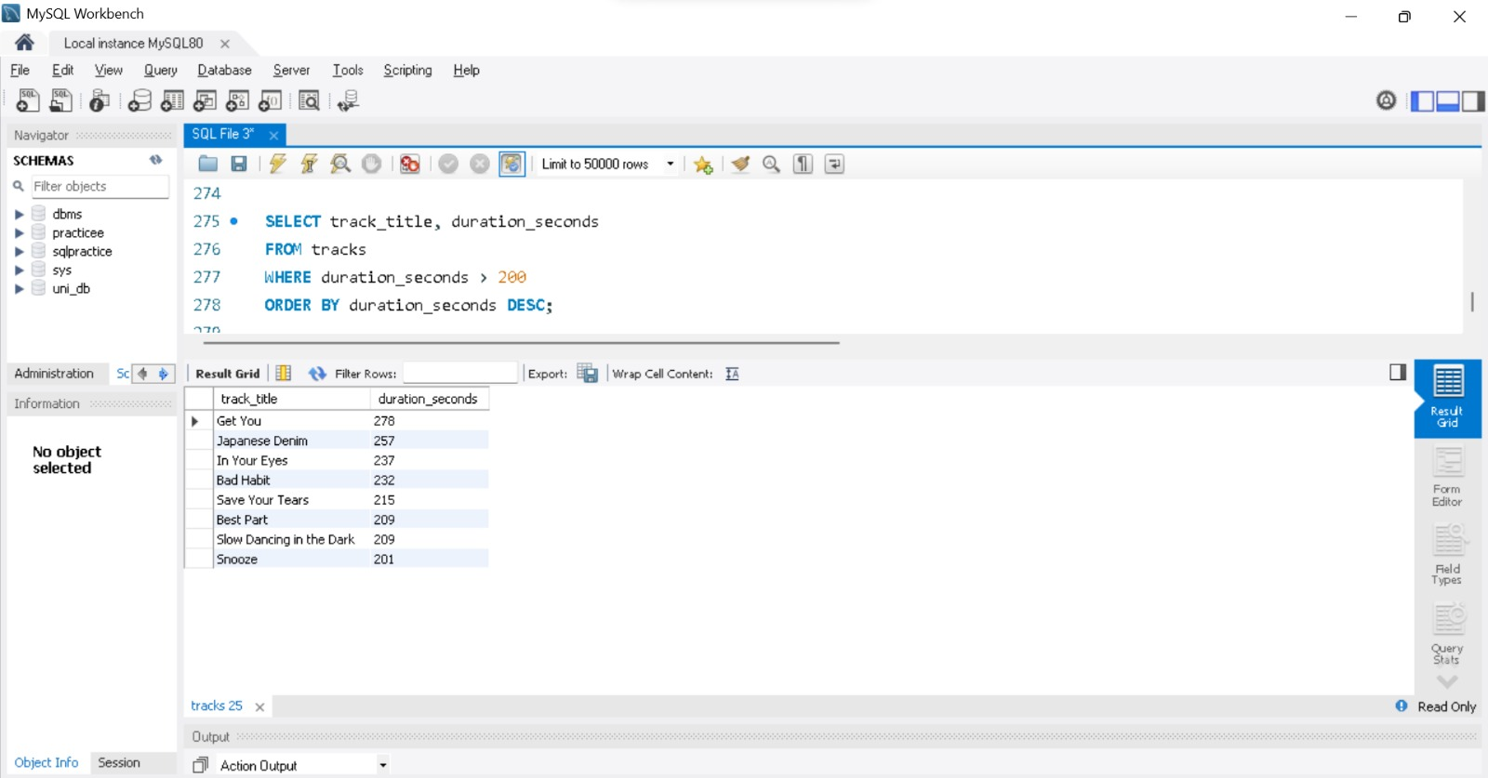
SQL Query:
SELECT track_title, duration_seconds
FROM tracks
WHERE duration_seconds > 200
ORDER BY duration_seconds DESC;
Explanation:
This query reads only two columns, keeps the tracks longer than 200 seconds with WHERE, and sorts them from longest to shortest with ORDER BY ... DESC.
Eight tracks are returned, from Get You (278 s) down to Snooze (201 s). Blinding Lights (200 s) is not listed because the condition is strictly greater than 200.

3.4 Update: Changing a Track Duration
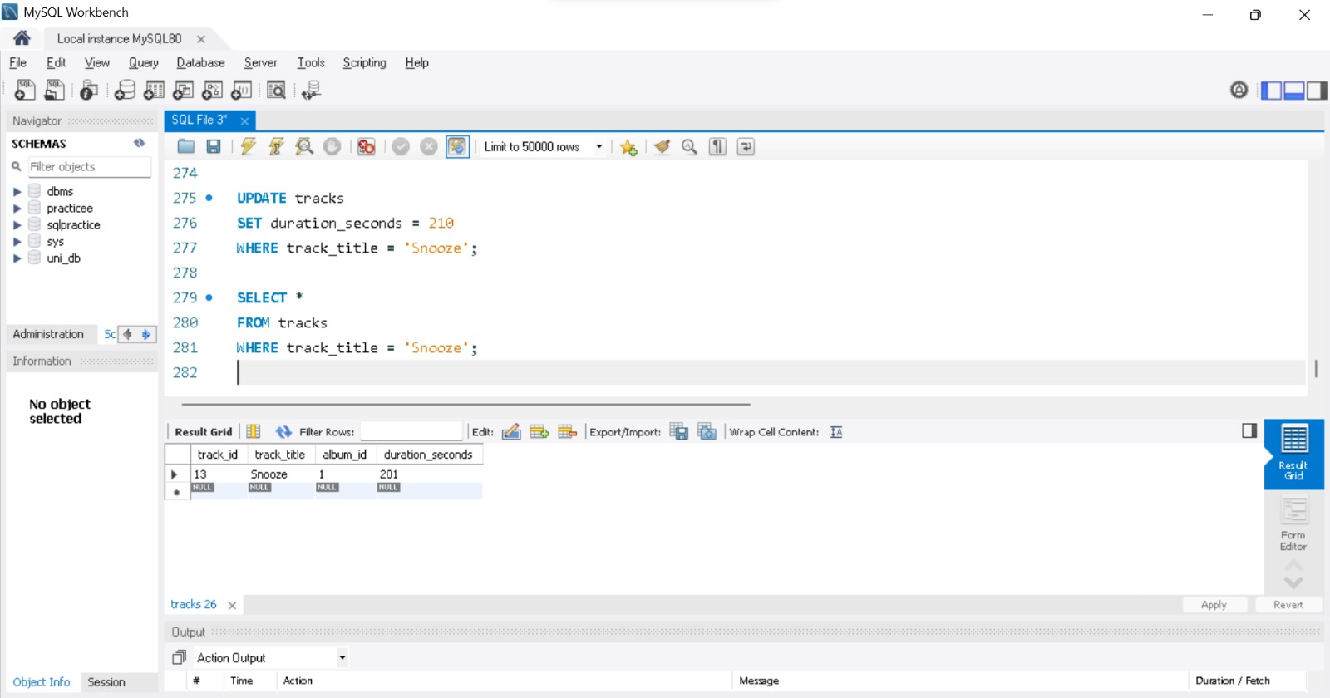
SQL Query:
UPDATE tracks
SET duration_seconds = 210
WHERE track_title = 'Snooze';

SELECT * FROM tracks
WHERE track_title = 'Snooze';
Explanation:
UPDATE modifies existing data. Here it sets duration_seconds to 210 for the row whose title is Snooze; the WHERE clause restricts the change to that row (without it every row of the table would be changed). The SELECT afterwards is used to check the result.
In this capture the check still returns 201. MySQL Workbench runs in Safe Update Mode, which rejects UPDATE and DELETE statements whose WHERE clause does not use a key column (Error 1175, shown in the Output panel of the next step). The mode is switched off with SET SQL_SAFE_UPDATES = 0, as done in the Delete step.

3.5 Delete: Removing a Track
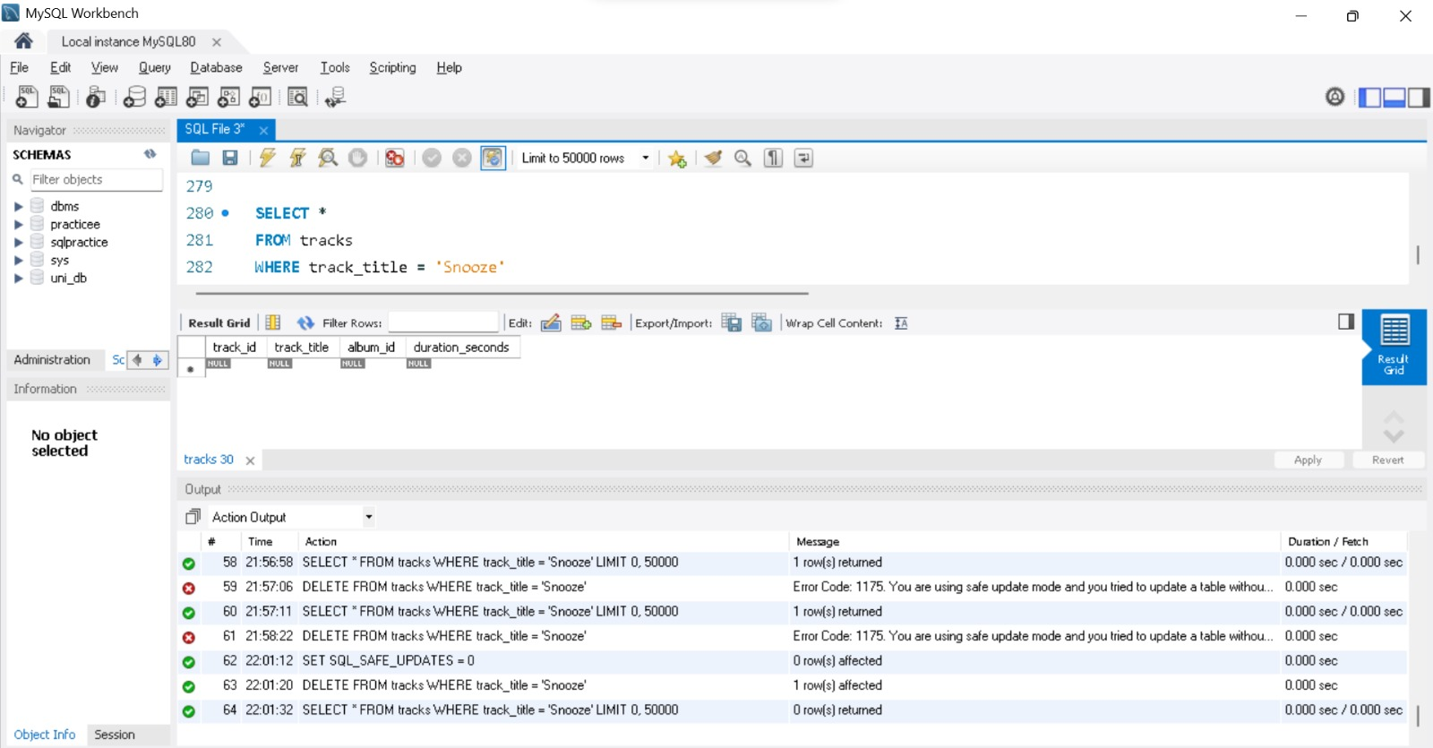
SQL Query:
SET SQL_SAFE_UPDATES = 0;
DELETE FROM tracks WHERE track_title = 'Snooze';
SELECT * FROM tracks WHERE track_title = 'Snooze';
Explanation:
The Output panel shows two earlier DELETE attempts that failed with Error 1175 (Safe Update Mode, because track_title is not a key column). After SET SQL_SAFE_UPDATES = 0 the DELETE succeeds and reports "1 row(s) affected".
The final SELECT returns an empty result (0 rows), confirming that the track Snooze has been removed from the table.

3.6 Row Count of Every Table After the Delete
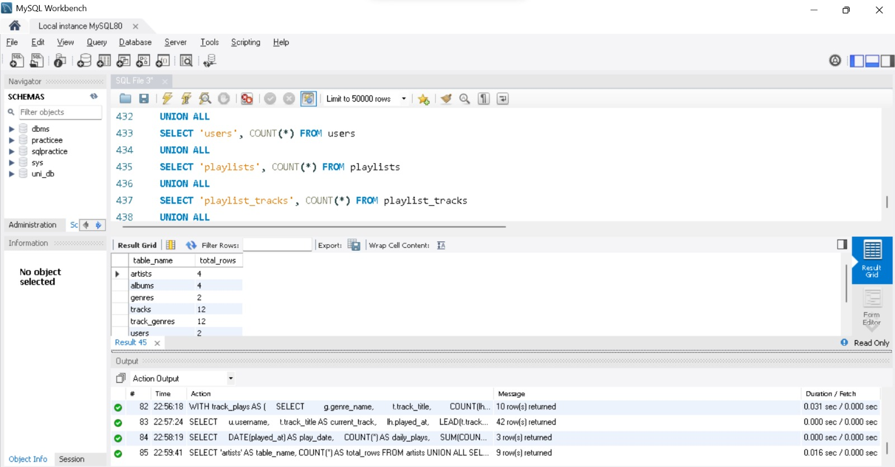
SQL Query:
SELECT 'artists' AS table_name, COUNT(*) AS total_rows FROM artists
UNION ALL
SELECT 'albums', COUNT(*) FROM albums
UNION ALL
SELECT 'genres', COUNT(*) FROM genres
UNION ALL
SELECT 'tracks', COUNT(*) FROM tracks
UNION ALL
SELECT 'track_genres', COUNT(*) FROM track_genres
UNION ALL
SELECT 'users', COUNT(*) FROM users
UNION ALL
SELECT 'playlists', COUNT(*) FROM playlists
UNION ALL
SELECT 'playlist_tracks', COUNT(*) FROM playlist_tracks
UNION ALL
SELECT 'listening_history', COUNT(*) FROM listening_history;
Explanation:
The same row-count query is executed again after the delete. The tracks table is back to 12 rows, which shows that the delete removed exactly the one row that was inserted earlier, while the other tables (4 artists, 4 albums, 2 genres, 12 track-genre links, 2 users) are unchanged.

4. Search, Playlist and Preference Analysis Queries

4.1 Searching a Song by Title
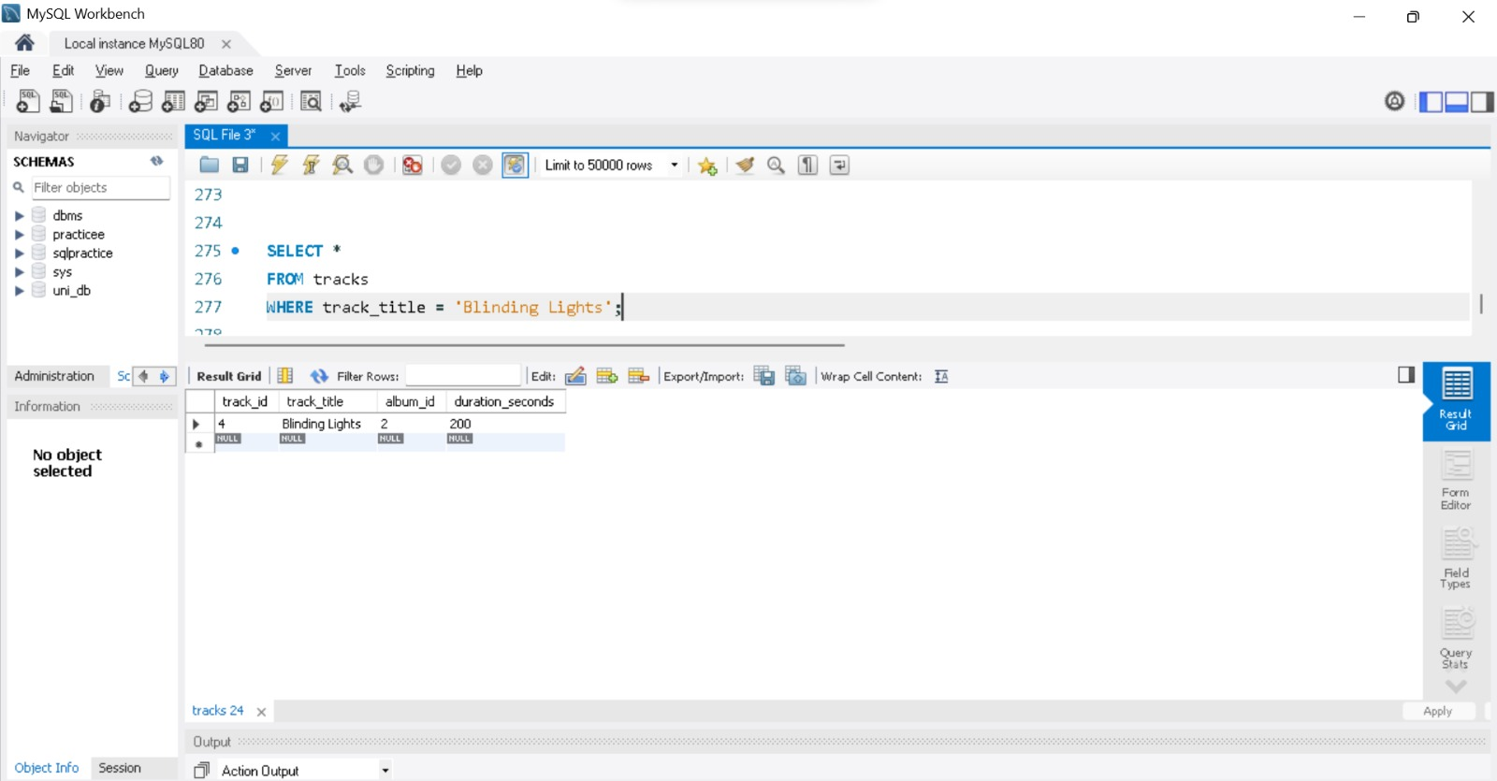
SQL Query:
SELECT *
FROM tracks
WHERE track_title = 'Blinding Lights';
Explanation:
This is an exact-match search on the song title. The WHERE clause filters tracks to the single matching row and SELECT * returns all its columns: track_id 4, album_id 2 and a duration of 200 seconds.

4.2 Artists and Their Albums
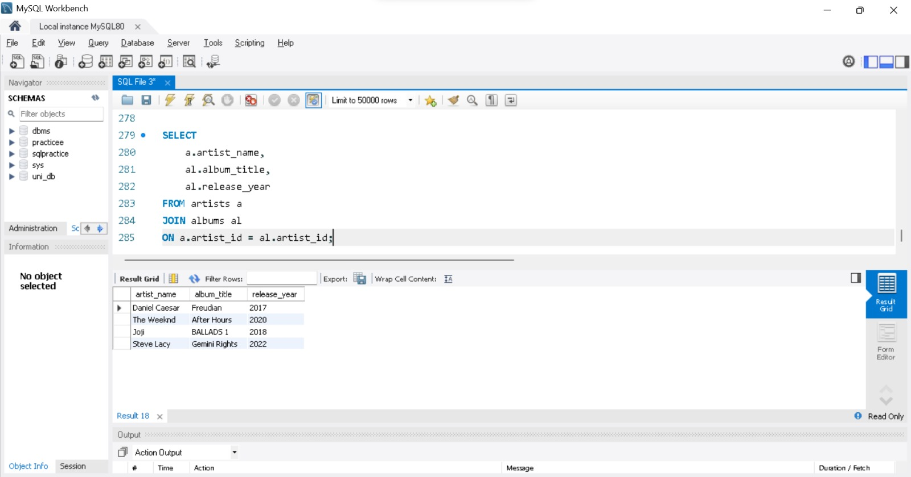
SQL Query:
SELECT
a.artist_name,
al.album_title,
al.release_year
FROM artists a
JOIN albums al
ON a.artist_id = al.artist_id;
Explanation:
An INNER JOIN matches each album to its artist through artist_id; a and al are table aliases. The result lists every artist with the album and its release year: Daniel Caesar (Freudian, 2017), The Weeknd (After Hours, 2020), Joji (BALLADS 1, 2018) and Steve Lacy (Gemini Rights, 2022).

4.3 Searching Songs by Genre
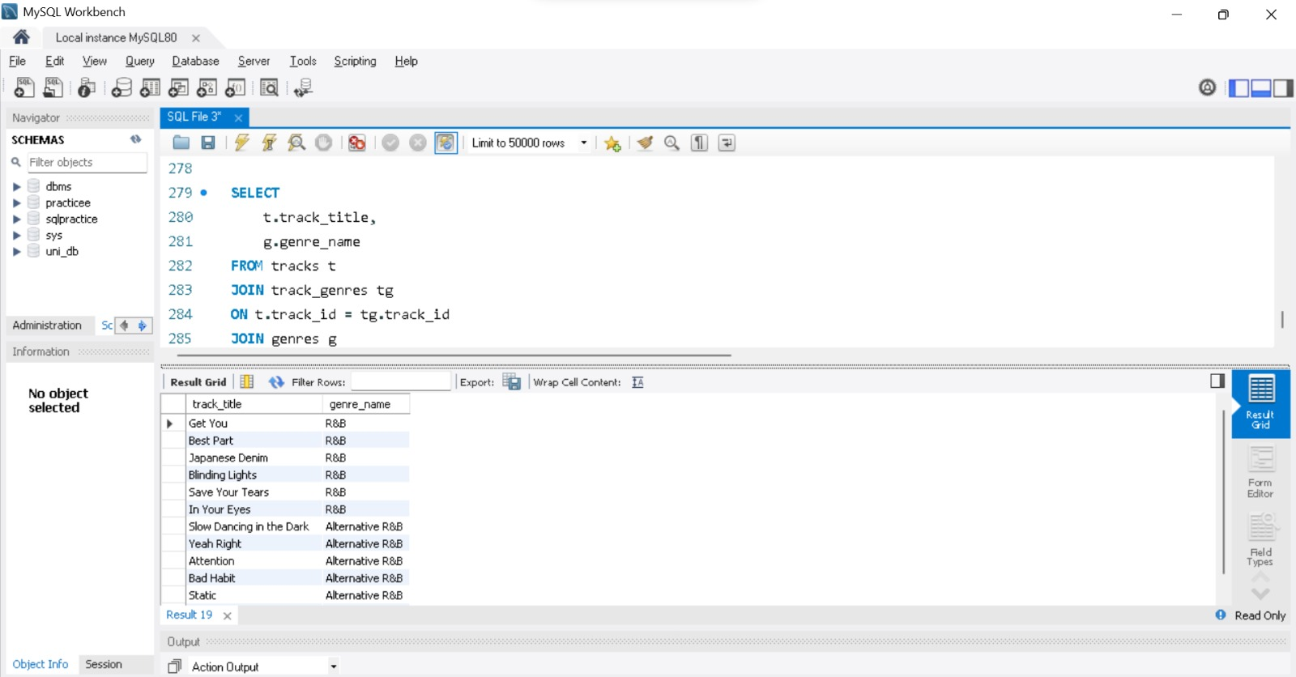
SQL Query:
SELECT
t.track_title,
g.genre_name
FROM tracks t
JOIN track_genres tg
ON t.track_id = tg.track_id
JOIN genres g
ON tg.genre_id = g.genre_id;
Explanation:
Tracks and genres are connected through the junction table track_genres, so two joins are needed. The result shows the genre of every track: Get You, Best Part, Japanese Denim, Blinding Lights, Save Your Tears and In Your Eyes are R&B, while Slow Dancing in the Dark, Yeah Right, Attention, Bad Habit and Static are Alternative R&B. Adding a WHERE g.genre_name = ... condition turns this into a search by genre.

4.4 Complete Track Listing with Album, Artist and Genre
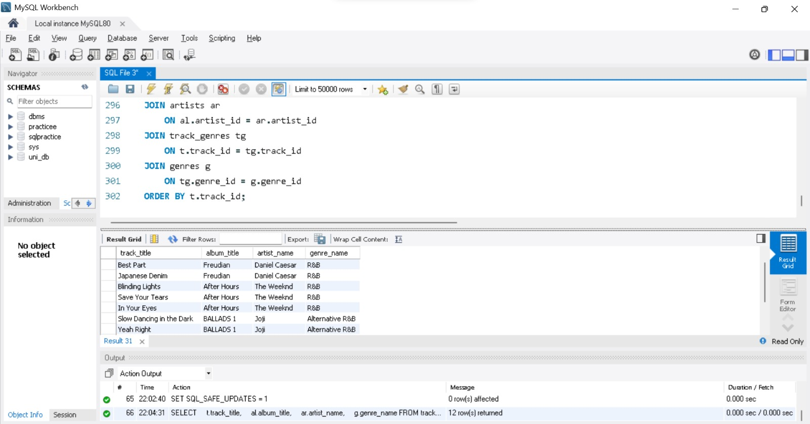
SQL Query:
SELECT
t.track_title,
al.album_title,
ar.artist_name,
g.genre_name
FROM tracks t
JOIN albums al
ON t.album_id = al.album_id
JOIN artists ar
ON al.artist_id = ar.artist_id
JOIN track_genres tg
ON t.track_id = tg.track_id
JOIN genres g
ON tg.genre_id = g.genre_id
ORDER BY t.track_id;
Explanation:
Four joins combine tracks, albums, artists and genres so that every song appears with its album, artist and genre, ordered by track_id. The query returns 12 rows (see the Output panel). The Output panel also shows SET SQL_SAFE_UPDATES = 1, which switched Safe Update Mode back on after the delete.

4.5 Creating Playlists: Users and Their Playlists
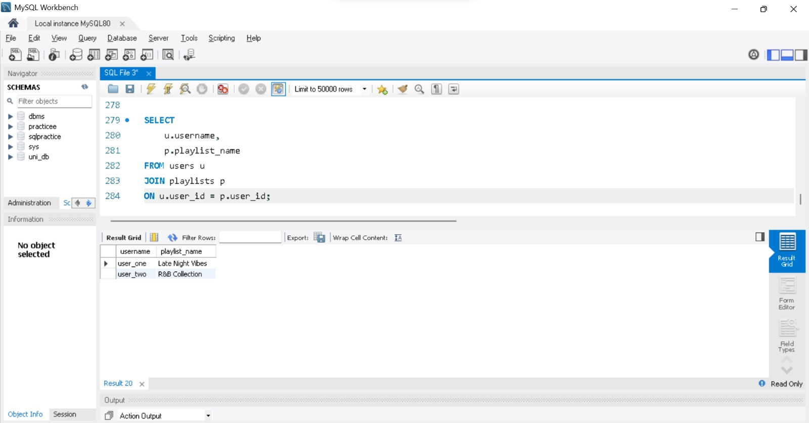
SQL Query:
SELECT
u.username,
p.playlist_name
FROM users u
JOIN playlists p
ON u.user_id = p.user_id;
Explanation:
The join links each playlist to the user who owns it. user_one owns the playlist Late Night Vibes and user_two owns R&B Collection.

4.6 Playlist Contents in Playing Order
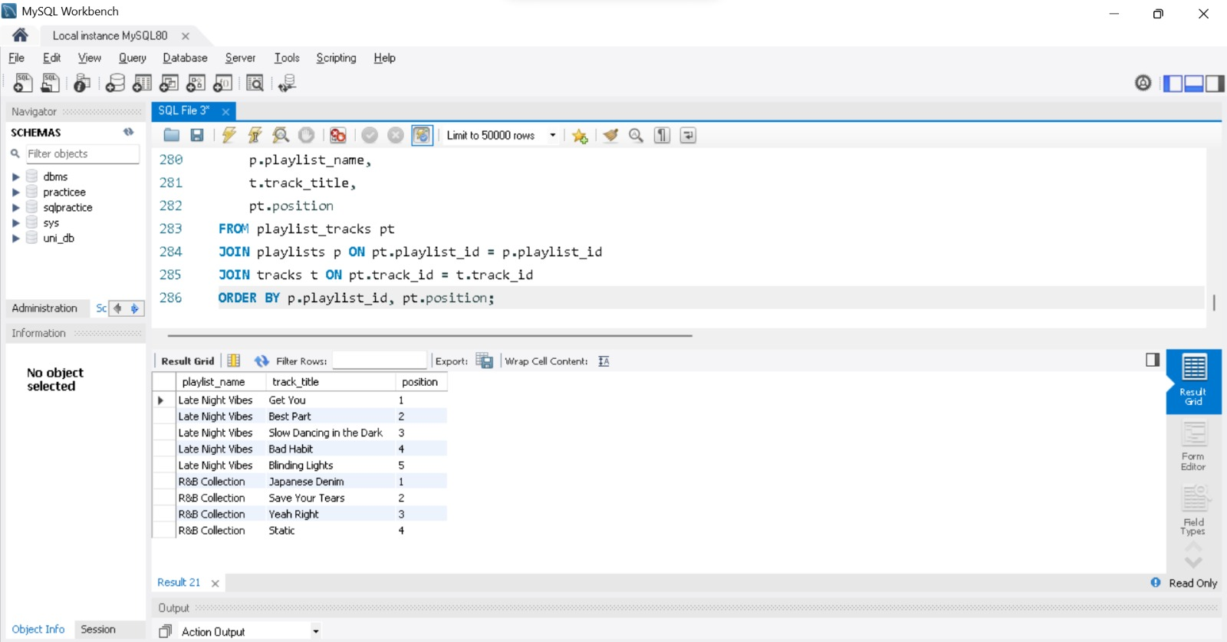
SQL Query:
SELECT
p.playlist_name,
t.track_title,
pt.position
FROM playlist_tracks pt
JOIN playlists p ON pt.playlist_id = p.playlist_id
JOIN tracks t ON pt.track_id = t.track_id
ORDER BY p.playlist_id, pt.position;
Explanation:
The junction table playlist_tracks is joined with playlists and tracks to list the songs of every playlist, sorted by playlist and by position. Late Night Vibes contains five songs (Get You, Best Part, Slow Dancing in the Dark, Bad Habit, Blinding Lights) and R&B Collection contains four (Japanese Denim, Save Your Tears, Yeah Right, Static).

4.7 Listening History of Users
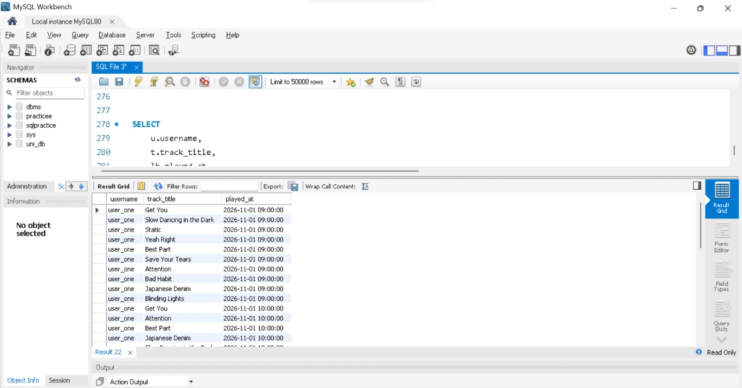
SQL Query:
SELECT
u.username,
t.track_title,
lh.played_at
FROM listening_history lh
JOIN users u ON lh.user_id = u.user_id
JOIN tracks t ON lh.track_id = t.track_id;
Explanation:
Each row of listening_history is joined with the user and the track so that the log shows who played which song and when. This is the data used later to analyse music preferences; for example, user_one played ten different tracks on 2026-11-01 at 09:00:00 and several of them again at 10:00:00.

4.8 Analysing Preferences: Tracks per Genre
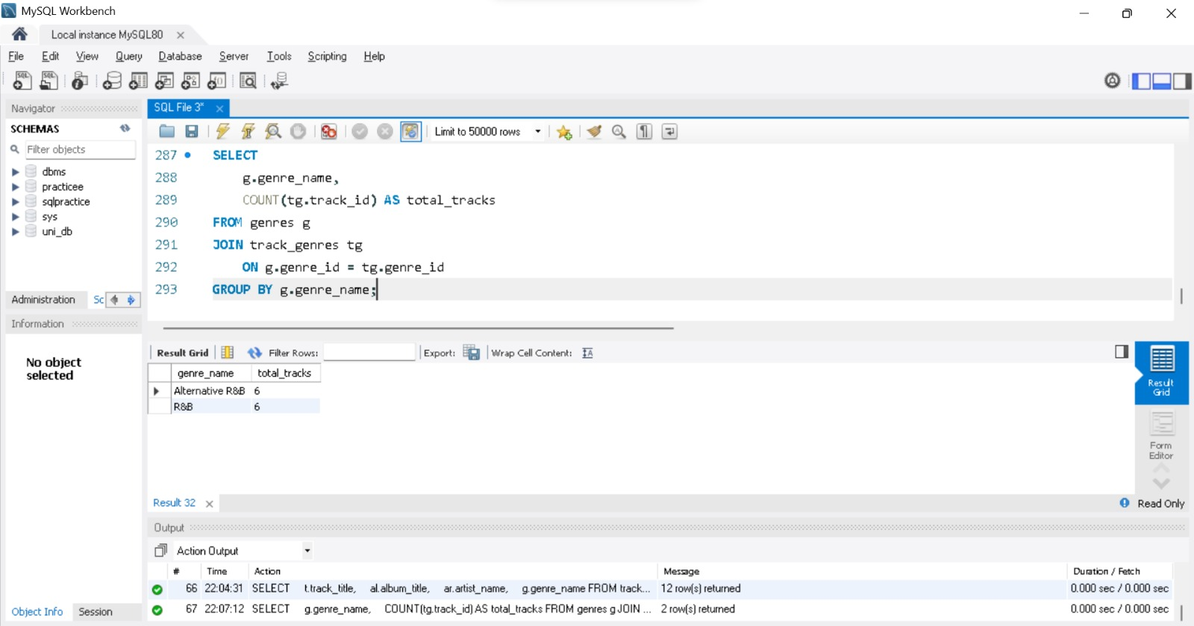
SQL Query:
SELECT
g.genre_name,
COUNT(tg.track_id) AS total_tracks
FROM genres g
JOIN track_genres tg
ON g.genre_id = tg.genre_id
GROUP BY g.genre_name;
Explanation:
GROUP BY collects the rows of each genre and COUNT() counts the tracks in every group. Both genres, Alternative R&B and R&B, contain 6 tracks in the library.

4.9 Artists with More Than One Album (HAVING)
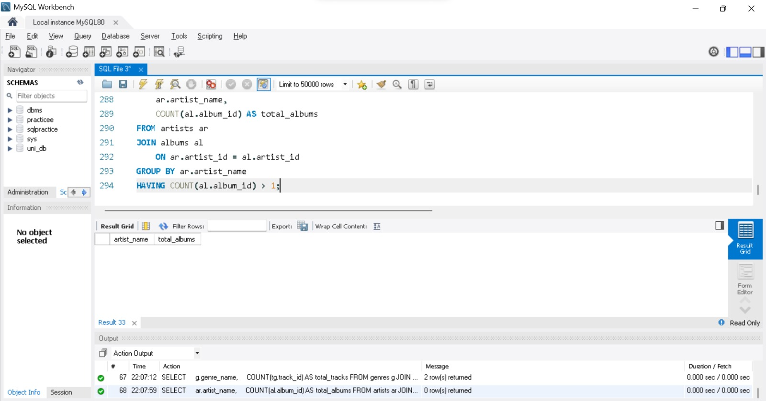
SQL Query:
SELECT
ar.artist_name,
COUNT(al.album_id) AS total_albums
FROM artists ar
JOIN albums al
ON ar.artist_id = al.artist_id
GROUP BY ar.artist_name
HAVING COUNT(al.album_id) > 1;
Explanation:
HAVING filters groups after aggregation, whereas WHERE filters rows before it. The query keeps only artists with more than one album. The result is empty (0 rows) because every artist in the current data has exactly one album.

4.10 Tracks Longer than the Average (Subquery)
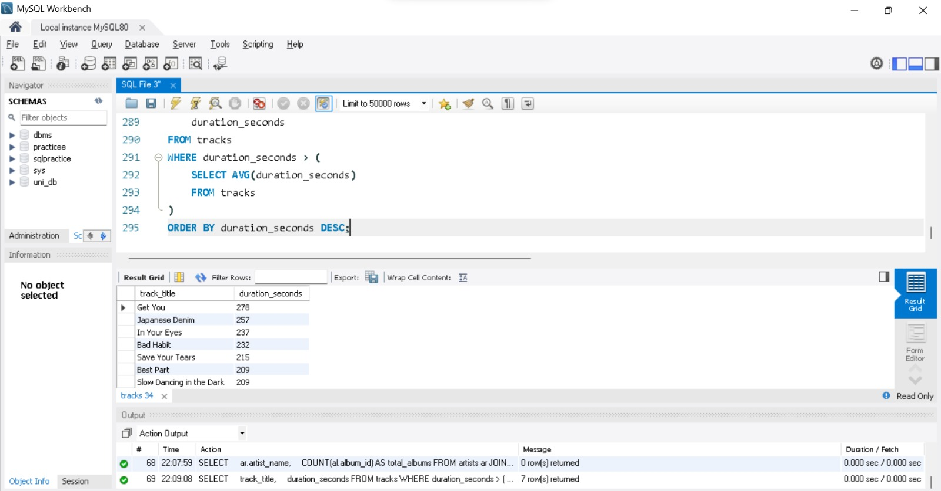
SQL Query:
SELECT
track_title,
duration_seconds
FROM tracks
WHERE duration_seconds > (
SELECT AVG(duration_seconds)
FROM tracks
)
ORDER BY duration_seconds DESC;
Explanation:
The inner query calculates the average duration of all tracks and the outer query returns the tracks that are longer than that average, longest first. Seven tracks qualify, starting with Get You (278 s), Japanese Denim (257 s) and In Your Eyes (237 s).

5. Indexing

5.1 Index on Track Title
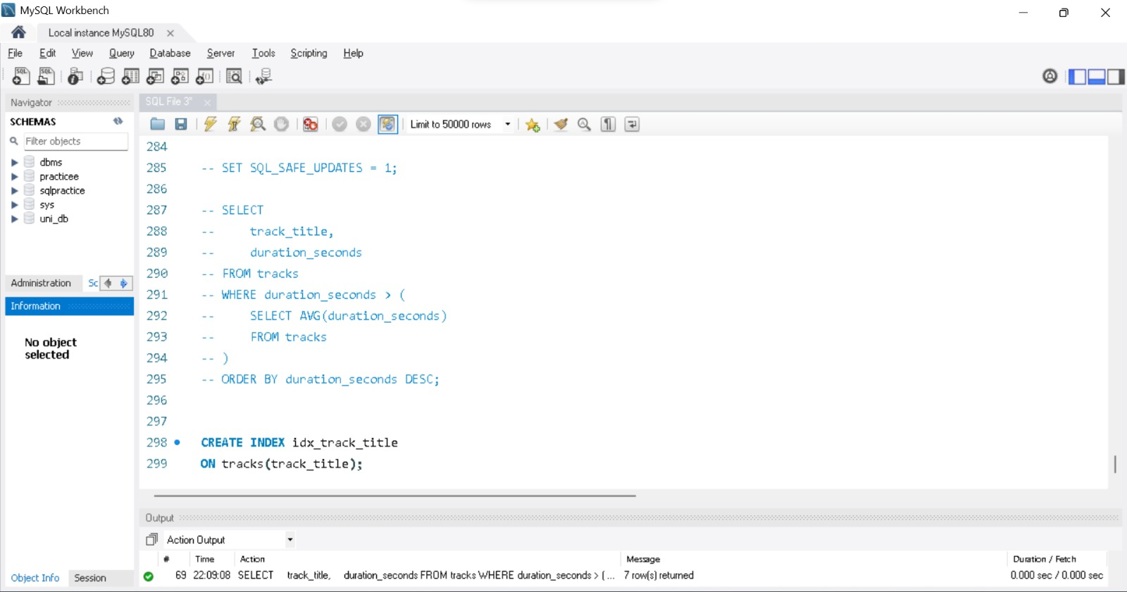
SQL Query:
CREATE INDEX idx_track_title
ON tracks(track_title);
Explanation:
This statement creates a B-Tree index named idx_track_title on tracks.track_title. With the index, MySQL can find a song by title directly instead of scanning every row of the table. (The statement is typed in the editor here; the next screenshot shows its successful execution in the Output panel.)

5.2 Index on Artist Name
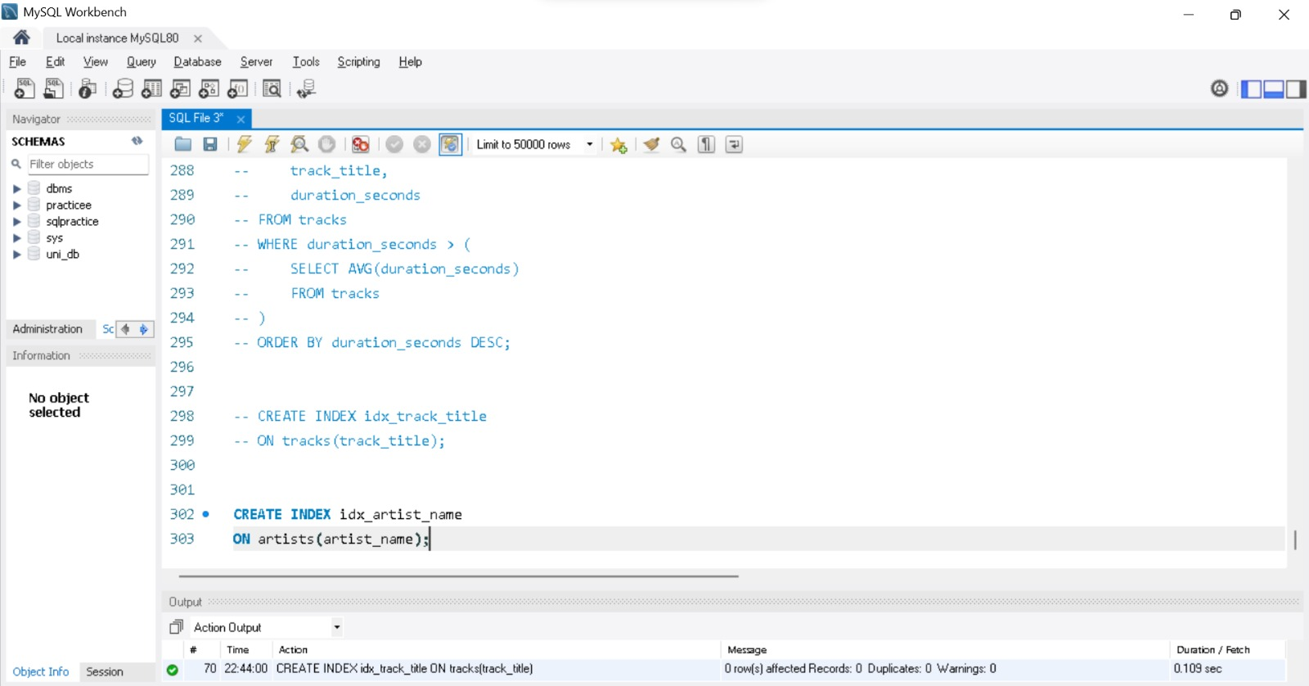
SQL Query:
CREATE INDEX idx_artist_name
ON artists(artist_name);
Explanation:
This statement creates the index idx_artist_name on artists.artist_name to speed up searches by artist. The Output panel confirms that the previous statement, CREATE INDEX idx_track_title, ran successfully (0 row(s) affected, 0 duplicates, 0 warnings, 0.109 sec).

5.3 Composite Index on Playlist Tracks
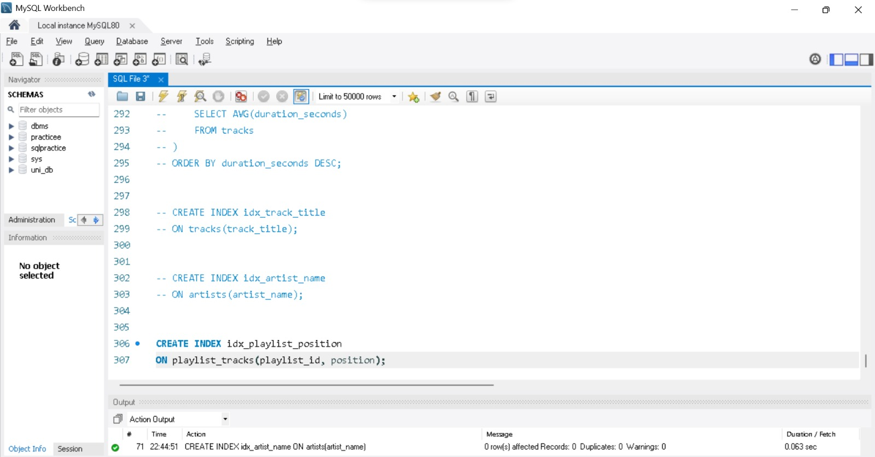
SQL Query:
CREATE INDEX idx_playlist_position
ON playlist_tracks(playlist_id, position);
Explanation:
A composite (multi-column) index is created on playlist_id and position. It supports queries that find the tracks of one playlist and return them in playing order, because the index already stores them sorted by playlist and then by position. The column order matters: the index can be used when playlist_id is in the condition, alone or together with position. The Output panel confirms that idx_artist_name was created (0.063 sec).

5.4 Viewing the Indexes of artists
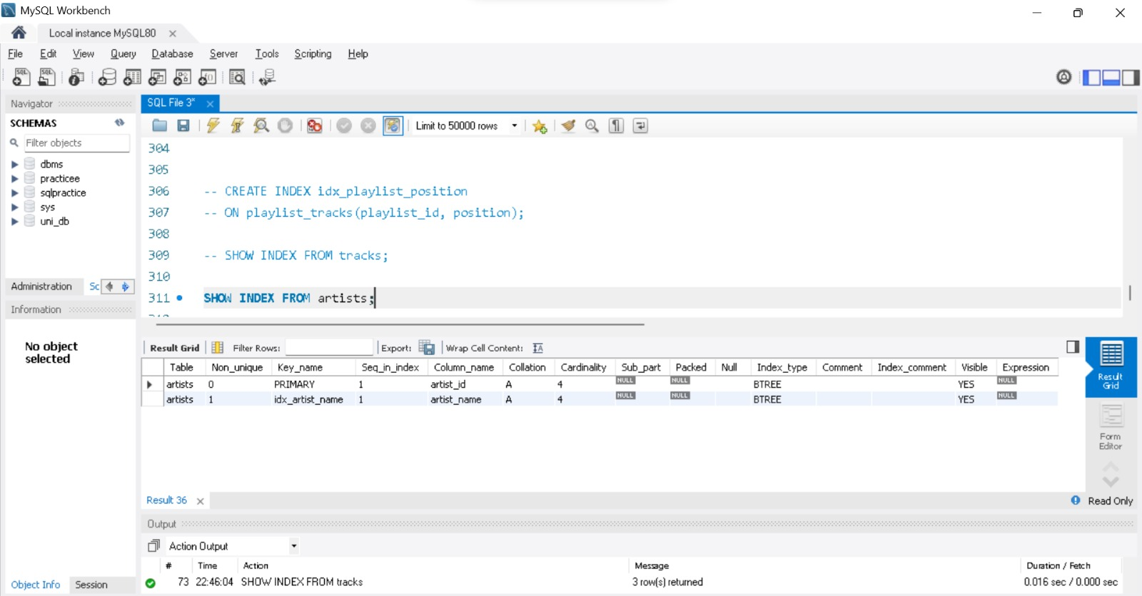
SQL Query:
SHOW INDEX FROM artists;
Explanation:
SHOW INDEX lists the indexes of a table. artists has the unique PRIMARY index on artist_id (Non_unique = 0) and the new non-unique index idx_artist_name on artist_name (Non_unique = 1). Both are of type BTREE with a cardinality of 4, one distinct value per artist.

5.5 Viewing the Indexes of playlist_tracks
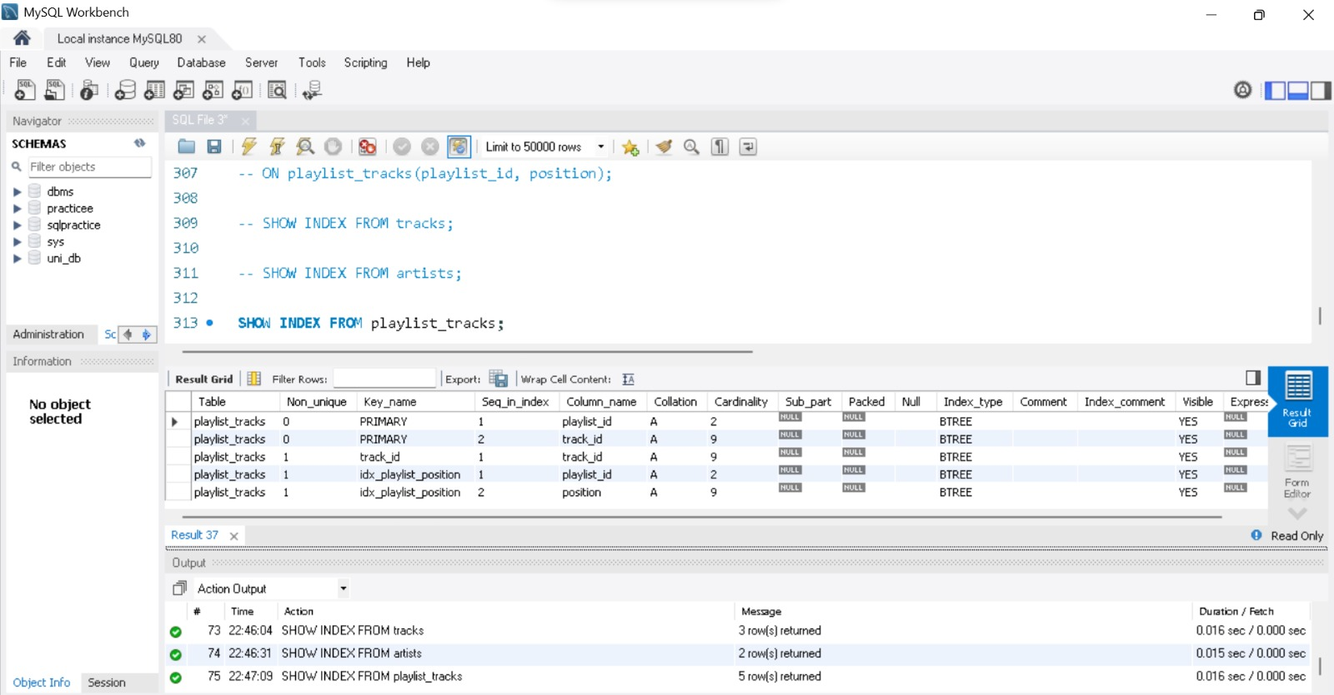
SQL Query:
SHOW INDEX FROM playlist_tracks;
Explanation:
Five index rows are returned: the composite PRIMARY key (playlist_id, track_id), an index on track_id, and the new composite index idx_playlist_position with playlist_id as the first column (Seq_in_index 1) and position as the second (Seq_in_index 2). The cardinality of 2 for playlist_id matches the two playlists.

5.6 Checking Index Usage with EXPLAIN
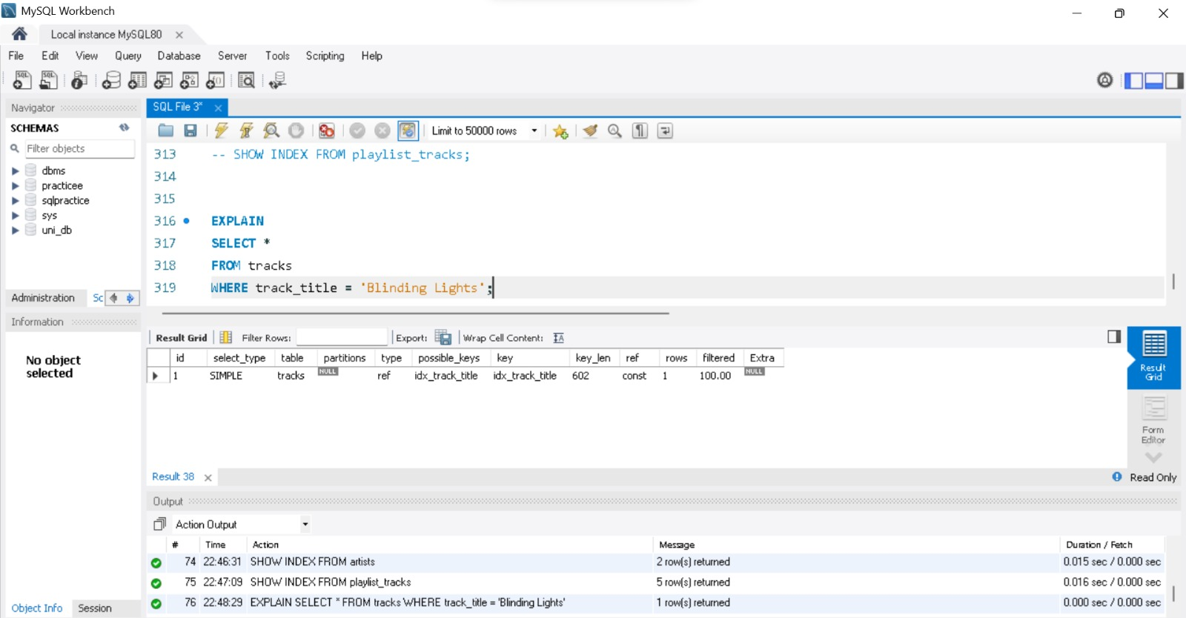
SQL Query:
EXPLAIN
SELECT *
FROM tracks
WHERE track_title = 'Blinding Lights';
Explanation:
EXPLAIN shows the execution plan of a query without running it. type = ref means an index lookup on a non-unique index, and both possible_keys and key show idx_track_title, so the optimizer uses the new index. key_len is 602 bytes (150 characters x 4 bytes in utf8mb4 plus 2 length bytes), ref = const means the title is compared with a constant, and rows = 1 is the estimated number of rows read. Without the index the plan would show type = ALL, a full table scan of every row.

5.7 Why a Leading Wildcard Prevents Normal Index Usage
Explanation:
A B-Tree index stores values in sorted order, so MySQL can use it only when the beginning of the value is known. A prefix search such as LIKE 'Blind%' can jump to the first matching entry and read a short range, so the index can be used. A search with a leading wildcard such as LIKE '%light%' can match the text anywhere in the value; the sorted order is of no help, so MySQL has to read and test every row (a full table scan, type = ALL in EXPLAIN).
For word searches inside text, a FULLTEXT index with MATCH ... AGAINST is designed for this purpose and avoids scanning every row.

6. Views

6.1 Creating the track_details View
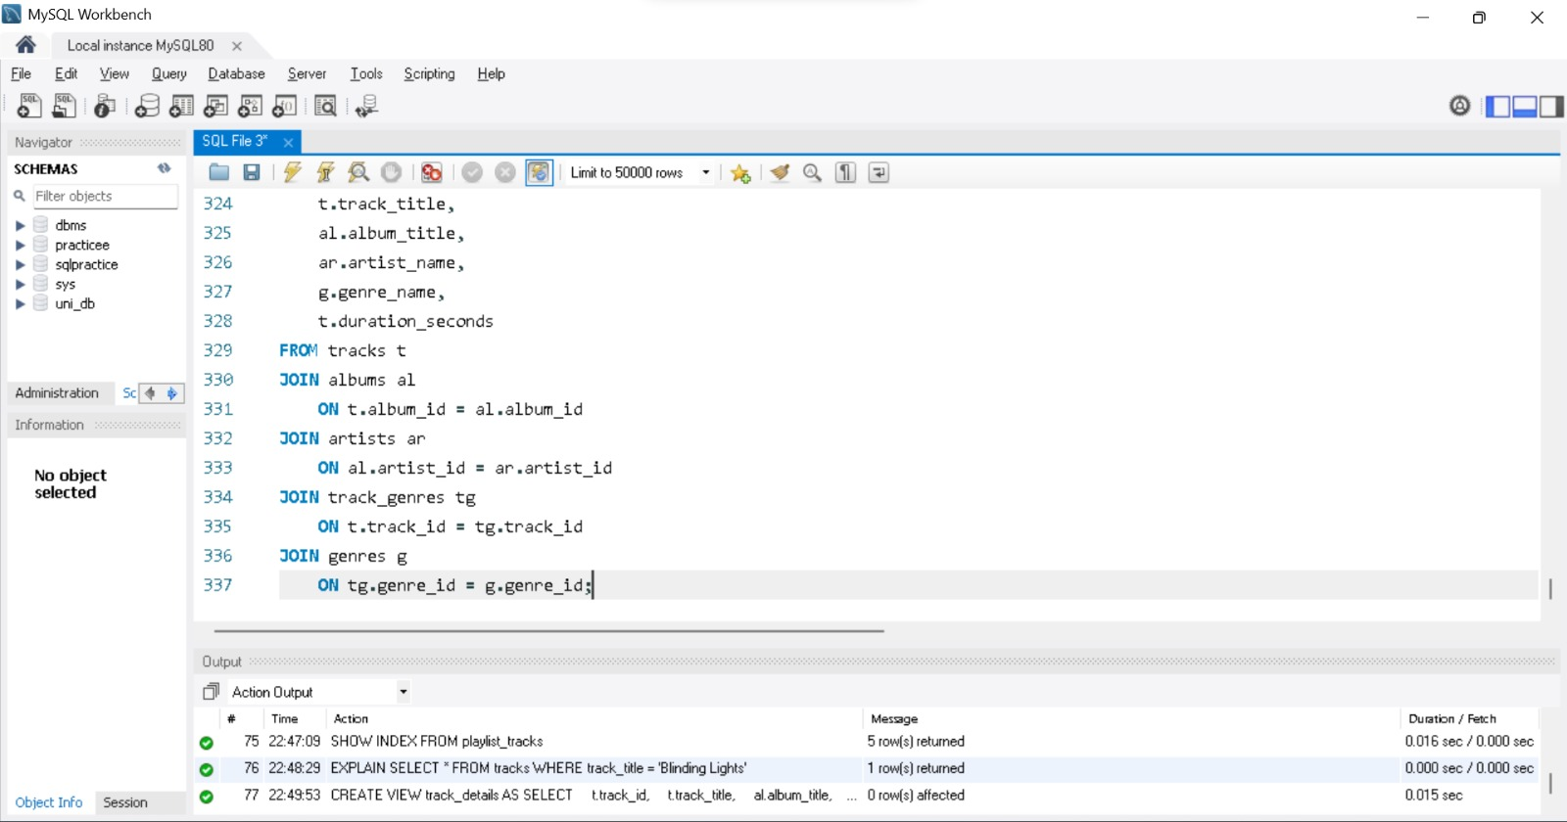
SQL Query:
CREATE VIEW track_details AS
SELECT
t.track_id,
t.track_title,
al.album_title,
ar.artist_name,
g.genre_name,
t.duration_seconds
FROM tracks t
JOIN albums al
ON t.album_id = al.album_id
JOIN artists ar
ON al.artist_id = ar.artist_id
JOIN track_genres tg
ON t.track_id = tg.track_id
JOIN genres g
ON tg.genre_id = g.genre_id;
Explanation:
A view is a stored SELECT statement that behaves like a virtual table; it holds no data of its own. track_details joins five tables (tracks, albums, artists, track_genres and genres) and exposes the track id, title, album, artist, genre and duration. The Output panel shows that CREATE VIEW executed successfully (0 row(s) affected).

6.2 Querying the track_details View
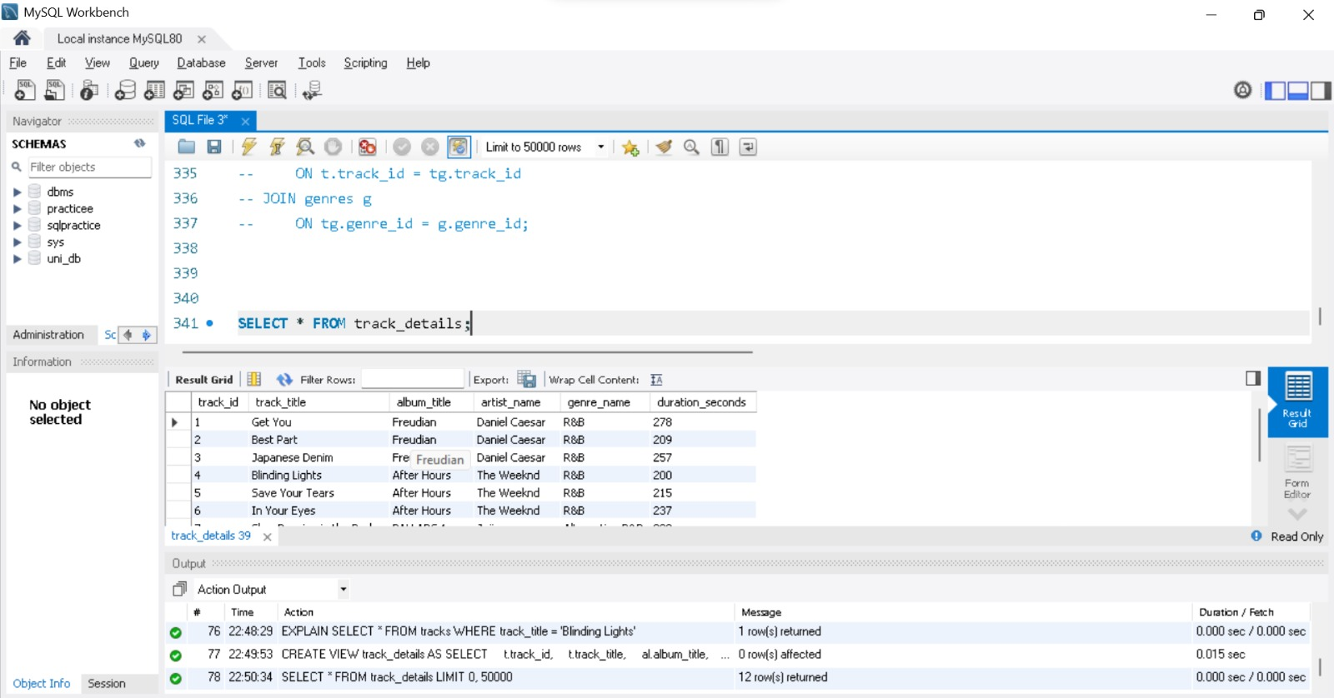
SQL Query:
SELECT * FROM track_details;
Explanation:
Querying the view returns the complete track information (12 rows) with a one-line statement instead of the four joins used earlier. This is how the view simplifies song searches: a search by title, artist, album or genre only needs a WHERE condition on track_details, for example on artist_name or genre_name. The data is always current because the view runs its underlying query each time it is used.

6.3 Creating the artist_track_count View
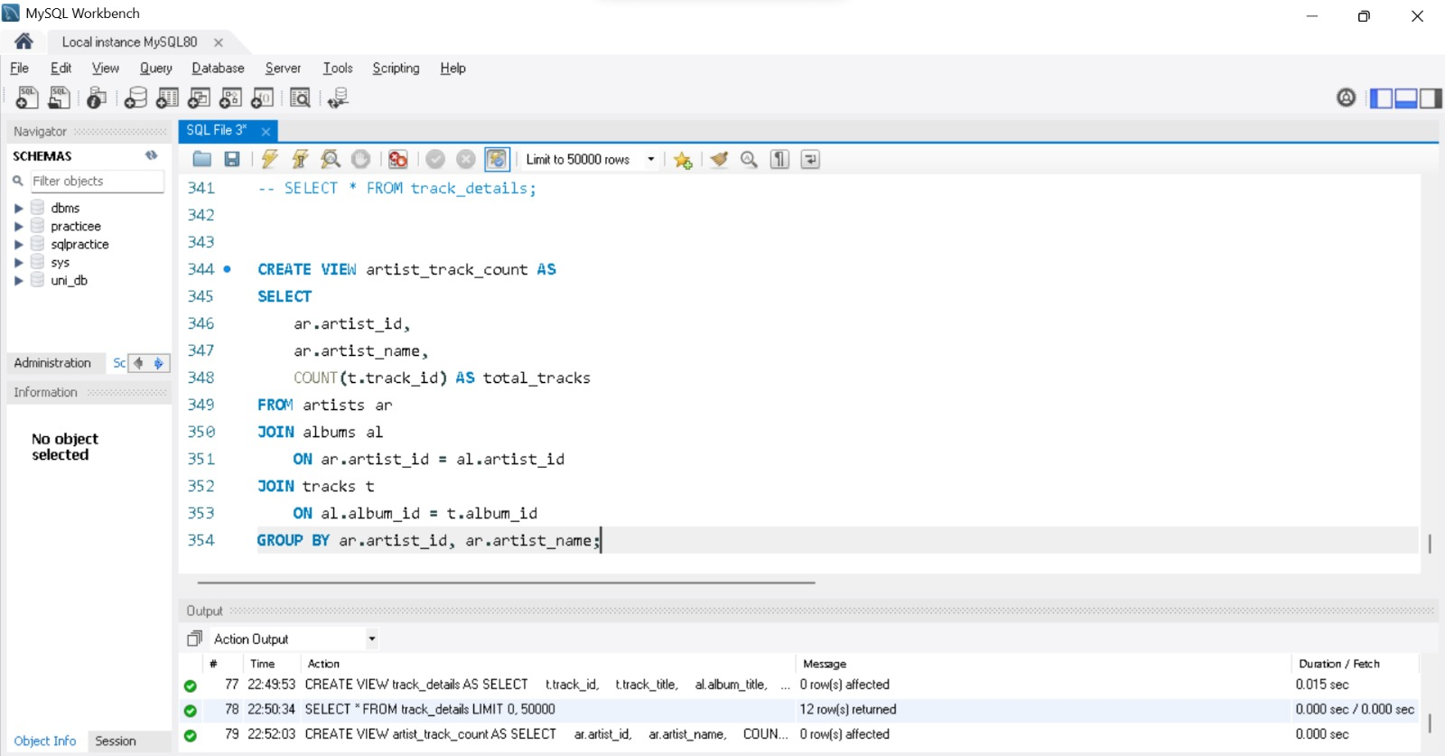
SQL Query:
CREATE VIEW artist_track_count AS
SELECT
ar.artist_id,
ar.artist_name,
COUNT(t.track_id) AS total_tracks
FROM artists ar
JOIN albums al
ON ar.artist_id = al.artist_id
JOIN tracks t
ON al.album_id = t.album_id
GROUP BY ar.artist_id, ar.artist_name;
Explanation:
This view joins artists, albums and tracks and uses GROUP BY with COUNT() to return the number of tracks per artist. Storing the aggregation in a view means the grouped query does not have to be rewritten every time. The Output panel confirms that the view was created.

6.4 Querying the artist_track_count View
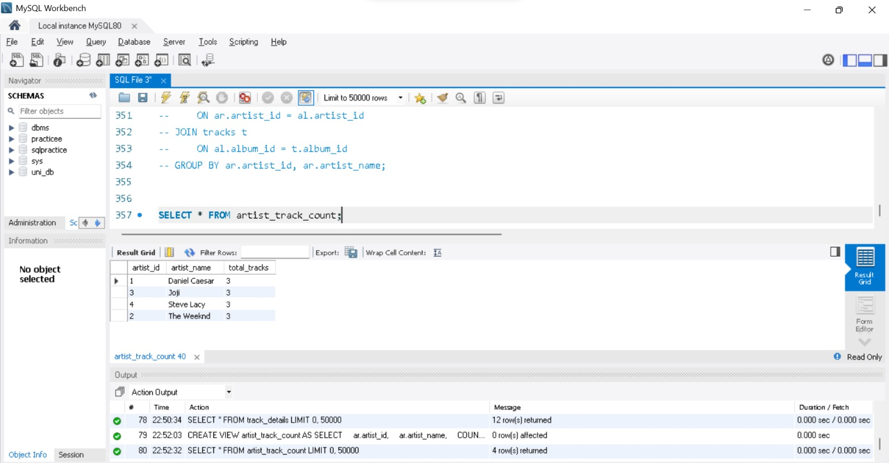
SQL Query:
SELECT * FROM artist_track_count;
Explanation:
The view returns one row per artist. Each of the four artists (Daniel Caesar, Joji, Steve Lacy and The Weeknd) has 3 tracks in the library.

6.5 Listing the Views of the Database
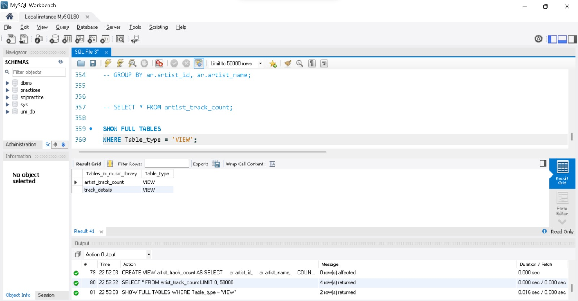
SQL Query:
SHOW FULL TABLES
WHERE Table_type = 'VIEW';
Explanation:
SHOW FULL TABLES adds a Table_type column; filtering on VIEW lists only the views. The database contains the two views created above, artist_track_count and track_details.

6.6 What Happens to a View if an Underlying Table Is Altered?
Explanation:
A view stores only its query, not data. Inserting, updating or deleting rows in the underlying tables is reflected in the view immediately.
If the structure of a table is altered, the view keeps working as long as the columns it uses still exist. Because track_details and artist_track_count list their columns explicitly, a column added later with ALTER TABLE does not appear in the view until the view is recreated (for example with CREATE OR REPLACE VIEW).
If a column used by the view is renamed or dropped, or the table is dropped, the view becomes invalid and querying it fails with an error such as "View references invalid table(s) or column(s)" until the view definition is corrected.

7. Window Functions

7.1 DENSE_RANK(): Top 5 Tracks per Genre by Play Count
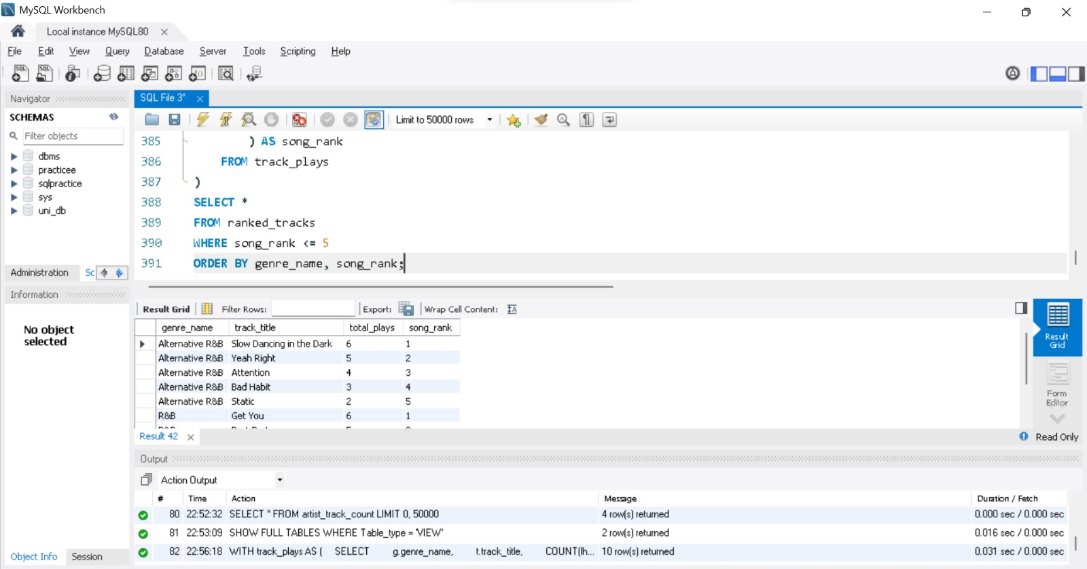
SQL Query:
WITH track_plays AS (
SELECT
g.genre_name,
t.track_title,
COUNT(lh.history_id) AS total_plays
FROM tracks t
JOIN track_genres tg ON t.track_id = tg.track_id
JOIN genres g ON tg.genre_id = g.genre_id
JOIN listening_history lh ON t.track_id = lh.track_id
GROUP BY g.genre_name, t.track_title
),
ranked_tracks AS (
SELECT
genre_name,
track_title,
total_plays,
DENSE_RANK() OVER (
PARTITION BY genre_name
ORDER BY total_plays DESC
) AS song_rank
FROM track_plays
)
SELECT *
FROM ranked_tracks
WHERE song_rank <= 5
ORDER BY genre_name, song_rank;
Explanation:
The first CTE (track_plays) counts how often each track was played within its genre. The second CTE ranks the tracks with DENSE_RANK() OVER (PARTITION BY genre_name ORDER BY total_plays DESC): the ranking restarts for every genre, and tracks with equal plays share a rank without gaps. The final query keeps ranks 1 to 5.
The result has 10 rows. In Alternative R&B the ranking is Slow Dancing in the Dark (6 plays), Yeah Right (5), Attention (4), Bad Habit (3) and Static (2); in R&B Get You (6 plays) is ranked first.

7.2 LEAD(): Next Track Played by a User
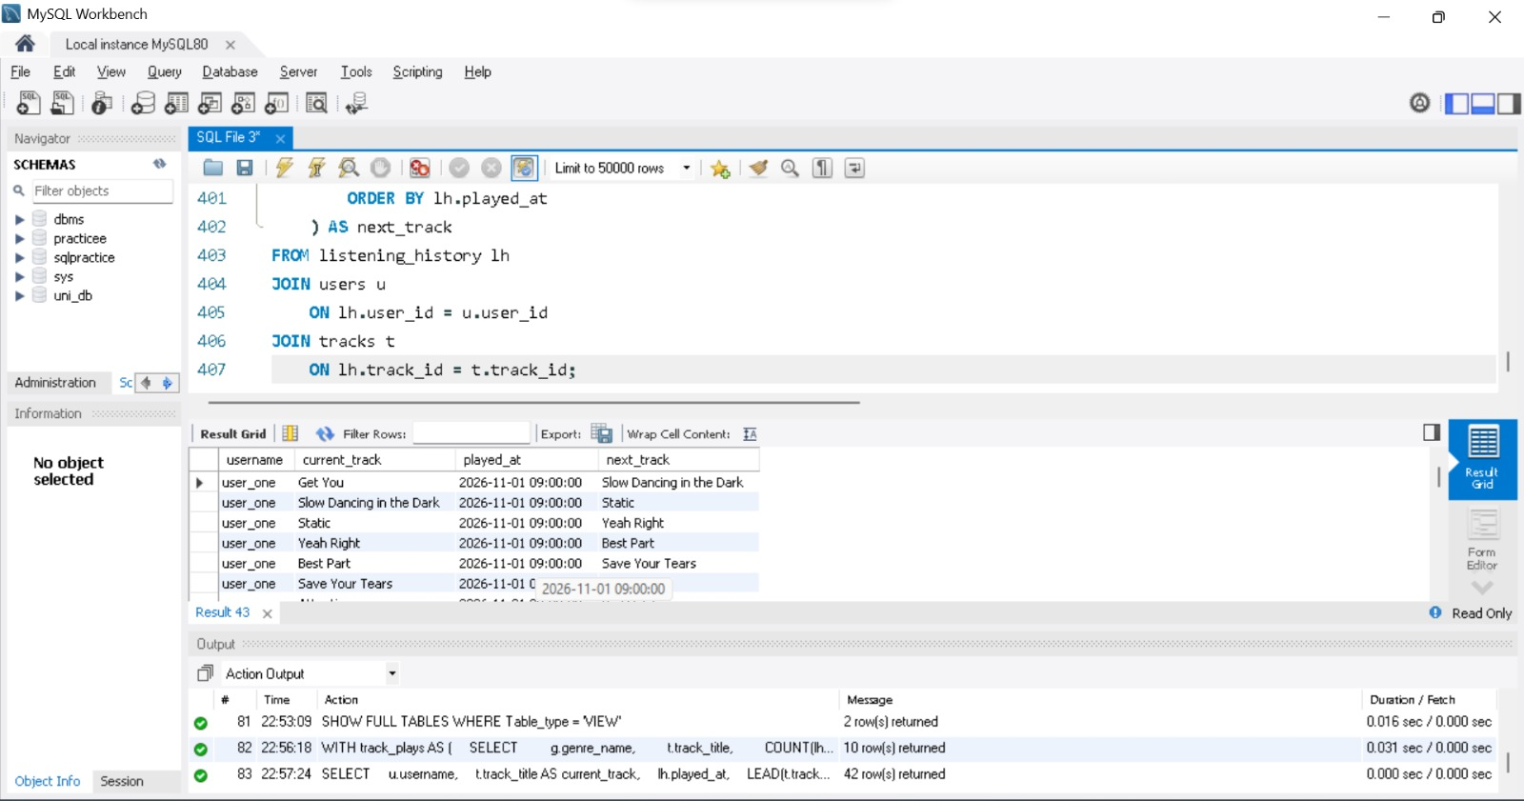
SQL Query:
SELECT
u.username,
t.track_title AS current_track,
lh.played_at,
LEAD(t.track_title) OVER (
PARTITION BY lh.user_id
ORDER BY lh.played_at
) AS next_track
FROM listening_history lh
JOIN users u
ON lh.user_id = u.user_id
JOIN tracks t
ON lh.track_id = t.track_id;
Explanation:
LEAD() looks at the next row of the window without a self-join. The window is split per user (PARTITION BY lh.user_id) and ordered by played_at, so next_track is the song the same user played right after the current one; the last play of each user has no next track and shows NULL.
The query returns 42 rows, one per play. For user_one, Get You is followed by Slow Dancing in the Dark, then Static, Yeah Right, Best Part and Save Your Tears.

7.3 Running Total of Plays per Day
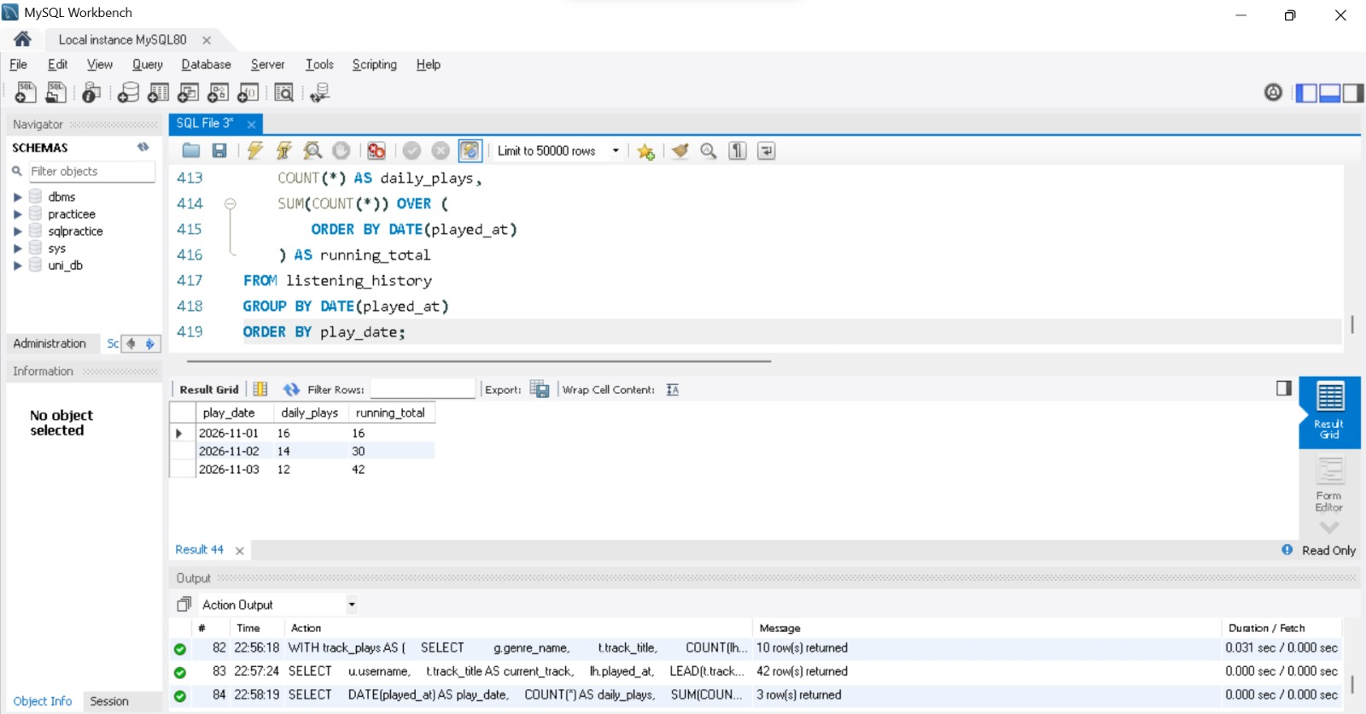
SQL Query:
SELECT
DATE(played_at) AS play_date,
COUNT(*) AS daily_plays,
SUM(COUNT(*)) OVER (
ORDER BY DATE(played_at)
) AS running_total
FROM listening_history
GROUP BY DATE(played_at)
ORDER BY play_date;
Explanation:
The query first groups the plays by day (COUNT(*) gives daily_plays). SUM(COUNT(*)) OVER (ORDER BY DATE(played_at)) then adds the daily counts cumulatively, so each row shows the total of all plays up to that day.
The result has three days: 2026-11-01 with 16 plays (running total 16), 2026-11-02 with 14 plays (30) and 2026-11-03 with 12 plays (42), which equals the 42 rows of the history table.

7.4 SUM() OVER (PARTITION BY album_id): Contribution of Each Track to Its Album
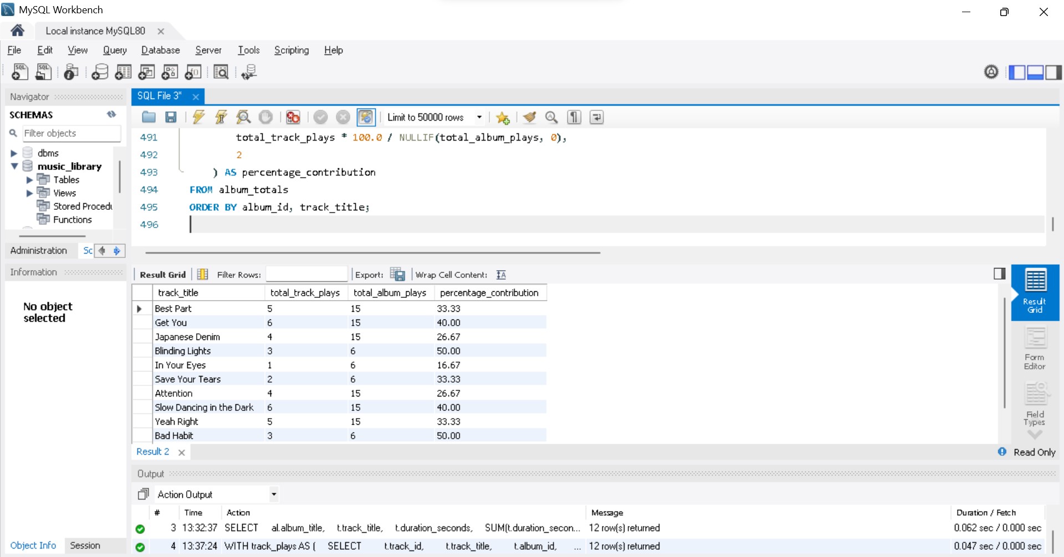
SQL Query:
WITH track_plays AS (
SELECT
t.track_id,
t.track_title,
t.album_id,
COUNT(lh.history_id) AS total_track_plays
FROM tracks t
LEFT JOIN listening_history lh
ON t.track_id = lh.track_id
GROUP BY t.track_id, t.track_title, t.album_id
),
album_totals AS (
SELECT
track_title,
album_id,
total_track_plays,
SUM(total_track_plays) OVER (
PARTITION BY album_id
) AS total_album_plays
FROM track_plays
)
SELECT
track_title,
total_track_plays,
total_album_plays,
ROUND(
total_track_plays * 100.0 / NULLIF(total_album_plays, 0),
2
) AS percentage_contribution
FROM album_totals
ORDER BY album_id, track_title;
Explanation:
The first CTE counts the plays of every track. In the second CTE SUM(total_track_plays) OVER (PARTITION BY album_id) adds up the plays of all tracks of the same album while keeping every track as its own row. The final query divides the two values, multiplies by 100 and rounds to two decimals; NULLIF(..., 0) prevents a division by zero.
Example: the album Freudian has 15 plays in total, so Get You (6 plays) contributes 40.00%, Best Part (5) 33.33% and Japanese Denim (4) 26.67%. In After Hours (6 plays) Blinding Lights contributes 50.00%.

8. Conclusion
The Music Library Management System was implemented in MySQL as nine related tables: artists, albums, tracks, genres, track_genres, users, playlists, playlist_tracks and listening_history.
CRUD operations were demonstrated on the tracks table. Joins, GROUP BY, HAVING and a subquery were used to search the library, list playlists and analyse the data. B-Tree indexes, including a composite index on playlist_tracks, were created and checked with SHOW INDEX and EXPLAIN. Two views, track_details and artist_track_count, replace repeated joins and aggregations with a simple SELECT. Finally, the window functions DENSE_RANK(), LEAD() and SUM() OVER were used to rank tracks per genre, find the next track played, compute a running total of daily plays and calculate each track’s share of its album’s plays.
Together these queries show how a relational database can store a music library and answer practical questions about its content and about the listening habits of its users.

