# Misplaced Books Report

|  |  |
| --- | --- |
| Shelf | Book Label |
| CAS-CHA | AS |

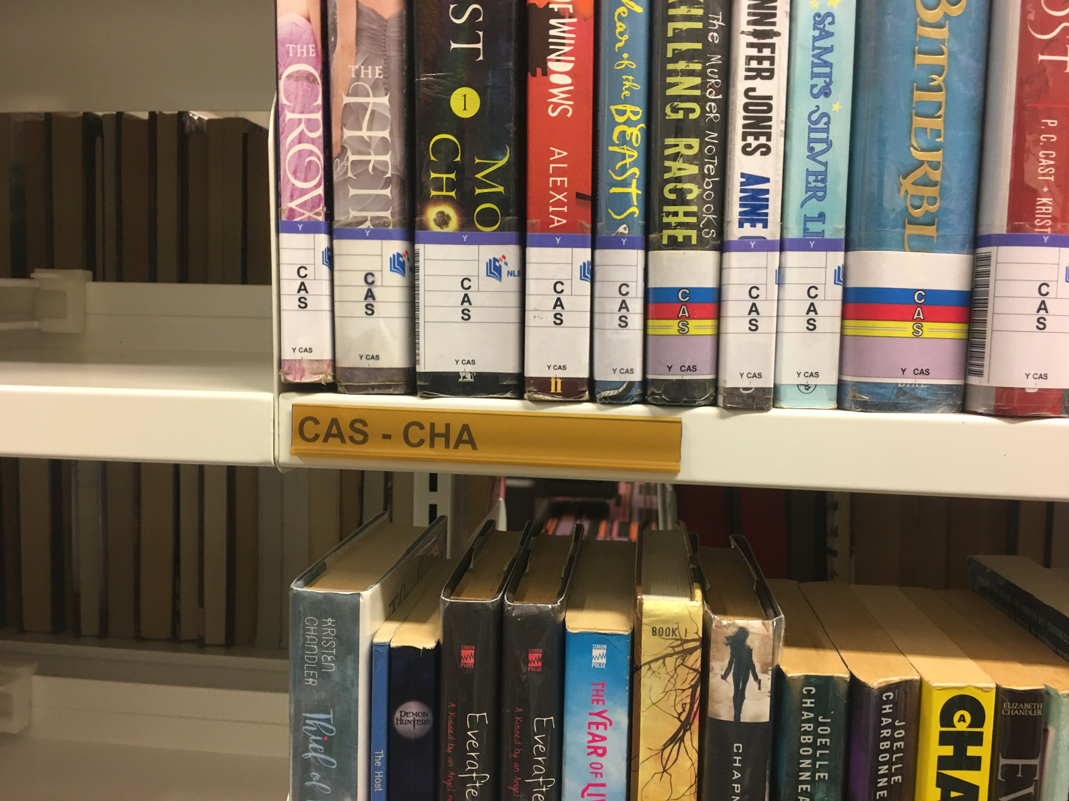

|  |  |
| --- | --- |
| Shelf | Book Label |
| ALA-AMA | AME |
| ALA-AMA | ME |
| ALA-AMA | AL |
| ALA-AMA | AL |
| ALA-AMA | AL |
| ALA-AMA | AME |
| ALA-AMA | AME |
| ALA-AMA |  |
| ALA-AMA |  |
| ALA-AMA |  |
| ALA-AMA | I |
| ALA-AMA |  |
| ALA-AMA | AMN |
| ALA-AMA | AME |
| ALA-AMA |  |
| ALA-AMA |  |

