
TITLE: | VTD01: Alarms Definitions, Alarms Notification and Alarms Dashboard | ITEM  NUMBER:
ITEM TYPE / NAME: Document / Plan and Report |  | REVISION: | 0.1

NOTES:

Change History
Rev. No. | Date | Revised by | Revision Details
0.2
0.1 | 06-June-2014 | Kartik Aiyar | Genesis

Table of Contents
1 Purpose 4
2 Scope 4
3 General Test Instructions 4
3.1 Equipment Requirements 4
3.1.1 General Equipment Requirements 4
3.1.2 Specific Equipment Requirements 5
3.2 Test Setup 5
3.2.1 Hardware and Software setup 5
3.2.2 Test Data Files 5
3.2.3 Test Model and Execution Strategy 5
4 Test Procedures 6
4.1 Monitor Alarms 7
4.1.1 Test Purpose 7
4.1.2 Test Requirements 7
4.1.3 Test Design and Strategy 7
4.2 Configure Alarm Definitions 8
4.2.1 Test Purpose 8
4.2.2 Test Requirements 8
4.2.3 Test Design and Strategy 8
4.3 Configure Alarms Notification Settings 10
4.3.1 Test Purpose 10
4.3.2 Test Requirements 11
4.3.3 Test Design and Strategy 11
4.4 Monitor Most Recent Active Alarms on Dashboard 12
4.4.1 Test Purpose 12
4.4.2 Test Requirements 12
4.4.3 Test Design and Strategy 12
5 Attachments 13

Table of Tables
Table 1: Required Equipment Table 6

Purpose
This document is the VTD01: Alarms Definitions, Alarms Notification and Alarms Dashboard Verification Test Procedures (VTD) for the Xirrus Management System Enterprise software. The purpose of the document is to test and verify the operational behavior and display attributes for Management System and provide the verification test design details for the Alarms Definitions, Alarms Notification and Alarms Dashboard as per XMS enterprise documents.
This document is intended for the Test Procedure Designers, Test Script Developers, Software Developers, Software Testers and any other parties interested in the software verification and validation processes in general.

Scope
The VTD01: Alarms Definitions, Alarms Notification and Alarms Dashboard covers the test procedures for the Xirrus Management System Enterprise software which supports the Management of Xirrus Arrays and other supported Xirrus products.
These procedures cover all type of Alarms supported by Xirrus products.
The scope of this document is restricted to the verification of the following requirements defined Xirrus Management System software.
- Monitor Alarms
- Alarms Definition
- Alarms Notification
- Alarms Dashboard

General Test Instructions

Equipment Requirements

General Equipment Requirements
The following equipment is required by all test procedures in this VTD:
Table 1: Required Equipment Table
Equipment | Make/Model
XMS Software | WOS, XMSE
Arrays | Xirrus, Avaya
Test Tool | Eclipse
Web browsers

Specific Equipment Requirements
Unless specified otherwise, all tests assume the use of the equipment specified above in Table 1: Required Equipment. Any other general or special test setup including but not limited to array reprogramming, is specifically stated in the body of the test procedure. Each test procedure has a table of equipment required for that test containing the identifying information of the equipment used for the test.
Equipment used where applicable must be verified with version.

Test Setup
Complete the “Test Conductor’s Name and Date” block at the beginning of the test procedure.

Hardware and Software setup
Ensure that workstation setup (hardware and Software) has been configured according Test Plan document.

Test Data Files
Added with verification test procedure in form of excel sheet.

Test Model and Execution Strategy
The strategy details for testing the various models for different versions of software are found within the Test Plan document.
All Test Suite should be scheduled to run on different Array. Each Test Suite is provided with the intelligence to decide at run time if it is to be skipped based on the Alarms supported by the model-under-test.

Test Procedures
The general strategy for the test design is as follows:
- This Verification Test Design should test all Alarms type supported by Array under test as per Test Plan Document.
- Only the Type of Alarm for which the model support should be considered.

There should be test case for each alarm type to test the Alarm display name, Alarm Notification, Alarm Definitions, Alarms List, Alarm panels and Alarm dashboard as per Xirrus Management System Documents. For each model-under-test, the Test case runs only if the parameter-under-test is supported in the array model.

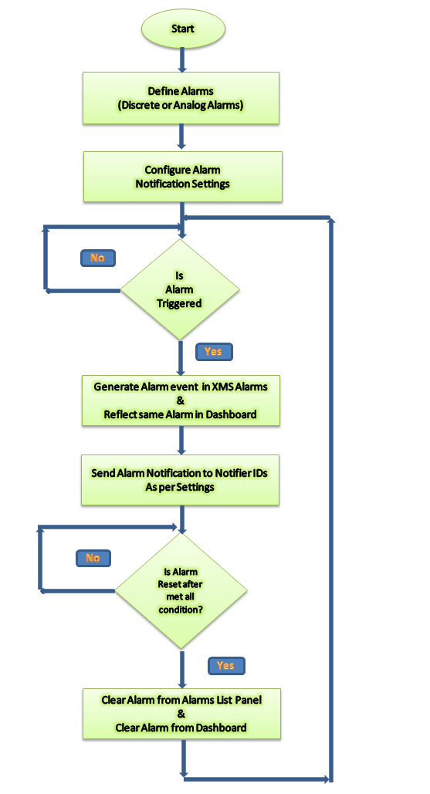

Monitor Alarms

Test Purpose
The purpose of this test is to verify the Alarms panel under Monitor – Troubleshooting. To verify GUI components, functional behavior of component on panel and Alarms generated in system are displayed or reported correctly.

Test Requirements
The requirements verified by this test procedure are listed Test Link under Test Design Management. Refer Xirrus Management System Documents for complete requirements description.

Test Design and Strategy
Alarms:
The web client Alarms page lists the alarms received by XMS for your Current Array Scope. All alarm levels are displayed — Critical, Major, Minor, Warning, and Clear. Values may be exported.
You may Clear or Delete alarms by selecting the check boxes to the left of the desired entries and clicking the appropriate button on the upper left.
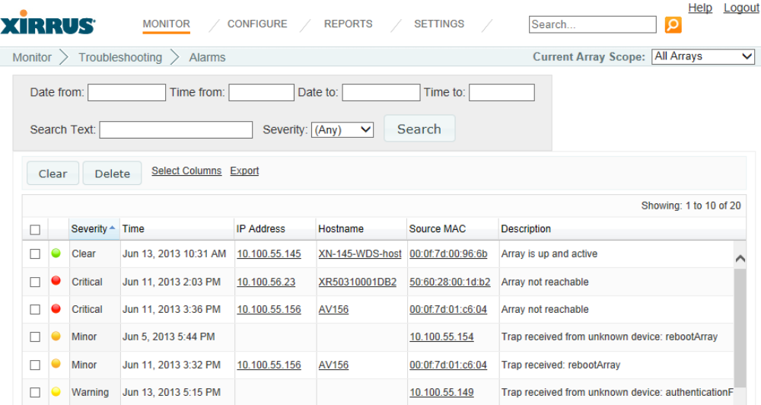
Summary of test scenarios:
- Initial condition, when there is no alarm generated
- Generate single Alarm verify
- Generate multiple alarms and verify
- Filter generated alarms using filter feature
- Short Alarms definitions using different column
- Clear single alarm and verify same
- Clear multiple alarms and verify same
- Delete single alarm and verify same
- Delete multiple alarms and verify same
- Export feature for alarms

Setup and Preconditions:
- Discover one array only.
- Generate few alarms

Test Cases:
- TC_Alarm_AlarmsPanel_GUI
    - Ref-1.1_Verify Buttons on alarms panel
    - Ref-1.2_Verify Active links on alarm panel
    - Ref-1.3_Verify data fields on alarm panel
- TC_Alarm_GeneratedAlarms
    - Ref-2.1_Verify alarm type and description
    - Ref-2.2_Verify date-time and format for generated alarm
    - Ref-2.2_Verify Severity of alarm its color significant
    - Ref-2.3_Verify columns for generated Alarm display panel
- TC_Alarm_ClearAlarms
    - Ref-3.1_Verify Clear functionality for generated alarm
    - Ref-3.2_Verify Cleared alarm is removed from dashboard
- TC_Alarm_DeleteAlarms
    - Ref-3.1_Verify Delete functionality for generated alarm
    - Ref-3.2_Verify deleted alarm is removed from dashboard
- TC_Alarm_FilterAlarms
    - Ref-4.1_Verify search filter without any filtering criteria
    - Ref-4.2_Verify Search alarms with date-time range
    - Ref-4.3_Verify search alarms with Severity
    - Ref-4.4_Verify search alarms with text in description field
    - Ref-4.5_Verify search alarms with all search criteria
- TC_Alarm_ShortAlarms
    - Ref-5.1_Verify shorting of alarms using different column
- TC_Alarm_ExportAlarms
    - Ref-6.1_Verify Export functionality and output file

Configure Alarm Definitions

Test Purpose
The purpose of this test is to verify the Alarms Definitions panel under Configure – Alarms – Alarms Definitions. To verify GUI components, functional behavior of component on panel and Defining type of Alarms need to monitor behavior of overall Array network.

Test Requirements
The requirements verified by this test procedure are listed Test Link under Test Design Management. Refer Xirrus Management System Documents for complete requirements description.

Test Design and Strategy
Alarm Definitions:
The Custom Alarms page allows you to define your own alarms. You can instruct XMS to monitor a specified operating condition on all Arrays and issue an alarm if your stated criteria are met on any Array. For example, you may set application traffic alarms to send a notification when usage of an application or application category exceeds the defined threshold, either system-wide or per-Array.
Discrete Alarm—a discrete alarm is issued if the condition described in Alarm Type becomes true. For example, the selected Alarm Category is IAP Status. If you select IAP Disabled as the alarm type, fields will be displayed allowing you to select a specific IAP Name to monitor and specify the Severity of the resulting alarm. In this example, an alarm will be issued if the specified IAP on any managed Array goes down.
Analog Alarm—an analog alarm is triggered any time its value is not within the specified range (subject to the deadband restrictions). You must specify additional parameters to define a Low Alarm Threshold and/or a High Alarm Threshold. The alarm is triggered when the value is greater than or equal to the upper threshold, or less than or equal to the lower threshold. To clear the alarm, the value must be less than the upper limit minus the Deadband, or greater than the lower limit plus the deadband. For an analog alarm, you may also set a Deadband value. This value keeps the alarm from being reissued multiple times by the same event. For example, the selected Alarm Category is Ethernet Errors. If you select Ethernet Interface retry percentage as the Alarm Type, fields will be displayed allowing you to select a specific Ethernet Interface Name to monitor, and specify the Severity of the resulting alarm. In this example, an alarm will be issued if retry percentage on the specified interface on any managed Array equals or exceeds the High Alarm Threshold.
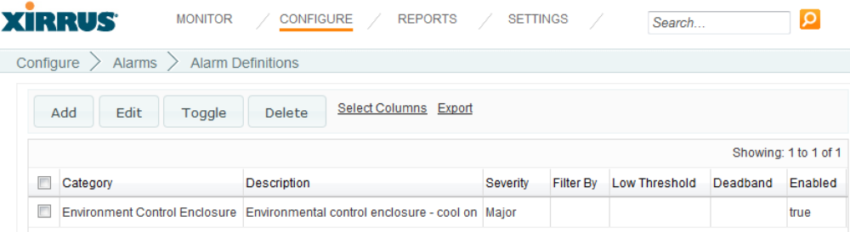
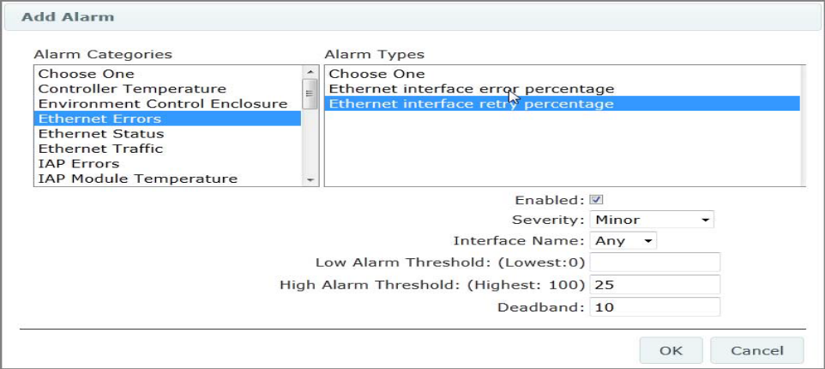

Summary of test scenarios:
- Initial condition, when there is no alarm definition
- Add single Alarm Definition and verify when its triggered
- Add multiple alarms definitions and verify when its triggered
- Edit Alarm definitions and verify when it triggered with new values
- Short Alarms definitions using different column
- Delete single alarm and verify same
- Delete multiple alarms and verify same
- Toggle feature
- Export feature for alarm definitions

Setup and Preconditions:
- Discover one array only.

Test Cases:
- TC_Alarm_DefinitionsPanel_GUI
    - Ref-1.1_Verify Buttons on alarm definitions panel
    - Ref-1.2_Verify Active links on alarm definitions panel
    - Ref-1.3_Verify columns names for Alarms definitions
- TC_Alarm_AddAlarmWin_GUI
    - Ref-2.1_Verify title of add alarm window
    - Ref-2.2_Verify button on add alarm window
    - Ref-2.3_Verify Alarm categories on add alarm window
- TC_Alarm_EditAlarmWin_GUI
    - Ref-3.1_Verify title of Edit alarm window
    - Ref-3.2_Verify button on Edit alarm window
- TC_Alarm_App_Control_Sys_wide
    - Ref-4.1_Verify Alarms Types listed for Alarm category Application Control System Wide
    - Ref-4.2_Verify Different fields available for Alarm Types Label, Value and Unit
    - Ref-4.3_Verify Adding Alarms type in Alarm Definitions
    - Ref-4.4_Verify Alarm is listed on Monitor Alarms Panel and Dashboard
    - Ref-4.5_Verify Alarm deleted from Alarm Definitions panel
    - Ref-4.6_Verify that deleted Alarm definition is not removed from Monitor Alarm and dashboard
    - Ref-4.7_Verify that selected alarm can be toggled from alarm definitions panel
- TC_Alarm_App_Control_per_Array
    - Ref-5.1_Verify Alarms Types listed for Alarm category Application Control Per Array
    - Ref-5.2_Verify Different fields available for Alarm Types Label, Value and Unit
    - Ref-5.3_Verify Adding Alarms type in Alarm Definitions
    - Ref-5.4_Verify Alarm is listed on Monitor Alarms Panel and Dashboard
    - Ref-5.5_Verify Alarm deleted from Alarm Definitions panel
    - Ref-5.6_Verify that deleted Alarm definition is not removed from Monitor Alarm and dashboard
    - Ref-5.7_Verify that selected alarm can be toggled from alarm definitions panel
- TC_Alarm_Controller_Temperature
    - Ref-6.1_Verify Alarms Types listed for Alarm category Controller Temperature
    - Ref-6.2_Verify Different fields available for Alarm Types Label, Value and Unit
    - Ref-6.3_Verify Adding Alarms type in Alarm Definitions
    - Ref-6.4_Verify Alarm is listed on Monitor Alarms Panel and Dashboard
    - Ref-6.5_Verify Alarm deleted from Alarm Definitions panel
    - Ref-6.6_Verify that deleted Alarm definition is not removed from Monitor Alarm and dashboard
    - Ref-6.7_Verify that selected alarm can be toggled from alarm definitions panel
- TC_Alarm_Env_Control_Enclosure
    - Ref-7.1_Verify Alarms Types listed for Alarm category Environment Control Enclosure
    - Ref-7.2_Verify Different fields available for Alarm Types Label, Value and Unit
    - Ref-7.3_Verify Adding Alarms type in Alarm Definitions
    - Ref-7.4_Verify Alarm is listed on Monitor Alarms Panel and Dashboard
    - Ref-7.5_Verify Alarm deleted from Alarm Definitions panel
    - Ref-7.6_Verify that deleted Alarm definition is not removed from Monitor Alarm and dashboard
    - Ref-7.7_Verify that selected alarm can be toggled from alarm definitions panel
- TC_Alarm_Ethernet
    - Ref-8.1_Verify Alarms Types listed for Alarm category Ethernet
    - Ref-8.2_Verify Different fields available for Alarm Types Label, Value and Unit
    - Ref-8.3_Verify Adding Alarms type in Alarm Definitions
    - Ref-8.4_Verify Alarm is listed on Monitor Alarms Panel and Dashboard
    - Ref-8.5_Verify Alarm deleted from Alarm Definitions panel
    - Ref-8.6_Verify that deleted Alarm definition is not removed from Monitor Alarm and dashboard
    - Ref-8.7_Verify that selected alarm can be toggled from alarm definitions panel
- TC_Alarm_Global_Station_Counts
    - Ref-9.1_Verify Alarms Types listed for Alarm category Global Station Count
    - Ref-9.2_Verify Different fields available for Alarm Types Label, Value and Unit
    - Ref-9.3_Verify Adding Alarms type in Alarm Definitions
    - Ref-9.4_Verify Alarm is listed on Monitor Alarms Panel and Dashboard
    - Ref-9.5_Verify Alarm deleted from Alarm Definitions panel
    - Ref-9.6_Verify that deleted Alarm definition is not removed from Monitor Alarm and dashboard
    - Ref-9.7_Verify that selected alarm can be toggled from alarm definitions panel
- TC_Alarm_IAPs
    - Ref-10.1_Verify Alarms Types listed for Alarm category IAPs
    - Ref-10.2_Verify Different fields available for Alarm Types Label, Value and Unit
    - Ref-10.3_Verify Adding Alarms type in Alarm Definitions
    - Ref-10.4_Verify Alarm is listed on Monitor Alarms Panel and Dashboard
    - Ref-10.5_Verify Alarm deleted from Alarm Definitions panel
    - Ref-10.6_Verify that deleted Alarm definition is not removed from Monitor Alarm and dashboard
    - Ref-10.7_Verify that selected alarm can be toggled from alarm definitions panel
- TC_Alarm_Intrusion_Detection
    - Ref-11.1_Verify Alarms Types listed for Alarm category Intrusion
    - Ref-11.2_Verify Different fields available for Alarm Types Label, Value and Unit
    - Ref-11.3_Verify Adding Alarms type in Alarm Definitions
    - Ref-11.4_Verify Alarm is listed on Monitor Alarms Panel and Dashboard
    - Ref-11.5_Verify Alarm deleted from Alarm Definitions panel
    - Ref-11.6_Verify that deleted Alarm definition is not removed from Monitor Alarm and dashboard
    - Ref-11.7_Verify that selected alarm can be toggled from alarm definitions panel
- TC_Alarm_Stations
    - Ref-12.1_Verify Alarms Types listed for Alarm category Station
    - Ref-12.2_Verify Different fields available for Alarm Types Label, Value and Unit
    - Ref-12.3_Verify Adding Alarms type in Alarm Definitions
    - Ref-12.4_Verify Alarm is listed on Monitor Alarms Panel and Dashboard
    - Ref-12.5_Verify Alarm deleted from Alarm Definitions panel
    - Ref-12.6_Verify that deleted Alarm definition is not removed from Monitor Alarm and dashboard
    - Ref-12.7_Verify that selected alarm can be toggled from alarm definitions panel
- TC_Alarm_VLAN
    - Ref-13.1_Verify Alarms Types listed for Alarm category VLAN
    - Ref-13.2_Verify Different fields available for Alarm Types Label, Value and Unit
    - Ref-13.3_Verify Adding Alarms type in Alarm Definitions
    - Ref-13.4_Verify Alarm is listed on Monitor Alarms Panel and Dashboard
    - Ref-13.5_Verify Alarm deleted from Alarm Definitions panel
    - Ref-13.6_Verify that deleted Alarm definition is not removed from Monitor Alarm and dashboard
    - Ref-13.7_Verify that selected alarm can be toggled from alarm definitions panel
- TC_Alarm_WDS
    - Ref-14.1_Verify Alarms Types listed for Alarm category WDS
    - Ref-14.2_Verify Different fields available for Alarm Types Label, Value and Unit
    - Ref-14.3_Verify Adding Alarms type in Alarm Definitions
    - Ref-14.4_Verify Alarm is listed on Monitor Alarms Panel and Dashboard
    - Ref-14.5_Verify Alarm deleted from Alarm Definitions panel
    - Ref-14.6_Verify that deleted Alarm definition is not removed from Monitor Alarm and dashboard
    - Ref-14.7_Verify that selected alarm can be toggled from alarm definitions panel

Configure Alarms Notification Settings

Test Purpose
The purpose of this test is to verify the Alarms Notification Settings panel under Configure- Alarms- Notification Settings. To verify GUI components, functional behavior of component on panel and setup Alarms notification to get notification when alarm occurred.

Test Requirements
The requirements verified by this test procedure are listed Test Link under Test Design Management. Refer Xirrus Management System Documents for complete requirements description.

Test Design and Strategy
Notification Settings:
You can set up email notifications to be sent when alarms occur. The email will identify the notifying Array by host name, IP address, and MAC address. Notifications may be restricted to apply only to a selected Array scope—a set of Arrays belonging to a selected profile or Array group.
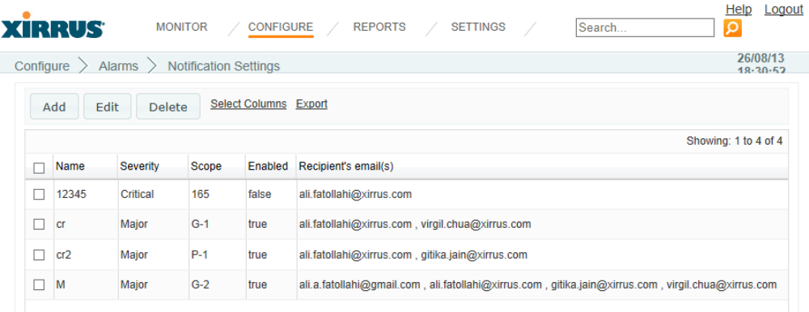
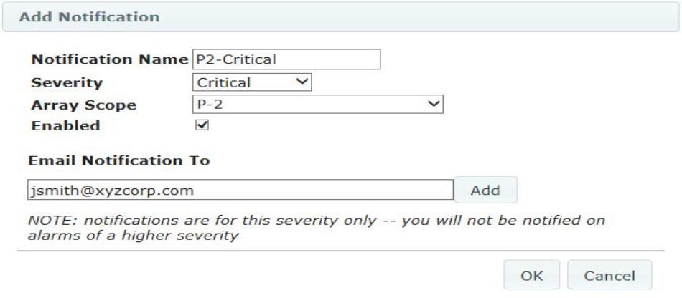
Summary of test scenarios:
- Initial condition, when there is no notification is set
- Add single notification policy and verify when triggered
- Add multiple notification policy and verify when its triggered
- Edit notification policy and verify when it triggered with new values
- Short notifications using different column
- Delete single notification policy and verify same
- Delete multiple notification policy and verify same
- Export feature for notification settings

Setup and Preconditions:
- Discover one or multiple array based on scenario.

Test Cases:
- TC_Alarm_NotificationSetting_GUI
    - Ref-1.1_Verify Buttons on Notification Settings Panel
    - Ref-1.2_Verify Active links on Notification Settings Panel
    - Ref-1.3_Verify columns names for Notification Settings Panel
- TC_Alarm_AddNotificationWin_GUI
    - Ref-2.1_Verify Buttons on Add Notification window
    - Ref-2.2_Verify title of add Notification window
    - Ref-2.3_Verify Labels and data fields for add Notification window
- TC_Alarm_EditNotificationWin_GUI
    - Ref-3.1_Verify Buttons on Edit Notification window
    - Ref-3.2_Verify title of Edit Notification window
    - Ref-3.3_Verify Labels and data fields for Edit Notification window
- TC_Alarm_AddSingleNotification
    - Ref-4.1_Verify Alarm Email notification when one Notification is added
    - Ref-4.2_Verify notification for single and multiple email IDs
- TC_Alarm_AddMultipleNotification
    - Ref-5.1_Verify Alarm Email notification when one Notification is added
    - Ref-5.2_Verify notification for single and multiple email IDs
- TC_Alarm_EditNotification
    - Ref-6.1_Verify Edit Notification functionality
- TC_Alarm_ExportNotification
    - Ref-7.1_Verify Export functionality and output file

Monitor Most Recent Active Alarms on Dashboard

Test Purpose
The purpose of this test is to verify the Most Recent Active Alarms widget added on dashboard to monitor most recent active alarms under Monitor – Dashboard. To verify GUI components, functional behavior of component on widget and Alarms generated in system are displayed or reported correctly.

Test Requirements
The requirements verified by this test procedure are listed Test Link under Test Design Management. Refer Xirrus Management System Documents for complete requirements description.

Test Design and Strategy
Alarms Dashboard:
This table lists the most recent alarms generated by your wireless network. For each alarm, the dashboard shows the severity, the date, and the beginning of the description. To see more information for an alarm in the list, click it to view the Alarm Details. All severity levels are displayed — Critical, Major, Minor, Warning, and Clear. Alarms are shown only for Arrays in the selected Array Group.
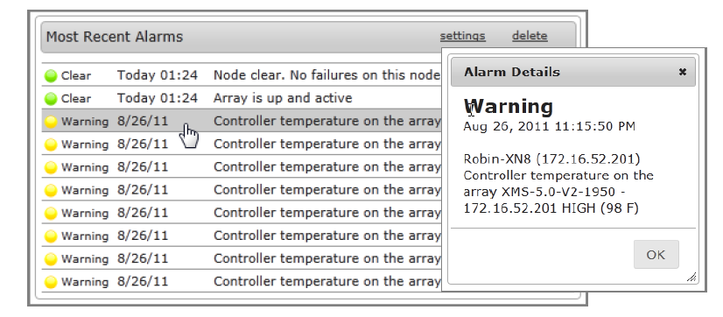
Summary of test scenarios:
- Initial condition, when there is no alarm
- When there is only one alarm generated
- When few alarms are alarms generated
- When alarms cleared

Setup and Preconditions:
- Generate few alarms in system
- Alarm type should be, Clear, Warning, Critical, Major and Minor

Test Cases:
- TC_Alarm_widget_GUI
    - Ref-1.1_Verify Most Recent Active Alarms Title of widget
    - Ref-1.2_Verify List of Alarms displaying in Most Recent Active Alarm widget
- TC_Alarm_details_GUI
    - Ref-2.1_Verify Clicking alarm in widget display Alarm details window
    - Ref-2.2_Verify Title of Alarm Details window
    - Ref-2.3_Verify contain of Alarm detail window
- TC_Alarm_Setting
    - Ref-3.1_Verify Setting window component
    - Ref-3.2_Verify Functionality of Setting for Alarm widget
- TC_Alarm_Delete
    - Ref-4.1_Verify Delete functionality of Alarm widget

Attachments
Excel sheet is attached, to display Test Suite and Test Case name.

