Business Summary Report: Predictive Insights for Collections Strategy
Prepared for: Head of Collections, Geldium

1. Summary of Predictive Insights
To understand what drives our customers to default, I analyzed our historical data, filled any missing values with statistical medians to maintain data integrity, and ran predictive machine learning models (specifically Logistic Regression for transparency). Here are the key findings I uncovered about our customer behavior:

Top 3 Risk Factors Driving Delinquency:
- Credit Utilization & Debt Overload: The predictive models identified a customer's 'Credit Utilization' and 'Debt-to-Income Ratio' as the two strongest mathematical predictors of default. When customers begin maxing out their available limits, it acts as the earliest warning sign of financial distress.
- Vulnerability in the 46-60 Age Bracket: Surprisingly, our highest delinquency rate sits with middle-aged customers (46-60 years old) at 21.7%. By comparison, the 31-45 age group is our safest, with only a 12.3% delinquency rate.
- Geographic and Employment Stress: From a geographic standpoint, Los Angeles carries our highest risk (19.6% delinquency), while New York is the safest (12.0%). Furthermore, unemployment drives a significant portion of defaults (19.4%), whereas retired individuals represent our most stable segment (11.5%).
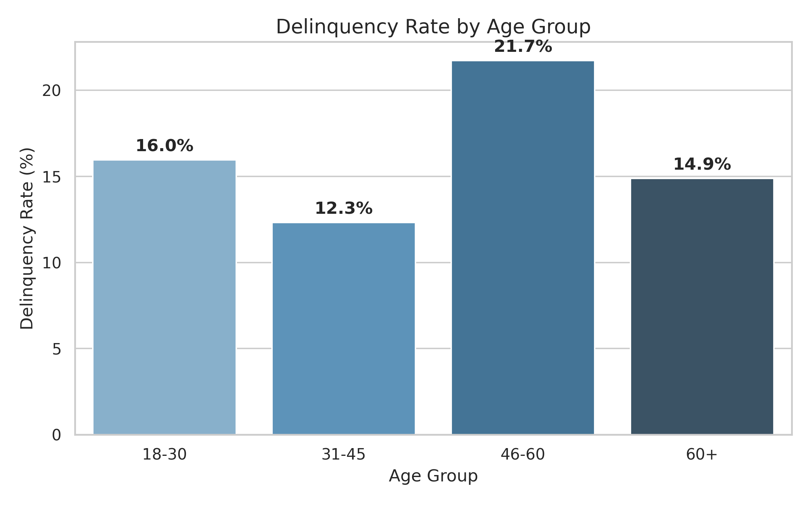
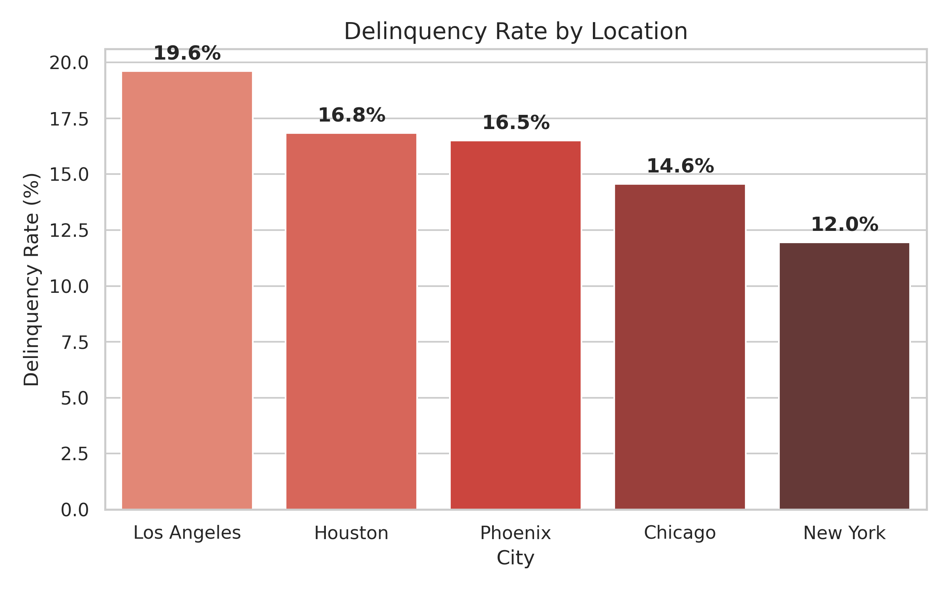

2. Recommendation Framework
Based on the data, waiting for a payment to be missed is too late. We must act on the predictive behaviors, specifically credit utilization.

Restated Insight:
High credit utilization and debt-to-income ratios are the strongest early indicators of future delinquency, long before the first missed payment occurs.

Proposed Recommendation:
Implement a 'Pre-Delinquency Outreach Program' that triggers supportive intervention when a customer's credit utilization crosses a high-risk threshold.
• Specific: Automatically flag accounts where credit utilization exceeds 75% and trigger a customized outreach email offering a free financial counseling call or a temporary restructuring plan.
• Measurable: Track the open rate of these emails and monitor if the delinquency rate among this flagged group decreases by 5%.
• Actionable: The data team has already identified the utilization metric. We simply need to route these flagged accounts to a specialized customer success team instead of standard collections.
• Relevant: This aligns perfectly with Geldium's goal of reducing total defaults while maintaining strong, positive customer relationships.
• Time-bound: Launch the pilot program next month, run it for one full quarter (90 days), and review the default rate drop.

Justification and Business Rationale:
By the time an account reaches the Collections team, the customer is already in a crisis. By shifting our focus to predictive metrics like utilization, we move from being 'reactive debt collectors' to 'proactive financial partners.' This saves the business money on write-offs and improves customer loyalty.

3. Ethical and Responsible AI Considerations
As we deploy this model, I have identified and accounted for several ethical and fairness considerations to protect both Geldium and our customers:
- Fairness Risk (Age Bias): Our data shows that the 46-60 age group defaults the most. If we aren't careful, the AI could start unfairly penalizing or denying credit limit increases to anyone in this age bracket, regardless of their personal financial health.
Mitigation: We will not use 'Age' as an automatic decision-maker for credit limits. Age is merely an analytical lens; decisions must strictly remain tied to individual behavior like payment history.
- Fairness Risk (Geographic Profiling): Because Los Angeles has a higher delinquency rate, the model might implicitly penalize applicants from that region.
Mitigation: Geographic location will be excluded from the final automated scoring matrix to ensure lending fairness and compliance with financial regulations.
- Explainability to Non-Technical Staff: It is crucial that our human agents understand why the AI flagged an account. Because I used a Logistic Regression model rather than a complex 'Black Box' neural network, our agents can clearly see the 'why'. If an agent asks why someone was flagged, the dashboard will simply show: 'Because their credit utilization hit 85% and their income dropped,' allowing for transparent, human-to-human conversations.

