Problem Statement 1: Design a LEX Code to count the number of lines, spaces, tab-meta character, and the rest of the characters in a given input pattern.

Code:
%{
#include <stdio.h>
int newlines=0,tabs=0,whitespaces=0,characters=0;
%}

%%
\n {newlines++;}
\t {tabs++;}
[" "] {whitespaces++;}
. {characters++;}
%%

int yywrap()
{
return 1;
}

int main()
{
printf("Enter a string : ");
yylex();
printf("No. of newlines : %d\n",newlines);
printf("No. of tabs : %d\n",tabs);
printf("No. of whitespaces : %d\n",whitespaces);
printf("No. of characters : %d\n",characters);
};

Output:
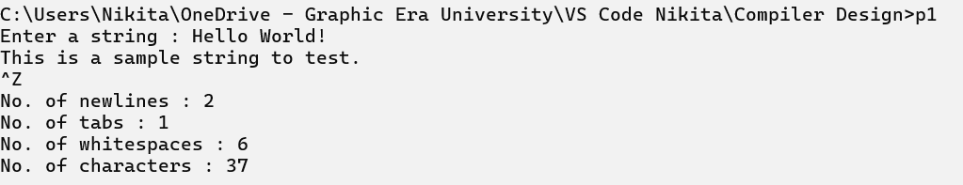

Problem Statement 2: Design a LEX Code to identify and print a valid identifier of C/C++ in a given input pattern.

Code:
%{
#include<stdio.h>
%}

%%
^[A-Za-z_][a-zA-Z_0-9]* {printf("Valid identifier");}
.* {printf("Invalid identifier");}
%%

int yywrap()
{
return 1;
}

int main()
{
printf("Enter the input: ");
yylex();
return 0;
}

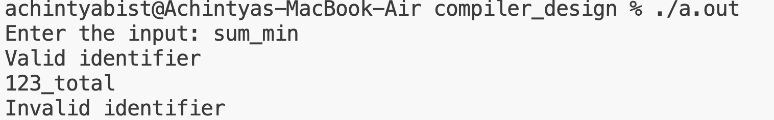
Output:

Problem Statement 3: Design a LEX Code to identify and print integer and float values in a given input pattern.

Code:
%{
#include <stdio.h>
%}

%%
[+-]?[0-9]+"."[0-9]+ {printf("Float : %s\n",yytext);}
[+-]?[0-9]+ {printf("Integer : %s\n",yytext);}
.|\n {;}
%%

int yywrap()
{
return 1;
}

int main()
{
printf("Enter input: ");
yylex();
}

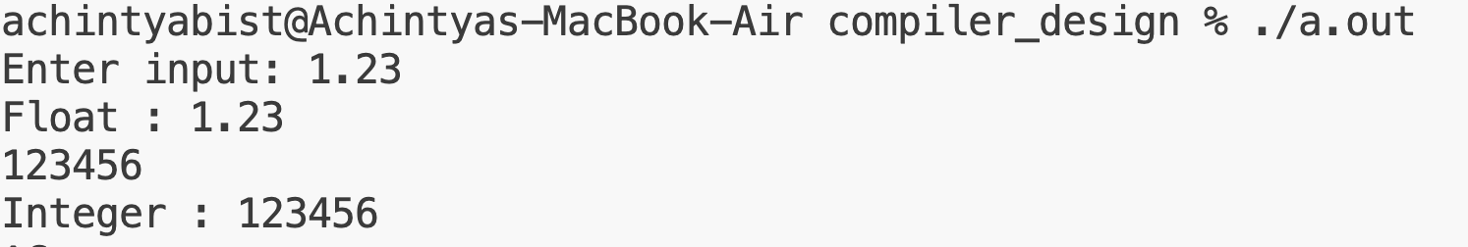
Output:

Problem Statement 4: Design a LEX Code for tokenizing (Identify and print OPERATORS, SEPARATORS, KEYWORDS, IDENTIFIERS) the following C-fragment:
int p=1, d=0,r=4; float m=0.0,
n=200.0;
while (p <= 3)
{ if(d==0)
{ m= m+n*r+4.5; d++; }
else
{ r++; m=m+r+1000.0; } p++; }

Code:
%{
#include<stdio.h>
%}

KEYWORDS int|char|float|if|else|while|short|auto|long|double|break
IDENTIFIERS [a-zA-Z_][a-zA-Z0-9_]*
SEPARATORS [;(){},]

%%
{KEYWORDS} {printf("Keyword : %s\n", yytext); }
{IDENTIFIERS} { printf("Identifier : %s\n", yytext); }
{SEPARATORS} {printf("Separator : %s\n", yytext); }
[+\-*/=<>]|"=="|"<="|">="|"++"|"--" {printf("Operator : %s\n", yytext); }
[ \t\n]+ { ; }
. { ; }
%%

int yywrap()
{
return 1;
}

int main()
{
printf("Enter C Code: ");
yylex();
return 0;
}

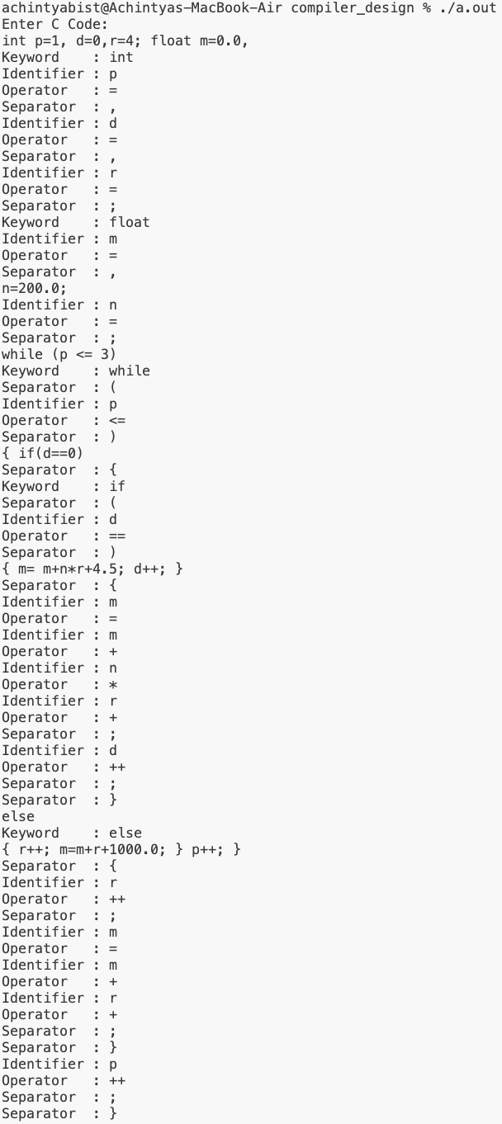
Output:

Problem Statement 5: Design a LEX Code to count and print the total number of characters, words, white spaces and lines in a given file named as ‘Input.txt’.

Code:
%{
#include <stdio.h>
int newlines=0,tabs=0,whitespaces=0,characters=0;
%}

%%
\n {newlines++;}
\t {tabs++;}
[" "] {whitespaces++;}
. {characters++;}
%%

int yywrap()
{
return 1;
}

int main()
{
extern FILE *yyin;
yyin=fopen("Input.txt","r");
yylex();
printf("No. of newlines : %d\n",newlines);
printf("No. of tabs : %d\n",tabs);
printf("No. of whitespaces : %d\n",whitespaces);
printf("No. of characters : %d\n",characters);
};

Input:-

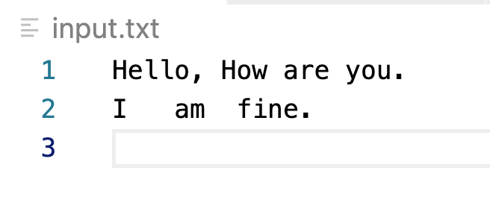
input.txt:

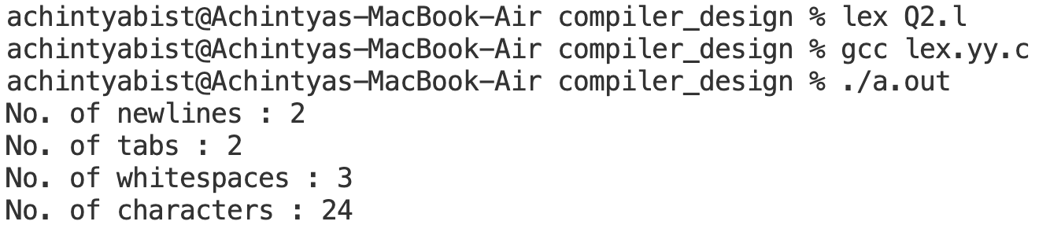
Output:-

Problem Statement 6: Design a LEX Code to replace all the white spaces of ‘Input.txt’ file by a single blank character and store the output in ‘Output.txt’ file.

Code:
%{
#include <stdio.h>
%}

%%
[ \t]+ { fprintf(yyout," "); }
.|\n { fprintf(yyout, "%s", yytext); }
%%

int yywrap()
{
return 1;
}

int main()
{
extern FILE *yyin, *yyout;
yyin = fopen("input.txt", "r");
yyout = fopen("output.txt", "w");
yylex();
}

Input:-

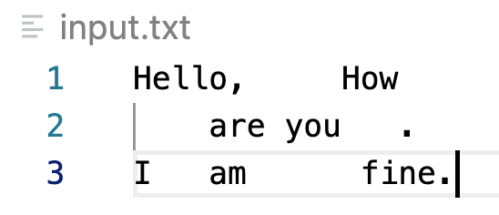
input.txt:

Output:-

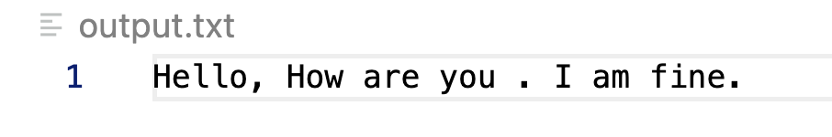
output.txt:

Problem Statement 7: Design a LEX Code to remove the comments from any C-Program (in.c) given at runtime and store into ‘out.c’ file.

Code:
%{
#include <stdio.h>
%}

%%
"//".* {;}
"/*"(.|\n)*?"*/" {;}
. {fprintf(yyout,"%c",yytext[0]);}
\n {fprintf(yyout,"\n");}
%%

int yywrap()
{
return 1;
}

int main()
{
extern FILE *yyin,*yyout;
yyin=fopen("in.c","r");
yyout=fopen("out.c","w");
yylex();
}

Input:-

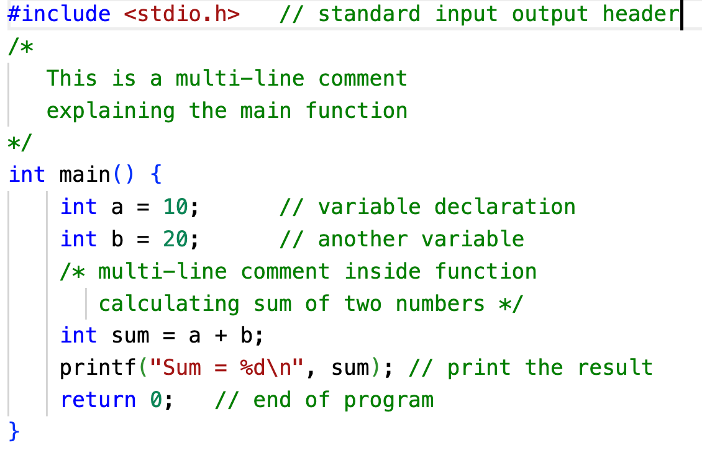
input.c:

Ouput:-

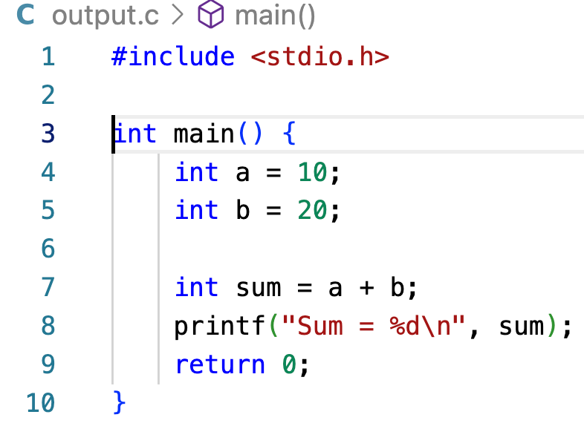
output.c:

Problem Statement 8: Design a LEX Code to extract all html tags in the HTML file given at run time and store into text file given at run time.

Code:
%{
#include <stdio.h>
%}

%%
"<"[^>]*">" {fprintf(yyout,"%s",yytext);}
[^<>\n] {;}
\n {fprintf(yyout,"\n");}
%%

int yywrap()
{
return 1;
}

int main()
{
extern FILE *yyin,*yyout;
yyin=fopen("Index.html","r");
yyout=fopen("Updated.html","w");
yylex();
}

Output:
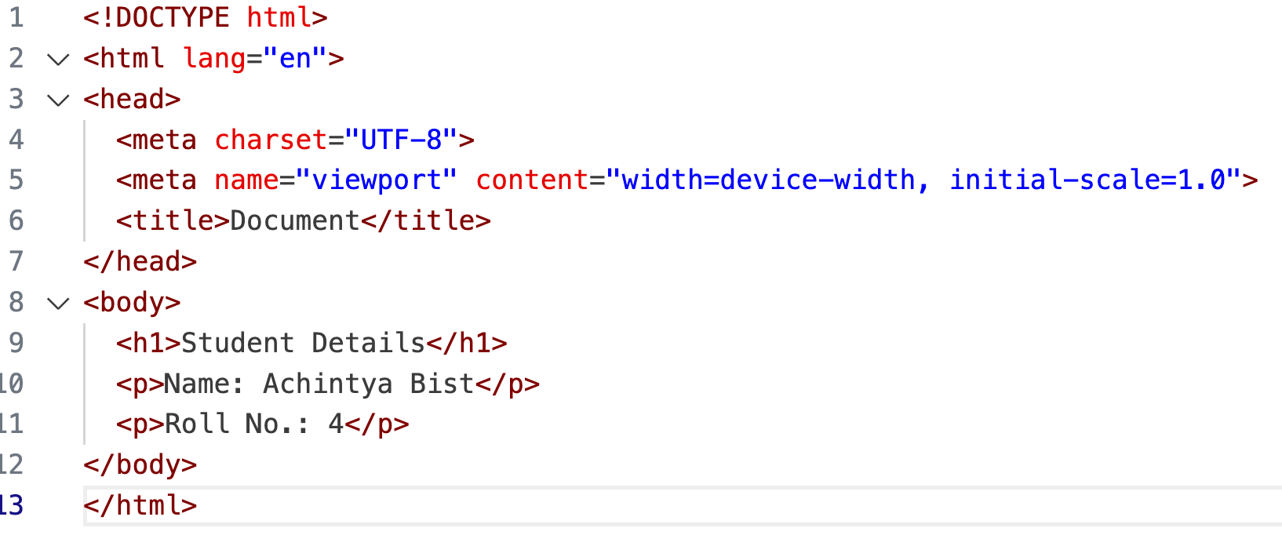
Input.html

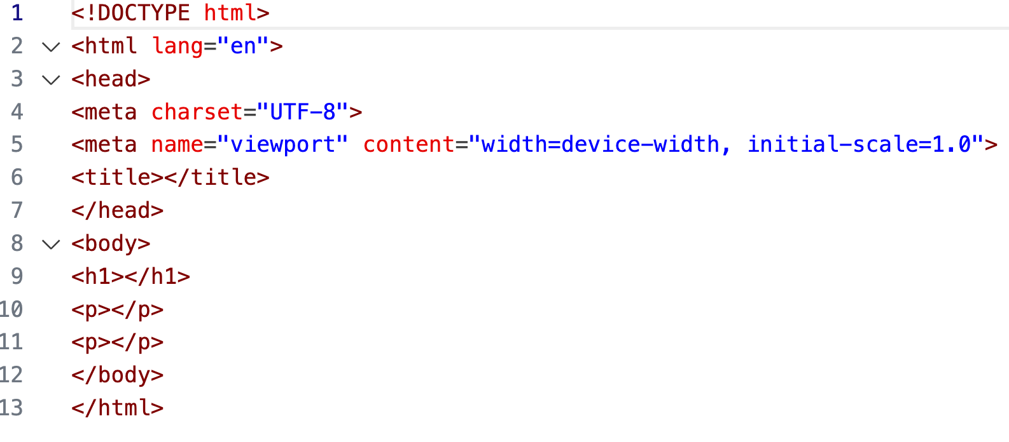
Output.html

Problem Statement 9: Design a DFA in LEX Code which accepts string containing even number of ‘a’ and even number of ‘b’ over the input alphabet {a, b}.

Code:
%{
#include<stdio.h>
%}
%s A B C DEAD

%%
<INITIAL>a BEGIN A;
<INITIAL>b BEGIN C;
<INITIAL>[^ab\n] BEGIN DEAD;
<INITIAL>\n {
BEGIN INITIAL;
printf("Accepted\n");
}

<A>a BEGIN INITIAL;
<A>b BEGIN B;
<A>[^ab\n] BEGIN DEAD;
<A>\n {
BEGIN INITIAL;
printf("Not Accepted\n");
}

<B>a BEGIN C;
<B>b BEGIN A;
<B>[^ab\n] BEGIN DEAD;
<B>\n {
BEGIN INITIAL;
printf("Not Accepted\n");
}

<C>a BEGIN B;
<C>b BEGIN INITIAL;
<C>[^ab\n] BEGIN DEAD;
<C>\n {
BEGIN INITIAL;
printf("Not Accepted\n");
}

<DEAD>a BEGIN DEAD;
<DEAD>b BEGIN DEAD;
<DEAD>[^ab\n] BEGIN DEAD;
<DEAD>\n {
BEGIN INITIAL;
printf("Not Valid\n");
}
%%

int yywrap(){
return 1;
}

int main(){
printf("Enter Input:\n");
yylex();
return 0;
}

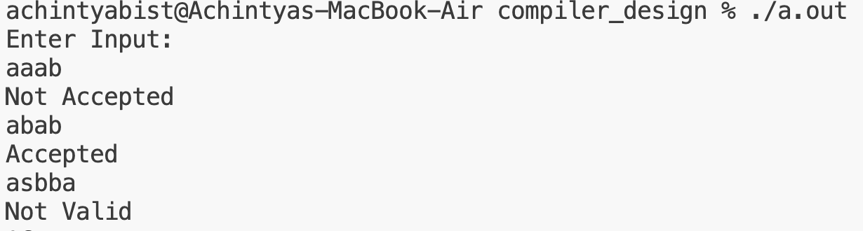
Output:

Problem Statement 10: Design a DFA in LEX Code which accepts string containing third last element ‘a’ over the input alphabet {a, b}.

