**Experiment no. 08**

**NAME: KARTIK RATHOD**

**BRANCH: COMPS DIV: 3 ROLL NO: 16**

|  |
| --- |
| Experiment No.8 |
| Implement Binary Search Tree ADT using Linked List. |
| Date of Performance: |
| Date of Submission: |

**Experiment No. 8: Binary Search Tree Operations**

**Aim :** Implementation of Binary Search Tree ADT using Linked List.

**Objective:**

1) Understand how to implement a BST using a predefined BST ADT.

2) Understand the method of counting the number of nodes of a binary tree.

**Theory:**

A binary tree is a finite set of elements that is either empty or partitioned into disjoint subsets. In other words node in a binary tree has at most two children and each child node is referred as left or right child.

Traversals in tree can be in one of the three ways : preorder, postorder, inorder.

Preorder Traversal

Here the following strategy is followed in sequence

1. Visit the root node R
2. Traverse the left subtree of R
3. Traverse the right sub tree of R

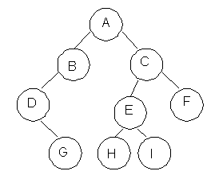

|  |  |
| --- | --- |
| **Description** | **Output** |
| Visit Root | A |
| Traverse left sub tree – step to B then D | ABD |
| Traverse right sub tree – step to G | ABDG |
| As left subtree is over. Visit root , which is already visited so go for right subtree | ABDGC |
| Traverse the left subtree | ABDGCEH |
| Traverse the right sub tree | ABDGCEHIF |

Inorder Traversal

Here the following strategy is followed in sequence

1. Traverse the left subtree of R
2. Visit the root node R
3. Traverse the right sub tree of R

|  |  |
| --- | --- |
| **Description** | **Output** |
| Start with root and traverse left sub tree from A-B-D | D |
| As D doesn’t have left child visit D and go for right subtree of D which is G so visit this. | DG |
| Backtrack to D and then to B and visit it. | DGB |
| Backtract to A and visit it | DGBA |
| Start with right sub tree from C-E-H and visit H | DGBAH |
| Now traverse through parent of H which is E and then I | DGBAHEI |
| Backtrack to C and visit it and then right subtree of E which is F | DGBAHEICF |

Postorder Traversal

Here the following strategy is followed in sequence

1. Traverse the left subtree of R
2. Traverse the right sub tree of R
3. Visit the root node R

|  |  |
| --- | --- |
| **Description** | **Output** |
| Start with left sub tree from A-B-D and then traverse right sub tree to get G | G |
| Now Backtrack to D and visit it then to B and visit it. | GD |
| Now as the left sub tree is over go for right sub tree | GDB |
| In right sub tree start with leftmost child to visit H followed by I | GDBHI |
| Visit its root as E and then go for right sibling of C as F | GDBHIEF |
| Traverse its root as C | GDBHIEFC |
| Finally a root of tree as A | GDBHIEFCA |

**Algorithm**

Algorithm: PREORDER(ROOT)

Input : Root is a pointer to root node of binary tree

Output : Visiting all the nodes in preorder fashion.

Description : Linked structure of binary tree

1. ptr=ROOT
2. if ptr!=NULL then

visit(ptr)

PREORDER(LSON(ptr))\

PREORDER(RSON(ptr))

End if

1. Stop

Algorithm: INORDER(ROOT)

Input : Root is a pointer to root node of binary tree

Output : Visiting all the nodes in inorder fashion.

Description : Linked structure of binary tree

1. ptr=ROOT
2. if ptr!=NULL then

INORDER (LSON(ptr))

visit(ptr)

INORDER (RSON(ptr))

End if

1. Stop

Algorithm: POSTORDER(ROOT)

Input : Root is a pointer to root node of binary tree

Output : Visiting all the nodes in postorder fashion.

Description : Linked structure of binary tree

1. ptr=ROOT
2. if ptr!=NULL then

PREORDER(LSON(ptr))

PREORDER(RSON(ptr))

visit(ptr)

End if

1. Stop

**Code:**

#include<stdio.h>

#include<stdlib.h>

#define MAX_SIZE 25

#define MAX(a, b) a>b ? a : b

struct TreeNode

{

int val;

struct TreeNode* left;

struct TreeNode* right;

};

struct TreeNode* root = NULL;

void insert(int);

void delete(int);

void exit(int);

int search(int);

struct TreeNode* queue[MAX_SIZE];

struct TreeNode* new_node = NULL;

struct TreeNode* queue[MAX_SIZE];

struct TreeNode* temp = NULL, *last_node = NULL, *key_node = NULL;

struct TreeNode* queue[MAX_SIZE];

int main()

{

int n, node_data;

char user_active = 'Y';

while(user_active == 'Y' || user_active == 'y')

{

printf("\n1. Insert\n2. Delete\n3. Search\n4. Exit ");

printf("\n\nEnter Your Choice: ");

scanf("%d", &n);

printf("\n");

switch(n)

{

case 1:

printf("Enter data for new node: ");

scanf("%d", &node_data);

insert(node_data);

break;

case 2:

printf("Enter node data: ");

scanf("%d", &node_data);

delete(node_data);

break;

case 3:

printf("Enter node data: ");

scanf("%d", &node_data);

search(node_data);

break;

case 4:

exit(n);

break;

default:

printf("Invalid choice");

}

}

return 0;

}

struct TreeNode* create(int data)

{

struct TreeNode* new_node = (struct TreeNode*) malloc (sizeof(struct TreeNode));

if(new_node == NULL)

{

printf("\nMemory can't be allocated for new node\n");

return NULL;

}

new_node->left = NULL;

new_node->right = NULL;

new_node->val = data;

return new_node;

}

void insert(int data)

{

int front = -1;

int rear = -1;

if(root == NULL)

{

struct TreeNode* new_node = create(data);

if(new_node)

{

root = new_node;

printf("\n * Node with data %d was inserted", data);

}

return;

}

queue[front+1] = root;

front = rear = 0;

while(front <= rear)

{

struct TreeNode* temp = queue[front];

front++;

if(temp->left != NULL)

{

queue[++rear] = temp->left;

}

else

{

new_node = create(data);

if(new_node)

{

temp->left = new_node;

printf("\n* Node with data %d was inserted", data);

}

return;

}

if(temp->right != NULL)

{

queue[++rear] = temp->right;

}

else

{

new_node = create(data);

if(new_node)

{

temp->right = new_node;

printf("\n* Node with data %d was inserted", data);

}

return;

}

}

}

void delete(int key)

{

int front = -1;

int rear = -1;

if(root == NULL)

{

return;

}

if(root->left == NULL && root->right == NULL)

{

if(root->val == key)

{

root = NULL;

printf("\n* Node with data %d was deleted", key);

return;

}

else

{

return;

}

}

queue[front + 1] = root;

front = rear = 0;

while (front <= rear)

{

temp = queue[front];

front++;

if (temp->val == key)

{

key_node = temp;

}

if (temp->left != NULL)

{

last_node = temp;

queue[++rear] = temp->left;

}

if (temp->right != NULL)

{

last_node = temp;

queue[++rear] = temp->right;

}

}

if (key_node != NULL)

{

key_node->val = temp->val;

if (last_node->right == temp)

{

last_node->right = NULL;

}

else

{

last_node->left = NULL;

}

printf("\n* Node with data %d was deleted", key);

free(temp);

return;

}

printf("\n* Node with data %d was not found", key);

}

int search(int key)

{

int front = -1;

int rear = -1;

int has_found;

if(has_found == -1) {

printf("\nNode was not found!");

} else {

printf("\nNode was found");

}

if (root == NULL)

{

return -1;

}

queue[front + 1] = root;

front = rear = 0;

while (front <= rear)

{

struct TreeNode* temp = queue[front];

front++;

if (temp->val == key)

{

return 1;

}

if (temp->left != NULL)

{

queue[++rear] = temp->left;

}

if (temp->right != NULL)

{

queue[++rear] = temp->right;

}

}

return -1;

}

**Output:**

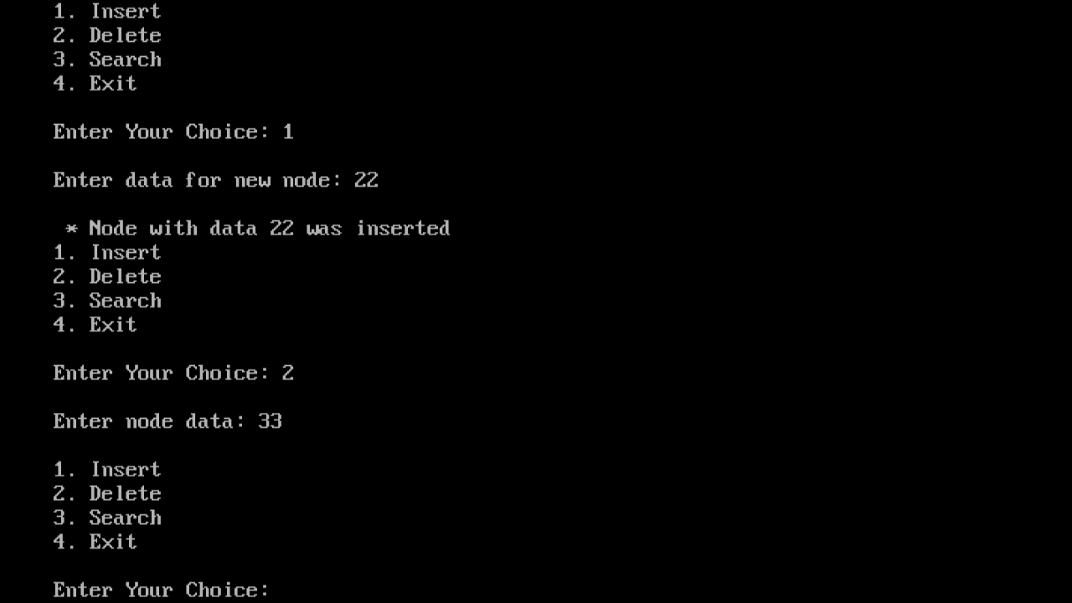

**Conclusion:** In conclusion, a BST with a linked list representation provides an elegant and effective solution for managing data in a hierarchical, sorted structure. It is a fundamental data structure used in various applications, such as databases, search engines, and symbol tables in computer science. Properly maintaining the BST's balance is essential for optimal performance, and it offers a powerful tool for organizing and managing data efficiently.