SYNOPSIS OF MINI PROJECT ON
“BOOK EXCHANGE SYSTEM”
Submitted In Partial Fulfillment Of The Requirements For The Award Of The Degree Of
BACHELOR OF TECHNOLOGY
In
COMPUTER SCIENCE & ENGINEERING
By
Kartik Sharma (2300680100148)
Himanshu Kumar (2300680100134)
Kapish Shanker (2300680100145)

Under Guidance of
Faculty Mentor Name

Navneet Gupta
Department of Computer Science & Engineering
Meerut Institute of Engineering and Technology, Meerut

Declaration

We hereby declare that the synopsis of the project entitled “Book Exchange System” to be submitted for the Degree of Bachelor of Technology in Computer Science and Engineering is our original work. The synopsis has not been submitted for the award of any degree, diploma, or fellowship of similar titles in previous work. It has not been submitted to any other University or Institution for the award of any degree or diploma.

Signature and detail of student
Kartik Sharma (2300680100148)
Himanshu Kumar (2300680100134)
Kapish Shanker (2300680100145)
Date: 03-12-2025

Table of Contents

S.NO | Chapter Name
1. | Introduction
2. | Problem Statement
3. | Objectives
4. | Proposed Solution
5. | Key Features
6. | System Architecture
7. | Methodology / Workflow
8. | Feasibility Study
9. | Expected Outcomes
10. | Impact
11. | Future Scope
12. | Conclusion
13. | Research and References

Introduction
Books are a vital source of knowledge, yet many students and readers face challenges in accessing the right books at the right time. High costs, limited availability, and lack of proper distribution often prevent learners from obtaining the resources they need. Traditional library systems or static book collections do not fully address the dynamic demand for exchanging and sharing books among peers. This results in wasted resources, duplication of purchases, and restricted access to diverse reading materials.
To overcome these challenges, a Book Exchange System provides an efficient and interactive platform for students and readers to share, borrow, and exchange books seamlessly. The system is designed to simplify the process of locating required books, connecting users with potential exchangers, and maintaining transparency in transactions. Through features such as user registration, book listing, search functionality, and request management, the platform ensures that books are utilized effectively rather than lying unused.
In today’s education-driven environment, where access to knowledge is crucial for academic success and personal growth, students need tools that make book sharing convenient and reliable. The Book Exchange System bridges this gap by offering a structured, real-time solution that enhances accessibility, reduces costs, and fosters a collaborative learning culture.

Problem Statement
.
- Students lack an affordable and convenient method to access academic books.
- No unified system exists for renting, buying, or exchanging books in an organized manner.
- Traditional libraries and bookshops fail to meet dynamic demand.
- High costs and duplication of purchases burden students financially.
- Lack of transparency and trust in informal book exchanges.

Objectives

- Provide a centralized book exchange platform.
- Reduce the cost of academic books through reuse.
- Enable book upload, search, renting, and buying.
- Promote sustainable practices by reducing duplication.
- Enhance accessibility and convenience for students.

Proposed Solution

A web-based system where users create accounts, upload books with images and details, and browse available options. The backend securely manages book, user, and transaction data.
The system will be a web-based platform where users can:
- Create accounts and manage profiles.
- Upload books with images, details, and availability status.
- Browse available books using search and filter options.
- Rent, borrow, or buy books at affordable rates.
- Track transactions securely through the backend.
Technologies: HTML, CSS, JavaScript (Frontend), Python/Flask (Backend), MySQL (Database).

Key Features
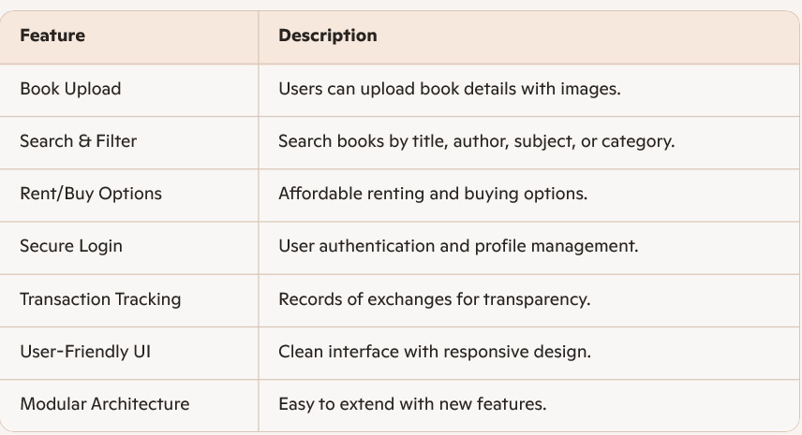

Methodology / Workflow

1. User registers/login.
2. Uploads book details.
3. System stores data.
4. Other users browse available books.
5. User selects rent/buy.
6. Transaction completes.

Workflow Diagram
START
↓
User Registers / Logs In
↓
Uploads Book Details
↓
System Stores Book Data
↓
Other Users Browse Books
↓
Rent / Buy Selected
↓
Confirmation & Completion
↓
END

Feasibility Study
- Technical Feasibility
  - React and JavaScript offer fast rendering and animation capabilities.
  - Tailwind CSS ensures consistent UI design.
  - Suitable for both desktop and mobile web environments.
- Operational Feasibility
  - Easy for students and teachers to use.
  - No installation required; works directly in browser.
- Financial Feasibility
  - Uses open-source technologies.
  - No additional infrastructure cost.

Expected Outcomes
- Affordable access to books.
- Increased reuse.
- Faster book availability.
- Reduced academic expense.

Impact
- Students: Affordable access to books, reduced expenses, faster availability, and collaborative learning.
- Institutions: Modern digital tool to support teaching and resource sharing.
- Community: Promotes reuse, sustainability, and wider knowledge sharing.
- Developers: Enhances technical skills and provides scope for future system expansion.

Conclusion

The Book Exchange System provides a practical and innovative solution to the challenges students face in accessing academic books. By offering a centralized digital platform for uploading, searching, renting, and exchanging books, it reduces costs, promotes reuse, and ensures timely availability of resources. The system not only supports academic excellence but also fosters a culture of collaboration and sustainability. With its user-friendly design and scope for future enhancements, the project has the potential to significantly improve the way educational resources are shared and utilized.

References
- Chat GTP
- Cursor
- Python/MySQL Docs
- HTML/CSS/JS Standard References

