
SESSION: 2025-26

MINI PROJECT REPORT
On
“Book Exchange Platform”

BACHELOR OF TECHNOLOGY IN COMPUTER
SCIENCE AND ENGINEERING
Submitted to-
(Mr. Navneet Gupta )
(Department of Computer Science & Engineering)
Submitted by-
Kartik Sharma (2300680100148)
Himanshu Kumar (2300680100134)
Kapish Shanker (2300680100145)

5th SEMESTER
DEPARTMENT OF COMPUTER
SCIENCE AND ENGINEERING
MEERUT INSTITUTE OF ENGINEERING AND TECHNOLOGY, MEERUT

DECLARATION

We hereby declare that the project entitled -“ Book Exchange Platform”, which is being submitted as Mini Project in department of Computer Science and engineering to Meerut Institute of Engineering and Technology, Meerut (U.P.) is an authentic record of our genuine work done under the guidance of Prof. “Mr. Navneet Gupta” of Computer Science and Engineering, Meerut Institute of Engineering and Technology, Meerut.

Date: 03/12/2025
Kartik Sharma (2300680100148)
Himanshu Kumar (2300680100134)
Kapish Shanker (2300680100145)

CERTIFICATE

This is to certify that Mini Project report titled – “Book Exchange Platform” submitted by Kartik Sharma (2300680100148), Himanshu Kumar (2300680100134), Kapish Shanker (2300680100145) has been carried out under the guidance of Assistant Professor Mr. Navneet Gupta Sir of "Computer Science & Engineering (CSE)", Meerut Institute of Engineering and Technology (MIET), Meerut. This project report is approved for Project/Mini Project in 5th Semester in CSE from Meerut Institute of Engineering and Technology, Meerut.

Supervisor Sign:
Supervisor Name: Mr. Navneet Gupta
Date: 03/12/2025

ACKNOWLEDGEMENT

I express my sincere indebtedness towards our guide Prof., “Mr. Navneet Gupta” of Computer Science and Engineering, Meerut Institute of Engineering and Technology, Meerut for his valuable suggestion, guidance and supervision throughout the work. Without his king patronage and guidance the project would not have taken shape. I would also like to express my gratitude and sincere regards for his kind approval of the project. Time to time counseling and advises.
I would also like to thank to our HoD Dr. (Prof.) “Vikas Shrivastava”, Department of Computer Science and engineering, Meerut Institute of Engineering and Technology, Meerut for his expert advice and counseling from time to time.
I owe sincere thanks to all the faculty members in the department of Computer Science and engineering for their kind guidance and encouragement time to time.

Date: 03/12/2024

Kartik Sharma (2300680100148)
Himanshu Kumar (2300680100134)
Kapish Shanker (2300680100145)

Table of contents
Description page no.
Declaration i
Certificate ii
Acknowledgement iii

Chapter 1 Introduction
Chapter 2 System Design
(Work flow/flow chart/DFD/ working principle/ constructional details of individual componenets)
Chapter 3 Technology Bucket
3.1 Description of HTML
3.2 Description of CSS
3.3 Description of Java Script
3.4 Description of Python
3.5 Description of Mysql
Chapter 4 Output screens
Appendices Implementation code
References

CHAPTER : 1
Book Exchange Platform – Project Introduction

The Book Exchange Platform is a user-friendly web application designed to simplify the process of sharing, renting, and buying books within a community. The platform connects readers who wish to exchange their books with others, helping reduce costs while promoting sustainable reading habits. Users can create an account, upload books by providing details such as title, author, description, and pricing for both rent and purchase. Images of books can also be uploaded to improve listing clarity.

Once uploaded, books are displayed in a clean and interactive interface where others can browse available listings. Each book card shows essential details along with options to rent or buy. Clicking these options reveals the book owner's contact details, including name, mobile number, and system-generated address information, ensuring smooth communication.

On the backend, MySQL is used to securely store book and user information, while the frontend relies on HTML, CSS, and JavaScript for an engaging user experience. The platform is built with scalability in mind, making it suitable for college campuses, local reading groups, or public communities.

This project ultimately aims to encourage reading, reduce book wastage, and foster a collaborative sharing culture.

FEATURES :
1. User-friendly Book Upload System
- Users can upload books with details like title, author,
description,rent price, buy price, and book image.
- Information is securely stored in MySQL.
2. Dynamic Book Listing
- All uploaded books are displayed in a clean grid layout.
- Each book card shows:
- Book image
- Title
- Author
- Description
- Rent & Buy options with prices
3. Rent & Buy Functionality
- Clicking Rent or Buy opens a modal showing:
- Owner’s name
- Mobile number (from MySQL)
- System-generated address & pincode
- Selected price
4. Responsive UI
- Built using HTML, CSS, and JavaScript.
- Works smoothly on different screen sizes.
5. Automatic Address Generator
- Each book listing is assigned a random address and pincode for demo purposes.
6. Backend Integration
- Secure data storage using MySQL database.
- Backend API handles fetching uploaded books.
7. Scalable & Community-Oriented
- Suitable for colleges, hostels, book clubs, and community groups.
- Promotes book sharing and reduces waste.

CHAPTER :2
SYSTEM DESIGN
FLOW CHART:

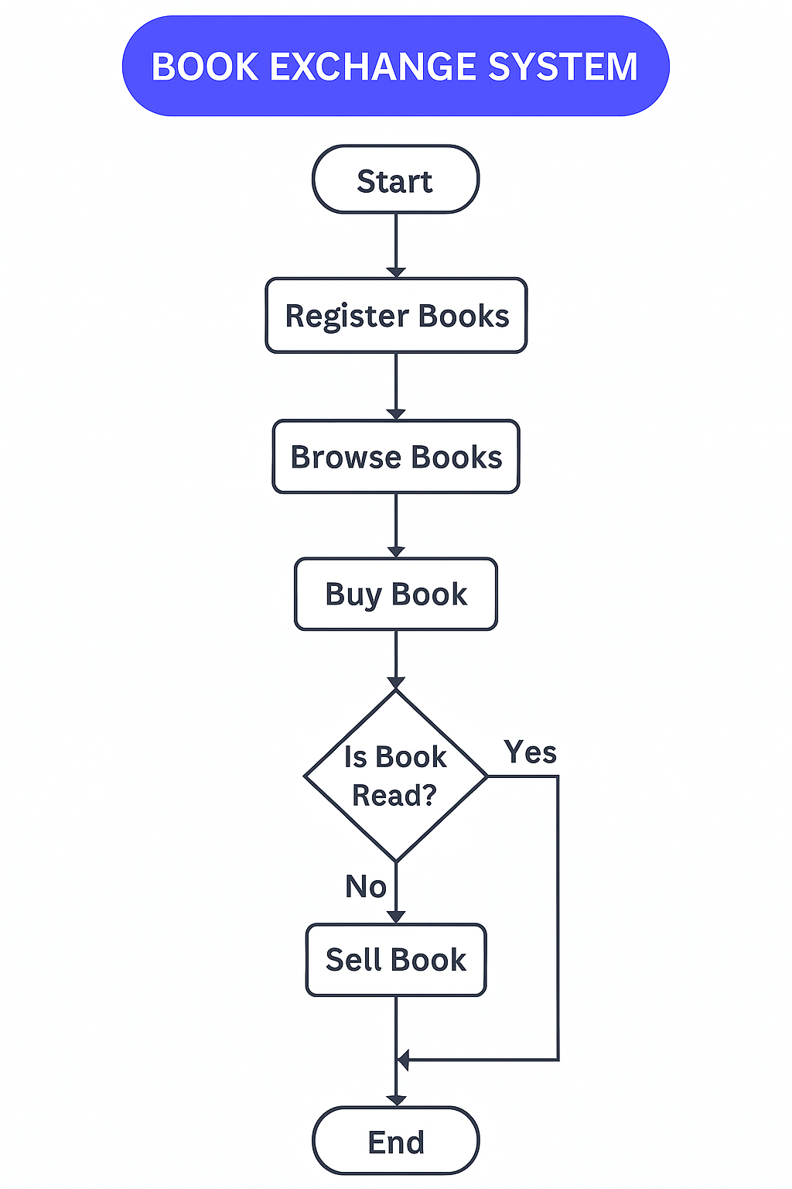

Architecture Overview:

Presentation Layer:
This layer represents the user interface, developed using HTML, CSS, and JavaScript. It is responsible for displaying weather data, user inputs, and interactive elements. Responsive design principles ensure compatibility across devices like smartphones, tablets, and desktops.

Application Layer:
This layer handles the app’s functionality, ensuring dynamic updates and real-time interactions. JavaScript plays a critical role here, managing features like data retrieval, processing, and user-triggered actions.

Data Layer:
This layer retrieves weather data from external APIs and organizes it for user-friendly presentation. JavaScript fetches and processes the data, ensuring accuracy and relevance.

System Features :

Real-Time Updates:
HTML structures the content, CSS styles the presentation, and JavaScript ensures realtime updates.

Dynamic Backgrounds:
CSS and JavaScript work together to implement interactive visuals based on current weather conditions.

Responsive Design:
HTML and CSS ensure seamless adaptability across different devices and screen sizes.

CHAPTER :3
Technologies Used

1. HTML (HyperText Markup Language)
HTML is used to create the structure of all web pages in the platform. It defines the layout of elements such as forms, buttons, book cards, images, and navigation menus. HTML ensures that content is properly organized and displayed in the browser.
2. CSS (Cascading Style Sheets)
CSS is used to design the appearance and styling of the platform. It handles fonts, colors, spacing, animations, layouts, and responsive design. CSS makes the book exchange platform look clean, attractive, and user-friendly.
3. JavaScript
JavaScript adds interactivity to the website. It is used for:
- Form validations
- Dynamic book card loading
- Handling button clicks
- Updating content without refreshing the page
- Improving overall user experience

4. Python
Python is used as the backend language to handle the server-side logic of the project. It manages:
- Storing user details
- Uploading book data
- Processing requests
- Communicating with the MySQL database
- Backend APIs for adding, updating, and retrieving book information
Python frameworks (like Flask/Django) can be used to build routes and APIs for the platform.
5. MySQL
MySQL serves as the database of the project. It stores:
- User information
- Book details
- Book images (paths)
- Rent price, buy price
- Upload history
- Transactions or exchange records

CHAPTER : 4
OUTPUT SCREEN
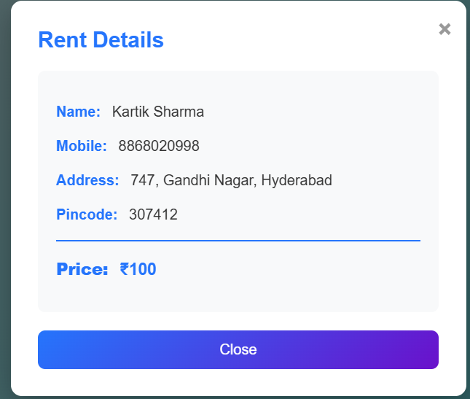
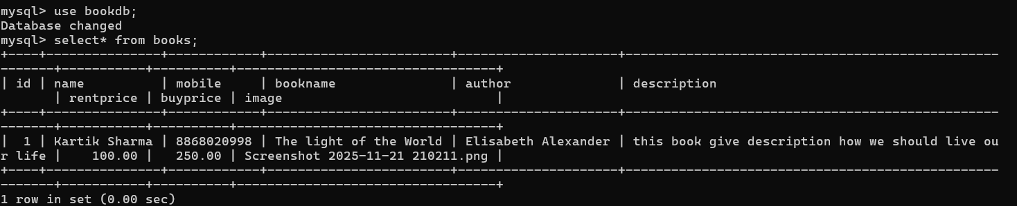

CONCLUSION:
The Book Exchange Platform project has proven to be a valuable tool for job seekers across various industries. By leveraging modern technologies and intuitive design, it simplifies the resume creation process, making it accessible and efficient for users at all levels of their careers. The result is a modern, versatile tool that stands as a model for how effective web technologies can be used to create dynamic, interactive applications.

REFERENCES:
1.Youtube
2. Cursor
3.VS Code editor
4.Git Hub
5.Chat gtp

