1. **Day - 1**
   1. **Video Tutorials for AngularJs**

[**http://redmine.zeuslearning.mumbai/projects/angularjs/files**](http://redmine.zeuslearning.mumbai/projects/angularjs/files)

Go to Run and Open following path:   
 **\\192.168.2.21\shared\Video Tutorials\AngularJS**

* 1. How to create angular application?

1. **Day - 2**
   1. What is modules, controllers, directives, filters?
   2. What is $scope,$rootScope?
   3. Data Binding? And how data binding works ?

**Task -**

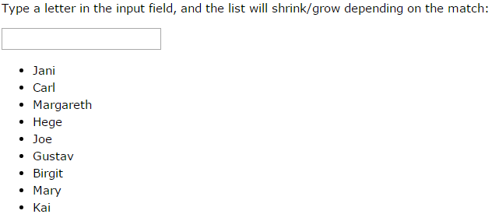

1. **Day - 3** 
   1. $http , $location, $interval, $timeout
   2. What is factory, service and provider? Difference between them?
   3. Event binding?

**Task** -

Write a program that will fetch data from following location “<http://www.w3schools.com/angular/customers.php>” and display that data in table

1. Write a program to validate form

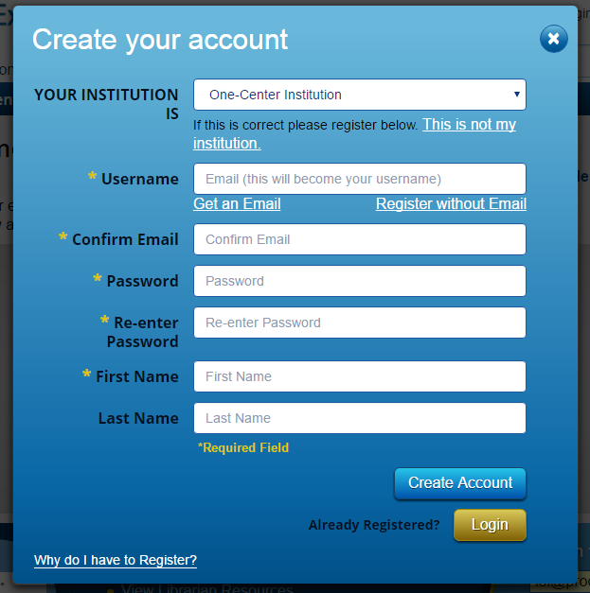

1. Create a shopping cart in that we can Add or Remove items. Also add validation for same item name

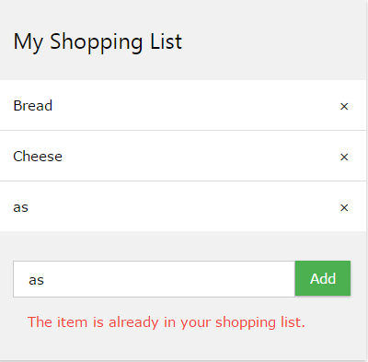

1. Create a HTML page that will contain above links to the above tasks. On click of any link open respective task on the new URL(Task URL). Also add BACK button to your tasks that will take you to the Home page(/Home). (Reuse above Tasks)