Project Blueprint
1. Project Title & Objective
Project Title:
HomePilot AI
Objective:
HomePilot AI is an intelligent home assistance application that helps users identify common household problems, estimate repair costs, and discover reliable nearby service professionals using Artificial Intelligence and location-based recommendations. The goal is to reduce the time, uncertainty, and risk involved in finding trustworthy repair services.

2. Target Audience
- Homeowners
- Tenants and renters
- Hostel and PG residents
- Families
- General public requiring home maintenance services

3. Core Features
1. AI Problem Diagnosis
Users can describe a household issue (e.g., "My AC is not cooling") and receive AI-generated possible causes, urgency level, and suggested solutions.
2. Repair Cost Estimation
The application provides an approximate repair cost range based on the detected issue to help users avoid overcharging.
3. Nearby Trusted Service Providers
Using location services and Google Maps integration, the application recommends nearby electricians, plumbers, appliance repair technicians, and other professionals who have previously fixed the specific problem or similar problems.
4. Search History & Saved Professionals
Users can revisit previous diagnoses and bookmark trusted professionals for future use.

4. App Flow (User Navigation)
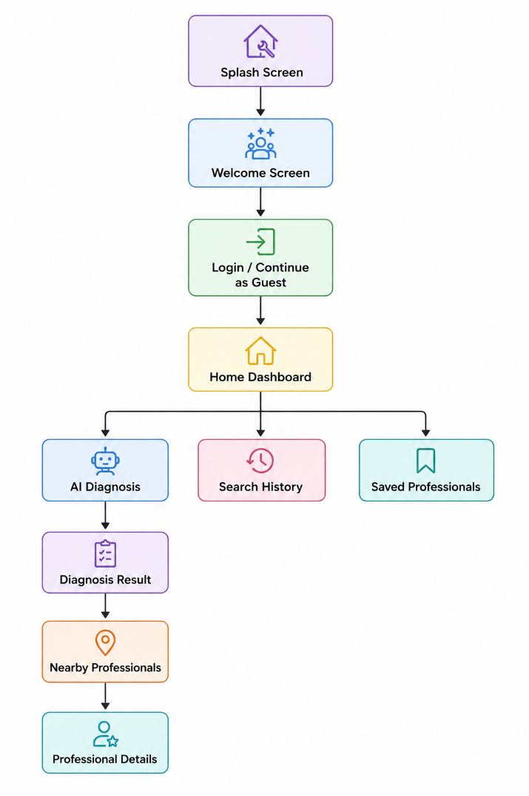

5. UI Wireframe Sketches
Screen 1 – Welcome / Home Screen
Contents:
- App Logo
- Greeting
- Search box:
"Describe your home problem..."
- Voice Input Button
- Recent Searches

Screen 2 – AI Diagnosis Screen
Contents:
- User problem
- AI Diagnosis
- Possible Causes
- Urgency Level
- Estimated Repair Cost
- "Find Nearby Professionals" button

Screen 3 – Nearby Professionals Screen
Contents:
- Google Map
- List of nearby technicians
- Rating
- Trust Score
- Distance
- Contact Button

Screen 4 – Professional Details Screen
Contents:
- Business Name
- Contact Information
- AI Trust Score (based on the number of times the professional has dealt with such issues)
- Google Rating
- Review Summary
- Save Professional Button

