DELOITTE Techno Utsav

Round 2.3: Working Prototype
Team: CGC_Symbiotes

Kartik Chawla
Bhavya Jain
Manik Nagpal

Theme Alignment: Internet of Things
Industry Alignment: Life Sciences and Health Care

Patient Surveillance

Heart:
The heart is the main organ within the human body, which responsible for pumping blood throughout the body. It is located in the middle of the thorax, slightly offset to the left and surrounded by the lungs. The heart is made up of two separate pumps: a right heart that pumps blood through the lungs, and a left heart that pumps blood through the peripheral organs as shown in Figure 2.1. At the same time, each of these hearts is a pulsatile two chamber pump composed of an atrium and a ventricle. Each atrium is a pump helps in moving blood into the ventricle. Then the ventricles supply the main pumping force that propels the blood either through the pulmonary circulation by the right ventricle or through the peripheral circulation by the left ventricle. That blood passes through the right ventricle and is pumped to the lungs where it is oxygenated and goes back to the heart through the left atrium, and then the blood passes through the left ventricle and is pumped again to be distributed to the entire body through. The heart also consists of three major types of cardiac muscle: atrial muscle, ventricular muscle, and specialized excitatory and conductive muscle fibers. The atrial and ventricular types of differ from the specialized excitatory muscles in the method of contraction. The latter muscles exhibit either automatic rhythmical electrical discharge or conduction of the action potentials through the heart, providing an excitatory system that controls the rhythmical beating of the heart. The cardiac events that occur from the beginning of one heartbeat to the beginning of the next are called the cardiac cycle.
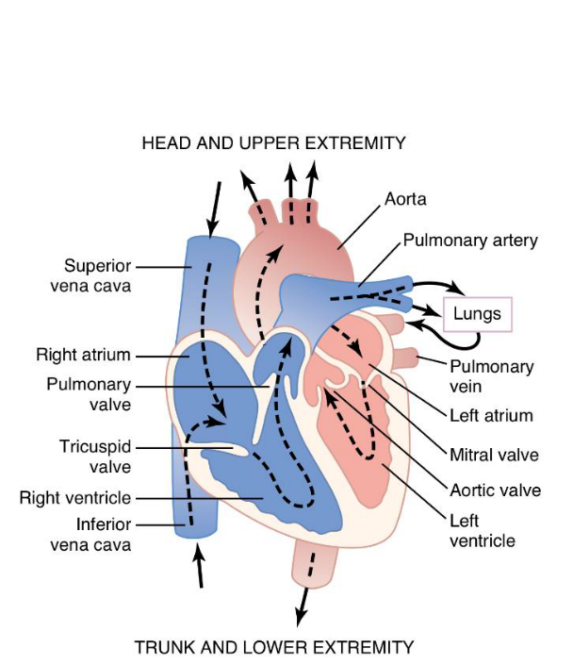

Heart Rate:
HR is the rate at which the heart beats and affected by the expansion of the arterial wall with each every beat. The most prominent areas for the pulses are wrist (Radial artery), neck (Carotid-artery), inside of the elbow (Brachial artery), behind the knee (Popliteal artery) and ankle joint (Posterior artery).
The HR changes according to age and the physical and psychological impacts on the body. Higher pulse rate indicates the presence of abnormality in the body which can also be caused by other reasons such as anxiety, anger, excitement, emotion, and heart disorders. The pulse rate of an individual can help in determining various problems within the body, but it cannot be used lone to diagnose an abnormality.
The average heart rate is about 72 bpm for sedentary males and 80 bpm for sedentary females but these rates are often significantly different for trained athletes.
Heart Rate Monitors:
Many heart monitoring devices ensure a more accurate measure of heart rate than manual methods. In most physical training situations they are the preferred method. These devices advantages:
1. Far more accurate than finger tests.
2. Give continuous and real-time readings that can be viewed via digital display.
3. When the heart rate is measured a simple formula can be used to work out whether the individual is training at the right intensity:
220 - Age = Maximum Heart Rate
4. Small and lightweight to carry. Some can be programmed to sound an alarm or warning when set heart rate ranges are breached.

2.3. Electrocardiograph:
Electrical current flows from the heart and a small fraction of it makes it way to the body surface as the cardiac impulse go through the heart. Electrocardiograph or ECG for short detects and records these electrical signals that are responsible for pumping blood by the heart all around the body.
A normal electrocardiogram is shown in Figure
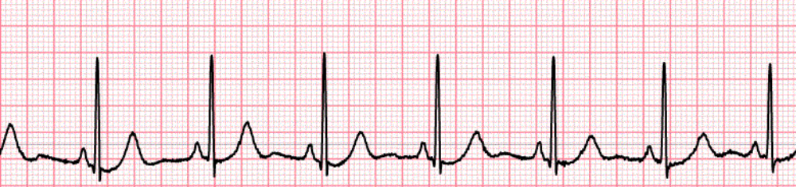
NORMAL ECG MACHINE
2.4. Photoplethysmograph:
The PPG is a low-cost and portable technique that for measuring blood volume changes by collecting the variations in reflected or transmitted light. The blood pressure, blood oxygen saturation, HR, cardiac output recently and information of the cardiovascular system can be supplied with this technique. PPG experiences developments continuously, some researchers have used digital cameras and others a smart phone to detect HR by PPG technique.
However, overcoming the motion artifact is a huge challenge for PPG as it is sensitive it. Adaptive noise cancellation (ANC), which uses accelerometers as a noise reference, is proposed in order to help in reducing the affection of motion artifact.

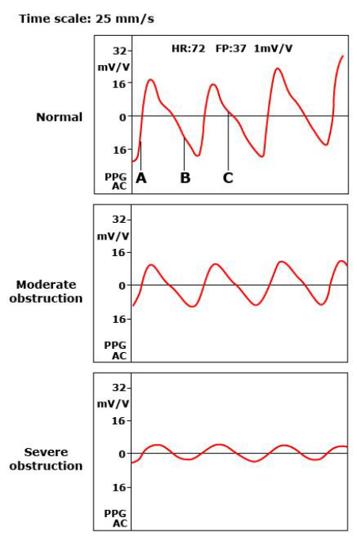
PPG of Different conditions

Detailed Level 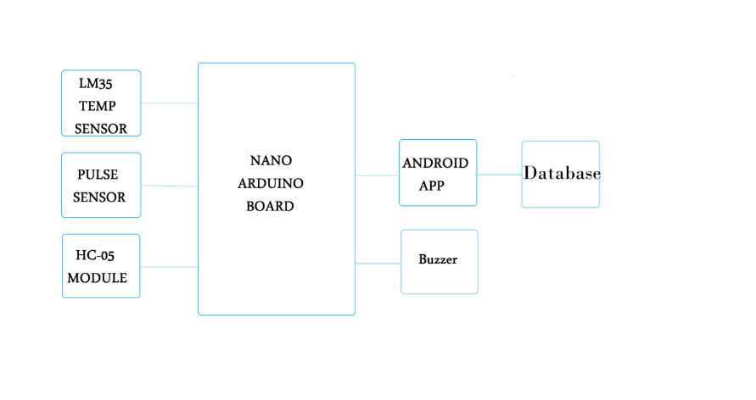
Project Design:
If we consider the project as a system containing several parts, the proposed system can be divided into two main units, the hardware and the software units.
For further simplification, each one of these units is classified into categories based on their functions as illustrated in Figure 3.3.
Figure Project’s system classification of units.
Hardware Design:
Hardware of this project can be considered as integration of three units: the data acquisition, the MCU, communication and alarm unit.
Data Acquisition Unit:
This unit is mainly responsible for obtaining patient’s vital parameters utilizing sensors.

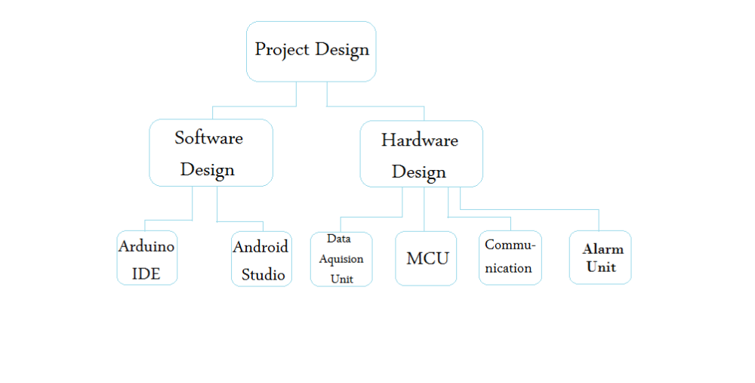
Sensors are devices that detect the variations and mainly are two types of them, Optical and solid state sensors. Optical sensors are while solid state sensors are
The two sensors used here are pulse sensor and the temperature sensor.
a. Pulse sensor:
It is an Open Source heart rate monitor which considered as a PPG device used to monitor the non-invasive heart rate. It measures the real-time heart beats and calculates BPM with the aid of algorithms implemented by Arduino.
This sensor has two sides, the front one which has a heart shape is the side to be attached to the skin. The pins of the pulse sensors are three as shown in Figure below.
If the frond side is facing you, then the most left pin is the GND while the middle one is the input voltage which will be connected to the +5v of the Arduino. The last one for outputting the electrical and will be wired with the analog bins of the Arduino.

Figure Pulse Sensor
The Pulse sensor converts the physical PPG into electrical signals. The sensor outputs a raw signal of analog voltage fluctuations, amplifies it and normalize the wave at V/2.
With every beat of the heart, a pulse wave travel along all arteries to the tissues where the Pulse
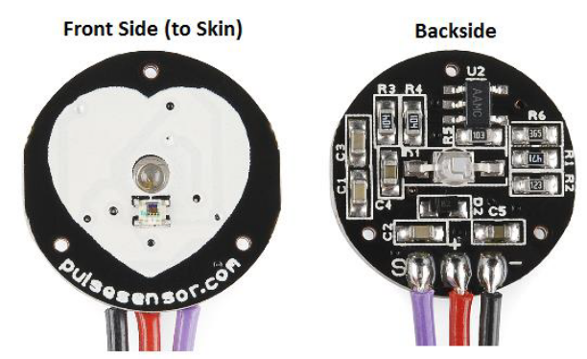
Microcontroller (MCU):
The filtration of the measured signals, apply calculation on it and prepare it for transmission to the next unit mainly done by the microcontroller unit.
In this project, the microcontroller chosen is a Nano Arduino board which is based on ATMEGA328 controller.
Nano Arduino is a small and complete board with the same functionality of Arduino Duemilanove just in different package. The only difference is that Nano Arduino doesn’t have a power jack instead it works with mini-B USB.
It fits perfectly for this project as it’s easy to use as well as it provides mobility feature due to its suitable size for a wearable device. Furthermore its ability to communicate with android applications via Bluetooth module as it supports serial port Bluetooth communication.
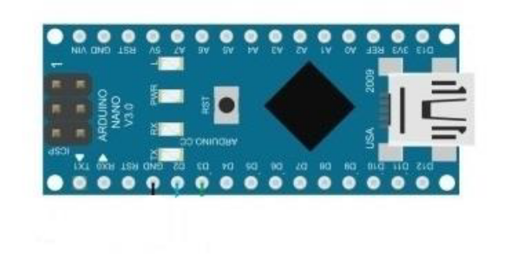 NANO ARDUINO

Software Design:
Several software tools were used throughout the entire development procedures of this project in order to program the Arduino board which is considered the core of this project besides developing the android application which will detect and alert when suspecting a heart attack.
Arduino IDE:
Is the required software environment to program the Arduino by writing a code and upload it to the Arduino. It also outputs the results for analysis using both serial monitor and serial plotter. The version used in this project is 1.8.3 (Genuino) which supports both serial monitor to print the HR wave while the serial monitor to print the temperature values.
The Arduino IDE used to write a code to the Nano Adruino that has three main functions. These functions are: measuring BPM, measuring body temperature, sending measured data and alert when detect an abnormality.
Measuring BPM:
The algorithm for measuring BPM and IBI is:
1. Initialize Arduino configurations.
-Baud Rate = 9600.
2. Apply input signals to A1.
3. Obtain data from reading A1.
4. Perform Calculations on the data.
5. Print it to the Serial Plotter.
6. Wait 1000ms until the next reading.
7. Repeat from step 3.

Hardware Implementation:
Is done to test the overall system functionalities, the hardware is implemented as it was discussed throughout this chapters with aid of figures including all components.
