**ECE 1004 : SIGNALS AND SYSTEMS**

**BINARY AMPLITUDE SHIFT KEYING**

by

|  |  |
| --- | --- |
| **NIKKI VERMA** | **17BLC1138** |
|  |  |
| **NILESH MATHUR** | **17BLC1186** |
| **KARTIK JOSHI** | **17BLC1187** |
|  |  |
|  |  |
|  |  |
|  |  |
|  |  |

A project report submitted to

**Prof.S.Revathi**

School of Electronics Engineering

in partial fulfillment of the requirements for the course of

**ECE1004 SIGNALS AND SYSTEMS**

**in**

**B.Tech(Electronics and Computer Engineering)**



**April 2018**

**Content page**

|  |  |  |
| --- | --- | --- |
| S.No | Content | Page No. |
| 1. | Abstract | 5 |
| 2. | Introduction | 6 |
| 3. | MATLAB Code to find the properties of the systems | 7 |
| 4. | Results of the properties of the systems | 9 |
| 5. | MATLAB CODE for Input and output in time domain and frequency domain | 14 |
| 6. | Results of time domain and frequency domain of input and output | 15 |
| 7. | Impulse response and frequency response of the systems | 16 |

**CERTIFICATE**

This is to certify that the Project work entitled **BINARY AMPLITUDE SHIFT KEYING** that is being submitted by **Nikki Verma(17BLC1138) , Nilesh Mathur(17BLC1186) , Kartik Joshi (17BLC1187**) for CAL in B.Tech Signals And Systems(ECE1004) is a record of bonafide work done under my supervision. The contents of this Project work have not been submitted for any other CAL course.

Place: Chennai

Date: March 29, 2018

Group Members:

NIKKI VERMA (17BLC1138)

NILESH MATHUR(17BLC1186)

KARTIK JOSHI(17BLC1187)

Submitted To:

REVATHI S

# 

# ACKNOWLEDGEMENT

In performing our project, we had to take the help and guideline of some respected persons, who deserve our greatest gratitude. We would like to show our gratitude to Revathi S Mam as well as to VIT University for giving us guideline for the project throughout numerous consultations. We thank VIT University for providing us with this excellent opportunity to conduct a project in this course

**ABSTRACT**

1. Initially we describe the system which is a day-to-day application of the Signals and systems concepts and mention what the inputs and outputs of the system is.
2. Next, we describe what are the different stages the input undergoes and what changes undergo the raw input data till the output stage is reached.
3. Binary amplitude shift keying (BASK) is one of the methods to squeeze more bits into each pulse of a signal transmission.
4. ASK is used almost in every digital communication link including your cell phone and cable TV. The In most wireless links such as satellite TV and high definition TV broadcast channels uses two ASK links in parallel, each of 16-levels, but rotated in phase 90 degrees, thus the 16x16 combination is known as 256 QAM. 4x4 or 64 QAM is also popular. In fiber optics it is quite common to ignore phase and use only one ASK channel .

**INTRODUCTION**

Binary Amplitude Shift Keying is a form of amplitude modulation that represents digital data as variations in the amplitude of a carrier wave. In an BASK system, the binary symbol 1 is represented by transmitting a fixed-amplitude carrier wave and fixed frequency for a bit duration

of T seconds. If the signal value is 1 then the carrier signal will be transmitted; otherwise, a signal value of 0 will be transmitted.

Any digital modulation scheme uses a finite number of distinct signals to represent digital data. ASK uses a finite number of amplitudes, each assigned a unique pattern of binary digits. Usually, each amplitude encodes an equal number of bits. Each pattern of bits forms the symbol that is represented by the particular amplitude. The demodulator, which is designed specifically for the symbol-set used by the modulator, determines the amplitude of the received signal and maps it back to the symbol it represents, thus recovering the original data. Frequency and phase of the carrier are kept constant.

**MATLAB CODE TO FIND PROPERTIES OF THE SYSTEM**

clc;

clear all;

close all;

%GENERATE CARRIER SIGNAL

Tb=1; fc=10;

t=0:Tb/100:1;

c=sqrt(2/Tb)*sin(2*pi*fc*t);

%generate message signal

N=6;

m=[1 0 1 1 0 1];

t1=0;t2=Tb

for i=1:N

t=[t1:.01:t2]

if m(i)>0.5

m(i)=1;

m_s=ones(1,length(t));

else

m(i)=0;

m_s=zeros(1,length(t));

end

message(i,:)=m_s;

%product of carrier and message

ask_sig(i,:)=c.*m_s;

t1=t1+(Tb+.01);

t2=t2+(Tb+.01);

%plot the message and ASK signal

subplot(5,1,2);axis([0 N -2 2]);plot(t,message(i,:),'r');

title('message signal');xlabel('t--->');ylabel('m(t)');grid on

hold on

subplot(5,1,4);plot(t,ask_sig(i,:));

title('ASK signal');xlabel('t--->');ylabel('s(t)');grid on

hold on

end

hold off

%Plot the carrier signal and input binary data

subplot(5,1,3);plot(t,c);

title('carrier signal');xlabel('t--->');ylabel('c(t)');grid on

subplot(5,1,1);stem(m);

title('binary data bits');xlabel('n--->');ylabel('b(n)');grid on

2

% ASK Demodulation

t1=0;t2=Tb

for i=1:N

t=[t1:Tb/100:t2]

%correlator

x=sum(c.*ask_sig(i,:));

%decision device

if x>0

demod(i)=1;

else

demod(i)=0;

end

t1=t1+(Tb+.01);

t2=t2+(Tb+.01);

end

%plot demodulated binary data bits

subplot(5,1,5);stem(demod);

title('ASK demodulated signal'); xlabel('n--->');ylabel('b(n)');grid on

**OUTPUT GRAPH**

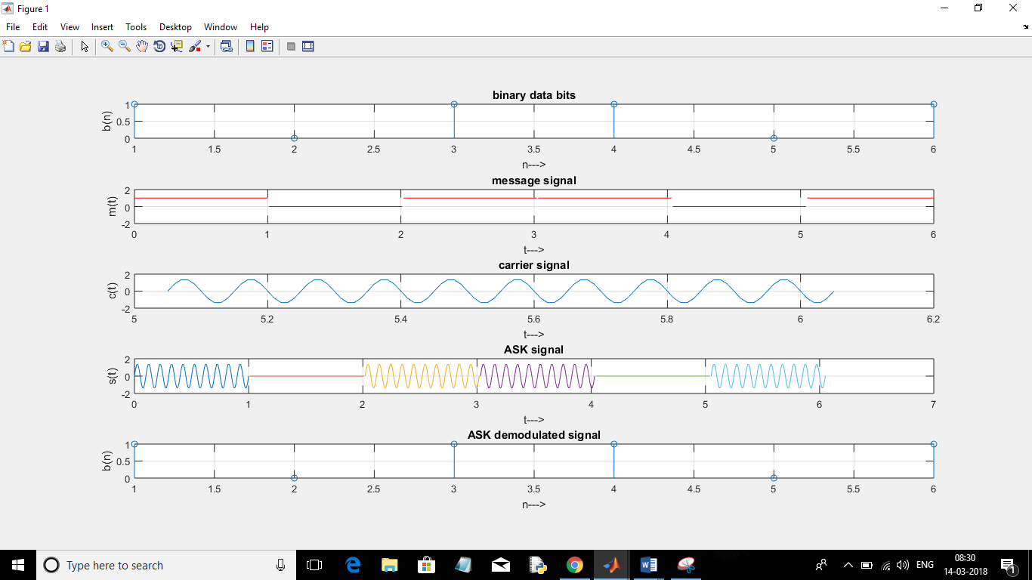

**PROVING PROPERTIES**

1. **Linearity –**

Input : m=[1 0 1 1 0 1]

**Output graph –**



Input 2:

m=[1 0 0 1 0 0 ]

**Output Graph –**

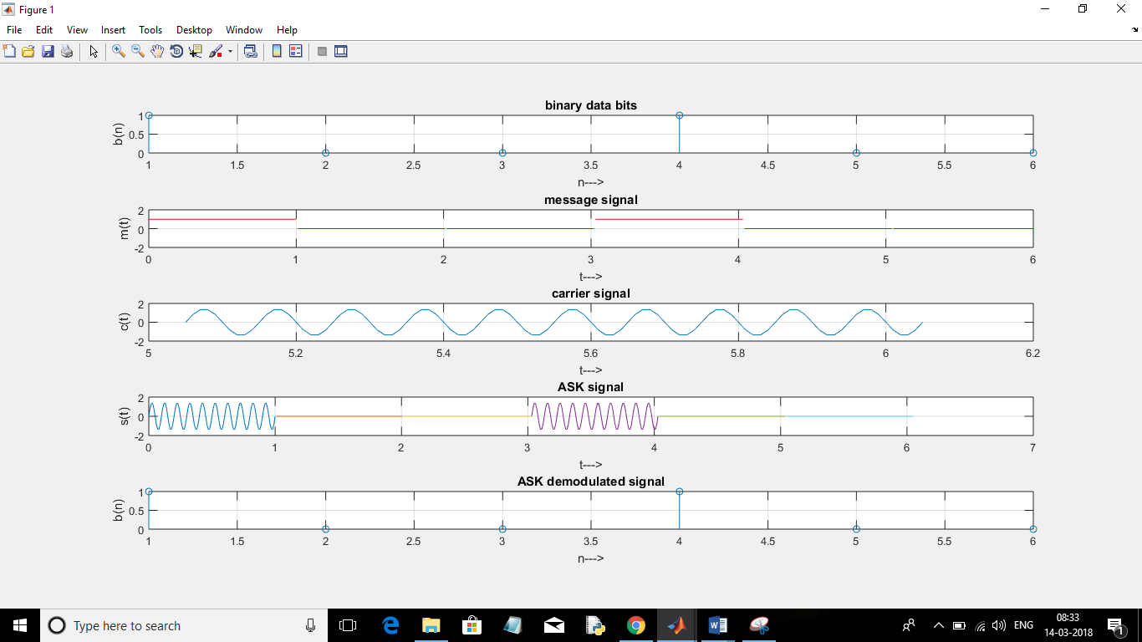

Input 3 = {Input 1 + Input 2}

m=[1 0 1 1 0 1]

**Output Graph –**



Since the modulated signal graph of third message signal is the graph so obtained by superimposing the output graph of message signal 1 and message signal 2 hence the given system is linear.

1. **Time Invariance -**

On Shifting the input by ‘k’ units (here 2) , the output also is getting shifted by ‘k’ units. Hence the system is Time Invariant.

**Output Graph –**

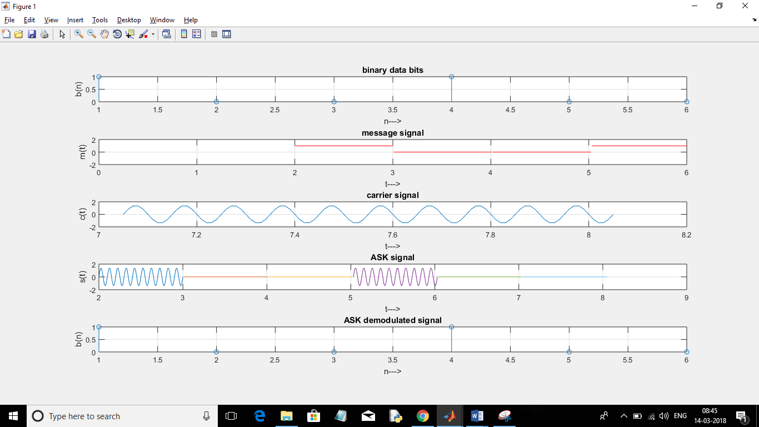

1. **Memory/Memory Less:**

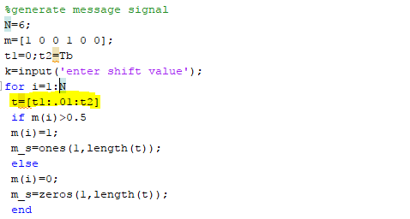

Note that the value of modulated signal is depending only on the present value of the message signal, the system is Memory Less.

**Causal –**

Since all Memory-less system are causal in nature, and Binary ASK system being memory-less (as explained above) is Causal in nature.

1. **Invertible -**

For unique message signal, we get unique modulated signal, hence the system is invertible

**RESULTS OF TIME DOMAIN AND FREQUENCY DOMAIN OF INPUT AND OUTPUT**

Matlab code for Fourier Transforms is-

w=1/fc;

j=sqrt(-1);

k=1;

for i=1:length(m)

X(i)=m(i)*exp((-j*w*k));

end

tt=1:8;

disp(X);

subplot(7,1,6);plot(tt,X);

for i=1:length(ask_sig)

v(i)=ask_sig(i)*exp((-j*w*k));

end

Y=sum(v);

disp(Y);

By combining this with the above code,we get following output-

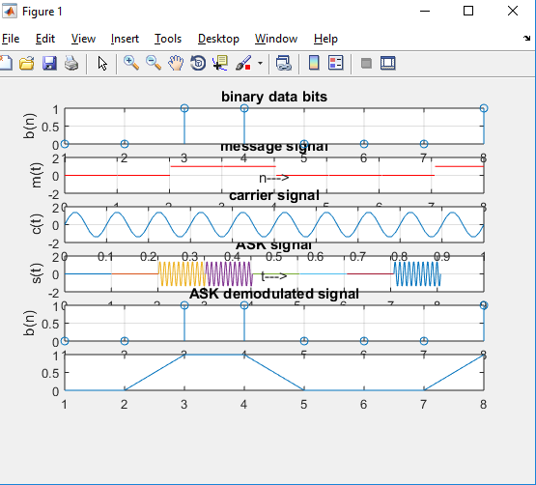

**IMPULSE RESPONSE AND FREQUENCY RESPONSE OF THE SYSTEMS**

Matlab code for impulse response and frequency response is-

for i=1:length(ask_sig)

v(i)=ask_sig(i)*exp((-j*w*k));

end

Y=sum(v);

disp(Y);

By combining this with above code,we get following output-



**INDUSTRIAL APPLICATIONS**

*Till now, the modulation techniques were used for analog signal, but now the modulation techniques we will discuss are used in digital signal modulation. First is ASK, it is very much similar to AM, in which Amplitude of the carrier is varied in proportional to the digital base band signal. As digital signal is a binary signal, so we will have only 2 different amplitude value in ASK. ASK modulation is shown below.*

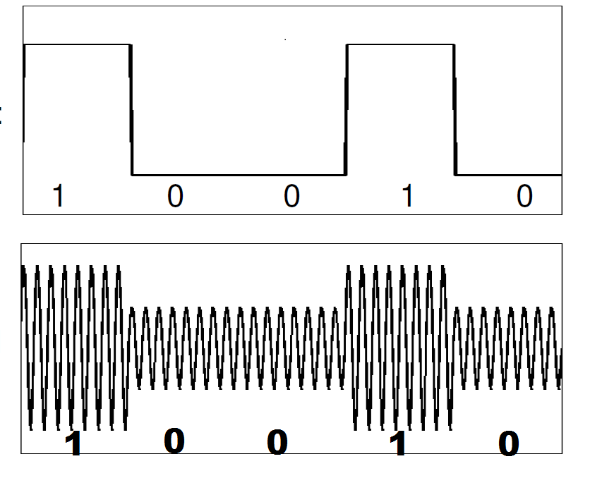

**APPLICATIONS**

1. ASK Modulation is used in **RF Modules**. I have used this module many time for making wireless robo car. We need to attach Encoder and Decoder IC to code decode the data. And the digital data from the Encoder is modulated by ASK and than it is transmitted

.

1. **2.** Some of the **RF remotes**and **RF car keys**also uses ASK modulation for transmitting digital data over air. While studying about RF car keys, I found that in some of the car keys, every time the button is pressed different data is transmitted so that one can't just simply copy and transmit the same data to unlock the car.