- ER Diagram:
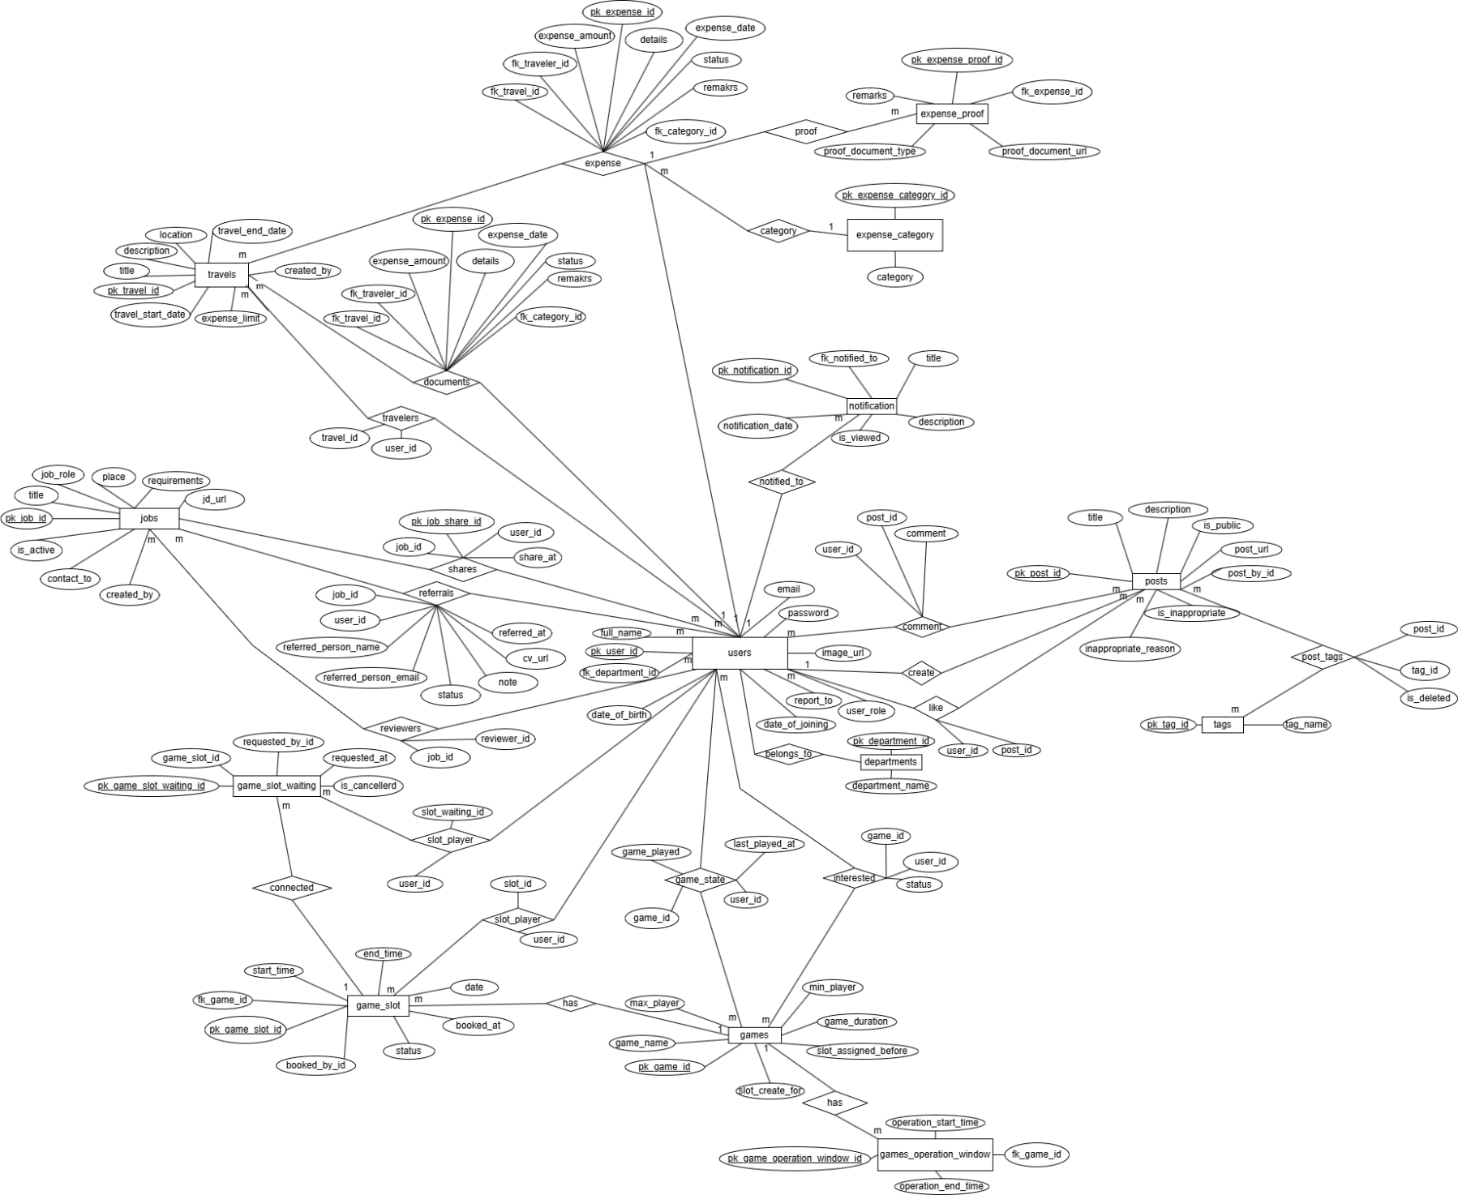
- Use-Case Diagram:
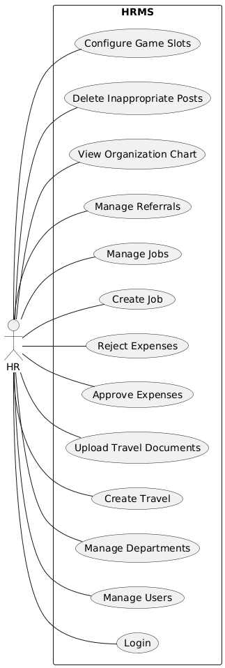
  - Hr use-case diagram:

  - Manager use-case diagram:
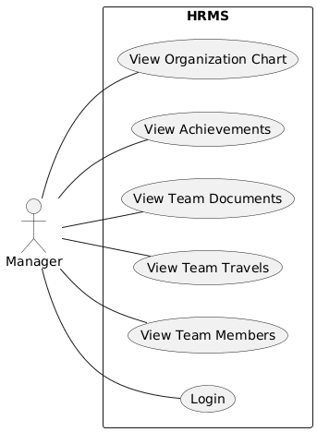

  - Employee use-case diagram:
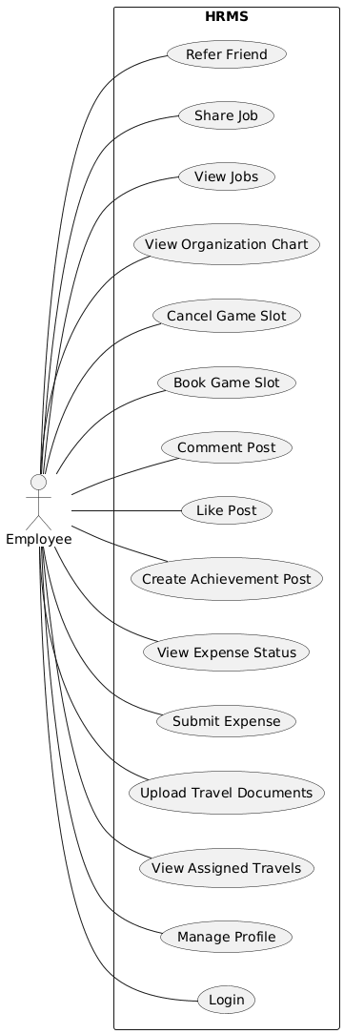
- Activity Diagram:
  - Create Travel:
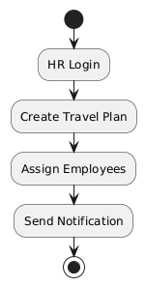
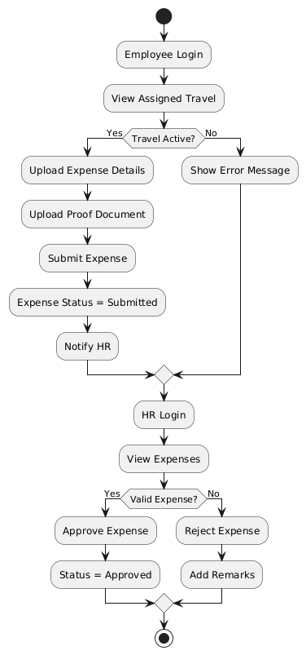
  - Travel Expense:

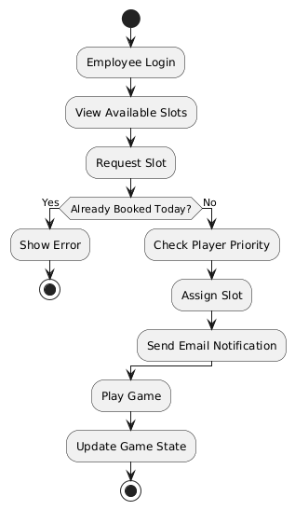
  - Book game slot:

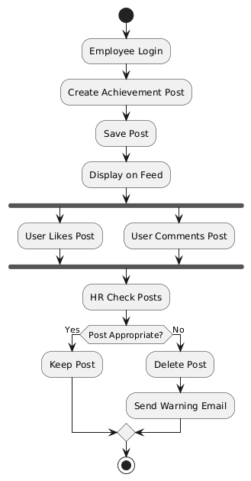
  - Post create:

  - Job Referee:
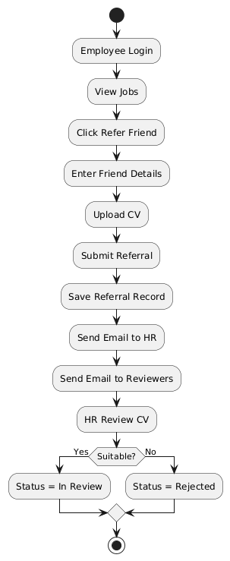
- Class Diagram:
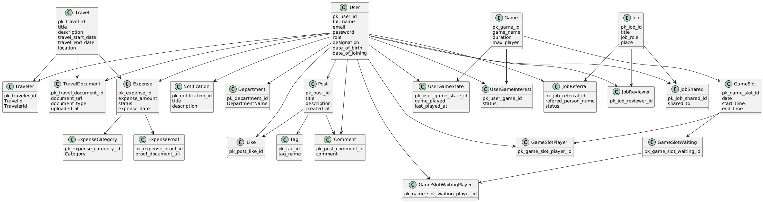
- Sequence Diagram:
  - Travel Expense Sequence: 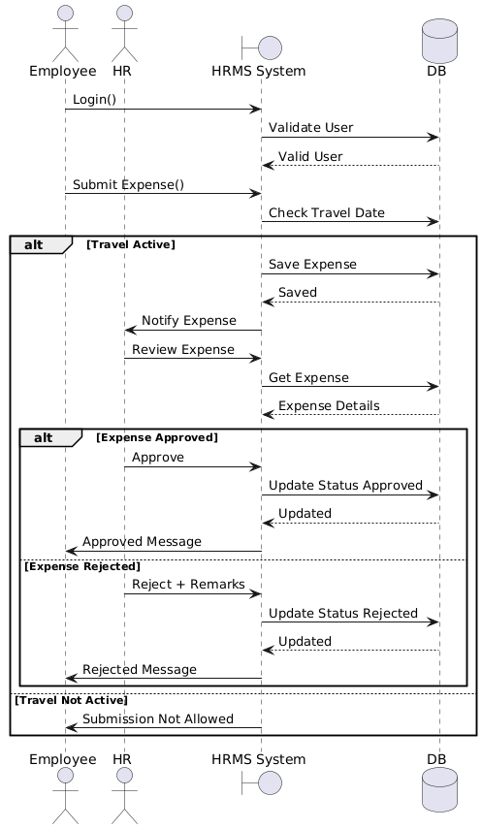

  - Job Referred Sequence:
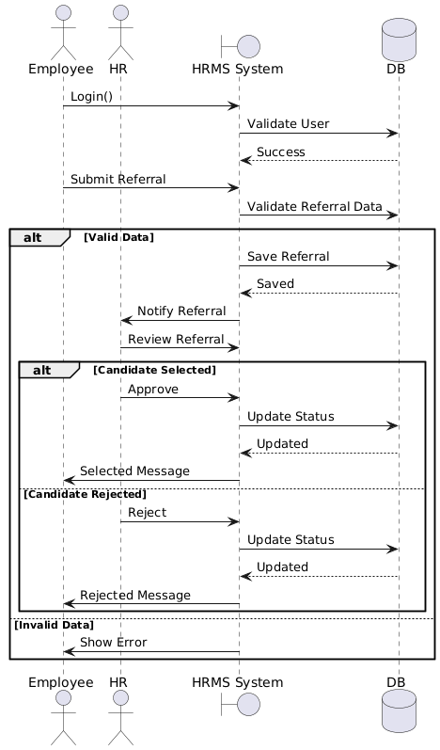
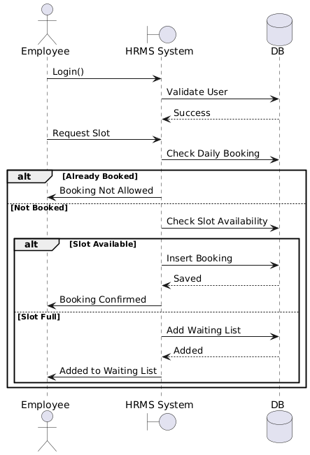
  - Slot Booking Sequence:

