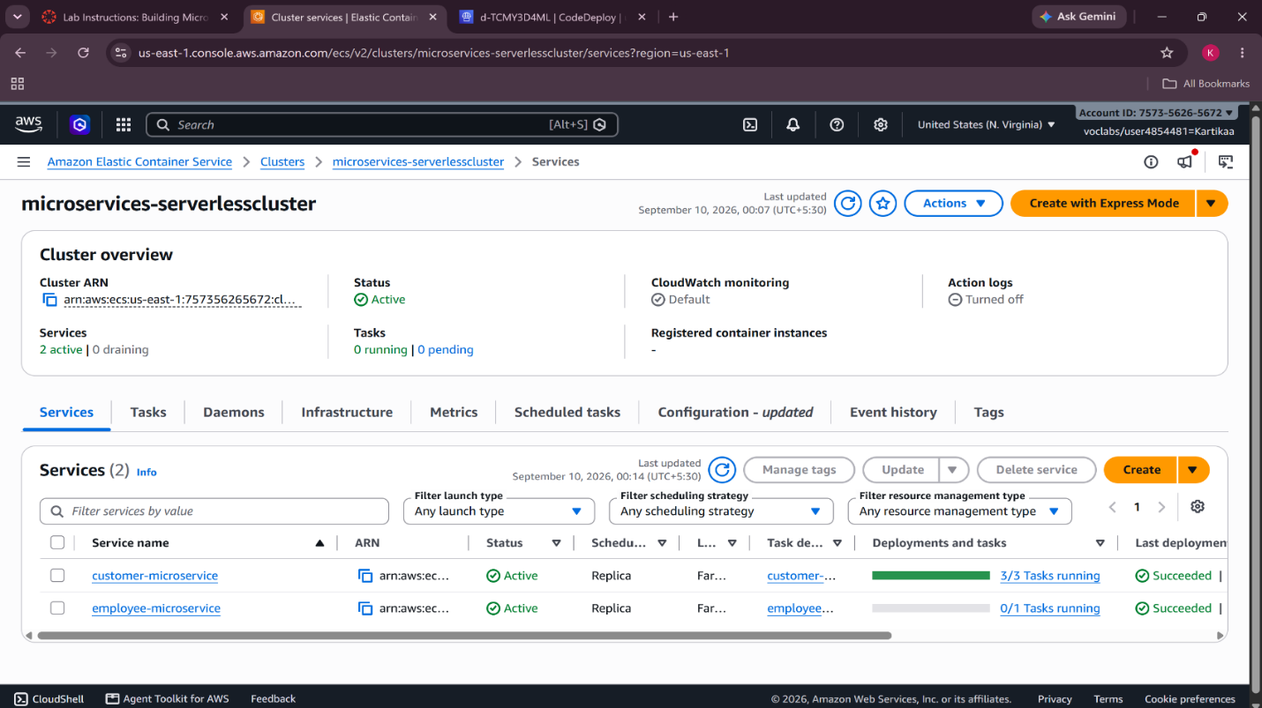
Figure 1: Amazon ECS cluster showing the Customer and Employee microservices running successfully.
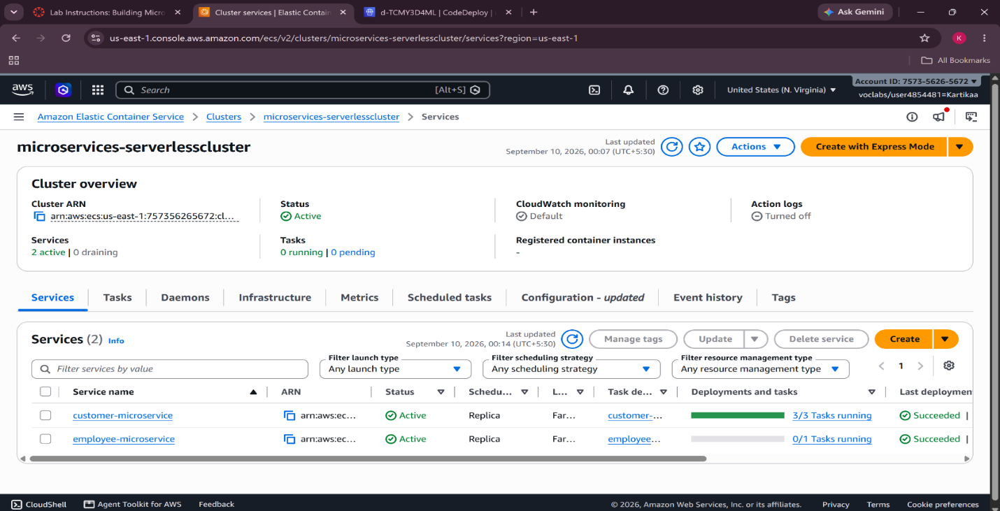
Figure 2: Amazon ECS cluster showing the Customer and Employee microservices in an active state.
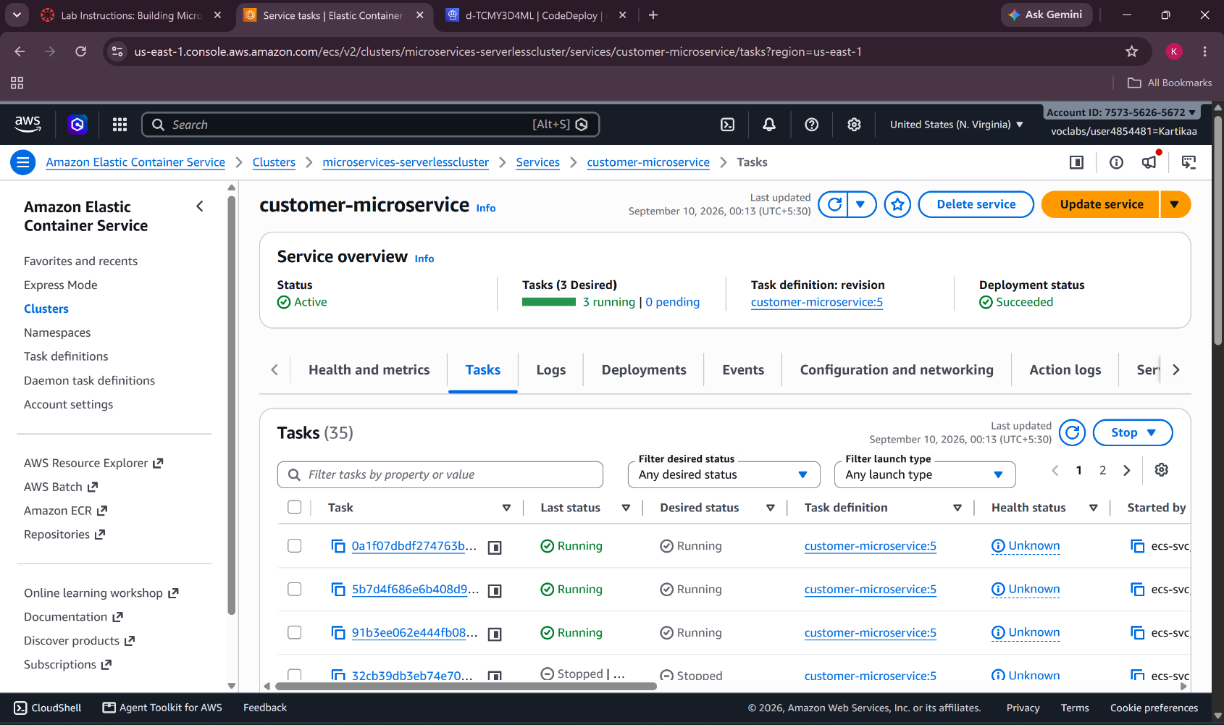
Figure 3: Customer Microservice showing running ECS tasks.
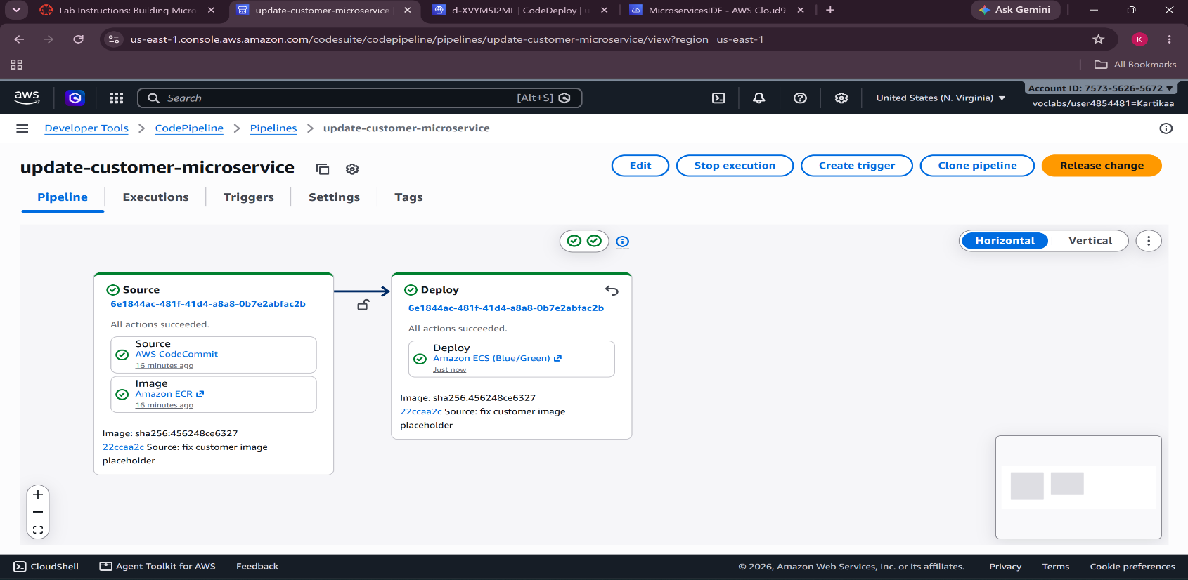
Figure 4: AWS CodePipeline showing successful source and blue/green deployment stages.
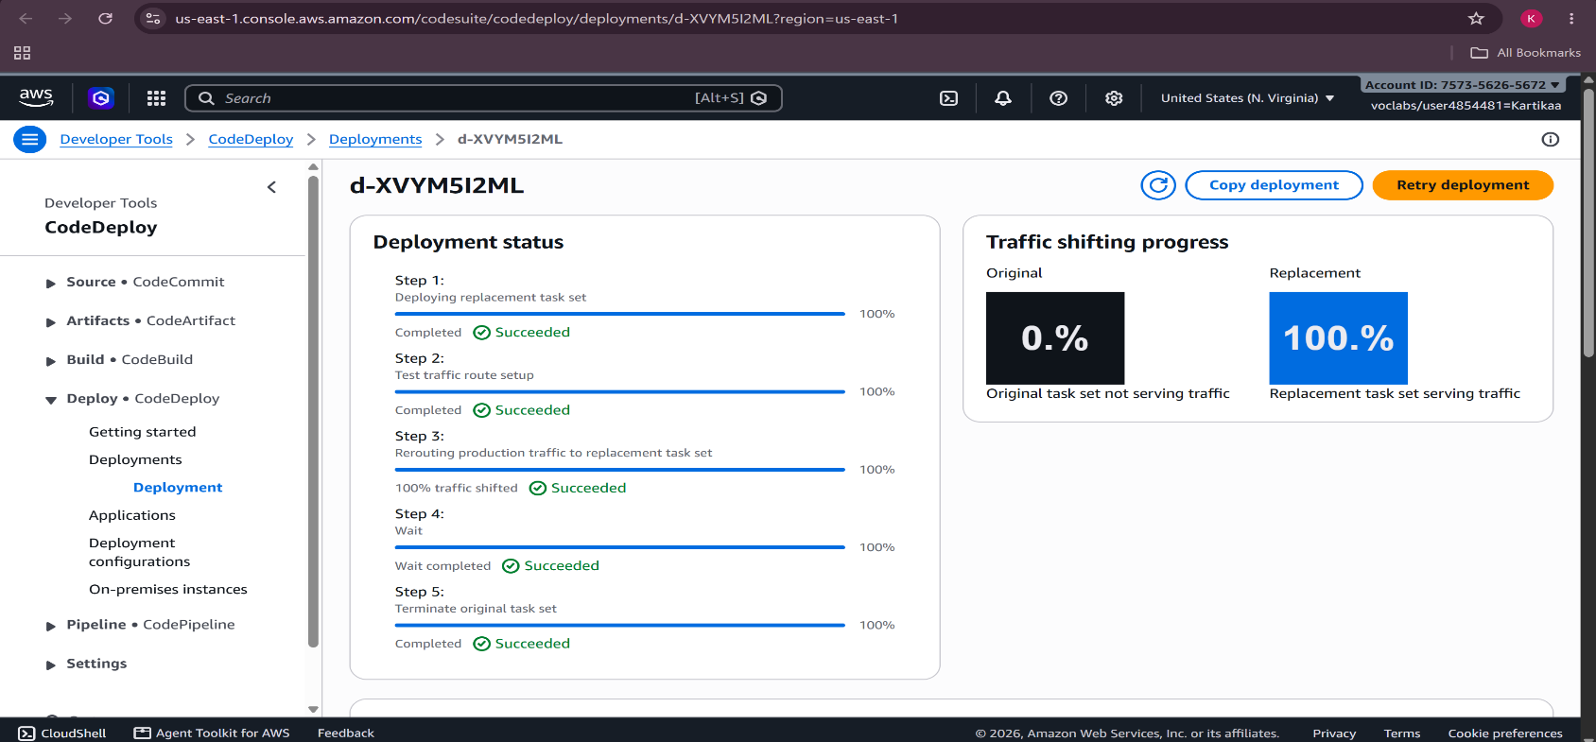
Figure 5: AWS CodeDeploy showing successful blue/green deployment with 100% of traffic shifted to the replacement task set.
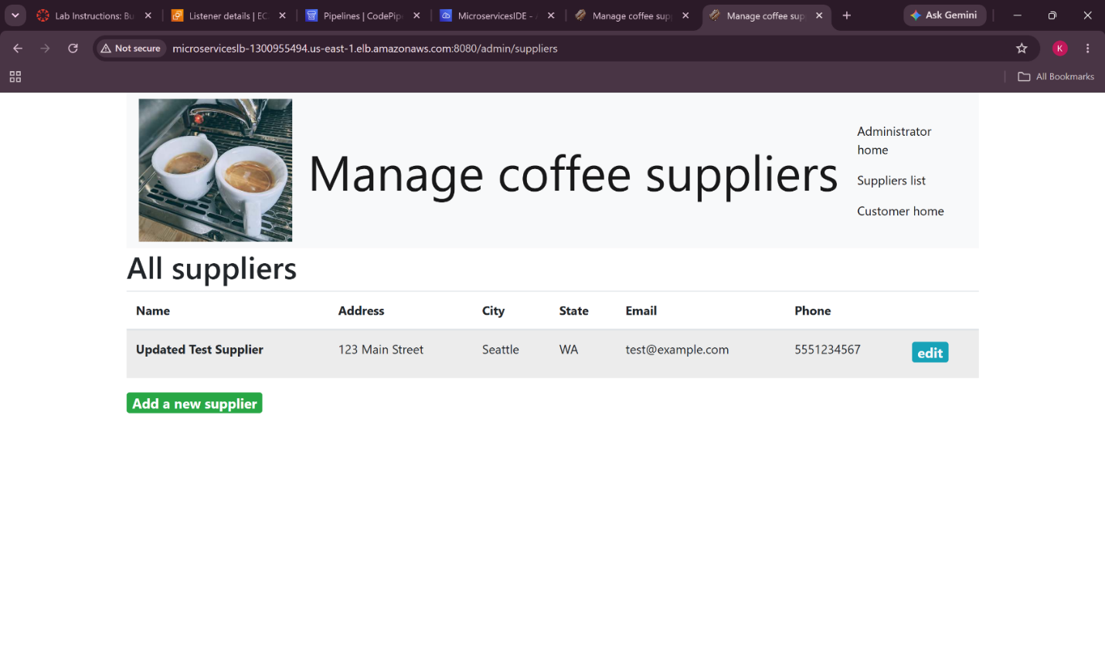
Figure 6: Coffee Suppliers application successfully accessed through the Application Load Balancer.

