Neural Assignment ICP-6

Name: Kartik Anumolu Student ID:700758573

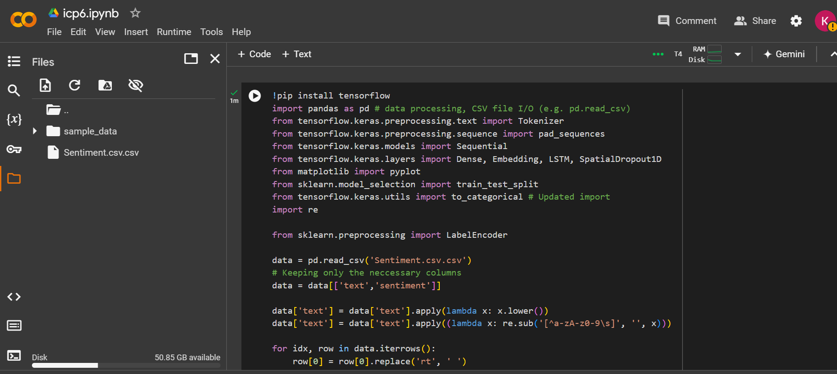

USING GRIDSEARCH CSV OBJECT

