**Kartika Nirwana Silalahi**

**41519120006**

**Pemrograman PL/SQL**

**- Screen Shoot Report Table Studi Kasus Pertemuan 14 -**

Berikut rancangan table yang akan dibuat pada database apotek.

Tabel Pembeli:

|  |  |  |  |  |  |
| --- | --- | --- | --- | --- | --- |
| No | Field | Type | Size | Null | Index |
| 1 | No_nota_pembeli | Varchar | 8 | N | Primary Key |
| 2 | Nama_pembeli | Varchar | 30 | Y |  |
| 3 | Total | Number | 11 |  |  |

Tabel Obat:

|  |  |  |  |  |  |
| --- | --- | --- | --- | --- | --- |
| No | Field | Type | Size | Null | Index |
| 1 | Kode_obat | Varchar | 8 | N | Primary Key |
| 2 | Nama_obat | Varchar | 30 | N |  |
| 3 | Jenis_obat | Varchar | 8 | N |  |
| 4 | Keluhan | Varchar | 50 | N |  |

Tabel Karyawan:

|  |  |  |  |  |  |
| --- | --- | --- | --- | --- | --- |
| No | Field | Type | Size | Null | Index |
| 1 | Nik | Varchar | 8 | N | Primary Key |
| 2 | Nama_karyawan | Varchar | 30 | N |  |
| 3 | Alamat_karyawan | Varchar | 50 | N |  |
| 4 | Bagian | Varchar | 10 | Y |  |

Tabel Banyak:

|  |  |  |  |  |  |
| --- | --- | --- | --- | --- | --- |
| No | Field | Type | Size | Null | Index |
| 1 | No_nota | Varchar | 8 | N | Foreign Key |
| 2 | Kode_obat | Varchar | 8 | N | Foreign Key |
| 3 | Banyaknya | Number | 9 | N |  |
| 4 | Sub_total | Number | 9 |  |  |

Tabel Login:

|  |  |  |  |  |  |
| --- | --- | --- | --- | --- | --- |
| No | Field | Type | Size | Null | Index |
| 1 | Nik | Varchar | 8 | N | Foreign Key |
| 2 | Username | Varchar | 20 | N | Primary Key |
| 3 | Password | Number | 8 | N |  |

Tabel Stok:

|  |  |  |  |  |  |
| --- | --- | --- | --- | --- | --- |
| No | Field | Type | Size | Null | Index |
| 1 | Kode_obat | Varchar | 8 | N | Foreign Key |
| 2 | Stok | Number | 9 | N |  |
| 3 | Harga | Number | 9 | N |  |

REPORT

**Report Karyawan:**

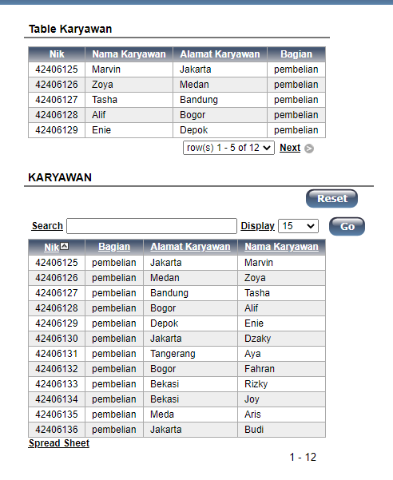



**Report Login:**

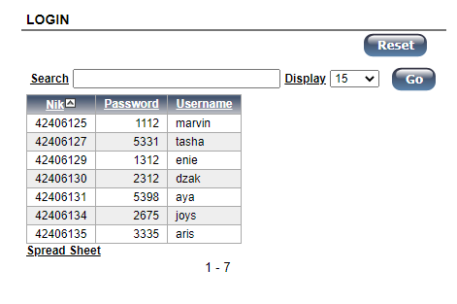

**Report Obat:**

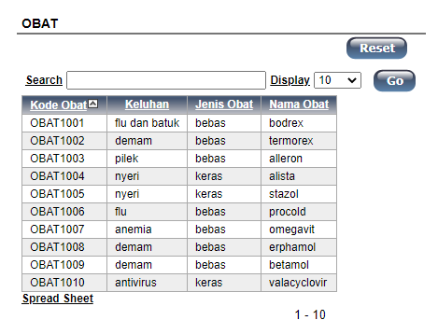

**Report Pembeli:**

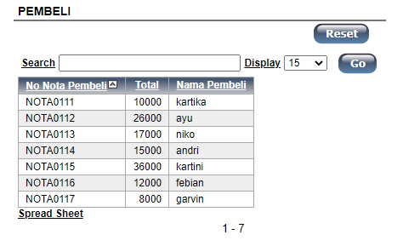

**Report Stok:**

