

QUALITY INSPECTION SYSTEM WHICH WILL

SEGREGATE THE ACCEPTED AND REJECTED OBJECT

# A SENIOR DESIGN PROJECT REPORT

## Submitted by

**01FE19BAR001 – RITUL SHAH**

**01FE19BAR008 – SUDARSHAN WAGHMARE**

**01FE19BAR023 – KARTIK AVADHANI**

**01FE19BAR035 – YASH BORKAR**

**01FE19BAR036 – SUMEET KONERI 01FE19BAR038 – GURUVASANTH**

## in the completion of Senior Design Project

**Under the Guidance of:**

**Shilpa Tanvashi**

# Bachelor of Engineering

**IN**

**AUTOMATION AND ROBOTICS**

**KLE TECHNOLOGICAL UNIVERSITY, HUBBALLI.**

**DECEMBER 07, 2022**

# KLE TECHNOLOGICAL UNIVERSITY,

## HUBBALLI - 580031



**DEPARTMENT OF AUTOMATION AND ROBOTICS**

**Certified that the project work entitled**

QUALITY INSPECTION SYSTEM WHICH WILL SEGREGATE THE ACCEPTED AND REJECTED OBJECT

Is a bonafide work carried out by

Ritul Shah, Sudarshan Waghmare, Kartik Avadhani, Yash Borkar, Sumeet Koneri and Guruvasanth B in partial fulfilment for the award of the degree of Bachelor Engineering in AUTOMATION AND ROBOTICS of the KLE Technological University, Hubballi during the year 2022-23. It is certified that all corrections/suggestions indicated for internal assignment have been incorporated in the report deposited in the departmental library. The project report has been approved as it satisfies the academic requirements in respect of project work prescribed for the Bachelor of Engineering Degree.

Signature of the guide Signature of the Coordinator Signature of the HOD

Shilpa Tanvashi Shilpa Tanvashi Arun Giriyapur

Name of the Examiners Signature with Date

1.

2.

## ABSTRACT

The number of intelligent inspection system is increasing day by day to achieve the vision of the industry. Inspecting with image processing for object recognition play an important role in systems aimed at semi-automated production. In industrial automation applications, computer vision is primarily used during the quality control phase. At this stage, there are many applications that use image processing techniques for object detection and classification, but few machine learning-based applications. In this work, we propose an automated application of visual quality control using cameras placed on a conveyor to prototype models. The product is detected in an image obtained from the assembly line and then classified as "accepted" or "rejected" with the help of machine learning methods and it detects real time. After the machine learning-based quality control, we segregate manually so that the "accepted" products is in accepted box and rejected products is in rejected box. So that accepted one’s are ahead move to the distributors plant and the rejected one’s are bifurcated.

Object detection using real time for which we have process train data set using manufactured toothbrushes (bamboo tree, neem tree. Brussels - soft, hard, medium).

### ACKNOWLEDGEMNT

We have put our sincere efforts into this project. However, it would not have been possible without the kind support of many individuals. We would like to extend our sincere thanks to all of them.

We sincerely acknowledge our guide Asst. Prof. Shilpa Tanvashi for their guidance and constant supervision as well as for providing necessary information regarding the project & also for their support in completing the project.

We would like to express our gratitude towards all the members of the department of Automation and Robotics for their kind co-operation and encouragement which helped us in the completion of this project.

We would like to express our special gratitude and thanks to Head of the Department Professor Arun Giriyapur for giving us attention and time.

Our genuine thanks and appreciation to all our classmates and people who have willingly helped us out with their abilities.

01FE19BAR001 01FE19BAR008 01FE19BAR023

01FE19BAR035 01FE19BAR036 01FE19BAR038

#### Table of Contents

|  |  |  |
| --- | --- | --- |
| Chapter No. | Title | Page No. |
|  | Abstract | i |
|  | Acknowledgment | ii |
|  | Table of Contents | iii |
|  | List of Tables and List of Figures | iv |
| 1 | 1.1 Introduction | 1 |
|  | 1.2 Problem Statement | 2 |
| 2 | Literature Survey | 3 |
| 3 | Requirement modelling and Analysis | 8 |
| 4 | Architecture of the system | 14 |
| 5 | Methodology | 16 |
|  | 5.1 Hardware | 16 |
|  | 5.2 Conceptual Design and Evaluation | 22 |
|  | 5.3 BOM | 27 |
|  | 5.4 The final list of hardware essential components | 28 |
|  | 5.5 Software | 32 |
|  | 5.6 Algorithm Used | 39 |
|  | 5.7 Code | 41 |
|  | 5.8 Working Prototype | 43 |
| 6 | Results and Conclusion | 45 |
|  | References | 47 |

List of Tables

|  |  |  |
| --- | --- | --- |
| Table | Content | Page No. |
| 4.1 | Analysis of Customer needs | 13 |
| 4.2 | Initial Requirement List | 14 |
| 4.3.1 | Specifications | 14 |
| 4.4 | Consolidate and prioritize the requirements | 15 |
| 4.6.1 | Metric Analysis | 18 |
| 4.7 | Test and Validation of Metric | 18 |
| 6.1.7 | Concept Screening | 29 |
| 6.1.8 | Concept Scoring | 30 |
| 6.3 | BOM | 34 |
| 6.5 | Motor Specification | 37 |

List of Figures

|  |  |  |
| --- | --- | --- |
| SI no | Figures | Page No. |
| 1. | 2.1 | 8 |
| 2. | 4.5.2 | 17 |
| 3. | 5.1 | 19 |
| 4. | 5.2 | 20 |
| 5. | 6.1.1 | 21 |
| 6. | 6.1.2 | 22 |
| 7. | 6.1.3 | 23 |
| 8. | 6.1.4 | 24 |
| 9. | 6.1.5 | 26 |
| 10. | 6.3.1 | 33 |
| 11. | 6.3.2 | 34 |
| 12. | 6.3.3 | 34 |
| 13. | 6.3.4 | 36 |
| 14. | 6.3.5 | 36 |
| 15. | 6.3.6 | 37 |
| 16. | 6.3.7 | 37 |
| 17. | 6.4 | 37 |

#### CHAPTER 1

##### 1.1 INTRODUCTION

A toothbrush is a tool that we use to brush our teeth. It has bristles on one end that help remove plaque and bacteria from your teeth and gums. To keep your mouth healthy, you need to use your toothbrush every day.

Toothbrushes come in a variety of sizes, materials and colours. They usually consist of a hard plastic handle and soft nylon bristles. Some models have features like interchangeable heads, ergonomic handles and travel bags. Not only can it be used to brush your teeth, but it can also be used to remove plaque from your tongue and gums. Toothbrushes can be purchased individually or in sets.

Teeth are the most important part of our body. Mouth and food are one. Healthy teeth can protect food from tooth decay. Teeth are different from other body parts. They don't get better with age.

The care and attention you give your teeth as a child will determine how healthy your teeth will be in old age. Brushing your teeth is an easy way to improve your dental health

A toothbrush is a small, portable brush used to clean teeth. A toothbrush is used with toothpaste to clean teeth, remove plaque and food debris, and massage gums. Toothbrushes are usually made of plastic, nylon or other synthetic materials. They have straightlined bristles and an easy-grip handle.

Quality inspection involves measuring, inspecting, testing, or measuring various characteristics of a product and comparing those results with specified requirements to determine conformity. By automating the inspection and sorting process, the quality control machine can help speed up the production line and reduce the need for manual labour.

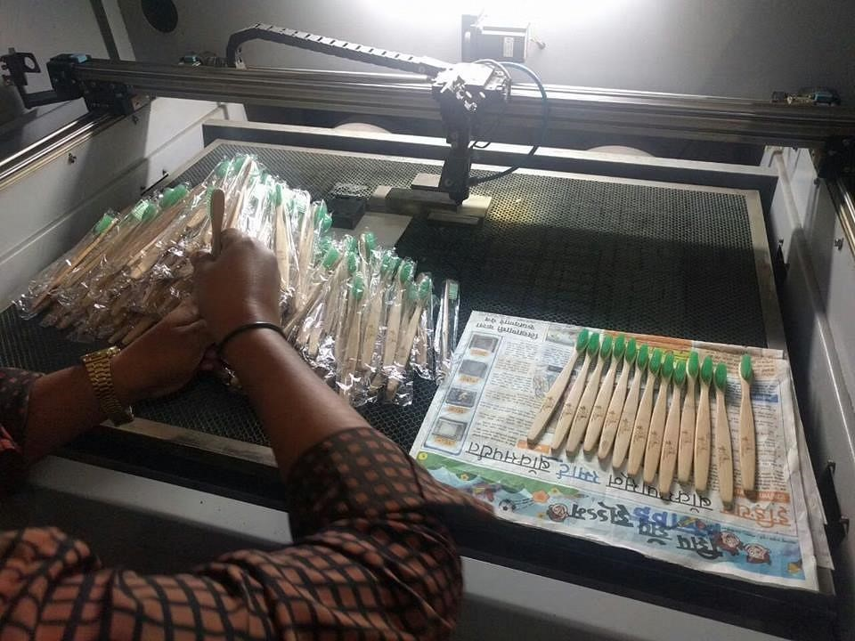

In pic: Bamboo toothbrushes in the making.

##### 1.2 Problem Statement

**To design and develop a quality inspection system device which will segregate the accepted and rejected object and implement it on a conveyor system.**

In this study, one of the most important points is detecting the product in the image which is taken by camera on the assembly line. Another important part is classifying the product to one of the classes “Accepted” or “Rejected” while the automation of visual quality control application for intelligent factory model is being performed. Object detection algorithm is carried out with machine learning algorithm.

**2.1 Motivation:**

First, such a device can help improve the quality of the products being manufactured by automatically sorting and inspecting products. the quality control machine can help identify and remove defective items, ensuring that only high-quality products reach the market. This can help improve the reputation of the manufacturer and increase customer satisfaction.

Second, a quality control machine can help reduce the cost of manufacturing. By identifying and removing defective products early in the manufacturing process, the quality control machine can help reduce the amount of wasted materials and labour. This can help save the manufacturer money and improve their bottom line.

Third, a quality control machine can help improve the efficiency of the manufacturing process. By **automating the inspection and sorting process**, the quality control machine can help speed up the production line and reduce the need for manual labour. This can help the manufacturer produce more products in a shorter amount of time, increasing their output and competitiveness.

Overall, manufacturing an industry quality control machine can help improve the quality, reduce the cost, and increase the efficiency of the manufacturing process, providing significant benefits to the manufacturer.

Fig. 2.1

Bamboo brushes

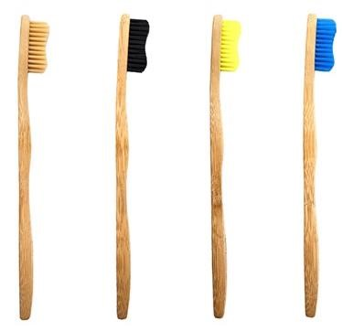

**CHAPTER 2**

#### LITERATURE SURVEY

**2.1 Research related to problem definition:**

**LITERATURE SURVEY** helps us to understand the already existing solutions in the market for the given problem statement. It helps us to understand the level of complexity that is required to solve the problem and also the ways to make our solution unique.

**2.1.1 Existing similar projects:**

The work In ref [1] presents object detection solutions for two different specific applications. Detection of quality control items in surgical toolboxes prepared for hospital sterilization, and detection of hull defects can prevent potential structural defects. The solution has two stages. First, we use a function pyramid architecture based on the Single Shot MultiBox Detector (SSD) to improve detection performance and use ground truth-based statistical analysis to select parameters for a set of standard boxes. A lightweight neural network is then utilized to achieve directional recognition results using regression methods. The first stage of the proposed method can detect small targets, which are considered in two scenarios. The second stage is simple but efficiently detects elongated targets while maintaining high running efficiency.

**2.1.2 Existing commercially available products:**

i) FOS-HVS Duo2400 by SICK Technologies

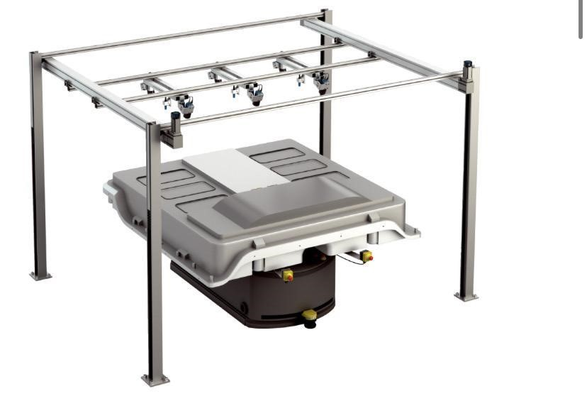

* Detect very small objects of various shapes. Screws, Nuts, Tools
* Reliable and accurate inspection of challenging surfaces with a wide variety of colours, structures and textures. Suitable for light, dark, smooth, ribbed, domed, glossy, matte and other surfaces
* No additional lighting required
* Visualization of results

Thread Recognition

* Faster and easier specimen change

**2.2 Relevant Technologies-Techniques and sensor technology used**

The review of existing technologies helps us to strategically plan the architectural layout, sensors, actuators, software tools that can be used to develop our solution.

**Neural Network**: Neural Networks efficiently creates pre-trained models and optimized algorithms for creating, training, visualizing, and simulating both shallow and deep neural networks. You can perform dynamic system modelling with classification, clustering, dimensionality reduction, regression, time series forecasting, and control. Deep learning networks include convolutional neural networks (**ConvNet**, **CNN**), directed acyclic graph (DAG) network topologies, and encoders for image classification, clustering, and feature learning. For time series classification and regression, the toolbox can perform long shortterm memory (LSTM) on deep learning networks. You can visualize middle layers and activations, modify network architecture, and continuously monitor training progress.

**Image Processing**: Image processing helps build efficient machine learning models, making prototypes efficient and intelligent. Computer vision techniques can be used to classify images using RGB colour coding.

**Machine Learning:** Machine learning concepts include techniques such as reinforcement learning that help solutions make decisions and take actions based on past rewards without human intervention. Various algorithms can be optimized for performance.

**Modelling:** Early prototyping involves modelling using toolchains such as MATLAB and SolidWorks to build, integrate, and simulate the various parts and assemblies of the prototype. This phase helps analyse the behaviour of the model in the real environment and optimize and adapt the model with respect to various aspects.

#### 2.3Published work from reputed sources and journals

**2.3.1 Recognition of the objects on the conveyor belt using graph matching algorithms:**

The problem of detecting mechanical parts on conveyors is solved in this post. A graph matching algorithm that computes the minimum distance between two graphs was chosen to solve the given problem. In particular, this article discusses finding the best combination of selecting feature points from an image, building a graph structure from these points, and searching for optimal parameters for graph matching algorithms. Object recognition accuracy is considered along with the time required for the method used.

**2.3.2 Long Term Temporal Context for Per-Camera Object Detection:**

With static surveillance cameras, useful contextual information can extend well beyond the seconds that a typical video understanding model might look at. Subjects exhibit similar behaviour for several days, with background objects remaining static. Due to power and memory limitations, sampling rates are low, often no faster than 1 frame per second, and can be erratic when using motion triggers. To work well in this environment, the model needs to be robust against irregular sample rates. In this article, we propose how to use the temporal context from unlabelled frames of a new camera to improve the performance of that camera. In particular, our model Context R-CNN indexes into a long-term memory bank built for each camera, allowing us to aggregate context features from other frames to improve object recognition performance-based attention-based propose an approach. Boost frame now. Apply Context R-CNN to the following two settings: (1) species detection with camera traps and (2) vehicle detection with traffic cameras. Both settings show that Context R-CNN outperforms the strong baseline. Furthermore, we show that a longer context time range yields better results.

**2.3.3 A Quality Control Application on a Smart Factory Prototype Using Deep Learning Methods:**

The number of smart factories is increasing day by day to realize the vision of Industry 4.0. Computer vision and image processing play an important role in systems aimed at unmanned production. In industrial automation applications, computer vision is primarily used during the quality control phase. At this stage, there are many applications using image processing techniques for object detection and classification, but few deep learning-based applications. In this work, an automated application of visual quality control is proposed using cameras placed on the assembly line of the smart factor model. Products are recognized from images captured on the assembly line and classified as "OK" or "Bad" using deep learning techniques. After quality control based on deep learning, "OK" products continue the production stage and "NOK" products are cut off from the production line by the PLC controlling the line. This application demonstrates that deep learning techniques for automation applications play a key role in the transition to Industry 4.0.

**2.3.4 Scalable and Efficient Object Detection:**

Model efficiency is becoming increasingly important in computer vision. In this article, we systematically examine design decisions for neural network architectures for object detection and suggest some key optimizations to improve efficiency.

First, we propose a weighted bidirectional feature pyramid network (BiFPN) that enables easy and fast multiscale feature fusion. We then propose a composite scaling method that uniformly scales the resolution, depth, and width of all backbones, feature networks, and box/class prediction networks simultaneously. Based on these optimizations and the Efficient Net backbone, we have developed a new family of object detectors called EfficientDet that consistently achieves much better efficiency than conventional techniques for a wide range of resource constraint.

**CHAPTER 3**

#### REQUIREMENT MODELLNG AND ANALYSIS

Requirement modelling and analysis involve engineering design at its core. Requirement modelling helps us to understand clients’ requirements and builds a solution that provides the utmost customer satisfaction. The analysis must be out on the listed requirements for proper engineering.

**3.1 Analyse customer needs:** We conducted the one-to-one interviews with our clients and conducted a market survey to understand the marketability of the solution.

Table 3.1 Analysis of Customer needs

|  |  |  |
| --- | --- | --- |
| No. | Customer Statement | Interpreted Need |
| 1. | It is very hard to carry heavy load at a time. | The solution should carry a enough payload of tooth brushes in a single batch. |
| 2. | It should be stable to carry the heavy loads. | The Load on the machine has to be stable |
| 3. | It should take the power from both the sources (AC/DC) | The solution has to take power source  from AC Mains |
| 4. | It should separate the damaged and undamaged brushes. | The solution should reject damaged brush and accept the undamaged brushes. |
| 5. | It should separately store the accepted and rejected brushes. | The solution should store the rejected brush separately. |
| 6. | It should have good storage capacity accepted brush. | Should have good storage for accepted brush. |
| 7. | It should have to indicate the total numbers of brushes had passed from conveyor | The solution has to give indication of other parameters like counting the toothbrush. |
| 8. | We expect the solution to be of reasonable price. | The solution should be cost-effective. |
| 9. | We should not face any problem while assembly and disassembly of the solution. | The solution should be ease in assembly and disassembly of the machine. |
| 10. | It should not harm | It should be safe to use. |

**3.2** **Generate initial requirement list:** For each requirement, we identify the source of the information and regenerate an initial requirement list.

Table 3.2 Initial Requirement List

|  |  |  |
| --- | --- | --- |
| No. | Source | Requirement |
| 1. | Client | The prototype should be able to differentiate the damages and undamaged brush. |
| 2. | Client | The prototype should be able to store the damages and undamaged one separately. |
| 3. | Team | The prototype should be cost-effective. |
| 4. | Client | The prototype is expected to work more than 2 hours continuously |
| 5. | Team | The prototype should be able to perform all the required functions smoothly. |
| 6. | Survey | The prototype is expected to be aesthetic. |
| 7. | Client | The prototype should have display the total numbers of brushes passes from the conveyor. |
| 8. | Team | The prototype should be able to detect the damaged brush |
| 9. | Survey | The prototype should have a warranty. |
| 10. | Client | The prototype should give signals when it is not performing if functions accurately/correctly. |
| 11. | Client | The prototype should be autonomous in nature. |

##### 3.3 Brainstorming

Analysed all the initial needs and requirements. Our team carried out various meetings and carried out a brainstorming process concerning the exact application and dimensional specification of the prototype to Inspect the Quality Control of the Brushes.

**3.3.1 Outcomes of the brainstorming**

* Application of the robot: Industrial sector,
* Components required:
  + - Basic Components: Chassis Frame, Roller, Bearing, Collection Box, Shaft, Conveyor Belt
    - Intelligence: Machine Learning, Deep Learning, Efficient controller✓ To drive mechanism: Sensor, Conveyor belt, motor, motor driver.
* Dimensional specification of the robot: Probable dimensions concluded after case study.Table 3.3.1 Specifications

|  |  |  |
| --- | --- | --- |
| No. | Specification | Dimension/Value |
| 1. | Height | 30 inches |
| 2. | Length | 78.4 inches |
| 3. | Breadth | 34 inches |
| 4. | Weight | 40 kg |
|  |  |  |

**3.4 Consolidate and prioritize the requirements:** We categorize each requirement into demand or wish. We also identify the type of industrial metric category that the requirement belongs too.

Table 3.4 Consolidate and prioritize the requirements

|  |  |  |  |  |
| --- | --- | --- | --- | --- |
| No. | Requirement | Importance | Demand/Wish | Category |
| 1. | The prototype should be able to differentiate the damages and undamaged brush. | 9 | Demand | Operation, kinematics, Intelligence |
| 2. | The prototype should be able to store the damages and undamaged one separately. | 8 | Wish | Storage,  Intelligence |
| 3. | The prototype should be costeffective. | 6 | Demand | Cost/  Marketability |
| 4. | The prototype is expected to work more than 2 hours  continuously | 10 | Demand | Kinematics,  Signals,  Operation,  Transport |
| 5. | The prototype should be able to perform all the required functions smoothly. | 8 | Demand | Energy, Signals |
| 6. | The prototype is expected to be aesthetic. | 7 | Wish | Cost/  Marketability |
| 7. | The prototype should have display the total numbers of brushes passes from the conveyor. | 7 | Demand | Operation, Intelligence |
| 8. | The prototype should be able to detect the damaged brushes | 9 | Demand | Operation |
| 9. | The prototype should have a warranty. | 6 | Wish | Material,  Quality control |
| 10. | The prototype should give signals when it is not performing if functions accurately/correctly. | 7.5 | Demand | Operation, Intelligence |
| 11. | The prototype should be autonomous in nature. | 7 | Wish | Operation, Kinematics, signals |

##### 3.5 Affinity Groups

Affinity groups are the collections of requirements that belongs to the same category or group. We first list all the requirements mentioned by the client. Then all the requirements are grouped into a specific category.

|  |
| --- |
| Safety |
| * Emergency stop button * Fire alarm * Electric shock proof * Inbuilt stabilizer * Well ventilated design * Well organized wiring * Reliable cooling * Emergency indicators * Should water resistant * Scheduled power on/off * Anti-theft alarm * Should not have sharp edges |

|  |
| --- |
| Performance |
| * Energy efficiency * Solar charging * Should have higher repeatability * Minimum noise * Should provide power back up * Should have more than one speed setting * Optimize performance based on workload * Should be responsive |

|  |
| --- |
| Quality |
| * Should be durable * Should be water resistance * Should be heat resistance * Should support variable power supply * Impact shoch proof * Self-temperature regulation * Should control odour emission |

|  |  |
| --- | --- |
| Aesthetics | |
| * Should have a compact design * Should glow in dark * Should have a responsive display | |
| • | LEDs indicators |
| • | Should use nature’s sounds for notifications |
| • | Sound outputs should be pleasant |
| • | Should be portable |

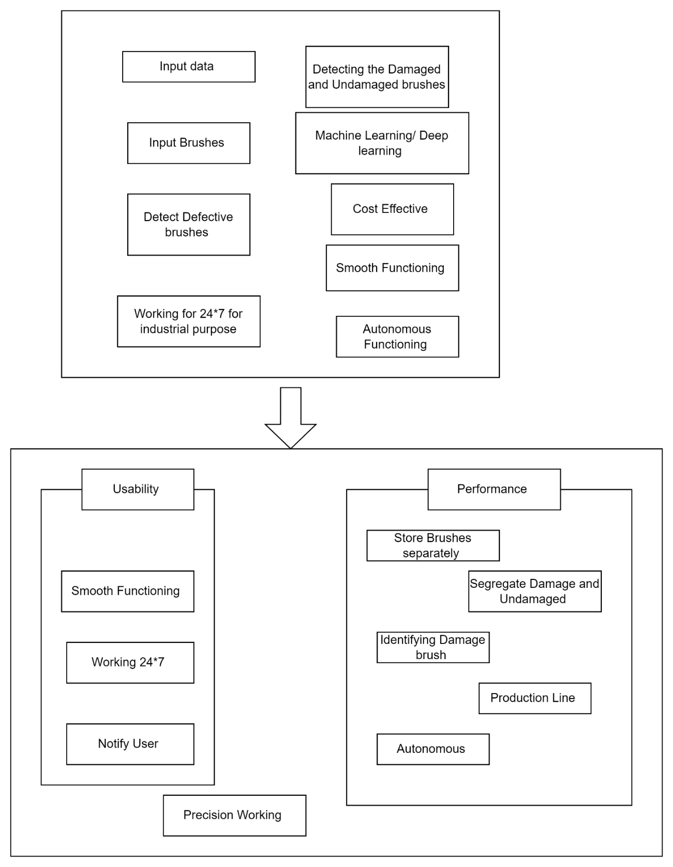

Fig. 3.5.2 Affinity Group

##### 3.6 Design Specification

Design specification includes assigning a matric number to all the measurements that are involved in the development of the solution. Here we need to specify every metric in their corresponding units. This eases the overall design complexity and help in the design process.

###### 3.6.1 Metric Analysis

Metric Analysis is used to specify the important metrics in the correct units. This ensures that all the metrics are defined with appropriate and standard units of their measurement.

Table3.6.1 Metric Analysis

|  |  |  |  |
| --- | --- | --- | --- |
| METRIC NO. | R. NO | METRIC | UNITS |
| 1. | 1 | Precision | %(percentage) |
| 2. | 6 | Height | mm |
| 3. | 7 | Length | mm |
| 4. | 8 | Breadth | mm |
| 5. | 5 | Weight | kg |
| 6. | 4 | Battery power | mAH |
| 7. | 3, | Cost | RUPEE |
| 8. | 2,5,11 | Autonomous working | Time/Work |
|  |  |  |  |

##### 3.7 Test and Validation of Matric

We assign the test and validation method to each metric based on its importance value. Here we first define all the metrics and their corresponding units. So that we can compare these values to the final model. Here we also describe the procedure or equipment of measurement of the metrics.

Table 3.7 Test and Validation of Metric

|  |  |  |  |  |  |
| --- | --- | --- | --- | --- | --- |
| S.no | R. No | Importance | Metric | Units | Validation/Test method |
| 1. | 1 | 9 | Precision | %(percentage) | Applying manual  testing |
| 2. | 6 | 7 | Height | mm | Meter scale |
| 3. | 7 | 7 | Length | mm | Meter scale |
| 4. | 8 | 9 | Breadth | mm | Meter scale |
| 5. | 5,9 | 6 | Weight | kg | Weighing machine |
| 6. | 4 | 10 | Battery power | mAH | Multi-meter |
| 7. | 3 | 10 | Cost | RUPEE | Budgeting Process |
| 8. | 2,5,11 | 8 | Autonomous working | Time/Work | Onsite testing |

**Revised Problem Statement:**

**To design and develop a Quality Inspection system which will segregate the accepted and rejected toothbrushes and implement it on a conveyor system.**

#### CHAPTER 4

##### ARCHITECHTURE OF THE SYSTEM

###### 4.1 Architectural Layout

The architectural layout is the skeletal structure of the solution. It involves an association and connection of various functions and sub-functions involved in the process. It is a blueprint of the solution that is in the process of development. It provides us with a basic understanding of the entire structure of the solution.

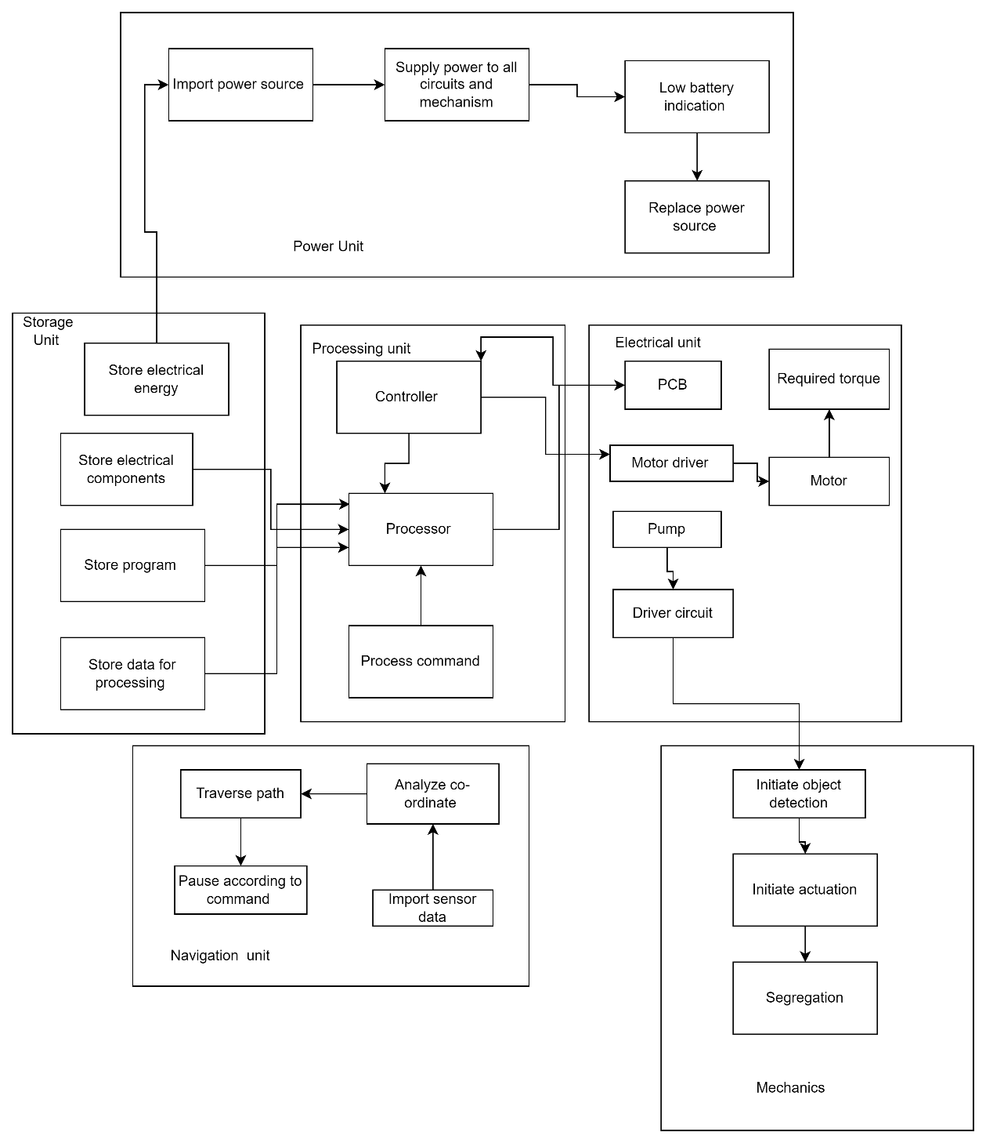

Fig. 4.1 Architectural Layout

###### 4.2 Flow Chart

A flowchart is the approach of pictorially representing the flow of functions and interconnectivity between various phases of the process. Flowcharts help us to understand the flow of the process more efficiently. It is easier to debug any malfunction in the system with the help of flowcharts.

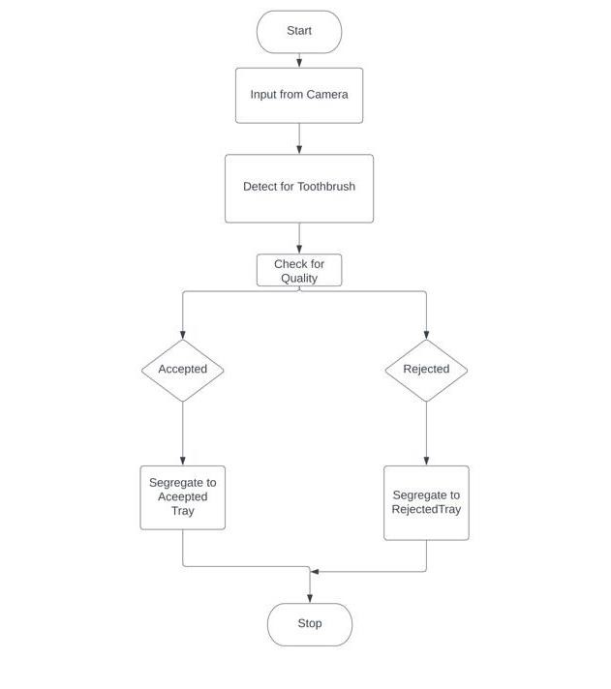

Fig. 4.2 Flow Chart

#### CHAPTER 5

##### METHODOLOGY

The methodology is the exact process that is followed from the start of the project until completion. The methodology followed in the project involves several phases of distinct importance. The process starts in a very abstract format. As we progress with the analysis, the specifications involved in making us choose the appropriate hardware and software to build the final solution.

###### 5.1 HARDWARE

Hardware involves all the necessary electrical components, mechanisms, characteristics of components, energy, and all other necessary specifications that are needed to be considered to build the solution.

5.1.1 Black Box

A black box is a device, system, or object which produces useful information without revealing any information about its internal workings.

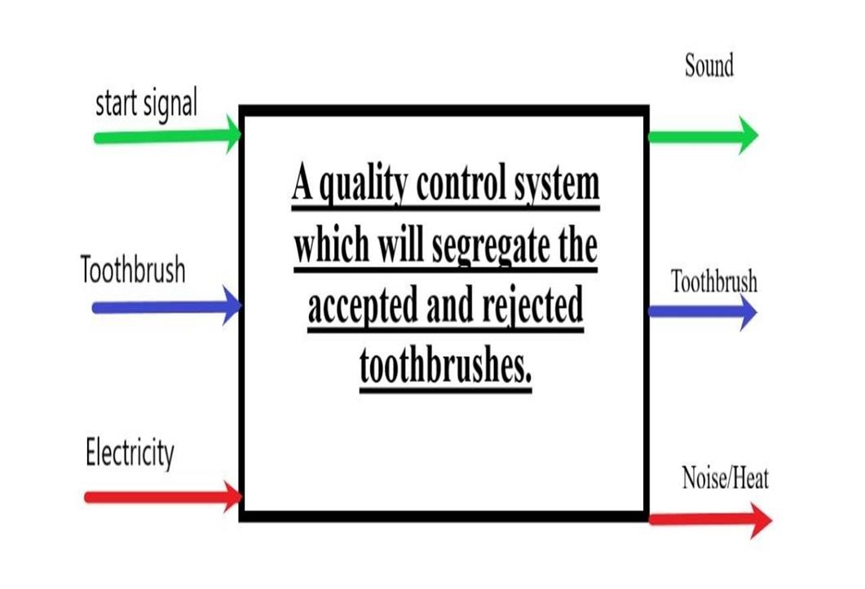 Fig. 5.1.1 Black Box

5.1.2 Gantt Chart

A Gantt chart is a horizontal bar chart that shows a project’s planned schedule and its tasks or events between a start and finish date. Each bar in the Gantt chart represents a task, while the dates are laid out horizontally.

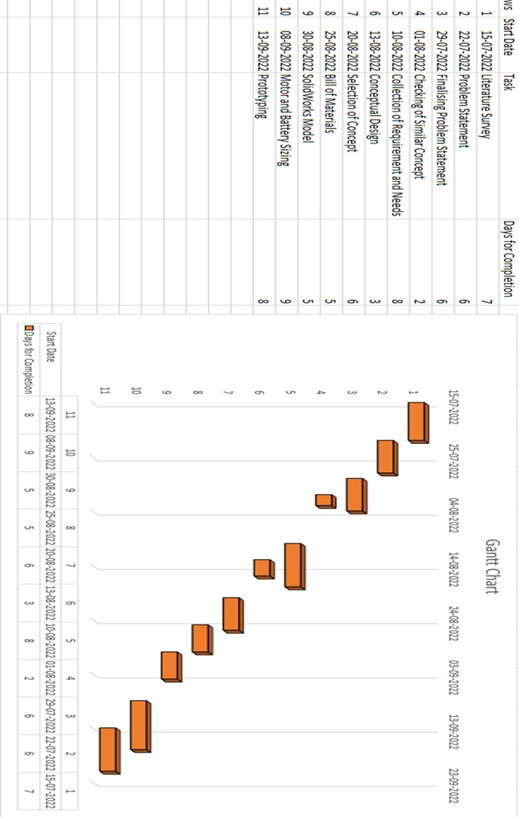

Fig.5.1.2 Gantt Chart

5.1.3 Function Structure

Functional Structure Diagrams (FSD) are graphical representations of the functions a product performs on its inputs and outputs. In FSD, normal functions are divided into elementary or atomic sub-functions. Each sub feature is not further divisible and is solution independent. subfunctions are bound by "threads" on which they operate. Flow is material, energy, or information used by or affecting a product. The FSD is used for many tasks in the design process. Most importantly, it can help break down complex design problems into manageable parts.

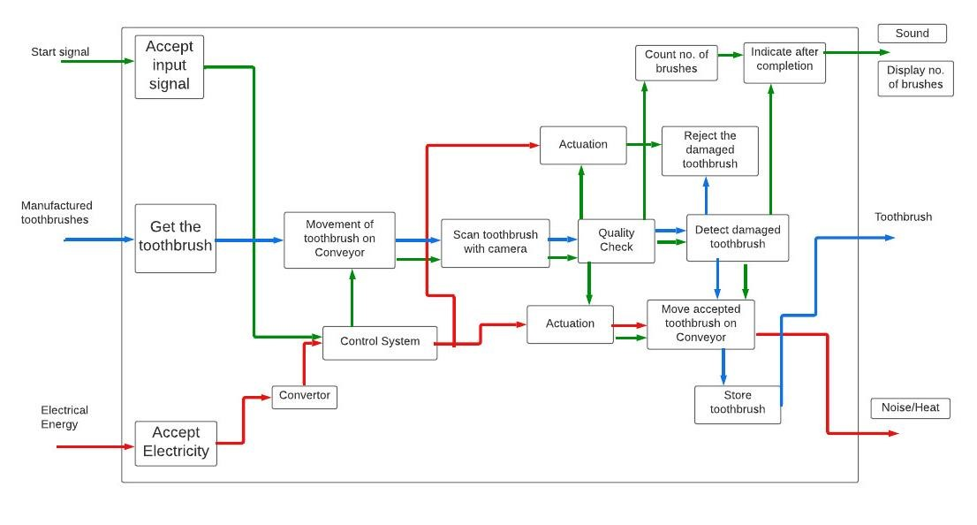

Fig. 5.1.3 Function Structure

5.1.4 Use Case Diagram

A use case diagram can be defined as a graphical representation of a user's possible interactions with a system. A use case diagram can show various use cases and different types of users the system has and will regularly be accompanied by other types of diagrams. The use cases are represented by circles or ellipses, users by stick diagram.

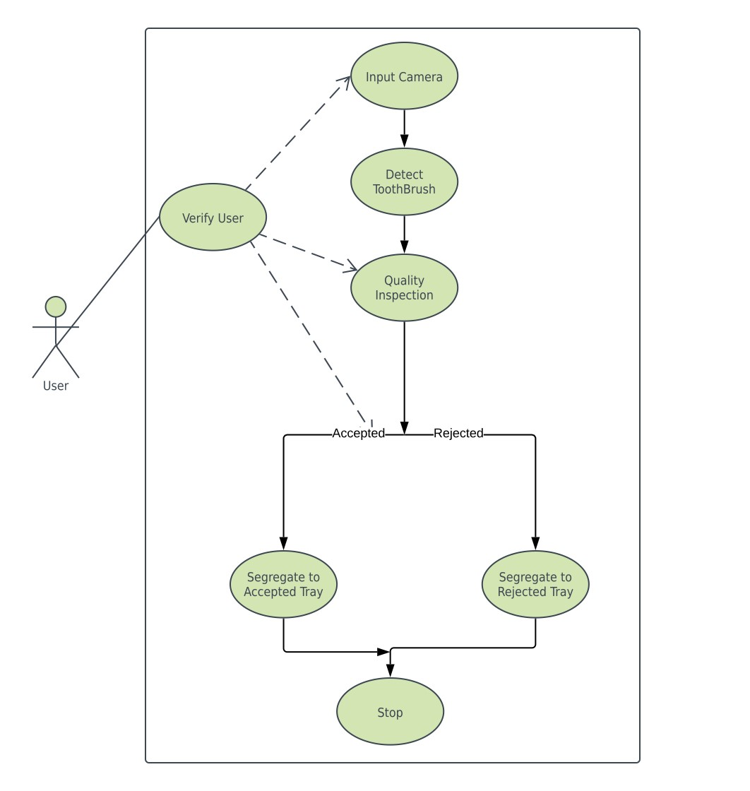

Fig. 5.1.4 Use Case Diagrams

**5.1.5 Morphological Chart:**

|  |  |  |  |  |
| --- | --- | --- | --- | --- |
|  | Design 1 | Design 2 | Design 3 | Design 4 |
| Object detection | Camera      A device that records an image of an object on  a photosensitive surface. It is essentially a blackout box with an opening to let in focused light onto an intensified film or plate. | Ultrasound    Ultrasonic sensors are primarily used as proximity sensors. They can be found  in parking technology and anti-collision safety systems. | Laser        "Laser" is an acronym for light amplification by stimul ated emission. | IR    **Infrared sensors** (IR **sensors) are** radiation-sensitive optoelectronic **component s** with spectral sensitivity in the infrared wavelength range **of** 780 nm **...** 50 **µm.** |
| Wireless support | Bluetooth    Bluetooth is a short-  range wireless technology standard used for  data **exchange** between  fixed and mobile devices over short distances and **within buildings...** | WIFI    A wireless or Wi-Fi network uses radio  frequency **signals** inste ad of wires to connect devices such as computers, printers and smartphones to the Internet and **to** each other. | RFID      **Radio Frequency**  **Identification** (RFID) uses electromagnetic fields to automatically identify and track tags attached to objects.  RFID **systems are...** |  |
| Processor | Arduino      Arduino is an **open source** electronics platform based on easyto-use hardware and software.. | Raspberry PI        Raspberry Pi **can be used** to learn programming skills,  build hardware projects,  home automation, implement Kubernetes  clusters  and **edge** computing, and even **be used** in industrial applications. | STEM 32      STM32  microcontrollers offer a **wide range** of serial and parallel  communication peripherals **to connect** with all **types** of electronic components **such as** sensors, displays, cameras, motors, etc. | Intel Edison        The Intel Edison board is a **very good** singleboard **computing** platform **on which** you **can** build **awes**  **ome things** like the Arduino. **Edison** can use platforms **such as** Arduino and **Eclipse.** |
| Movement | BLDC Motor        A motor converts **the** supplied electrical energy into mechanical energy. Various types of motors are **commonly used. These**  **include** brushless **direc t**  **current** motors **(BLDC**  **).** | Stepper Motor      A stepper motor, also known as **a**  **stepper** motor or **stepper** motor, is a brushless DC electric motor that divides **one revolution** into a number of equal steps. | Servo Motor      Servo **motors,** or **other wise known** as **"servos,"** ar e electronic devices and rotary or linear  actuators  that **precisely** rotate **or** push machine **parts.** Servos  are **primarily** used **for**  angular or  linear **positions** and specific **velocities** and **accelerations.** | Hydraulics      **Hydraulic** motors for many **applications** such as winches, crane  drives, **selfpropelled** cranes, excavators, mixer and agitator drives, **rolling mills.** |
| Conveyor type | Motor    AC induction motors are ideal for conveyor systems that operate continuously in one direction. | Rack and Pinion        **Rack** and pinion **gears have** two  main **functions. It converts the rotary motion** of the steering **wheel** into the linear motion **required to turn** the wheels **of the vehicle.** |  |  |
| Indication | LED        A **light emitting** diode  (LED) is a semiconductor device that emits light when **an electric** current **is passed** through it. | Buzzer    A buzzer or **buzzer** is **a** mechani cal, electromechanical, or piezoelectric **audible signalling device.** | Display        **A** device with a screen that displays characters or graphics representing data in computer memory. | Speaker      **A** device **that converts** electrical energy into **acoustic** signal energy **and radiates it indoors** or **outdoors.** |

Fig. 5.1.5 Morphological Chart

**5.2 Conceptual Sketches:**

**Concept A:**

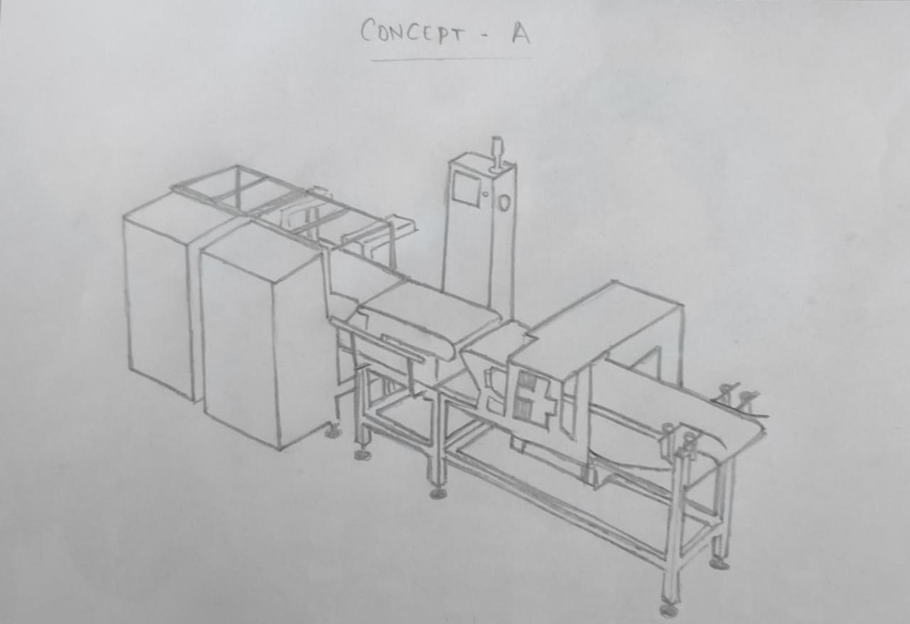

**Concept B:**

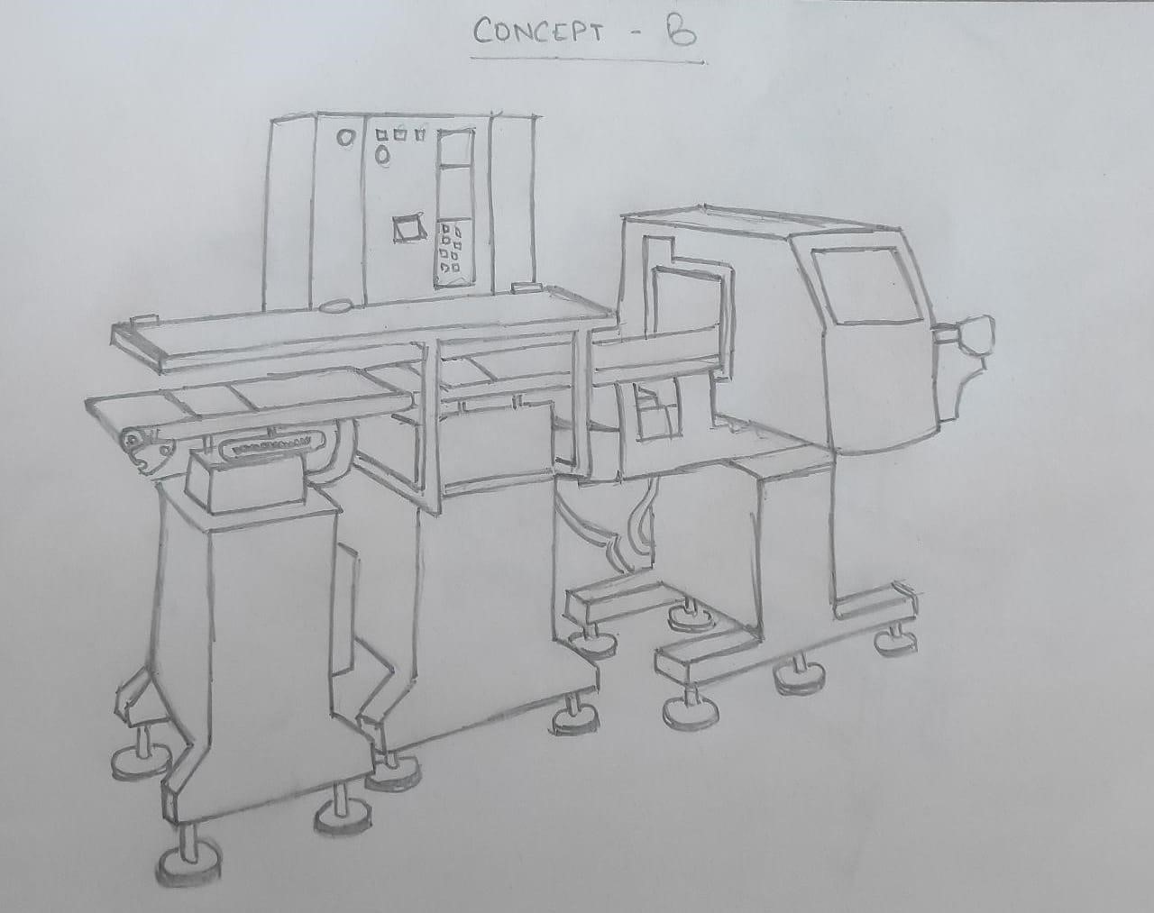

**Concept C:**

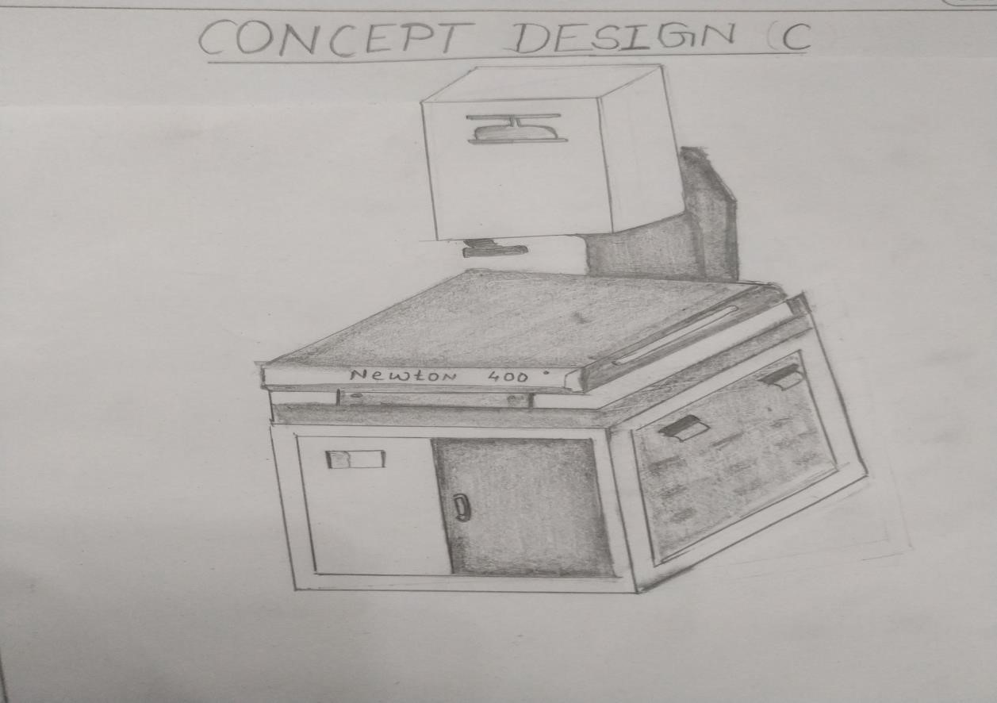

**Concept D:**

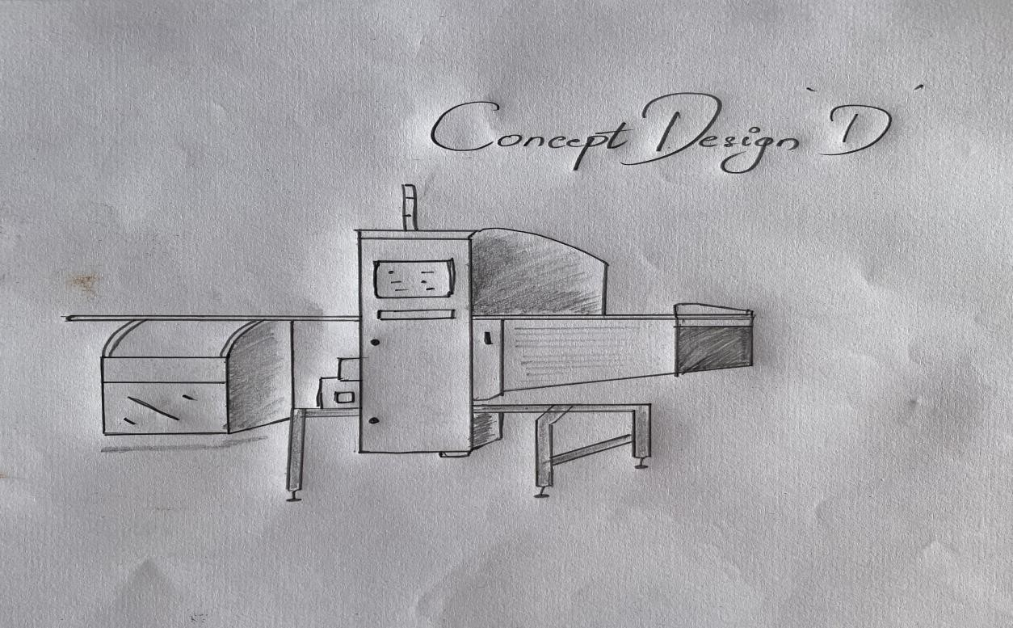

**5.2.1 Concept Screening:**

Table 5.2.1 Concept Screening

|  |  |  |  |  |  |  |  |
| --- | --- | --- | --- | --- | --- | --- | --- |
| Selection criteria | Concept B | Concept A | Concept C | | Conce D | pt | Reference |
| **Ease of**  **operation** | + | + | + | + | | 0 | |
| **Ease of**  **manufacturing** | - | - | - | 0 | | 0 | |
| **Object Detection** | + | + | - | - | | 0 | |
| **Load Detection** | 0 | 0 | 0 | 0 | | 0 | |
| **Processor** | - | + | + | - | | 0 | |
| **Power**  **Efficiency** | - | 0 | - | + | | 0 | |
| **Human**  **interaction** | + | + | - | - | | 0 | |
| **Safety** | 0 | + | + | - | | 0 | |
| **Durability** | 0 | - | - | + | | 0 | |
| **Portability** | - | 0 | 0 | + | | 0 | |
| **Cost efficiency** | 0 | - | - | 0 | | 0 | |
| PLUS | 3 | 5 | 3 | 4 | |  | |
| SAME | 3 | 3 | 2 | 3 | |
| MINUS | 4 | 3 | 6 | 4 | |
| NET | -1 | 2 | -  3 | 0 | |
| RANK | 3 | 1 | 5 | 2 | |
| CONTINUE? | NO | YE  S | N  O | YES | |
|  |  |  |  |  | |

**5.2.3 Concept Scoring:**

Table 5.2.3 Concept Scoring

|  |  |  |  |  |  |
| --- | --- | --- | --- | --- | --- |
|  |  |  | **Concept A** |  | **Concept D** |
| **Selection Criteria** | **Weights** | **R a**  **t i**  **n**  **g** | **Weighted Score** | **R a t i**  **n**  **g** | **Weighted Score** |
| **Ease of operation** | 20% | 3 | 0.60 | 3 | 0.60 |
| **Ease of manufacturing** | 12% | 4 | 0.48 | 2 | 0.24 |
| **Object Detection** | 10% | 3 | 0.30 | 3 | 0.30 |
| **Load Detection** | 10% | 4 | 0.40 | 3 | 0.30 |
| **Processor** | 10% | 2 | 0.20 | 3 | 0.30 |
| **Power Efficiency** | 8% | 2 | 0.16 | 3 | 0.24 |
| **Human interaction** | 8% | 3 | 0.24 | 3 | 0.24 |
| **Safety** | 6% | 3 | 0.18 | 4 | 0.24 |
| **Durability** | 6% | 2 | 0.12 | 2 | 0.12 |
| **Portability** | 5% | 2 | 0.10 | 3 | 0.15 |
| **Cost efficiency** | 5 | 3 | 0.15 | 2 | 0.10 |
| Total Sc | ore |  | 2.93 |  | 2.8 3 |
| Ra | nk |  | 1 |  | 2 |
| Continu | e? |  | Develop |  | No |

**5.2.4 Selected Concept:**

**Concept A:**



###### 5.3 Bill of Material

A bill of materials (BOM) is data that identifies the elements or raw materials used to produce a physical thing, whether it be a design or a product.

Table 5.3 BOM

|  |  |  |  |
| --- | --- | --- | --- |
| SR No | Material | Qty | Cost (Rs) |
| 1 | Arduino | 1 | 1,000 |
| 2 | Brushless motor | 1 | 599 |
| 3 | Mild Steel 2mm Box Pipe | 16 | 47/KG |
| 4 | Servo Motor | 1 | 250 |
| 5 | Steel Plate 2mm(4*4) | 1 | 875 |
| 6 | Steel Pipe 15’ | 2 | 70/KG |
| 7 | Wires | 2 | 100 |
| 8 | Bearing (35mm) | 4 | 180 |
| 9 | LED light | 4 | 80/pc |
| 10 | Foam Sheet | 2 | 349 |
| 11 | Webcam | 1 | 599 |
| 12 | M2 Nut & bolt | 20 | 100 |
| 13 | Rexine Conveyor Belt | 1 | 1503 |
| 14 | Switch | 1 | 99 |

**5.4 The final list of hardware essential components:**

All the vital hardware components that we necessary for the project to meet the requirements are as follow,

**5.4.1 Arduino:** Arduino is an open-source platform used to create electronics projects. Arduino is a combination of a physical programmable circuit board (often called a microcontroller) and a software or IDE (Integrated Development Environment) that runs on a computer and is used to write computer code and upload it to the physical board).

Arduino hardware and software are designed for artists, designers, hobbyists, hackers, beginners, and anyone interested in creating interactive objects and environments. Arduino can interact with buttons, LEDs, motors, speakers, GPS devices, cameras, the internet, and even smartphones and TVs. This flexibility, coupled with the fact that the Arduino software is free, hardware boards are fairly inexpensive, and both software and hardware are easy to learn, provide a wide variety of Arduino code and instructions for a large number of users. resulting in a large community. I have released an Arduino based project.

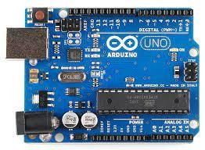

Fig 5.4.1 Arduino

**5.4.2 Brushless Motor:** A motor converts the supplied electrical energy into mechanical energy. Various types of motors are commonly used. Among them, brushless DC (BLDC) motors are widely used in many applications due to their high efficiency and excellent controllability. Brushless DC motors do not use brushes. With brushed motors, the brushes deliver current through the commutator into the coils on the rotor.

So how does a brushless motor pass current to the rotor coils? It doesn’t—because the coils are not located on the rotor. Instead, the rotor is a permanent magnet; the coils do not rotate, but are instead fixed in place on the stator. Because the coils do not move, there is no need for brushes and a commutator.

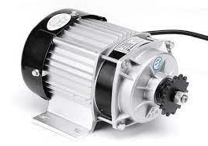 Fig. 5.4.2 BLDC Motor

**5.4.3 Servo-motor:** Servo motors, or as they are known as "servos", are electronic devices and rotary or linear actuators that precisely rotate or push machine parts. Servos are primarily used for angular or linear positions and specific velocities and accelerations.

A servo motor is a type of motor that can rotate with great precision. This type of motor typically consists of a control circuit that provides feedback on the current position of the motor shaft. This feedback allows the servo motor to rotate with great precision. Use servo motors when you want to rotate an object by a specific angle or distance. It consists of a simple motor operated via a servomechanism. A motor driven by a DC power supply is called a DC servo motor, and an AC motor is called an AC servo motor.

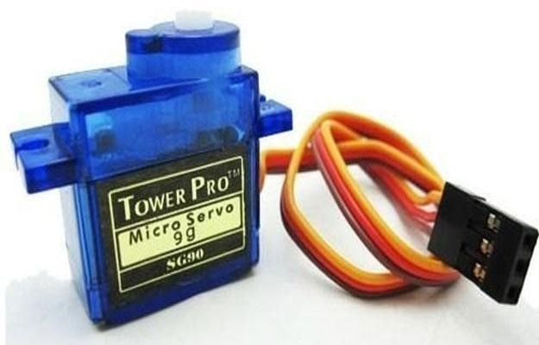

Fig. 5.4.3 Servo-Motor

**5.4.4 Bearing:** Bearings enhance machine functionality and contribute to energy conservation. Bearings are hidden in invisible machines and work quietly in harsh environments. Still, rolling bearings are essential to ensure stable machine operation and top performance.

The word "carry" includes the meaning "to carry", which means "to support" or "to bear a burden". This refers to the fact that the bearing supports and carries the load of the rotating shaft.

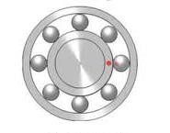

Fig. 5.4.4 Bearing

**5.4.5 LED Lights:** The LED has a leg over common orthodox incandescent light in terms of efficiency, low consumption power, compact size, longer range and an ability to retain the quality for a longer period of time. It comes with a wide variety of applications ranging from automotive headlamps, camera flashes, aviation lighting, traffic signal, and medical devices.LEDs are PN junction diodes that are primarily used as an alternative to incandescent lamps. It is based on the electroluminescence effect, the process by which a diode converts current into light when electrons change state in the LED semiconductor.

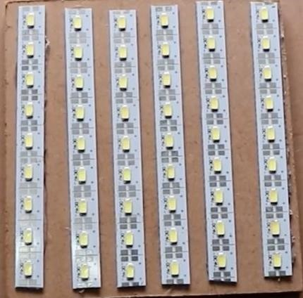

Fig. 5.4.5 LED Lights

**5.4.6 Web-Camera:** A webcam is a small digital video camera that connects to your computer. Also known as a webcam that can take pictures and videos. These cameras come with software that must be installed on your computer to stream video in real time over the internet. You can capture images, including HD video, but the video quality may be lower than other camera models.Webcam functionality is primarily dependent on your computer's processor and computer's operating system. It can offer advanced features such as image archiving, motion detection, custom encoding, and even automation. Additionally, webcams are used for social video recording, video broadcasting, computer vision, and are primarily used for security surveillance and video conferencing.



Fig. 5.4.6 Web Camera

**5.4.7 Conveyor Belt**: A conveyor belt is a system for transporting or moving physical objects such as materials, goods or even people from one point to another. Unlike other conveyors that use chains, spirals, hydraulics, etc., belt conveyors use belts to move items. This is a loop of flexible material strung between pulleys driven by an electric motor.

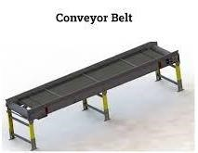

Fig. 5.4.7 Conveyor Belt

###### 5.5 SOFTWARE: SolidWorks

**SolidWorks** is one of SolidWorks Corporation's products based on the Dassault Systems 3D Experience platform. SolidWorks Mechanical Design Automation software is a featurebased, parametric solid modelling design tool that enables designers to quickly sketch ideas, experiment with features and dimensions, and create models and detailed drawings. It uses an easy-to-use Windows graphical user interface, allowing designers to use simple drag-anddrop (DD) and copy-and-paste functionality just like in Windows. Many of the icons for Print, Open, Cut, Save, etc. are also part of the SolidWorks application, familiar with Windows functionality. When you create a model in SolidWorks, it exists and you can visualize it in 3D.

SolidWorks is organized into three basic types: part mode, assembly mode, and drawing mode. Part mode is the basic building block of this software. For example, you must create the parts before creating the assembly. Assembly mode contains parts or other assemblies called subassemblies.

**5.5.1** **MOTOR SPECIFICATION:**

Permanent magnet synchronous motors (PMSM or brushless DC motors) are used in many industrial applications due to their high efficiency, high torque, and small volume. Research was conducted using genetic algorithms to develop a complete model of the BLDC motor and design an optimal controller for its position control.

Table 5.5.1 Motor Specification

|  |  |
| --- | --- |
| Number of poles | 8 |
| Stator resistance | 0.0905 ohms |
| Stator inductance | 0.11 mH |
| Rated Torque | 50 Nm |
| Rated Speed | 140 deg/sec |
| Bandwidth | 6-8 Hz |
| Supply voltage | 28 V |
| Nominal current | 11 A |
| Sampling period | 10µs |
| Friction constant | 0.0001 Kg-m s/rad |
| Motor moment of Inertia | 0.000018395 Kg-m s2 /rad |

**5.5.2 SolidWorks Model:**

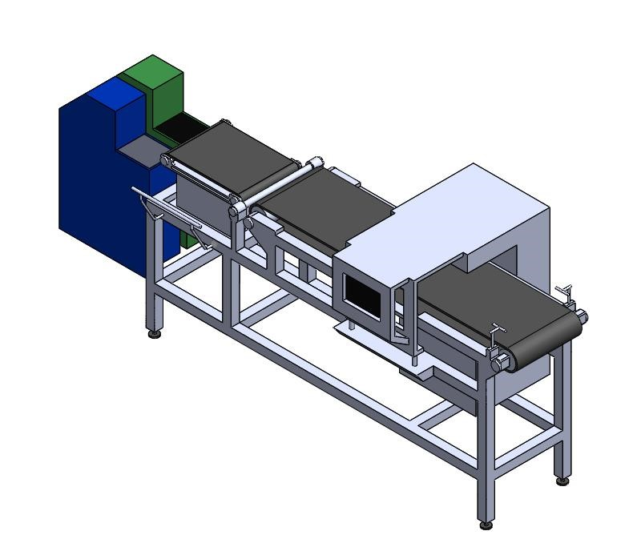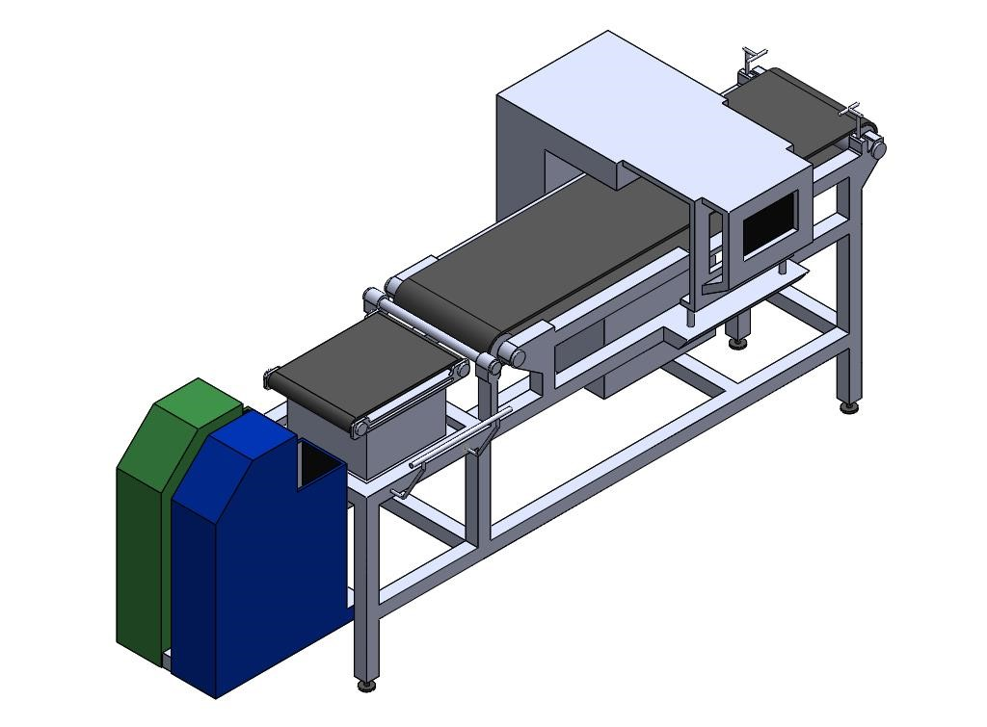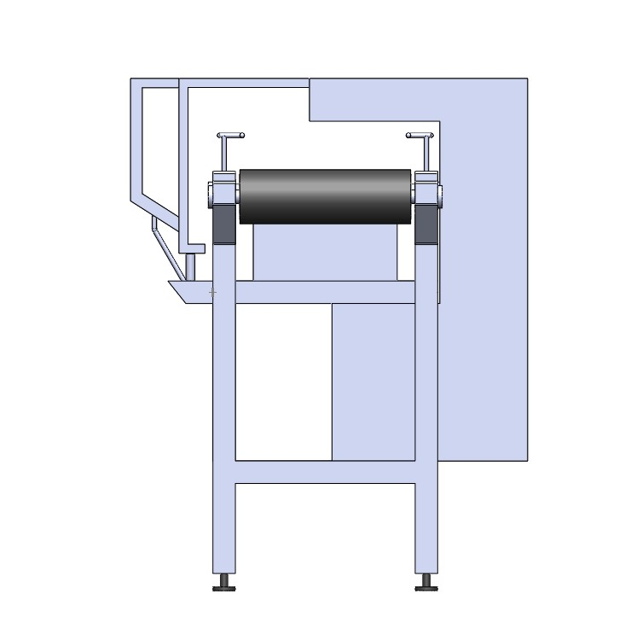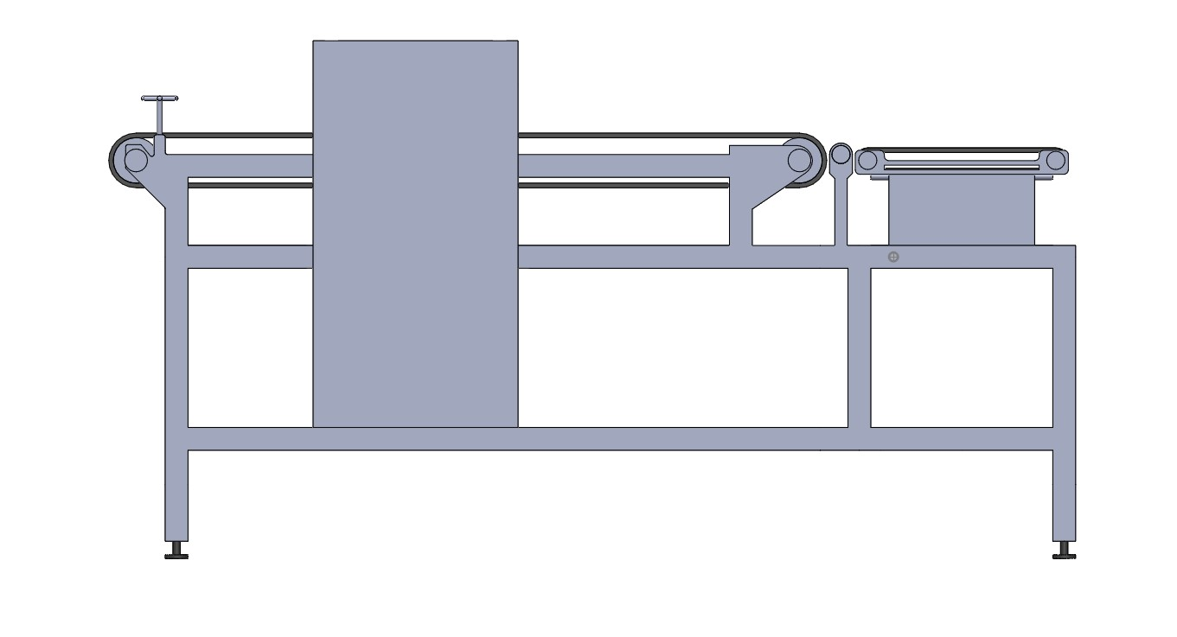

**5.5.3 Part Drawing:**

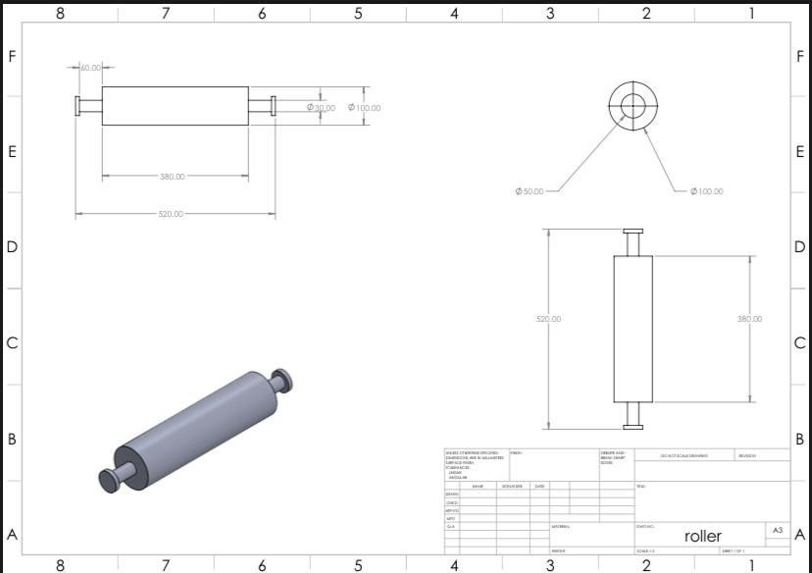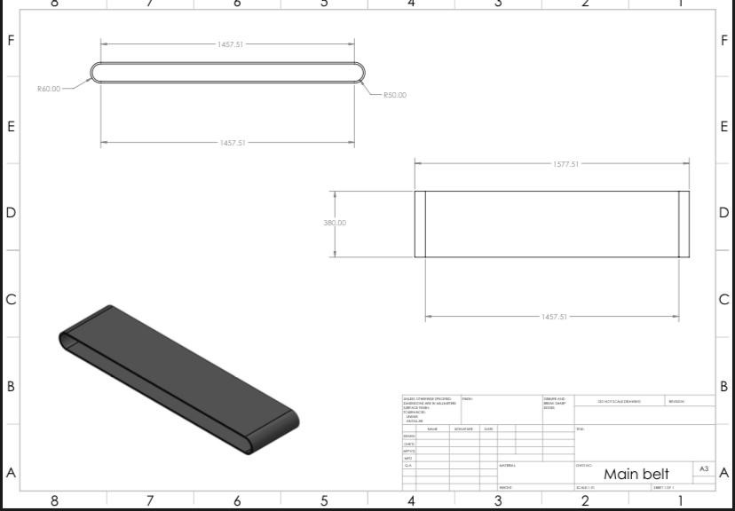

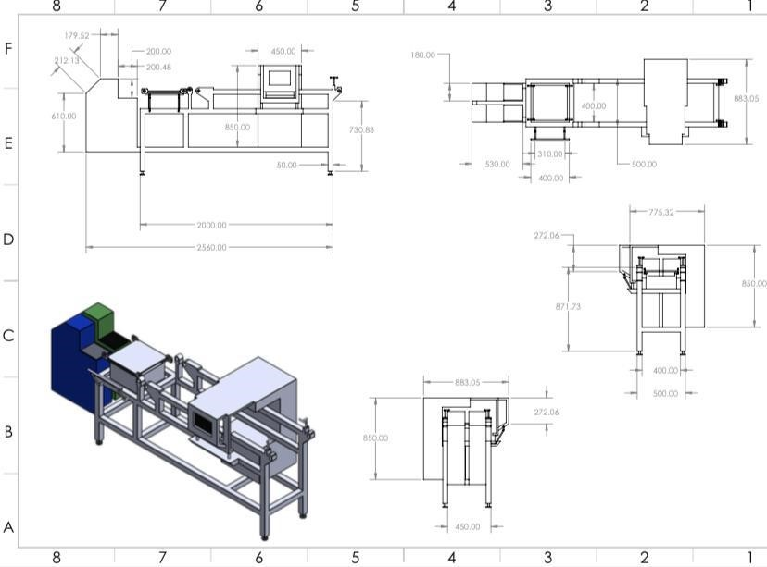

**5.5.4 Material Selection:**

Table 5.5.4 Material Selection

|  |  |  |
| --- | --- | --- |
| **Part** | **Material Used** | **Qty** |
| Chassis Frame | Mild Steel 2mm Box Pipe | 16 |
| Casing | 2mm Steel Plate (4x4) | 1 |
| Roller | 15’ Steel Pipe | 2 |
| Bearing | 35mm | 4 |
| Collection Box | Foam Sheet | 2 |
| Shaft | 16mm | 4 |
| Conveyor Belt | Rexine | 1 |
| LED | Electric Component | 1m |

**5.5.5 Dataset Samples:**

We have collected data set of 1000 images in Accepted Samples and 1000 Images in rejected samples and 1000 empty background images, and we have trained them accordingly. We collected these data sets with different lighting conditions, angle, Distance, Focus, Position and angle. These datasets were captured on a Canon 700D Camera which had a 20MP Image sensor, The reason behind using this camera is because the toothbrushes have tiny bristles and this camera can capture the tiny details clearly, We used the same camera for the model the get better accuracy.

##### • Rejected Samples—

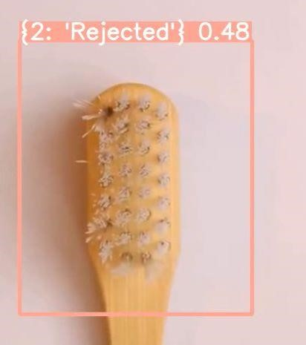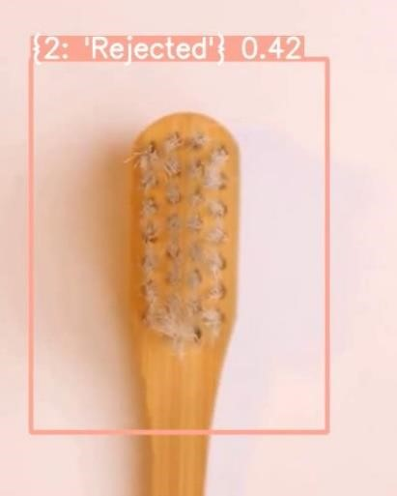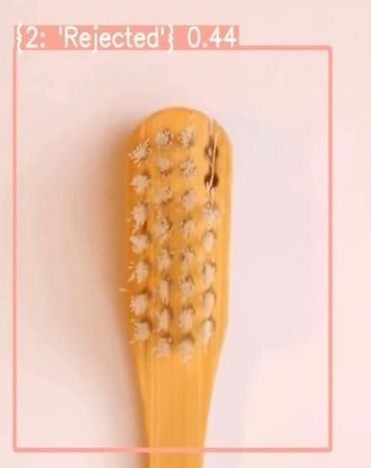

#### • Accepted Samples—

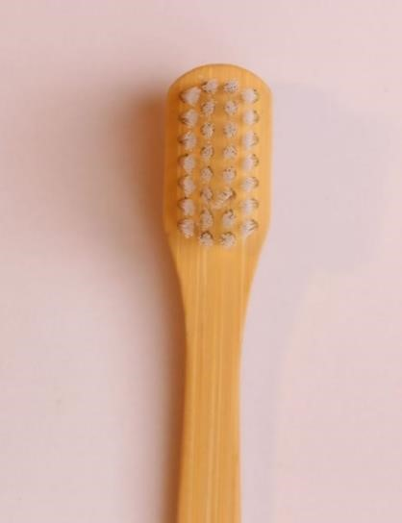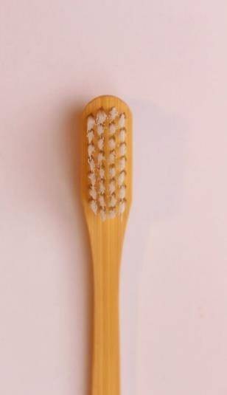

##### 5.6 Algorithm Used: Classifier Algorithm

Classification algorithms are used to classify data into classes or categories. It can be done with both structured and unstructured data. There are three types of classification: binary classification, multiclass classification, and multilabel classification.

A function that weights the input characteristics so that the output separates one class into positive values and the other class into negative values.

**Logistic regression**: Is a calculation used to predict a binary outcome: either something happens, or does not. This can be exhibited as Yes/No, Pass/Fail, Alive/Dead, etc. Independent variables are analysed to determine the binary outcome with the results falling into one of two categories. The independent variables can be categorical or numeric, but the dependent variable is always categorical. Written like this:

**P(Y=1|X) or P(Y=0|X)**

It calculates the probability of dependent variable Y, given independent variable X. This can be used to calculate the probability of a word having a positive or negative connotation (0, 1, or on a scale between). Or it can be used to determine the object contained in a photo (tree, flower, grass, etc.), with each object given a probability between 0 and 1.

**5.6.1 PyCharm:**

PyCharm is a purpose-built Python integrated development environment (IDE) that provides Python developers with a wide range of essential tools that are tightly integrated to create a working environment for productive Python, web, and data science development.

The main reason PyCharm created this IDE was for Python programming and running on multiple platforms like Windows, Linux and macOS. The IDE includes code analysis tools, debuggers, testing tools, and version control options. It also supports developers creating Python plugins using the various APIs available. IDEs let you work directly with multiple databases without integrating with other tools. This IDE is built specifically for Python, but can also be used to create HTML, CSS, and JavaScript files. It also comes with a beautiful user interface that can be customized with plugins to suit your needs.

**5.6.2 OpenCV:**

OpenCV (Open-Source Computer Vision Library) is an open-source computer vision and machine learning software library. OpenCV was developed to provide a common infrastructure for computer vision applications and accelerate the use of machine vision in commercial products.

This library has over 2500 optimized algorithms, including a comprehensive set of classical and cutting-edge computer vision and machine learning algorithms. Use these algorithms to detect and recognize faces, identify objects, classify human behavior in videos, track camera motion, track moving objects, extract 3D models of objects, and 3D from stereo cameras. Generate point clouds and stitch images together to generate high resolution. Image resolution for the entire scene, searching for similar images from image databases, removing red-eye from images taken with flash, tracking eye movements, detecting landscapes, creating markers for overlaying with augmented reality, and more. OpenCV has a community of over 47,000 users and over 18 million estimated downloads. This library is widely used by companies, research groups, and government agencies.

**5.7 CODE**: Code for Image detection, object detection using Open CV and actuation using Arduino.

import os import cvzone

from cvzone.ClassificationModule import Classifier import cv2 cap = cv2.VideoCapture(1)

classifier = Classifier('Resources/Model/keras_model.h5',

'Resources/Model/labels.txt')

imgArrow = cv2.imread('Resources/arrow.png', cv2.IMREAD_UNCHANGED) classIDBin =

0

# Import all the brush images imgWasteList = [] pathFolderWaste = "Resources/Waste" pathList = os.listdir(pathFolderWaste) for path in pathList:

imgWasteList.append(cv2.imread(os.path.join(pathFolderWaste, path),

cv2.IMREAD_UNCHANGED))

# Import all the bin images imgBinsList = [] pathFolderBins = "Resources/Bins" pathList = os.listdir(pathFolderBins) for path in pathList:

imgBinsList.append(cv2.imread(os.path.join(pathFolderBins, path),

cv2.IMREAD_UNCHANGED))

# 0 = Accepted # 1 = Rejected classDic = {0: None,

1: 2,

2: 0} while True: _, img = cap.read()

imgResize = cv2.resize(img, (454, 340))

imgBackground = cv2.imread('Resources/background.png')

predection = classifier.getPrediction(img) classID = predection[1] print(classID) if classID != 0:

imgBackground = cvzone.overlayPNG(imgBackground, imgWasteList[classID -

1], (909, 127))

imgBackground = cvzone.overlayPNG(imgBackground, imgArrow, (978, 320)) classIDBin = classDic[classID]

imgBackground = cvzone.overlayPNG(imgBackground, imgBinsList[classIDBin],

(895, 374))

imgBackground[148:148 + 340, 159:159 + 454] = imgResize

# Displays

# cv2.imshow("Image", img) cv2.imshow("Output", imgBackground) cv2.waitKey(1)

#include <Servo.h>

#define numOfValsRec 1

#define digitsPerValRec 1

Servo servoAccept; Servo servoReject; int valsRec[numOfValsRec];

int stringLength = numOfValsRec * digitsPerValRec + 1; //$00 int counter = 0; bool counterStart = false; String receivedString; void setup() { Serial.begin(9600); servoAccept.attach(7);

} void receiveData(){

while(Serial.available())

{

char c = Serial.read(); if (c=='$'){ counterStart = true;

}

if (counterStart){ if (counter < stringLength){

receivedString = String(receivedString+c); counter++;

}

if (counter >=stringLength){

//$00

for(int i = 0; i<numOfValsRec; i++)

{

int num = (i*digitsPerValRec)+1;

valsRec[i] = receivedString.substring(num,num + digitsPerValRec).toInt();

}

receivedString = ""; counter = 0;

counterStart = false;

}

}

} } void loop() { receiveData();

if (valsRec[0] == 1){servoAccept.write(180);}else{servoAccept.write(0);}

##### 5.8 Working Prototype

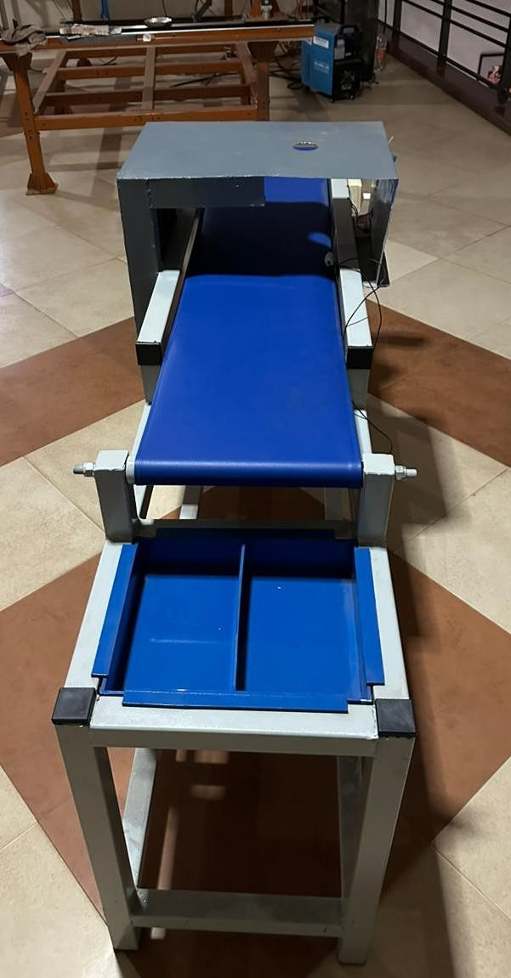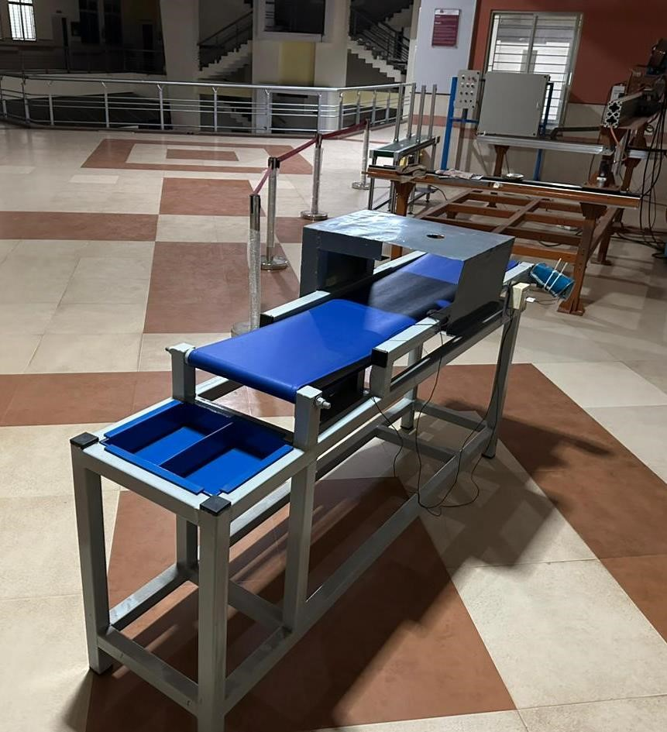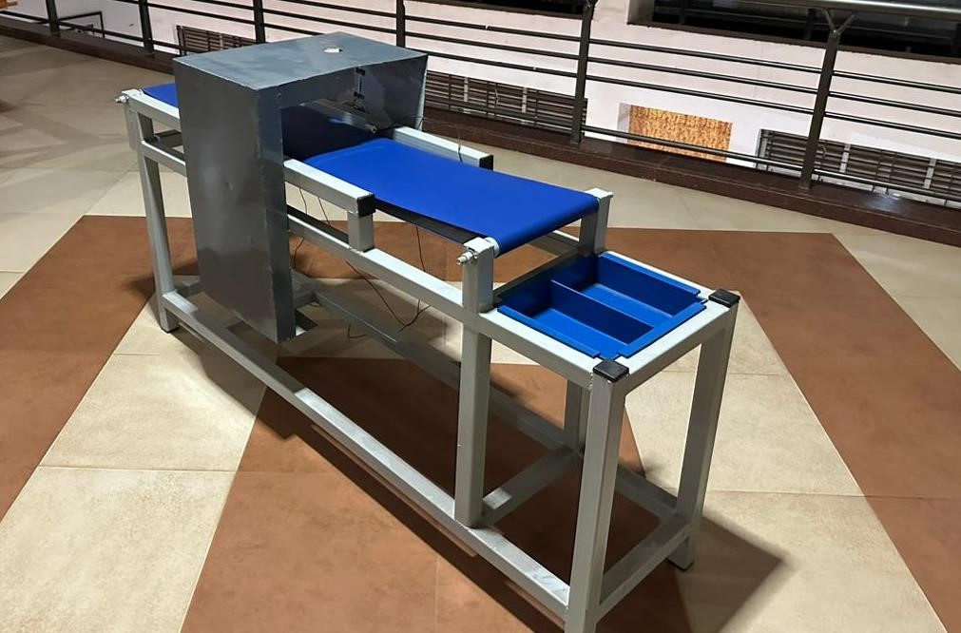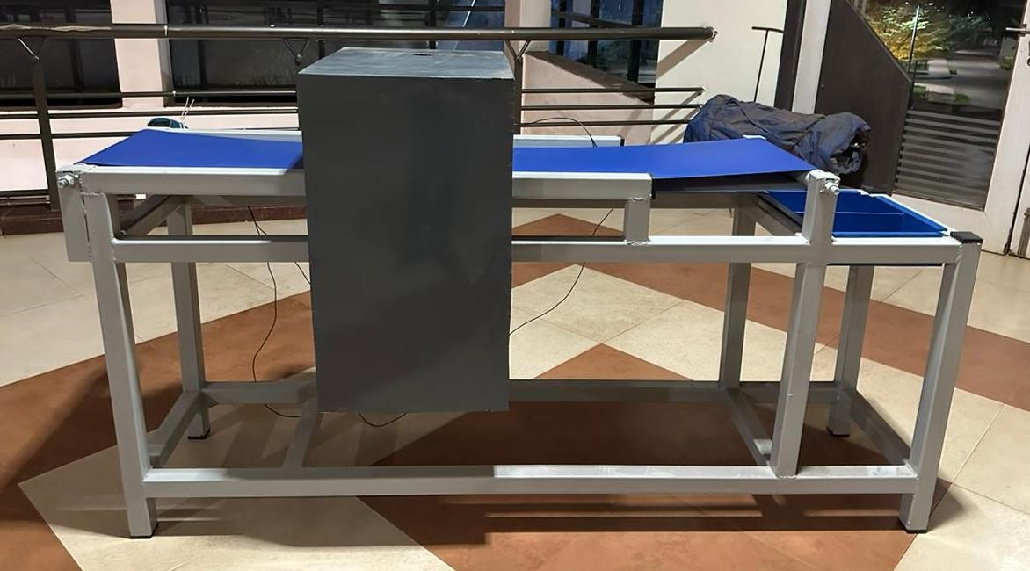

#### CHAPTER 6

##### RESULTS AND CONCLUSION

**Result:**

Proposed Inspection system is Semi-Automated, computer vision-based application used to inspect tooth brushes,

Proposed a new model architecture called Quality Inspection model. The model is SemiAutomated, computer vision is mostly used at the quality control stage.

Using Machine learning based algorithms, the tooth brush is detected in an image obtained from the camera placed on the assembly line and then classified as "accepted" or "not accepted" with the help of machine learning methods and it detects real time. After the machine learning-based quality control, we segregate manually so that we the "accepted" products is in accepted box and rejected products is in rejected box. So that accepted one’s are ahead move to the distributors plant and the rejected one’s are bifurcated.

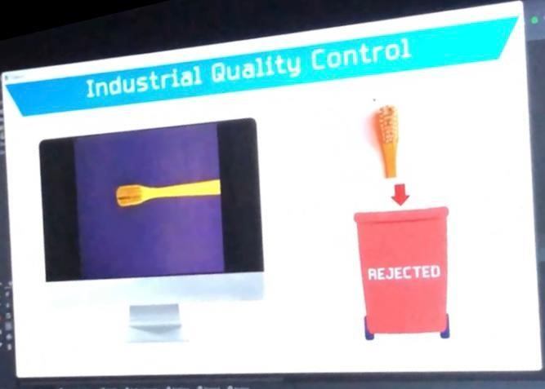

Rejected Sample

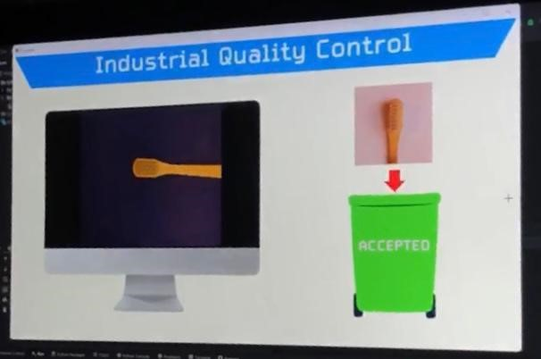

Accepted Sample

**Conclusion:**

The Quality Inspection system designed and developed in this project has successfully achieved its goal of accurately and efficiently segregating accepted and rejected toothbrushes. The system, which is implemented on a conveyor system, has shown good results in terms of its ability to identify toothbrushes that meet the required standards and to reject those that do not. Overall, this project has provided valuable solution to the problem of ensuring the quality of toothbrushes, and it has the potential to improve the efficiency and reliability of the tooth brush manufacturing process.

Based on the additional information provided, it appears that the project utilized image processing techniques using OpenCV and TensorFlow to identify the quality of toothbrushes. This likely involved training a machine learning model to recognize different qualities of toothbrushes based on their visual characteristics. The model was then used to automatically inspect toothbrushes and segregate them into accepted and rejected categories. This implementation likely made the inspection process more efficient and accurate compared to traditional methods. Overall, the use of image processing and machine learning in this project has likely contributed to the development of better quality control methods in the toothbrush manufacturing industry.

Quality inspection devise can help improve the efficiency of the manufacturing process. By automating the inspection and sorting process, the quality control machine can help speed up the production line and reduce the need for manual labour. This can help the manufacturer produce more products in a shorter amount of time. The accuracy of the device is **86%.**

#### References

1. [**https://www.thebetterindia.com/82441/bamboo-india-socialenterprise-pune-farmers-yogeshshinde/#:~:text=Just%20in%20India%2C%20more%20than,bi odegrade%20for%20thousands%20of%20years.**](https://www.thebetterindia.com/82441/bamboo-india-social-enterprise-pune-farmers-yogesh-shinde/#:~:text=Just%20in%20India%2C%20more%20than,biodegrade%20for%20thousands%20of%20years)
2. [**https://markmeets.com/features/understanding-themanufacturing-process-behind-toothbrush/**](https://markmeets.com/features/understanding-the-manufacturing-process-behind-toothbrush/)
3. [**https://arxiv.org/pdf/1704.04861v1.pdf**](https://arxiv.org/pdf/1704.04861v1.pdf)

1. [**https://medium.datadriveninvestor.com/5-ai-ml-researchpapers-on-object-detection-you-must-read-7432e9d2a6f6**](https://medium.datadriveninvestor.com/5-ai-ml-research-papers-on-object-detection-you-must-read-7432e9d2a6f6)

1. [**https://openaccess.thecvf.com/content_CVPR_2020/papers/Beer y_Context_R-CNN_Long_Term_Temporal_Context_for_PerCamera_Object_Detection_CVPR_2020_paper.pdf**](https://openaccess.thecvf.com/content_CVPR_2020/papers/Beery_Context_R-CNN_Long_Term_Temporal_Context_for_Per-Camera_Object_Detection_CVPR_2020_paper.pdf)
2. [**https://openaccess.thecvf.com/content_CVPR_2020/papers/Tan_**](https://openaccess.thecvf.com/content_CVPR_2020/papers/Tan_EfficientDet_Scalable_and_Efficient_Object_Detection_CVPR_2020_paper.pdf)

[**EfficientDet_Scalable_and_Efficient_Object_Detection_CVPR_2 020_paper.pdf**](https://openaccess.thecvf.com/content_CVPR_2020/papers/Tan_EfficientDet_Scalable_and_Efficient_Object_Detection_CVPR_2020_paper.pdf)

1. [**https://medium.datadriveninvestor.com/5-ai-ml-researchpapers-on-object-detection-you-must-read-7432e9d2a6f6**](https://medium.datadriveninvestor.com/5-ai-ml-research-papers-on-object-detection-you-must-read-7432e9d2a6f6)
2. [**https://www.choice.com.au/health-and-body/dentists-and-dentalcare/dental-products/articles/eco-friendly-toothbrushes**](https://www.choice.com.au/health-and-body/dentists-and-dental-care/dental-products/articles/eco-friendly-toothbrushes)
3. [**https://openaccess.thecvf.com/content_cvpr_2017/papers/Huang**](https://openaccess.thecvf.com/content_cvpr_2017/papers/Huang_SpeedAccuracy_Trade-Offs_for_CVPR_2017_paper.pdf)

[**_SpeedAccuracy_Trade-Offs_for_CVPR_2017_paper.pdf**](https://openaccess.thecvf.com/content_cvpr_2017/papers/Huang_SpeedAccuracy_Trade-Offs_for_CVPR_2017_paper.pdf)

1. [**https://8.makesense.io/**](https://8.makesense.io/)
2. [**https://www.solidworks.com/**](https://www.solidworks.com/)
3. [**https://colab.research.google.com/**](https://colab.research.google.com/)
4. [**https://jupyter.org/**](https://jupyter.org/)
5. [**https://medium.datadriveninvestor.com/5-ai-ml-researchpapers-on-object-detection-you-must-read-7432e9d2a6f6**](https://medium.datadriveninvestor.com/5-ai-ml-research-papers-on-object-detection-you-must-read-7432e9d2a6f6)
6. [**https://app.diagrams.net/**](https://app.diagrams.net/)
7. [**https://www.arduino.cc/reference/en/libraries/**](https://www.arduino.cc/reference/en/libraries/)
8. [**http://openaccess.thecvf.com/content_CVPR_2020/papers/Tan_**](http://openaccess.thecvf.com/content_CVPR_2020/papers/Tan_EfficientDet_Scalable_and_Efficient_Object_Detection_CVPR_2020_paper.pdf)

[**EfficientDet_Scalable_and_Efficient_Object_Detection_CVPR_2 020_paper.pdf**](http://openaccess.thecvf.com/content_CVPR_2020/papers/Tan_EfficientDet_Scalable_and_Efficient_Object_Detection_CVPR_2020_paper.pdf)

1. [**http://openaccess.thecvf.com/content_ICCV_2019/papers/Howar d_Searching_for_MobileNetV3_ICCV_2019_papr.pdf**](http://openaccess.thecvf.com/content_ICCV_2019/papers/Howard_Searching_for_MobileNetV3_ICCV_2019_papr.pdf)
2. [**https://www.lucidchart.com/pages/landing/flowchartsoftware?utm_source=google&utm_medium=cpc&utm_campaig n=_chart_en_tier3_desktop_search_nb_exact_&km_CPC_Camp aignId=2083826535&km_CPC_AdGroupID=76733726837&km_ CPC_Keyword=online%20flowchart&km_CPC_MatchType=e &km_CPC_ExtensionID=&km_CPC_Network=g&km_CPC_A dPosition=&km_CPC_Creative=442345704234&km_CPC_Targ etID=kwd-**](https://www.lucidchart.com/pages/landing/flowchart-software?utm_source=google&utm_medium=cpc&utm_campaign=_chart_en_tier3_desktop_search_nb_exact_&km_CPC_CampaignId=2083826535&km_CPC_AdGroupID=76733726837&km_CPC_Keyword=online%20flowchart&km_CPC_MatchType=e&km_CPC_ExtensionID=&km_CPC_Network=g&km_CPC_AdPosition=&km_CPC_Creative=442345704234&km_CPC_TargetID=kwd-1637899288&km_CPC_Country=9040224&km_CPC_Device=c&km_CPC_placement=&km_CPC_target)

[**1637899288&km_CPC_Country=9040224&km_CPC_Device=c**](https://www.lucidchart.com/pages/landing/flowchart-software?utm_source=google&utm_medium=cpc&utm_campaign=_chart_en_tier3_desktop_search_nb_exact_&km_CPC_CampaignId=2083826535&km_CPC_AdGroupID=76733726837&km_CPC_Keyword=online%20flowchart&km_CPC_MatchType=e&km_CPC_ExtensionID=&km_CPC_Network=g&km_CPC_AdPosition=&km_CPC_Creative=442345704234&km_CPC_TargetID=kwd-1637899288&km_CPC_Country=9040224&km_CPC_Device=c&km_CPC_placement=&km_CPC_target)

[**&km_CPC_placement=&km_CPC_target=**](https://www.lucidchart.com/pages/landing/flowchart-software?utm_source=google&utm_medium=cpc&utm_campaign=_chart_en_tier3_desktop_search_nb_exact_&km_CPC_CampaignId=2083826535&km_CPC_AdGroupID=76733726837&km_CPC_Keyword=online%20flowchart&km_CPC_MatchType=e&km_CPC_ExtensionID=&km_CPC_Network=g&km_CPC_AdPosition=&km_CPC_Creative=442345704234&km_CPC_TargetID=kwd-1637899288&km_CPC_Country=9040224&km_CPC_Device=c&km_CPC_placement=&km_CPC_target)

1. [**https://www.geeksforgeeks.org/libraries-in-python/**](https://www.geeksforgeeks.org/libraries-in-python/)
2. [**https://www.makesense.ai/**](https://www.makesense.ai/)
3. [**https://teachablemachine.withgoogle.com/train/image**](https://teachablemachine.withgoogle.com/train/image)
4. [**https://www.jetbrains.com/pycharm/**](https://www.jetbrains.com/pycharm/)