**Name: Shivam Sinha**

**Reg. No.: 2148025 MDS 171 – Database Technologies**

**EXECUTING SQL QUERIES TO PERFORM VARIOUS ACTIONS ON A UNIVERSITY SCHEMA**

**Instructor (Instructor_id, Name, Designation, Dept_name)**

**Student (Stud_id, Name, DOB, Dept_name, Tot_credit (Default value is 0))**

1. **Create the above two tables for an OLAP applications.**

CREATE TABLE INSTRUCTOR(INST_ID NUMBER(38),INST_NAME VARCHAR(38),DESIGNATION VARCHAR(38),DEPT_NAME VARCHAR(38));

CREATE TABLE STUDENT(STUD_ID NUMBER(38),STUD_NAME VARCHAR(38),DOB DATE,DEPT_NAME VARCHAR(38),TOT_CREDIT NUMBER(4) DEFAULT 0);

1. **Insert the necessary values to execute the following queries.**

INSERT INTO STUDENT (STUD_ID,STUD_NAME,DOB,DEPT_NAME,TOT_CREDIT) VALUES (2148025,'SHIVAM','25-FEB-98','COMPUIER-SCIENCE',98);

INSERT INTO STUDENT (STUD_ID,STUD_NAME,DOB,DEPT_NAME,TOT_CREDIT) VALUES (2148002,'ASWIN','02-APR-97','PHYSICS',108);

INSERT INTO STUDENT (STUD_ID,STUD_NAME,DOB,DEPT_NAME,TOT_CREDIT) VALUES (2148045,'AISHWARYA','16-DEC-97','MATHS',105);

INSERT INTO STUDENT (STUD_ID,STUD_NAME,DOB,DEPT_NAME,TOT_CREDIT) VALUES (2148013,'KOMAL','31-MAR-99','PHYSICS',90);

INSERT INTO STUDENT (STUD_ID,STUD_NAME,DOB,DEPT_NAME,TOT_CREDIT) VALUES (2148019,'SAHIL','05-FEB-98','COMPUTER-SCIENCE',48);

INSERT INTO STUDENT (STUD_ID,STUD_NAME,DOB,DEPT_NAME,TOT_CREDIT) VALUES (2148033,'SAIF','21-OCT-98','COMPUTER-SCIENCE',88);

INSERT INTO STUDENT (STUD_ID,STUD_NAME,DOB,DEPT_NAME,TOT_CREDIT) VALUES (2148024,'ABHISHEK','13-DEC-96','PHYSICS',51);

INSERT INTO STUDENT (STUD_ID,STUD_NAME,DOB,DEPT_NAME,TOT_CREDIT) VALUES (2148016,'JOSHUA','23-AUG-97','MATHS',30);

INSERT INTO STUDENT (STUD_ID,STUD_NAME,DOB,DEPT_NAME,TOT_CREDIT) VALUES (2148028,'NEERAJ','05-JUN-99','MATHS',63);

INSERT INTO STUDENT (STUD_ID,STUD_NAME,DOB,DEPT_NAME,TOT_CREDIT) VALUES (2148030,'ADITYA','10-JUL-98','PHYSICS',99);

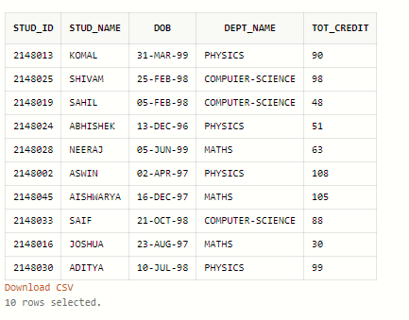

INSERT INTO INSTRUCTOR(INST_ID,INST_NAME,DESIGNATION,DEPT_NAME) VALUES (202101,'PROF. NEETHU','ASSOCIATE PROFESSOR','PHYSICS');

INSERT INTO INSTRUCTOR(INST_ID,INST_NAME,DESIGNATION,DEPT_NAME) VALUES (202111,'PROF. PIYAL','ASSISTANT PROFESSOR','MATHS');

INSERT INTO INSTRUCTOR(INST_ID,INST_NAME,DESIGNATION,DEPT_NAME) VALUES (202121,'PROF. VARUN','PROFESSOR','COMPUTER-SCIENCE');

INSERT INTO INSTRUCTOR(INST_ID,INST_NAME,DESIGNATION,DEPT_NAME) VALUES (202112,'PROF. RAINA','ASSOCIATE PROFESSOR','MATHS');

INSERT INTO INSTRUCTOR(INST_ID,INST_NAME,DESIGNATION,DEPT_NAME) VALUES (202123,'PROF. NAGRAJ','ASSISTANT PROFESSOR','COMPUTER-SCIENCE');

INSERT INTO INSTRUCTOR(INST_ID,INST_NAME,DESIGNATION,DEPT_NAME) VALUES (202129,'PROF. VENU','ASSOCIATE PROFESSOR','PHYSICS');

INSERT INTO INSTRUCTOR(INST_ID,INST_NAME,DESIGNATION,DEPT_NAME) VALUES (202109,'PROF. SANDRA','ASSOCIATE PROFESSOR','PHYSICS');

INSERT INTO INSTRUCTOR(INST_ID,INST_NAME,DESIGNATION,DEPT_NAME) VALUES (202113,'PROF. REGINA','PROFESSOR','MATHS');

INSERT INTO INSTRUCTOR(INST_ID,INST_NAME,DESIGNATION,DEPT_NAME) VALUES (202130,'PROF. GREGORY','ASSOCIATE PROFESSOR','MATHS');

INSERT INTO INSTRUCTOR(INST_ID,INST_NAME,DESIGNATION,DEPT_NAME) VALUES (202126,'PROF. BOBBY','PROFESSOR','COMPUTER-SCIENCE');

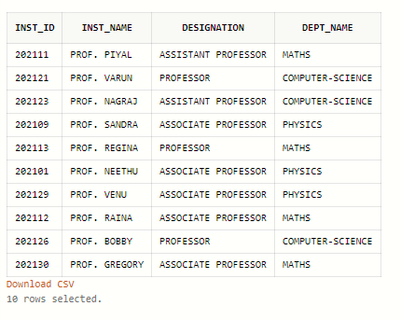

1. **Display the details of students of the University.**

SELECT * FROM STUDENT;



1. **Display the list of students of the University who born between 10 th March 1997 and 10 th March1998.**

SELECT * FROM STUDENT WHERE DOB BETWEEN '10-MAR-1997' AND '10-MAR-1998';

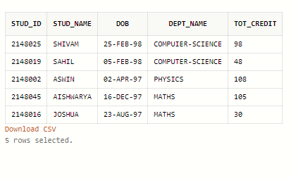

1. **Display the Names of the students along with their ID who have secured more than 100 credits.**

SELECT STUD_ID,STUD_NAME,TOT_CREDIT FROM STUDENT WHERE TOT_CREDIT > 100;

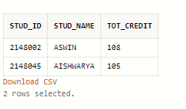

1. **Display the Names of the students along with their ID who have secured less than 50 credits and belongs to Computer Science department.**

SELECT STUD_ID,STUD_NAME,DEPT_NAME,TOT_CREDIT FROM STUDENT WHERE TOT_CREDIT < 50 AND DEPT_NAME='COMPUTER-SCIENCE';

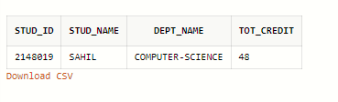

1. **Display the name of the Instructors who are working for the department of physics.**

SELECT INST_NAME,DEPT_NAME FROM INSTRUCTOR WHERE DEPT_NAME='PHYSICS';

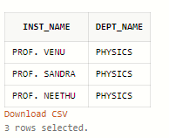

1. **Display the name of the associate professors working for the department of maths.**

SELECT INST_NAME,DEPT_NAME,DESIGNATION FROM INSTRUCTOR WHERE DEPT_NAME='MATHS' AND DESIGNATION='ASSOCIATE PROFESSOR' ;

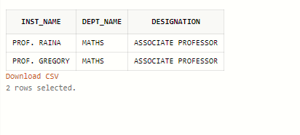

1. **Add the Basic_Pay, HRA and Gross_Salary columns into the instructor table AND insert the value for that**

ALTER TABLE INSTRUCTOR ADD BASIC_PAY NUMBER(38);

ALTER TABLE INSTRUCTOR ADD HRA NUMBER(38);

ALTER TABLE INSTRUCTOR ADD GROSS_SALARY NUMBER(38);

UPDATE INSTRUCTOR SET BASIC_PAY = 20000 WHERE INST_NAME='PROF. VARUN';

UPDATE INSTRUCTOR SET BASIC_PAY = 28000 WHERE INST_NAME='PROF. SANDRA';

UPDATE INSTRUCTOR SET BASIC_PAY = 21000 WHERE INST_NAME='PROF. REGINA';

UPDATE INSTRUCTOR SET BASIC_PAY = 19500 WHERE INST_NAME='PROF. NEETHU';

UPDATE INSTRUCTOR SET BASIC_PAY = 30000 WHERE INST_NAME='PROF. GREGORY';

UPDATE INSTRUCTOR SET BASIC_PAY = 20000 WHERE INST_NAME='PROF. RAINA';

UPDATE INSTRUCTOR SET BASIC_PAY = 21500 WHERE INST_NAME='PROF. NAGRAJ';

UPDATE INSTRUCTOR SET BASIC_PAY = 33000 WHERE INST_NAME='PROF. VENU';

UPDATE INSTRUCTOR SET BASIC_PAY = 20500 WHERE INST_NAME='PROF. BOBBY';

UPDATE INSTRUCTOR SET BASIC_PAY = 20000 WHERE INST_NAME='PROF. PIYAL';

UPDATE INSTRUCTOR SET HRA = 0.1*BASIC_PAY;

UPDATE INSTRUCTOR SET GROSS_SALARY = HRA+BASIC_PAY;

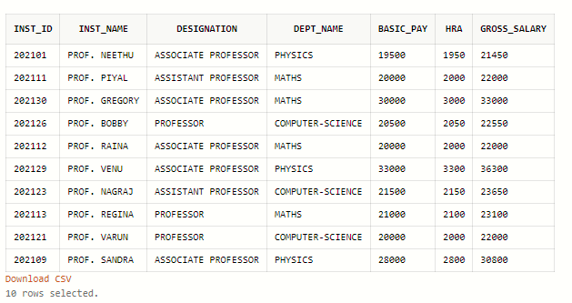

1. **Change the data type of the any existing column in table.**

**a. Numeric to alphanumeric**

**b. Increase and decrease the size the columns**

ALTER TABLE INSTRUCTOR MODIFY (PHONE_NUM CHAR(38));

ALTER TABLE INSTRUCTOR MODIFY (PHONE_NUM CHAR(20));

ALTER TABLE INSTRUCTOR MODIFY (PHONE_NUM CHAR(45));

1. **Drop the column “Basic_Pay” and evaluate the changes happened in the updated values.**

ALTER TABLE INSTRUCTOR DROP COLUMN BASIC_PAY;

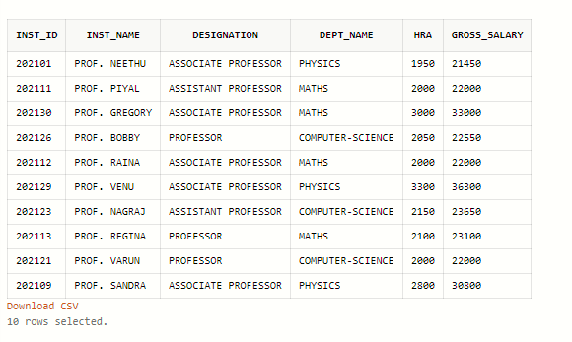

**13.Create a table Student_Regno with the values(Name and stud_id) taken from Student table**

CREATE TABLE STUDENT_REG AS SELECT STUD_NAME,STUD_ID FROM STUDENT;

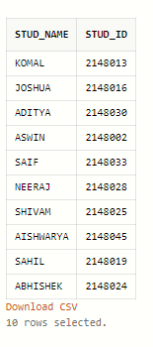

**14.List the Student ID and Student Name along with their Total Credit who has secured 1 st Rank based on the total credits the student scored.**

SELECT STUD_ID,STUD_NAME,TOT_CREDIT FROM STUDENT where TOT_CREDIT=(SELECT MAX(TOT_CREDIT) from STUDENT);

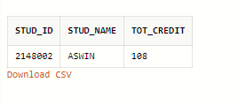

**15.Demonstrate Drop and Truncate command.**

`

DROP TABLE STUDENT_REG;



SELECT * FROM STUDENT_REG;



TRUNCATE TABLE STUDENT_REG;

TRUNC

SELECT * FROM STUDENT_REG;

