**NAME:**Kartikay Agrawal

**ROLL NO:**2148064

***Exercise: Demonstration of ETL Process using SSIS Tool***

Q1.Develop a SSIS package which produces the following CSV files with a row for every

record.

File: Vehicle_Details_Petrol.csv

S.No, Price, Age, KM, Fuel_Type = ‘Petrol’

File: Vehicle_Details_Diesel.csv

S.No, Price, Age, KM, Fuel_Type = ‘Diesel’

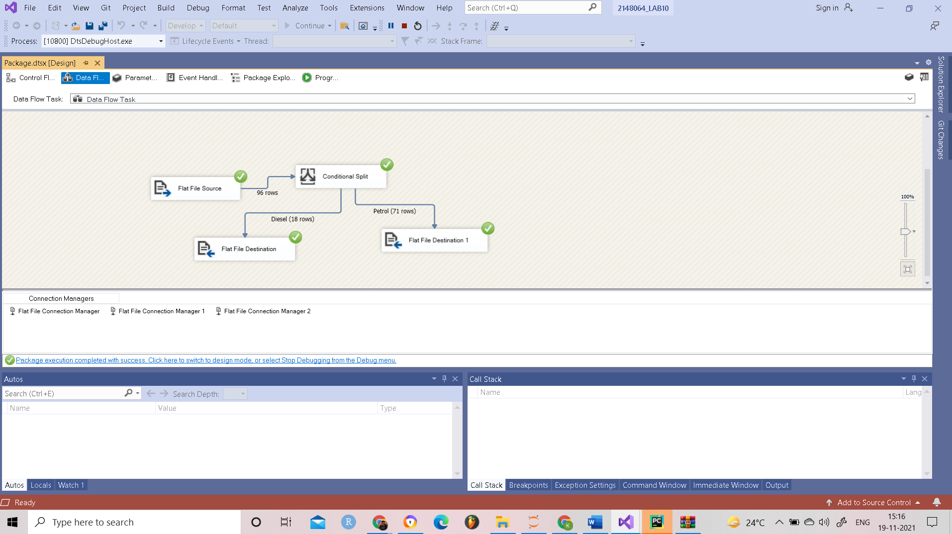

*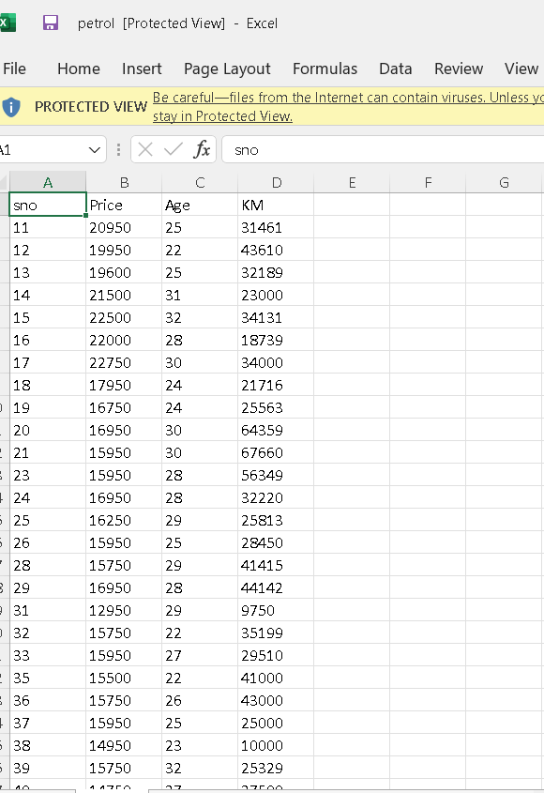 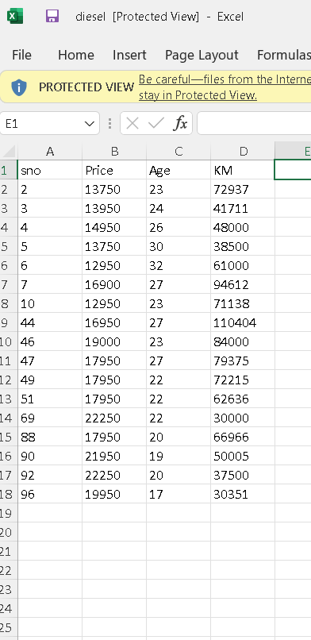

Q2. Develop a SSIS package which loads the data in to the Data Warehouse in the

dimension Fule_Type as specified below.

Excel

1. Source: Vehicle_Details_Petrol.csv

2. Destination: Fuel_Type_Petrol Excel

1. Source: Vehicle_Details_Diesel.csv

2. Destination: Fuel_Type_Diesel Excel

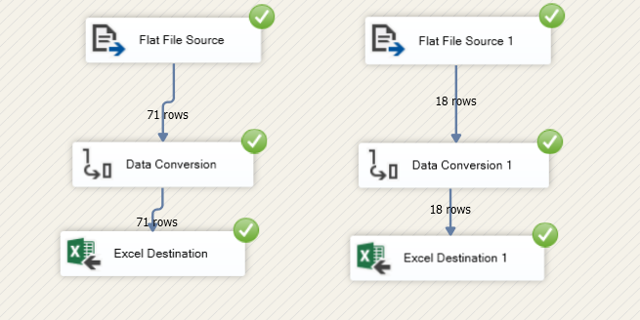

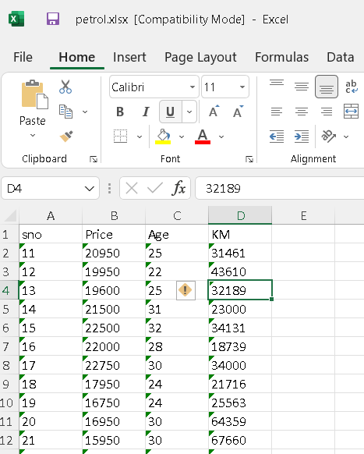 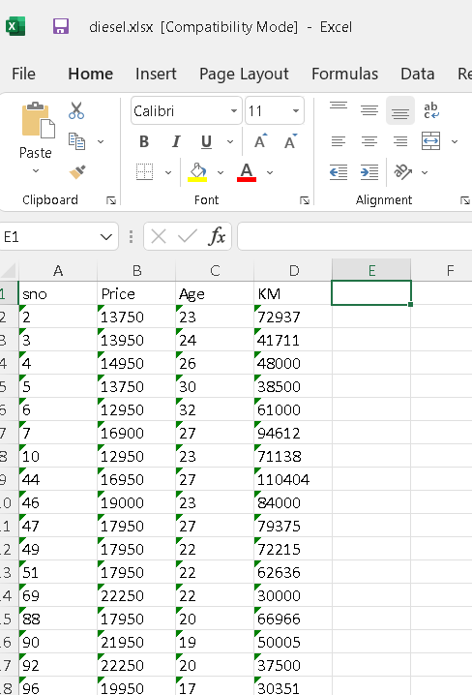

Q3. Demonstrate the following transformations available in SSIS on the tables created for

your Application Domain.

**THE EXCEL SHEET PROVIDES US WITH THE ANNUAL INCOMES OF 10 PROFFESORS IN A REPUTED EDUCATIONAL INSTITUTION.**

**THE OUTPUT EXCEL FILE PROVIDES US WITH THE INFORMATION OF THE MAXIMUM AND MINIMUM SALARIES OF THE PROFESSORS IN THE INSTITUTION TO BE ABLE TO CALCULATE AND ANALYSE THE FACTORS AFFECTING THIS PAY GAP SUCH AS CHECKING IF THE PROFFESORS ARE BEING UNDERPAID,OVERPAID,ETC**

