**Name:**Kartikay Agrawal

**Roll No:**2148064

***DBT EXERCISE 11***

**Demonstration of OLAP and Reporting Using BI Tools**

Q2. Design a Report from the available data cube from OLAP server/Database Server.

a. Report generation using Pivot Table in Excel

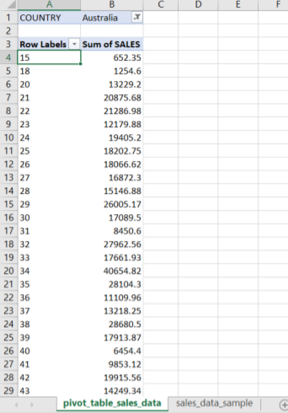 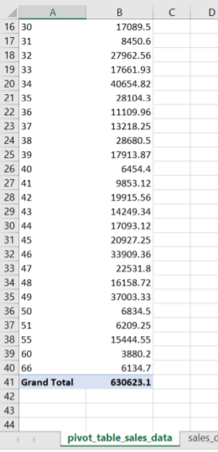

b. Report generation using Power BI

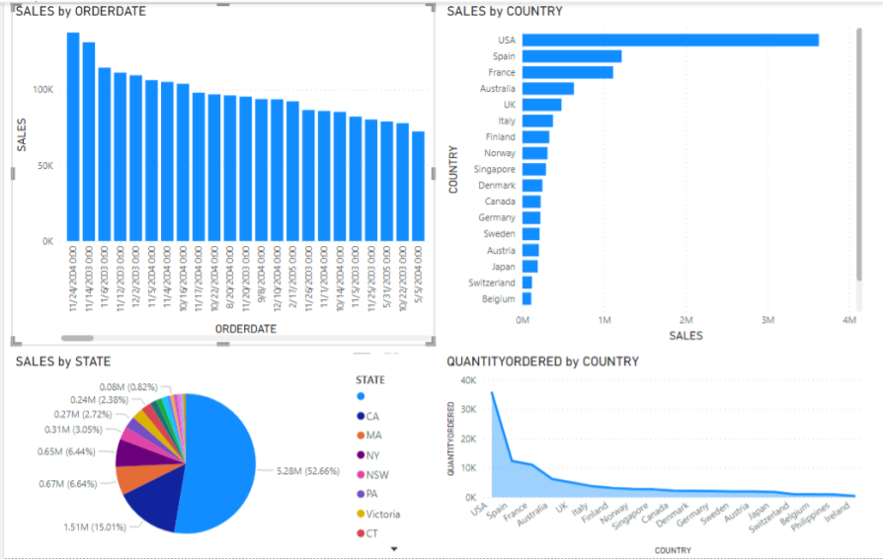

**Inferences:**

We have considered sales data from Kaggle. We consider sales by years 2003, 2004, 2005. We visualize in a bar plot and observe the performance of sales based on days. The pie chart shows the state-wise distribution of sales in the United States. We alsoplot a line graph to show the amount of sales achieved in each country where we see that the US has ranked the highest. Finally, we consider a histogram of sales by country and observe that the United States of America had the most sales volume-wise.