Name:Kartikay Agrawal

Roll number:2148064

**Lab Excercise 4**

1. Convert the ER Model of your business domain into Relational Model using ERD Plus.

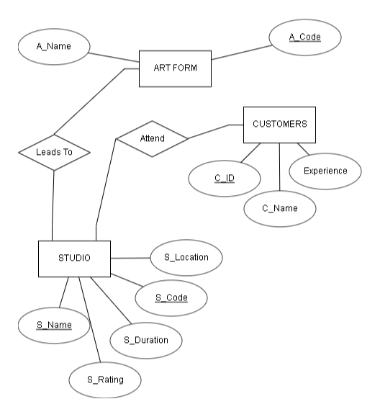

1. Create the necessary relations / tables for the identified database objects from the Relational Model of your business domain with all necessary constraint specifications such as UNIQUE, NOT NULL, PRIMARY KEY, FOREIGN KEY, DEFAULT and CHECK.

CREATE TABLE ART_FORM

(A_NAME VARCHAR(10) NOT NULL CHECK(A_NAME='JAMPADS' OR A_NAME='PHOTOSHOOT' OR A_NAME='STUDIO'),

A_CODE NUMBER(1) UNI UNIQUE);

CREATE TABLE STUDIO

(S_CODE VARCHAR(4) PRIMARY KEY,

S_NAME VARCHAR(20),

S_LOCATION VARCHAR(50),

S_DURATION NUMBER(3) CH CHECK(S_DURATION BETWEEN 30 AND 120),

S_RATING NUMERIC(1));

CREATE TABLE CUSTOMER

(C_ID VARCHAR(4) PRIMARY KEY,

C_NAME VARCHAR(20),

C_EXPEREIENCE VARCHAR(10) DEFAULT 'GOOD',

STUDIO_CODE VARCHAR(20),

FOREIGN KEY(STUDIO_CODE) REFERENCES STUDIO(S_CODE));

Table created.

Table created.

Table created.

3. Demonstrate the enforcement of constraint using alter and DML commands.

ALTER TABLE ART_FORM MODIFY A_NAME VARCHAR(20);

ALTER TABLE STUDIO MODIFY S_RATING number(2,1);

INSERT INTO ART_FORM(A_NAME,A_CODE) VALUES ('JAMPADS',1);

INSERT INTO ART_FORM(A_NAME,A_CODE) VALUES ('PHOTOSHOOT',2);

INSERT INTO ART_FORM(A_NAME,A_CODE) VALUES ('STUDIO',3);

INSERT INTO STUDIO(S_CODE,S_NAME,S_LOCATION,S_DURATION,S_RATING) VALUES (1432,'RocknRoll','Noida',45,4.5);

INSERT INTO STUDIO(S_CODE,S_NAME,S_LOCATION,S_DURATION,S_RATING) VALUES (2146,'BeautynBeast','Surat',30,4);

INSERT INTO STUDIO(S_CODE,S_NAME,S_LOCATION,S_DURATION,S_RATING) VALUES (1643,'LightsCamAction','Gurgaon',120,4.8);

INSERT INTO CUSTOMER(C_ID,C_NAME,C_EXPEREIENCE,STUDIO_CODE) VALUES ('J123','Pankaj','Excellent',1432);

INSERT INTO CUSTOMER(C_ID,C_NAME,C_EXPEREIENCE,STUDIO_CODE) VALUES ('P342','Uday','Bad',2146);

INSERT INTO CUSTOMER(C_ID,C_NAME,STUDIO_CODE) VALUES ('S143','Shrey',1643);

UPDATE CUSTOMER SET C_NAME=NULL WHERE C_ID='S143';

DELETE FROM STUDIO WHERE S_RATING<4.5;

Table altered.

Table altered.

1 row(s) inserted.

1 row(s) inserted.

1 row(s) inserted.

1 row(s) inserted.

1 row(s) inserted.

1 row(s) inserted.

1 row(s) inserted.

1 row(s) inserted.

1 row(s) inserted.

1 row(s) updated.

1 row(s) deleted.

4. List the constraints enforced on each table.

SELECT CONSTRAINT_NAME FROM USER_CONSTRAINTS WHERE TABLE_NAME='ART_FORM';

SELECT CONSTRAINT_NAME FROM USER_CONSTRAINTS WHERE TABLE_NAME='STUDIO';

SELECT CONSTRAINT_NAME FROM USER_CONSTRAINTS WHERE TABLE_NAME='CUSTOMER';

|  |
| --- |
| **CONSTRAINT_NAME** |
| SYS_C0065232340 |
| SYS_C0065232341 |
| UNI |

[Download CSV](https://livesql.oracle.com/apex/f?p=590:1:15530489592090::NO:RP::)  
3 rows selected.

|  |
| --- |
| **CONSTRAINT_NAME** |
| SYS_C0065232343 |
| SYS_C0065232344 |

[Download CSV](https://livesql.oracle.com/apex/f?p=590:1:15530489592090::NO:RP::)  
2 rows selected.

|  |
| --- |
| **CONSTRAINT_NAME** |
| SYS_C0065232345 |
| CH |

[Download CSV](https://livesql.oracle.com/apex/f?p=590:1:15530489592090::NO:RP::)  
2 rows selected.

5. Demonstrate dropping of any one constraint.

ALTER TABLE CUSTOMER DROP CONSTRAINT CH;

Table altered.