**Name: Kartikay Agrawal**

**Reg. No.: 2148064 MDS 171 – Database Technologies**

**Demonstration of SET operators and Sub Queries in SQL.**

CREATE TABLE ART_FORM

(A_NAME VARCHAR(20) NOT NULL CHECK(A_NAME='JAMPADS' OR A_NAME='PHOTOSHOOT' OR A_NAME='STUDIO'),

A_CODE NUMBER(1) UNIQUE);

CREATE TABLE STUDIO

(S_CODE VARCHAR(4) PRIMARY KEY,

S_NAME VARCHAR(20),

S_LOCATION VARCHAR(50),

S_DURATION NUMBER(3) CHECK(S_DURATION BETWEEN 30 AND 120),

S_RATING NUMBER(2,1));

CREATE TABLE CUSTOMER

(C_ID VARCHAR(4) PRIMARY KEY,

C_NAME VARCHAR(20),

C_EXPEREIENCE VARCHAR(10) DEFAULT 'GOOD',

STUDIO_CODE VARCHAR(20),

FOREIGN KEY(STUDIO_CODE) REFERENCES STUDIO(S_CODE));

INSERT INTO ART_FORM(A_NAME,A_CODE) VALUES ('JAMPADS',1);

INSERT INTO ART_FORM(A_NAME,A_CODE) VALUES ('PHOTOSHOOT',2);

INSERT INTO ART_FORM(A_NAME,A_CODE) VALUES ('STUDIO',3);

INSERT INTO STUDIO(S_CODE,S_NAME,S_LOCATION,S_DURATION,S_RATING) VALUES (1432,'RocknRoll','Noida',45,4.5);

INSERT INTO STUDIO(S_CODE,S_NAME,S_LOCATION,S_DURATION,S_RATING) VALUES (2146,'BeautynBeast','Surat',30,4);

INSERT INTO STUDIO(S_CODE,S_NAME,S_LOCATION,S_DURATION,S_RATING) VALUES (1643,'LightsCamAction','Gurgaon',120,4.8);

INSERT INTO CUSTOMER(C_ID,C_NAME,C_EXPEREIENCE,STUDIO_CODE) VALUES ('J123','Pankaj','Excellent',1432);

INSERT INTO CUSTOMER(C_ID,C_NAME,C_EXPEREIENCE,STUDIO_CODE) VALUES ('P342','Uday','Bad',2146);

INSERT INTO CUSTOMER(C_ID,C_NAME,STUDIO_CODE) VALUES ('S143','Shrey',1643);

**Q1. Write compound SQL statements to demonstrate the following SET operations on the tables created for your Application domain. (UNION, UNION ALL, INTERSECT and MINUS).**

**a. The Operations should be performed on tables with logical sense and mention**

**valid justification.**

**UNION:** In this case, the query gives the list of all the studios which are good or located in Noida.

**UNION ALL:** In this case, the query gives the list of all the studios which are good or having more than 4 rating with repetition.

**INTERSECT:** In this case, the query gives the list of all the studios which are good and located in Noida.

**MINUS:**I In this case, the query gives the list of all the studios which are not good.

**Union:**

SELECT S_CODE

FROM STUDIO WHERE S_LOCATION='NOIDA'

UNION

SELECT STUDIO_CODE

FROM CUSTOMER WHERE C_EXPEREIENCE='GOOD';

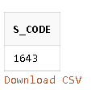

**Union all:**

SELECT S_CODE

FROM STUDIO WHERE S_RATING>4

UNION ALL

SELECT STUDIO_CODE

FROM CUSTOMER WHERE C_EXPEREIENCE='GOOD';

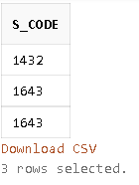

**Intersect:**

SELECT S_CODE

FROM STUDIO WHERE S_LOCATION='NOIDA'

INTERSECT

SELECT STUDIO_CODE

FROM CUSTOMER WHERE C_EXPEREIENCE='GOOD';



**Minus:**

SELECT S_CODE

FROM STUDIO

MINUS

SELECT STUDIO_CODE

FROM CUSTOMER WHERE C_EXPEREIENCE='GOOD';

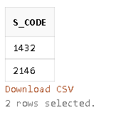

**b. What is the difference between UNION and UNION ALL?**

The only difference between Union and Union All is that Union extracts the rows that are being specified in the query while Union All extracts all the rows including the duplicates (repeated values) from both the queries.

**c. Show how to sort the result set of a compound query which performs SET**

**operations.**

SELECT S_CODE

FROM STUDIO

UNION

SELECT STUDIO_CODE

FROM CUSTOMER WHERE C_EXPEREIENCE='GOOD'

ORDER BY S_CODE;

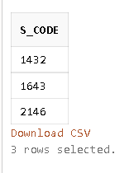

**d. Mention the difference between Sub queries and Set operations used in SQL**

A subquery is a SELECT statement that is embedded in the clause of another SELECT statement.

Set operators are used to combine the results of two or more component queries into one result. Queries containing set operators are called compound queries.

**Q2. Perform the different operations on the tables created for your Application domain using different sub queries options.**

SELECT * FROM STUDIO WHERE S_CODE IN(

SELECT STUDIO_CODE FROM CUSTOMER WHERE C_NAME LIKE 'Shrey');

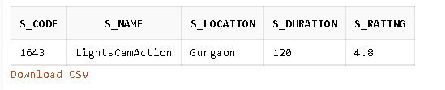

CREATE TABLE CUSTOMER_OLD(CUS_ID REFERENCES CUSTOMER(C_ID), CUS_NAME VARCHAR(30) );

INSERT INTO CUSTOMER_OLD

SELECT C_ID,C_NAME FROM CUSTOMER

WHERE C_ID IN (SELECT C_ID

FROM CUSTOMER) ;

SELECT * FROM CUSTOMER_OLD;

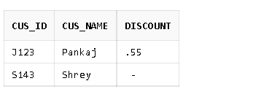

ALTER TABLE CUSTOMER_OLD ADD DISCOUNT NUMERIC(2,2);

UPDATE CUSTOMER_OLD SET DISCOUNT=.55 WHERE CUS_ID IN (SELECT C_ID

FROM CUSTOMER WHERE STUDIO_CODE=1432);

SELECT * FROM CUSTOMER_OLD;

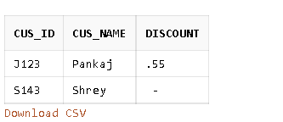

SELECT * FROM STUDIO WHERE S_CODE IN(

SELECT STUDIO_CODE FROM CUSTOMER WHERE C_ID IN (SELECT CUS_ID

FROM CUSTOMER_OLD WHERE DISCOUNT=.55));

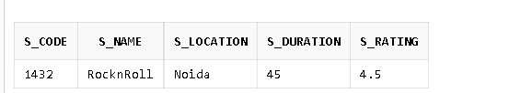

DELETE FROM CUSTOMER_OLD WHERE CUS_ID IN (SELECT C_ID

FROM CUSTOMER WHERE STUDIO_CODE=2146);

1 row(s) deleted.