**Name: Kartikay Agrawal**

**Reg. No.: 2148064 MDS 171 – Database Technologies**

**Exercise: Demonstration of JOIN Operations and Built-in functions in SQL Queries.**

CREATE TABLE ART_FORM

(A_NAME VARCHAR(20) NOT NULL CHECK(A_NAME='JAMPADS' OR A_NAME='PHOTOSHOOT' OR A_NAME='STUDIO'),

A_CODE NUMBER(1) UNIQUE);

CREATE TABLE STUDIO

(S_CODE VARCHAR(4) PRIMARY KEY,

S_NAME VARCHAR(20),

S_LOCATION VARCHAR(50),

S_DURATION NUMBER(3) CHECK(S_DURATION BETWEEN 30 AND 120),

S_RATING NUMBER(2,1));

CREATE TABLE CUSTOMER

(C_ID VARCHAR(4) PRIMARY KEY,

C_NAME VARCHAR(20),

C_EXPEREIENCE VARCHAR(10) DEFAULT 'GOOD',

STUDIO_CODE VARCHAR(20),

FOREIGN KEY(STUDIO_CODE) REFERENCES STUDIO(S_CODE));

INSERT INTO ART_FORM(A_NAME,A_CODE) VALUES ('JAMPADS',1);

INSERT INTO ART_FORM(A_NAME,A_CODE) VALUES ('PHOTOSHOOT',2);

INSERT INTO ART_FORM(A_NAME,A_CODE) VALUES ('STUDIO',3);

INSERT INTO STUDIO(S_CODE,S_NAME,S_LOCATION,S_DURATION,S_RATING) VALUES (1432,'RocknRoll','Noida',45,4.5);

INSERT INTO STUDIO(S_CODE,S_NAME,S_LOCATION,S_DURATION,S_RATING) VALUES (2146,'BeautynBeast','Surat',30,4);

INSERT INTO STUDIO(S_CODE,S_NAME,S_LOCATION,S_DURATION,S_RATING) VALUES (1643,'LightsCamAction','Gurgaon',120,4.8);

INSERT INTO CUSTOMER(C_ID,C_NAME,C_EXPEREIENCE,STUDIO_CODE) VALUES ('J123','Pankaj','Excellent',1432);

INSERT INTO CUSTOMER(C_ID,C_NAME,C_EXPEREIENCE,STUDIO_CODE) VALUES ('P342','Uday','Bad',2146);

INSERT INTO CUSTOMER(C_ID,C_NAME,STUDIO_CODE) VALUES ('S143','Shrey',2648);

Q1. Perform the different JOIN operations on the tables created for your Application

Displaying all the common studios and their customers

SELECT *

FROM STUDIO

INNER JOIN CUSTOMER ON S_CODE=STUDIO_CODE

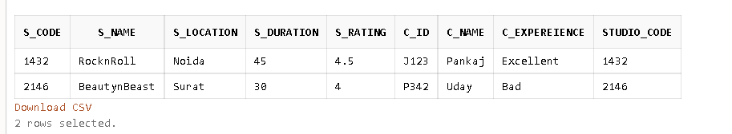

Displaying all the studios along with their customers

SELECT *

FROM STUDIO

FULL JOIN CUSTOMER ON S_CODE=STUDIO_CODE

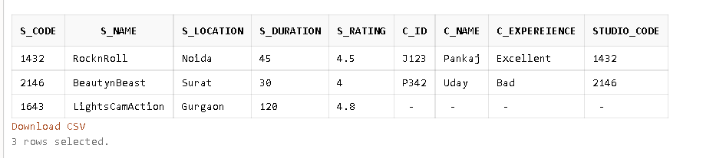

Displaying all the customers and their common studios

SELECT *

FROM STUDIO

RIGHT JOIN CUSTOMER ON S_CODE=STUDIO_CODE

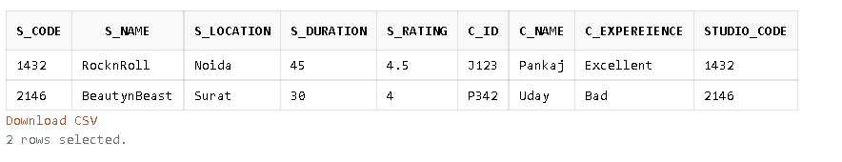

Displaying all the studios and their only common customers

SELECT *

FROM STUDIO

LEFT JOIN CUSTOMER ON S_CODE=STUDIO_CODE

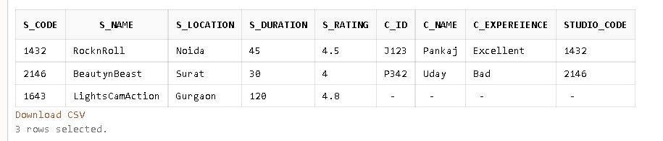

Q2. Demonstrate the following Built-in functions using the tables created for your

Application domain.

SELECT FLOAT(50.55) FROM DUAL;

SELECT CEIL(52.51) FROM DUAL;

SELECT ROUND(400.8754,3) FROM DUAL;

SELECT SIGN(-7900) FROM DUAL;

SELECT SIGN(4398) FROM DUAL;

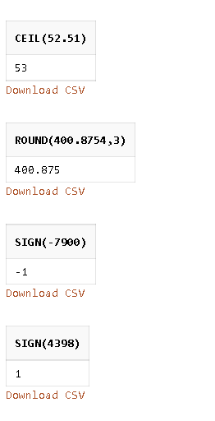

SELECT CEIL(S_RATING) FROM STUDIO;

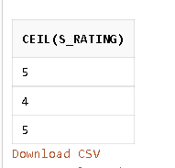

SELECT UPPER(C_NAME) from CUSTOMER;

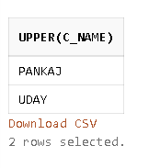

SELECT LENGTH(C_EXPEREIENCE) FROM CUSTOMER;

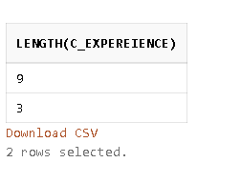

SELECT SUBSTR(C_ID,1,2) FROM CUSTOMER;

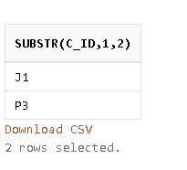

SELECT CONCAT(S_NAME,(CONCAT(',',S_LOCATION))) FROM STUDIO;

