Name:Kartikay Agrawal

Roll No:2148064

Exercise: Demonstration of Aggregate Functions And Views using SQL Queries.

CREATE TABLE ART_FORM

(A_NAME VARCHAR(20) NOT NULL CHECK(A_NAME='JAMPADS' OR A_NAME='PHOTOSHOOT' OR A_NAME='STUDIO'),

A_CODE NUMBER(1) PRIMARY KEY);

CREATE TABLE STUDIO

(S_CODE VARCHAR(4) PRIMARY KEY,

S_NAME VARCHAR(20),

S_LOCATION VARCHAR(50),

S_DURATION NUMBER(3) CHECK(S_DURATION BETWEEN 30 AND 120),

S_RATING NUMBER(2,1));

CREATE TABLE CUSTOMER

(C_ID VARCHAR(4) PRIMARY KEY,

C_NAME VARCHAR(20),

C_EXPEREIENCE VARCHAR(10) DEFAULT 'GOOD',

STUDIO_CODE VARCHAR(20),

ART_CODE NUMBER(1),

FOREIGN KEY(STUDIO_CODE) REFERENCES STUDIO(S_CODE),

FOREIGN KEY(ART_CODE) REFERENCES ART_FORM(A_CODE));

INSERT INTO ART_FORM(A_NAME,A_CODE) VALUES ('JAMPADS',1);

INSERT INTO ART_FORM(A_NAME,A_CODE) VALUES ('PHOTOSHOOT',2);

INSERT INTO ART_FORM(A_NAME,A_CODE) VALUES ('STUDIO',3);

INSERT INTO STUDIO(S_CODE,S_NAME,S_LOCATION,S_DURATION,S_RATING) VALUES (1432,'RocknRoll','Noida',45,4.5);

INSERT INTO STUDIO(S_CODE,S_NAME,S_LOCATION,S_DURATION,S_RATING) VALUES (2146,'BeautynBeast','Surat',30,4);

INSERT INTO STUDIO(S_CODE,S_NAME,S_LOCATION,S_DURATION,S_RATING) VALUES (1643,'LightsCamAction','Gurgaon',120,4.8);

INSERT INTO STUDIO(S_CODE,S_NAME,S_LOCATION,S_DURATION,S_RATING) VALUES (1573,'LightsCamAction','Delhi',120,3);

INSERT INTO STUDIO(S_CODE,S_NAME,S_LOCATION,S_DURATION,S_RATING) VALUES (1284,'Jamway','Bangalore',120,4.2);

INSERT INTO STUDIO(S_CODE,S_NAME,S_LOCATION,S_DURATION,S_RATING) VALUES (1393,'DharmaProd','Mumbai',120,5);

INSERT INTO CUSTOMER(ART_CODE,C_ID,C_NAME,C_EXPEREIENCE,STUDIO_CODE) VALUES (1,'J123','Pankaj','Excellent',1432);

INSERT INTO CUSTOMER(ART_CODE,C_ID,C_NAME,C_EXPEREIENCE,STUDIO_CODE) VALUES (2,'P342','Uday','Bad',2146);

INSERT INTO CUSTOMER(ART_CODE,C_ID,C_NAME,STUDIO_CODE) VALUES (3,'S143','Shrey',2648);

INSERT INTO CUSTOMER(ART_CODE,C_ID,C_NAME,STUDIO_CODE) VALUES (3,'S144','Jimmy',1393);

INSERT INTO CUSTOMER(ART_CODE,C_ID,C_NAME,STUDIO_CODE) VALUES (2,'P443','Sasha',6618);

INSERT INTO CUSTOMER(ART_CODE,C_ID,C_NAME,STUDIO_CODE) VALUES (3,'S145','Shabir',2648);

Perform the following tasks:

Q1. Write SQL statements to demonstrate the following Simple Aggregate functions on the

tables created for your Application domain.

AVG, SUM, COUNT, MIN, MAX, MEDIAN, CORR and STDDEV

**TO FIND THE AVERAGE RATING OF THE REGISTERED STUDIOS**

SELECT AVG(S_RATING) AS AVG_RATING FROM STUDIO;

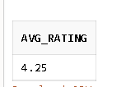

**TO FIND THE TOTAL MAXIMUM DURATION OF ALL THE REGISTERED STUDIOS AFTER A SINGLE DAY OF BOOKING**

SELECT SUM(S_DURATION) AS TOTAL_DURATION FROM STUDIO;

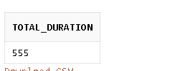

**TO FIND THE NUMBER OF DIFFERENT STUDIOS OPTED BY CUSTOMERS**

SELECT COUNT(STUDIO_CODE) AS OPTED_STUDIOS FROM CUSTOMER;

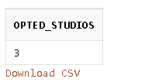

**TO FIND THE MINIMUM,MAXIMUM,MEDIAN AND STD DEV OF ALL THE RATINGS OF STUDIOS FOR ANALYSIS AND IMPROVEMENT IN THE BUSINESS CASE**

SELECT MIN(S_RATING) AS MIN_RATING FROM STUDIO;

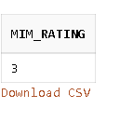

SELECT MAX(S_RATING) AS MAX_RATING FROM STUDIO;

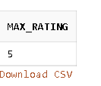

SELECT MEDIAN(S_RATING) AS MEDIAN_RATING FROM STUDIO;

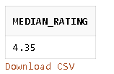

SELECT ROUND(STDDEV(S_RATING),3) AS AVG_RATING FROM STUDIO;

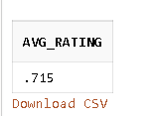

**TO FIND THE POSSIBILITY OF ANY DEPENDENCY BETWEEN RATINGS AND DURATION TIME IN A STUDIO**

SELECT CORR(S_RATING,S_DURATION) AS CORR_B/W_RATING_N_DUR FROM STUDIO;



Q2. Demonstrate the usage of GROUPBY and HAVING clause in compound SQL

statements using Aggregate functions on the tables created for your Application domain.

**TO FIND THE MOST FAMOUS STUDIO ALONG WITH THE ART FORM IT IS LINKED WITH**

SELECT COUNT(STUDIO_CODE),ART_CODE FROM CUSTOMER GROUP BY ART_CODE HAVING COUNT(STUDIO_CODE)>1;



Q3. Demonstrate the creation and processing of SQL Views on the tables created for your

Application Domain.

Specification:

a. The Operations should be performed on tables with logical sense and mention

valid justification.

b. At least 1 Compound SQL Query with a suitable aggregate function should be

demonstrated for all the Tables

c. At least 3 views should be created which holds the records from single table and

multiple tables.

d. Perform the insert, delete and update operations on the Views. State the

inferences.

CREATE VIEW CUSTOMERS AS SELECT C_NAME,C_ID FROM CUSTOMER;

SELECT * FROM CUSTOMERS;

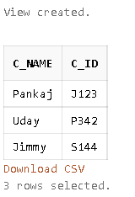

INSERT INTO CUSTOMERS(C_NAME,C_ID) VALUES('AJAY','S123');



CREATE VIEW STUDIOS AS SELECT S_NAME,S_LOCATION FROM STUDIO;

SELECT * FROM STUDIOS;

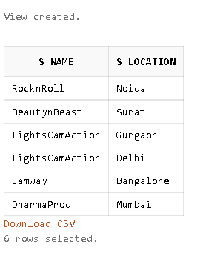

INSERT INTO STUDIOS(S_NAME,S_LOCATION) VALUES ('DUNK','GURGAON')



***Since the view doesn’t have a primary key we cannot insert values into it.Hence we’ll have to make a view with the primary key.***

CREATE VIEW STUDIOS_IMP AS SELECT S_CODE,S_NAME,S_LOCATION FROM STUDIO;

SELECT * FROM STUDIOS_IMP;

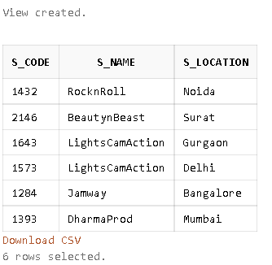

INSERT INTO STUDIOS_IMP(S_CODE,S_NAME,S_LOCATION) VALUES (3253,'DUNK','GURGAON')



**CHANGING THE LOCATION OF STUDIO WITH CODE 1432 DUE TO SHIFTING**

UPDATE STUDIOS_IMP SET S_LOCATION='DELHI' WHERE S_CODE=1432;

SELECT * FROM STUDIO WHERE S_CODE=1432;

SELECT * FROM STUDIOS_IMP WHERE S_CODE=1432;

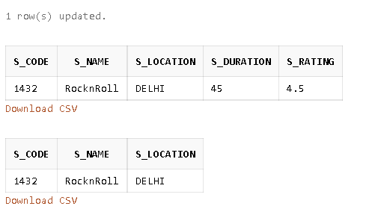

***THE ROWS GET UPDATED IN BOTH TABLE AND VIEW***

DELETE FROM STUDIOS_IMP WHERE S_CODE=1393;



***We cannot delete an item from the table/view by deleting it from the view as they have a parent child relation.It will get deleted only when we delete it from the parent table.***

**COMBINIG AND COMPARING THE CUSTOMER EXPEREINCE AND STUDIO RATINGS**

CREATE VIEW FEEDBACK AS(SELECT CUSTOMER.C_EXPEREIENCE,STUDIO.S_RATING FROM CUSTOMER INNER JOIN STUDIO ON S_CODE=STUDIO_CODE);

SELECT * FROM FEEDBACK;

