**NAME:**Kartikay Agrawal

**ROLL NUMBER:**2148064

**Exercise: Demonstration of Normalisation Process.**

**1. A database used in an order-entry system is to contain information about customers,**

**items, and orders. The following information is to be included.**

**• For each customer**

**o Customer number (unique)**

**o Valid “ship-to” addresses (several per customer)**

**o Balance**

**o Credit limit**

**o Discount**

**• For each order**

**o Heading information: customer number, “ship-to”; address, date of order.**

**Details lines (several per order): each giving item number, quantity ordered.**

**• For each item**

**o Item number (unique)**

**o Manufacturing plants**

**o Quantity on hand at each plant**

**o Stock danger level for each plant**

**o Item description**

**For internal processing reasons a “quantity outstanding”; value is associated with each detail**

**line of each order. This value is initially set equal to the quantity of the item ordered and is**

**(progressively) reduced to zero as (partial) shipments are made. Design a database for this**

**data.**

Entities:

* Customer
* Order
* Item
* Manufacturing Plant

Attributes:

* Customer
  + CID
  + Ship_To_Address
  + Balance
  + Credit Limit
  + Discount
* Order
  + CID
  + OID
  + Date
  + Ship_To_Address
  + DETAILS
    - Item_NO
    - Quantity_Ordered
    - Quantity_Outstanding
* Item
  + Item_NO
  + Desc
* Manufacturing Plant
  + Item_NO
  + MID
  + Stock_dlevel
  + Quantity_inhand

Relationship:

* Customer Places an Order
* Order Consists of Items
* Items are manufactured by Manufacturing Plant

## Cardinality:

* Customer can Place Many Orders but an Order can belong to only one Customer => 1 : N
* An Order can have Many Items and one item may belong to many orders => N : N
* An Item is manufactured by many Manufacturing Plant and a Manufacturing Plant can Produce Many Items => N : N

Participation Types:

* Customer is Total and Order is Total.
* Order is Total and Item is Partial.
* Item is Total and Manufacturing Plant is Partial.

**2. The following is an unnormalized PATIENT record:**

**(PIDNO, PNAME, FAMDOCNO, DOCNAME, DOCADDR, *(APPTMT-DATE,**

**APPTMT-TIME, CONSULTANT-NAME-CONSULTANT-PHONE, HOSPITAL,**

**HOSPITAL-ADDR)) where * represents repeating groups of information. The**

**business rules are,**

**• On any given day, a consultant attends at just one hospital**

**• On any given day, a patient will have only one appointment (APPTMT) with a given**

**consultant**

**• Patient id numbers (PIDNO) and consultant names are unqiue**

**• Family doctor numbers (FAMDOCNO) and hospital names are unique**

**• Family doctor names (DOCNAME) and patient names (PNAME) are not unique**

**• Consultants have just one phone number, used as home base.**

**Reduce the above relation into normalized forms.**

Unnormalized Form

(PIDNO, PNAME, FAMDOCNO, DOCNAME, DOCADDR, *(APPTMT-DATE,

APPTMT-TIME, CONSULTANT-NAME-CONSULTANT-PHONE, HOSPITAL,

HOSPITAL-ADDR))

1NF –

* There should be no repeating groups
* All the key attributes should be defined
* All attributes should be dependent on primary key
* PATIENT(PIDNO, PNAME, FAMDOCNO, DOCNAME, DOCADDR)
* APPOINTMENT(PIDNO , APPTMT_DATE , APPTMT_TIME, CONSULTANT_NAME , CONSULTANT_PHONE , HOSPITAL, HOSPITAL_ADDR)

2NF –

* It should be 1NF.
* It should include no partial dependencies.
* PATDOC(PIDNO,FAMDOCNO)
* PATIENT(PIDNO, PNAME)
* DOCTOR(FAMDOCNO, DOCNAME, DOCADDR)
* PATCON(PIDNO,CONSULTANT_NAME)
* APPOINTMENT(PIDNO, APPTMT_DATE, APPTMT_TIME)
* CONSULTATION(CONSULTANT_NAME,CONSULTANT_PHONE, HOSPITAL, HOSPITAL_ADDR)

3NF –

* It should be 2NF
* It should have no transitive dependencies
* PATDOC(PIDNO,FAMDOCNO)
* PATIENT(PIDNO, PNAME)
* DOCTOR(FAMDOCNO, DOCNAME, DOCADDR)
* PATCON(PIDNO,CONSULTANT_NAME)
* APPOINTMENT(PIDNO, APPTMT_DATE, APPTMT_TIME)
* CONSULTATION( CONSULTANT_NAME,CONSULTANT_PHONE,HOSPITAL)
* HOSPITAL( HOSPITAL, HOSPITAL_ADDR)

**3. Produce the Third Normal Form of this document by normalization.**

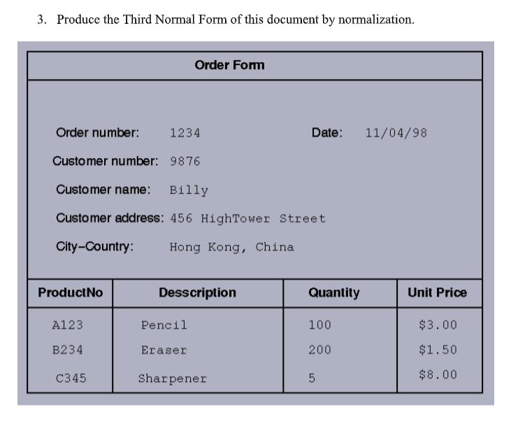

Unnormalized Form

(ORDERNO, CUSTOMERNO, C_NAME, C_ADDRESS, CITY_COUNTRY, DATE, *(PRODUCTNO, DESCRIPTION, QUANTITY, UNIT_PRICE))

1NF

* + CUSTOMER(ORDERNO, CUSTOMERNO, C_NAME, C_ADDRESS, CITY_COUNTRY,DATE)
  + ORDER(ORDERNO, PRODUCTNO, DESCRIPTION, QUANTITY, UNIT_PRICE)

2NF

* + CUSTOMER(ORDERNO, CUSTOMERNO, C_NAME, C_ADDRESS, CITY_COUNTRY , DATE)
  + ORDER(ORDERNO, PRODUCTNO)
  + PRODUCT(PRODUCTNO, DESCRIPTION, UNIT_PRICE,QUANTITY)

3NF

* CUSTOMERADD(C_ADDRESS , CITY_COUNTRY)
  + ORDER(ORDERNO, CUSTOMERNO, DATE,C_NAME,C_ADDRESS)
  + ORDER_DETAILS(ORDERNO, PRODUCTNO)
  + PRODUCT(PRODUCTNO, DESCRIPTION, UNIT_PRICE, QUANTITY)