**MDS272B – IMAGE AND VIDEO ANALYTICS**

**ROLL NO: 2148064**

**NAME: Kartikay Agrawal**

**ASYNCHRONOUS ASSIGNMENT**

1. **What is called Digital Image? Explain types of images with examples.**

*Digital Image is a collection of pixels for a x-y co-ordinate having a numerical value for every co-ordinate called intensity of that pixel. There are many types of Images that are as follows :*

1. *Binary Image - Image having only two intensity values 0 and 1 ,i.e , black and white is a binary image.The uses of binary images are text recognition , object detection and also used in OCR , QR code creation.*

**

1. *Grayscale Image : Images in which it have only the shades of gray is a grayscale image. Available number of different gray levels is determined by the number of bits used for each pixel. If there are 32 shades of gray then then every bit will be having 5bits/pixel of data. The use of grayscale image is for extracting descriptors , segmentation.*

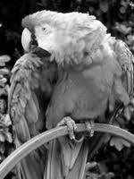

1. *Colored Image : Image having 3 planes of different color combined together is colored image also called RGB image. It have 8 bit for every image that is 24 bits/pixel for one pixel of whole combined 3 planes. Colored images are used where we need high detailed image with proper coloring , textures , intensity. Real life images.*



________________________________________________________________________________

1. **Describe the Sampling technique in Digital Image Processing (DIP) and give an area where we can apply this technique in real-time.**

*Sampling is a process that Is done on the x-axis of the image. It is a process that alters with the resolution of the image , in which a single value is selected from different values of the time interval to represent it.*

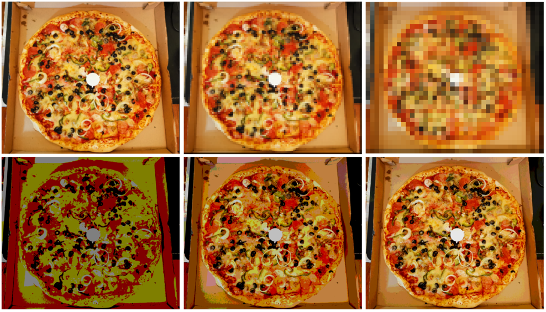

*USE OF SMAPLING*

*The use of sampling is that the image is generally in analog form to store it in some place we need to convert it to digital format and that can be done by sampling. Or it can be used to reduce the quality of an image to send it everywhere easily without any heavy load because as the resolution decreases the size of the image also decreases.*

________________________________________________________________________________

1. **Briefly explain about Basic Relations between Pixels - Neighbors, Connectivity, Distance Measures between pixels.**
2. *Neighbors of the pixels : The collection of pixels surrounding the particular pixel are called neighbors of that pixel. There are two type of neighbors first is 4-neighbors , that are the adjacent horizontal and vertical pixels , second one is 8-neighbors where the 4-neighbors as well as the diagonal pixels are also considered.*

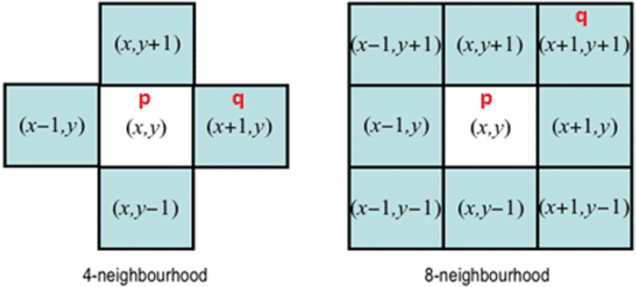

1. *Connectivity: Pixels are said to be connected if*
2. *they are adjacent in some adjacency*
3. *Their gray level specifies for that particular area*

*There are different types of connectivity*

1. ***4-connectivity:****Two or more pixels are said to be 4-connected if they are 4-adjacent with each others.*
2. ***8-connectivity:****Two or more pixels are said to be 8-connected if they are 8-adjacent with each others.*
3. ***m-connectivity:****Two or more pixels are said to be m-connected if they are m-adjacent with each others.*

*Connectivity is used to establish boundaries in an image.*

1. *Distance measures between pixels*

*Distance between two pixels is computed in many ways that are distance measures between pixel.*

* *Euclidean Distance : Computed as the square-root of the sum of square of differences of the co-ordinates.*

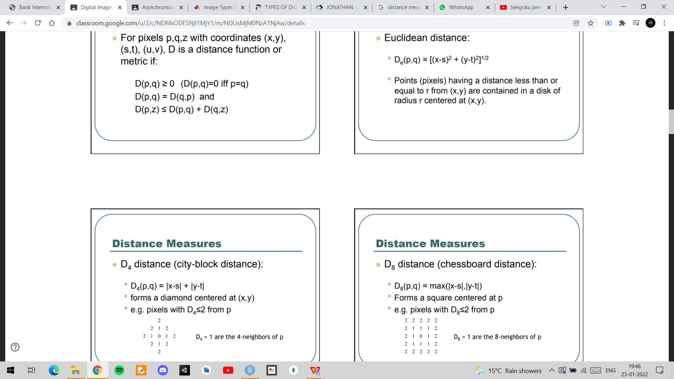

* *D4 Distance : It is calculated as the sum of absolute difference of the co-ordinates.*

**

* *D8 distance : It is calculated as the maximum of the sum of absolute difference of the co-ordinates*

**

________________________________________________________________________________

1. **Explain the importance of histogram in DIP.**

*Histogram in DIP is quite important in many aspects.Following are the resons :*

1. *First , by seeing an image histogram we can identify the type of Image even without seeing which type of image it is.*
2. *It can be used for image analysis and extraction of information.*
3. *To adjust the brightness or contrast of an image the most easiest way to do is by using histogram.*
4. *They are also important in the area of image threshold which is used in Computer vision.*
5. *Also, for equalization of image histogram is used.*



