Name: Kartikay Agrawal

Roll No. 2148064

**MDS272B - IMAGE AND VIDEO ANALYTICS**

1. **Write a program to perform contrast enhancement techniques and contrast stretching.**

**CONTRAST ENHANCEMENT**

***%Contrast enhancement of RGB image using histogram equalisation***

% read the image

k=imread("5.jpg");

figure

%Display original image.

subplot(121)

imshow(k)

subplot(122)

imhist(k)

% Apply histogram equalisation.

% on Red channel

k2(:,:,1)=histeq(k(:,:,1));

% on Green channel

k2(:,:,2)=histeq(k(:,:,2));

% on Blue channel

k2(:,:,3)=histeq(k(:,:,3));

% Display enhanced image.

figure

subplot(121)

imshow(k2)

subplot(122)

imhist(k2)

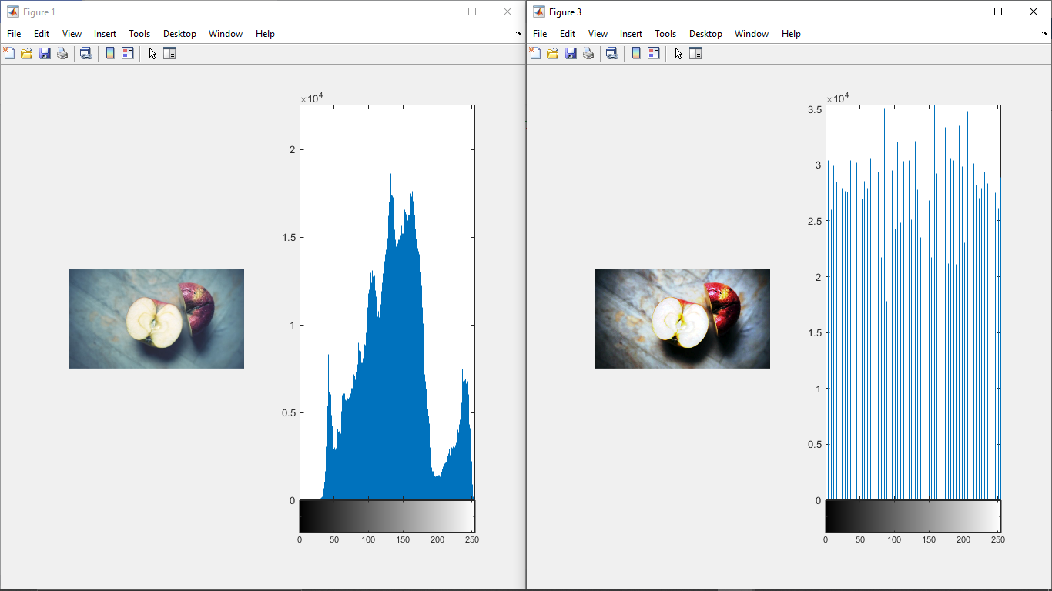

**Interpretation:**

Apply contrast enhancement of Red channel, Green channel, and Blue channel separately. As a result, each color component will be enhanced accordingly and the resultant color combination will be very different from the original color combination.

k(:,:,1)=histeq(k(:,:,1)); contrast enhancement of Red channel.

k(:,:,2)=histeq(k(:,:,2)); contrast enhancement of Green channel.

k(:,:,3)=histeq(k(:,:,3)); contrast enhancement of Blue channel.

***%% Contrast enhancement of a Grayscale image using imadjust(),histeq() and adapthist()***

% read the image

a=imread("7.jpeg");

b1 = imadjust(a);

b2 = histeq(a);

b3 = adapthisteq(a);

subplot(421);

imshow(a);

subplot(422);

imhist(a);

subplot(423);

imshow(b1);

subplot(424);

imhist(b1);

subplot(425);

imshow(b2);

subplot(426);

imhist(b2);

subplot(427);

imshow(b3);

subplot(428);

imhist(b3);

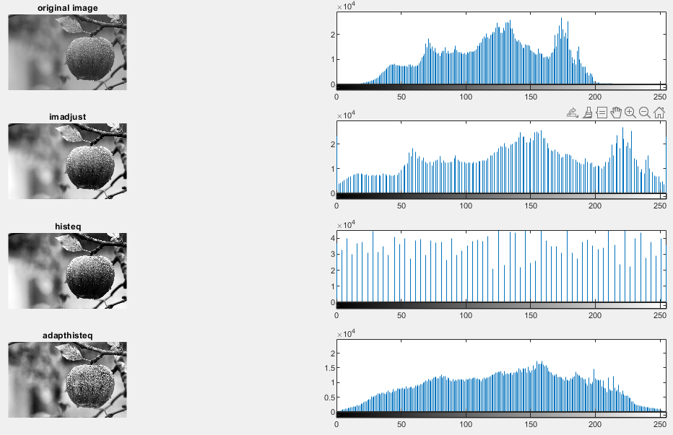

**Iterpretation:**

* Imadjust() increases the contrast of the image by mapping the values of the input intensity image to new values such that, by default, 1% of the data is saturated at low and high intensities of the input data.
* Histeq() performs histogram equalization. It enhances the contrast of images by transforming the values in an intensity image so that the histogram of the output image approximately matches a specified histogram (uniform distribution by default).
* Adapthiste**q()** performs contrast-limited adaptive histogram equalization. Unlike histeq, it operates on small data regions (tiles) rather than the entire image. Each tile's contrast is enhanced so that the histogram of each output region approximately matches the specified histogram (uniform distribution by default). The contrast enhancement can be limited in order to avoid amplifying the noise which might be present in the image.

**CONTRAST STRETCHING**

***%contrast stretching***

I = imread(6.png');

strtch=imadjust(I,[0.3,0.6],[0.0,1.0]);

figure;

subplot(221);

imshow(I);title('original image');

subplot(222);

imhist(I);

subplot(223);

imshow(strtch);title('stretched');

subplot(224);

imhist(strtch);

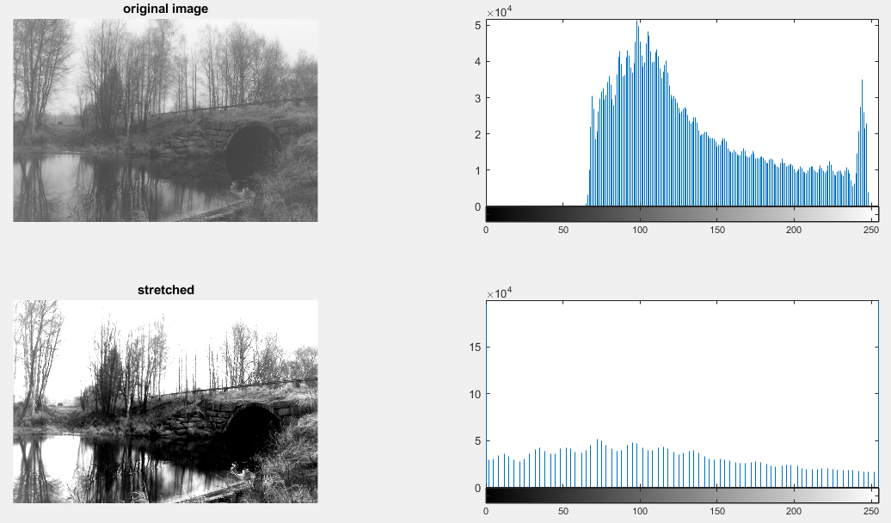

**Iterpretation:**

strtch=imadjust(I,[0.3,0.6],[0.0,1.0]);

maps intensity values in I to new values in STRTCH such that values between low_in and high_in map to values between low_out and high_out.

***%using stretchlim***

J = imadjust(I,stretchlim(I),[]);

figure

subplot(221);

imshow(I);title('original image');

subplot(222);

imhist(I);

subplot(223);

imshow(J);title('stretched');

subplot(224);

imhist(J);

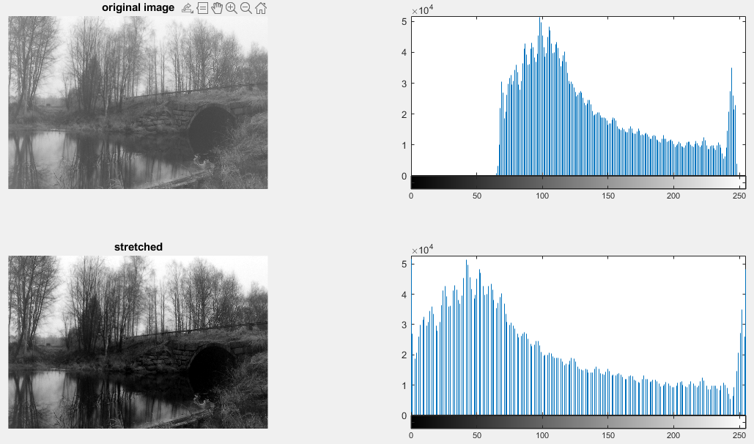

**Iterpretation:**

Stretchlim() Find limits to contrast stretch image.

stretchlim([I](https://in.mathworks.com/help/images/ref/stretchlim.html#bupc6cj-I)) computes the lower and upper limits that can be used for contrast stretching grayscale or RGB image I. The limits are returned in lowhigh. By default, the limits specify the bottom 1% and the top 1% of all pixel values.