**NAME :** Kartikay Agrawal

**ROLL NO :** 2148064

**MDS 272B – Image and Video Analytics**

**Lab 4 – Linear and Non-Linear Filtering**

Perform the filtering operation on the grayscale image(s) using linear and non-linear filtering methods.  
  
After performing above said operations, kindly answer the following questions.  
1. Describe your observations on filtering?  
2. What is the difference between linear and non-linear point operations?  
3. What are the advantages of linear filtering?

**AIM –** The aim of this is to explore the concepts of Image Sharpening and Smoothing.

**Image Filtering**

Filtering is a technique for modifying or enhancing an image. For example, you can filter an image to emphasize certain features or remove other features. Image processing operations implemented with filtering include smoothing, sharpening, and edge enhancement.

**Linear filtering**

Linear filteringis the filtering method in which the value of output pixel is linear combinations of the neighbouring input pixels. it can be done with convolution. For examples, mean/average filters or Gaussian filtering.

**Non-linear filtering**

Non-linear filtering is one that cannot be done with convolution multiplication. A sliding median filter is a simple example of a non-linear filter.

% read the image

I = imread('toy train.jpg');

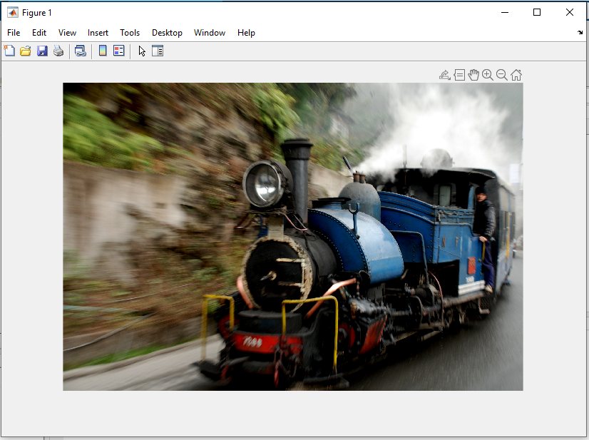

% convert the rgb image into grayscale one

gi = rgb2gray(I);

imshow(gi);

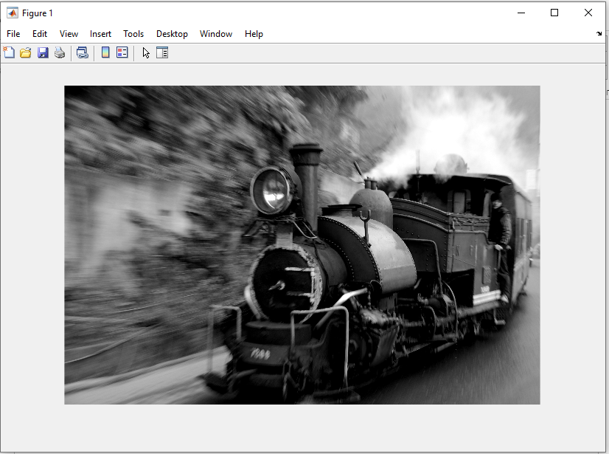

[h](https://in.mathworks.com/help/images/ref/fspecial.html#d123e99797) = fspecial([type](https://in.mathworks.com/help/images/ref/fspecial.html#d123e99465)) creates a two-dimensional filter h of the specified type. fspecial returns h as a correlation kernel, which is the appropriate form to use with imfilter.

% average filter

H = fspecial('average', [3 3]);

avgFilter = imfilter(gi ,H,'replicate');

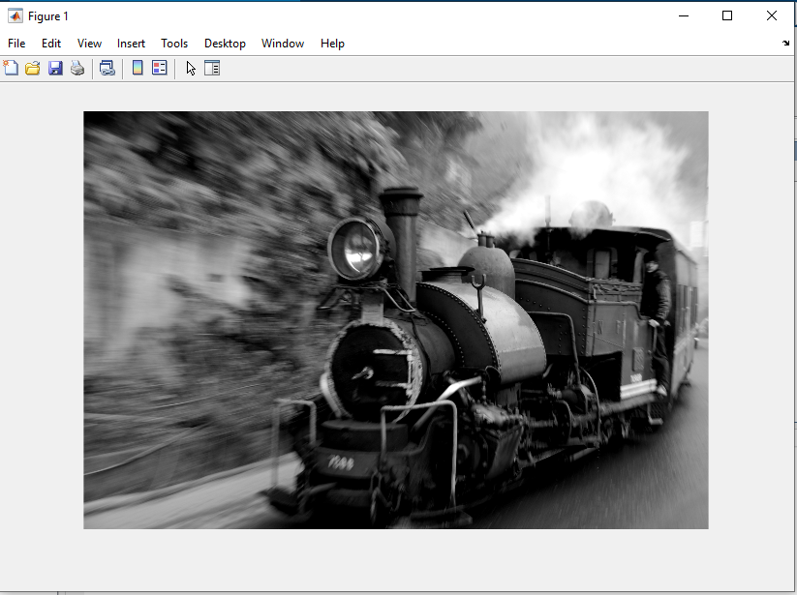imshow(avgFilter);

**INTERPRETATION:**

The filtering is to use the weighted average of 9 pixels encompassed by the filtering window to replace the pixel value at the center of the filtering window.

% gaussian filter

hg = fspecial('gaussian',[3 3], 0.5);

gaussFilter = imfilter(gi , hg, 'replicate');

imshow(gaussFilter);

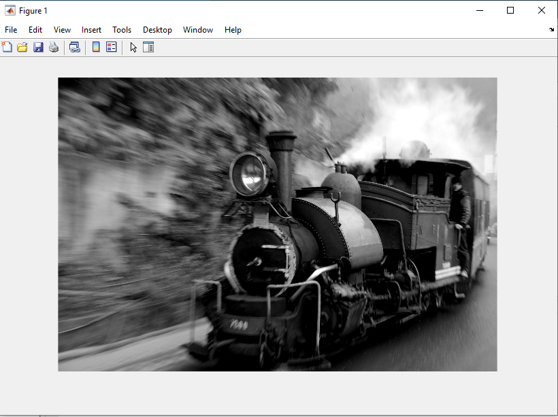

**INTERPRETATION:**

A Gaussian Filter is a low pass filter used for reducing noise (high frequency components) and blurring regions of an image.

**Non-linear filtering**

% Median filtering

If2 = medfilt2(gi, [3 3]) ; % 3-by-3 median filtering

figure(3)

image(If2);

title("Noisy Image filtered by a 3-by-3 median filter");

v=0:1/255:1;

colormap([v' v' v']); % LUT for displaying in gray levels

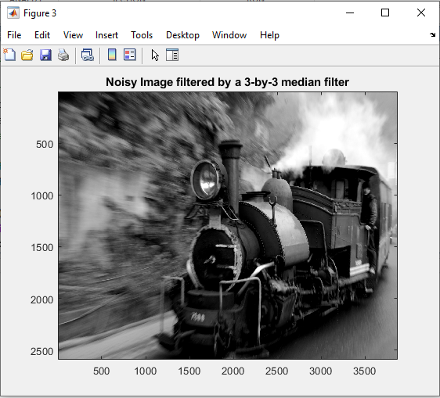

**INTERPRETATION:**

Median filtering is a nonlinear process useful in reducing impulsive, or salt-and-pepper noise. It is also useful in preserving edges in an image while reducing random noise.

**Q What is the difference between linear and non-linear point operations?**

Linear filtering is the filtering method in which the value of output pixel is linear combinations of the neighbouring input pixels. it can be done with convolution.For examples, mean/average filters or Gaussian filtering.

A non-linear filtering is one that cannot be done with convolution or Fourier multiplication. A sliding median filter is a simple example of a non-linear filter.

**Q What are the advantages of linear filtering?**

A linear filter is one that can be done with a convolution, which is just the linear sum of values in a sliding window. It can be done equivalently in the Fourier domain by multiplying the spectrum by an image. A blurring filter where you move over the image with a box filter (all the same values in the window) is an example of a linear filter.

A non-linear filter is one that cannot be done with convolution or Fourier multiplication. A sliding median filter is a simple example of a non-linear filter.