Name: Kartikay Agrawal

Roll No. 2148064

**Assignment 1**

***RESIZE***

I = imread('Christ.png');

J = imresize(I, 0.5);

figure

imshow(I);

figure

imshow(J);

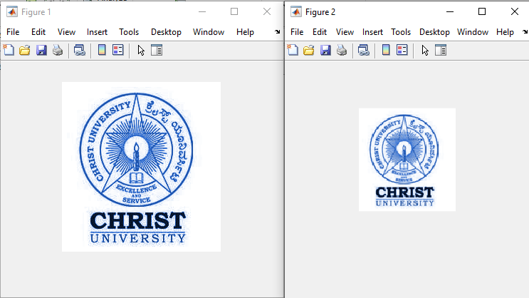

I = imread('Christ.png');

J = imresize(I, 0.4,'nearest');

figure

imshow(I)

title("Original Image")

figure

imshow(J)

title("Resized Image Using Nearest Neighbour Interpolation")

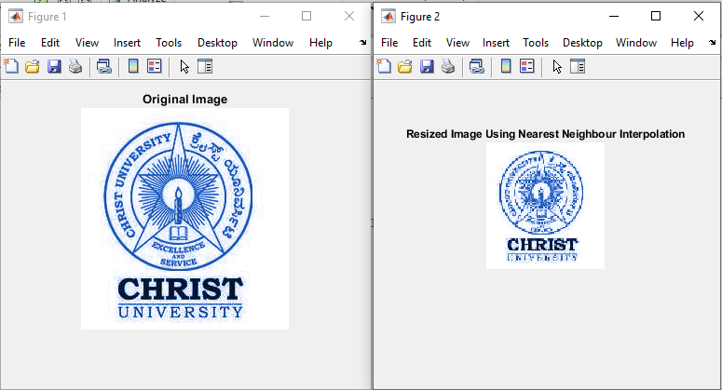

***Color Image to GRAY image***

Color_image = imread("Pepper.jpg");

Gray_image = rgb2gray(Color_image);

figure

imshow(Color_image)

figure

imshow(Gray_image)

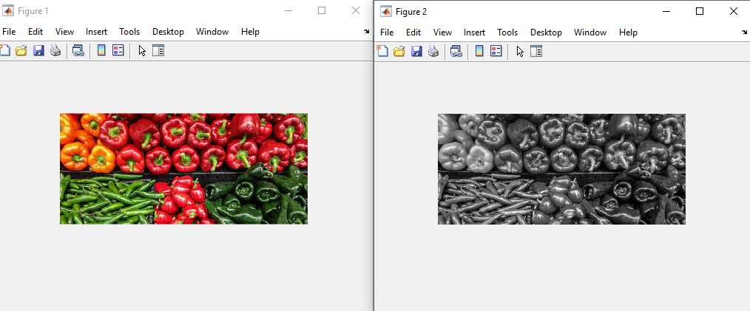

***Gray Image to binary image***

Gray_image = rgb2gray(Color_image);

Binary_image = imbinarize(Gray_image);

figure

imshow(Gray_image)

figure

imshow(Binary_image)

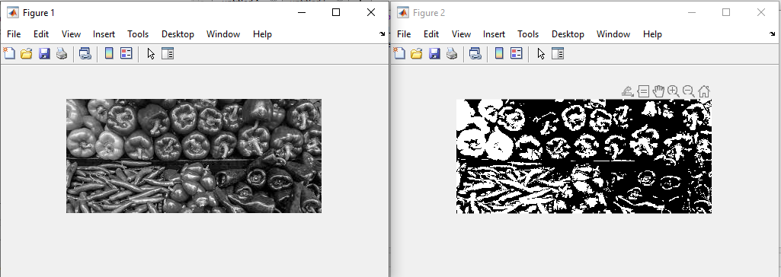

***Rotation of Binary, Gray scale, color image***

Color_image = imread("Pepper.jpg");

Gray_image = rgb2gray(Color_image);

Binary_image = imbinarize(Gray_image);

Rotated_image1 = imrotate(Color_image, 45);

Rotated_image2 = imrotate(Gray_image,180);

Rotated_image3 = imrotate(Binary_image,90);

figure

imshow(Rotated_image1)

figure

imshow(Rotated_image2)

figure

imshow(Rotated_image3)

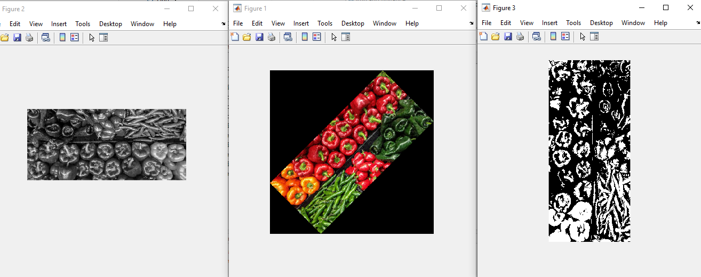

***Histogram Equalization***

Color_image = imread("Pepper.jpg");

Gray_image = rgb2gray(Color_image);

figure

imshow(Gray_image)

figure

imhist(Gray_image,64)

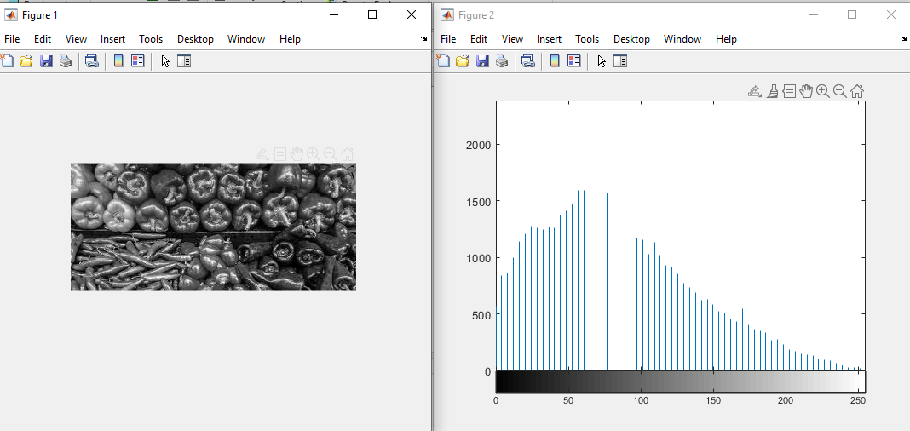

***Image filtering***

Color_image = imread("Pepper.jpg");

Blurred_image = imgaussfilt(Color_image,2);

figure

imshow(Color_image)

figure

imshow(Blurred_image)

