**NAME:Kartikay Agrawal**

**ROLL NO: 2148064**

**Lab Test**

%1(a) Write a Matlab program to determine the frequency of a given pixel occurring in an image.

pixel = input('Enter the pixel value: ');

frequency = 0;

im = rgb2gray(imread('C:/Users/Admin/OneDrive/Desktop/Mountain.jpg'));

[m,n] = size(im);

for i=1:m

for j=i:n

if(im(i,j)==pixel)

frequency = frequency + 1;

end

end

end

fprintf('Frequency = %d\n',frequency);



Observations

We can observe from the given image that intensity value of 89 has a frequency of 2.

%1(b)Write a matlab program to calculate the mean value of every row in a two-dimensional matrix M * N.

im = rgb2gray(imread('C:/Users/Admin/OneDrive/Desktop/Mountain.jpg'));

[m,n] = size(im);

for i=1:m

sum=0;

SUM=double(sum);

for j=1:n

SUM= SUM+double(im(i,j));

end

rowmean = SUM/double(n);

fprintf('Row %d Mean = %d\n',i,rowmean);

end

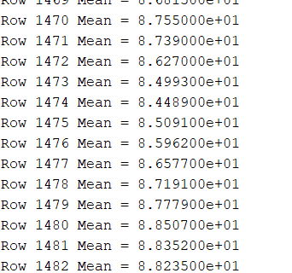

Observations

We can observe from the given rows that rowsums are having an approximate average of 87 value throughout it’s rows,but from (a) part we observe that it has very less frequency values at 89 pixel value.Hence we can say the image has a high variance about mean.

%2 Write a matlab program Resizing a grayscale image to 50% and rotate image to 45 degrees.

im = rgb2gray(imread('C:/Users/Admin/OneDrive/Desktop/Mountain.jpg'));

figure,imshow(2);

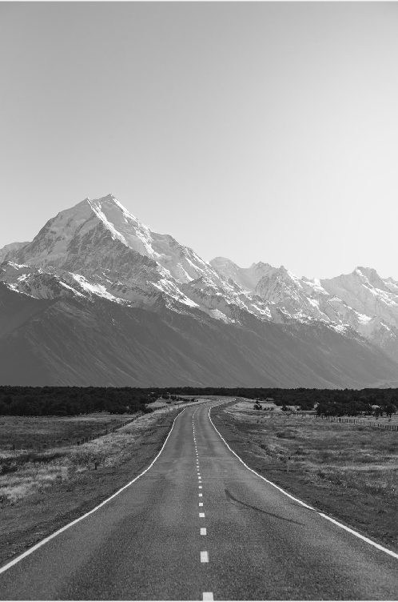

im2=imresize(im,0.5,’nearest’);

figure,imshow(2);

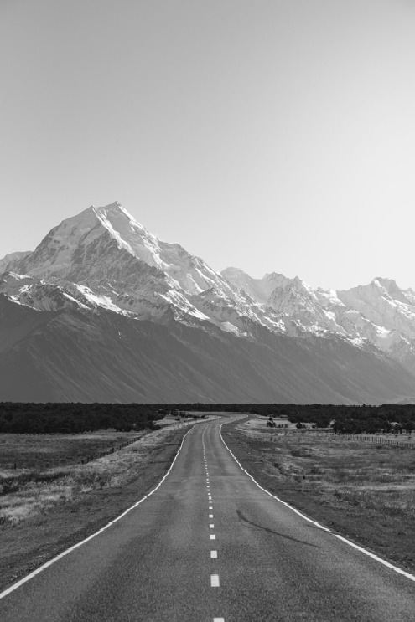

Observations

The image size has shrunk on resizing the image we can observe loss of pixel values.

im3=imrotate(im2,45);

figure,imshow(3);

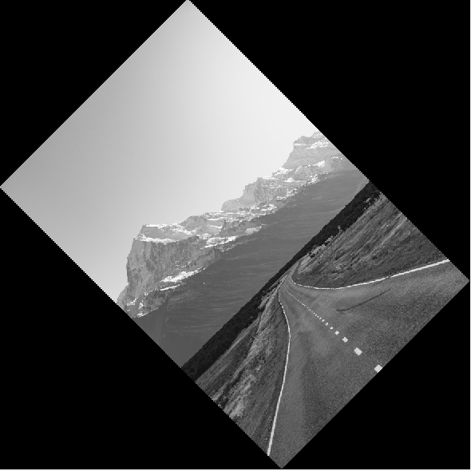

Observations

The frame has been made big enough to fit the full rotated image.

im3=imrotate(im2,45,’bilinear’,’crop’);

figure,imshow(3);

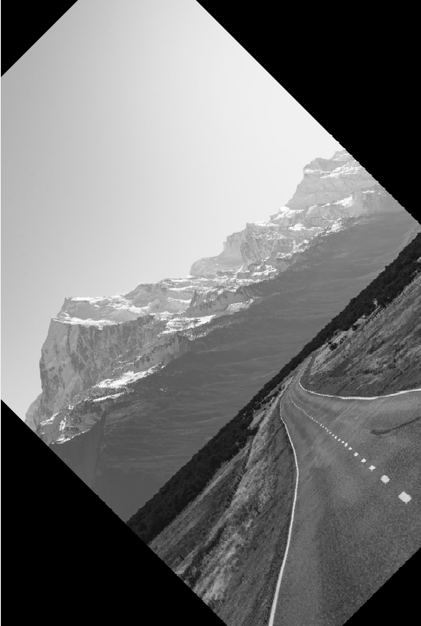

Observations

The output image has the same size as the unrotated image.