**NAME:** Kartikay Agrawal

**ROLL NO:** 2148064

**MDS272B - Image and Video Analytics**

**Q. Write a program to implement various image enhancement techniques**

**\* Image Sharpening**

**\* Image Smoothing**

**Image Sharpening**

A = imread('parthenon.jpg');

B = imsharpen(A, 'Radius', 2,'Amount', 1);

figure;

subplot(221); imshow(A); title('Original Image');

subplot(222); imhist(A); title('Hist of Original Image');

subplot(223); imshow(B); title('Sharpened Image');

subplot(224); imhist(B); title('Histogram of Sharpened Image');

**Output**

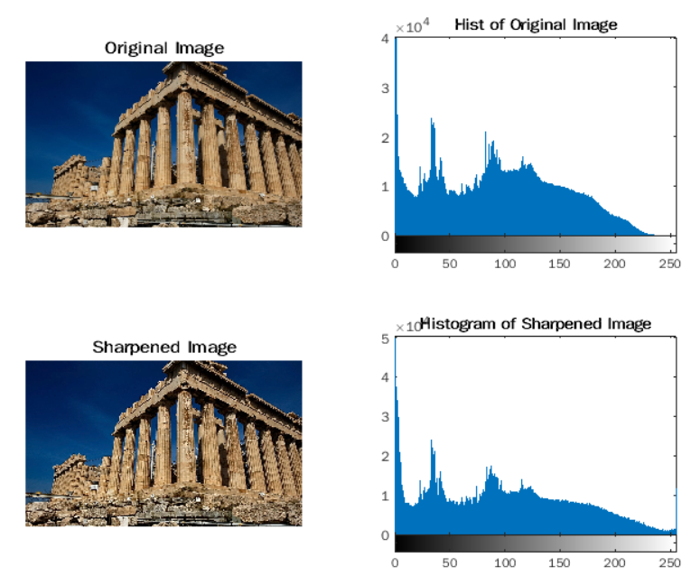

**Inferences**

Here the MATLAB function imsharpen() is used with arguments Radius as 2 and Amount as 1.

The Radius argument is defined as the standard deviation of the Gaussian lowpass filter. It can take any positive value with a default value of 1. A higher value of the Gaussian lowpass filter sharpens wider areas around the edges whereas a lower value sharpens narrower regions. We can see from the output that the image has been sharpened around the edges and from the histogram, we can infer that the tail (higher values of the pixel intensities) is elongated which means the pixel intensities are saturated at higher values.

The Amount argument is the strength of the sharpening effect defined by a numeric scalar, ideally in the range (0, 2). A value of the amount argument greater than 2 will lead to undesirable effects in the image. Hence, we have use the Amount value as 1.

**Image Smoothing**

C = imgaussfilt(A, 4);

D = imgaussfilt(A, [8, 1]);

figure;

subplot(321); imshow(A); title('Original Image');

subplot(322); imhist(A); title('Histogram of Original Image');

subplot(323); imshow(C); title('Smoothened Image with sig = 4');

subplot(324); imhist(C); title('Histogram of Smoothened Image with sig = 4');

subplot(325); imshow(D); title('Smoothened Image with sig_x = 8 and sig_y = 1');

subplot(326); imhist(D); title('Hist of Smoothened Image with sig = (8, 1)');

**Output**

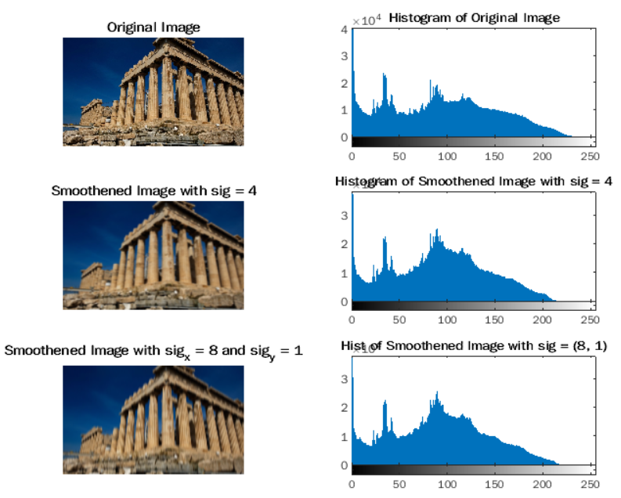

**Inferences**

Here the MATLAB function imgaussfilt() has been used for the purpose of image smoothing using a 2-D Gaussian smoothing kernel with arguments as 4 in one case and a vector of positive numbers [8, 1] in second case as the standard deviations of the Gaussian distribution.

The point of using a sigma value for the Gaussian smoothing filter is to smoothen the image to our required degree. As we increase the value of the standard deviation, the image becomes blurrier. As a result, when we compare the original image with the smoothened image, we can see that the smoothened image is blurrier as the value of sigma is increased from 0.5, which is the default value, to 4 and (8, 1) respectively. As a result, with an increased sigma value, the details in the image become blurrier and the image is smoothened out.