1. Program to demonstrate Spatial filtering using Built-in and user defined functions with different size of kernels. (Smoothing, Sharpening)

CODE(INBUILT):

%Image Sharpening

I = imread(Spiderman.jpeg');

J = imsharpen(I,'Radius',5,'Amount',4);

imshowpair(I,J,'montage');

title('Original Image (left) and Sharpened Image (right)');

%Image Smoothing

%Gaussian Filter

I = imread('KDB.jpg');

blur1 = imgaussfilt(I,2);

blur2 = imgaussfilt(I,4);

blur3 = imgaussfilt(I,8);

figure;

subplot(2,3,1);imshow(I);title('Original');

subplot(2,3,2);imshow(blur1);title('Blurred Image sigma = 2');

subplot(2,3,3);imshow(blur2);title('Blurred Image sigma = 4');

subplot(2,3,4);imshow(blur3);title('Blurred Image sigma = 8');

OUTPUT:

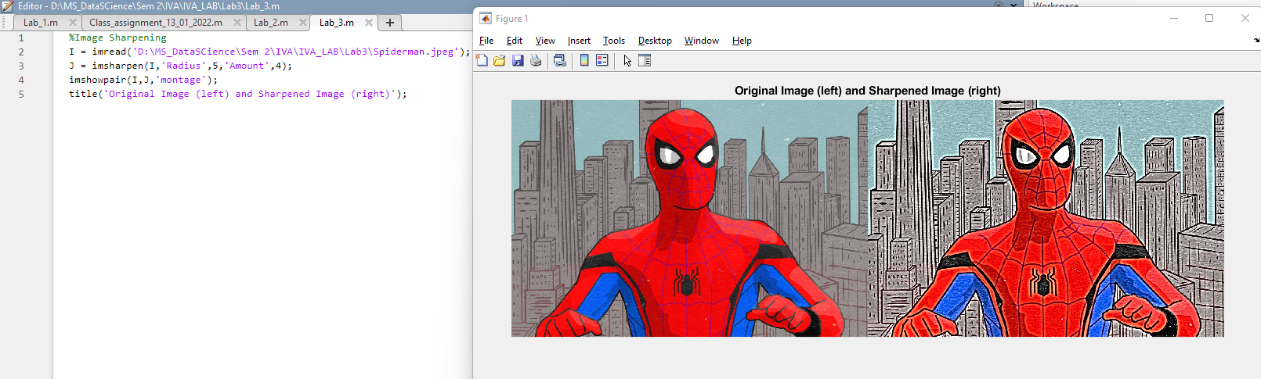

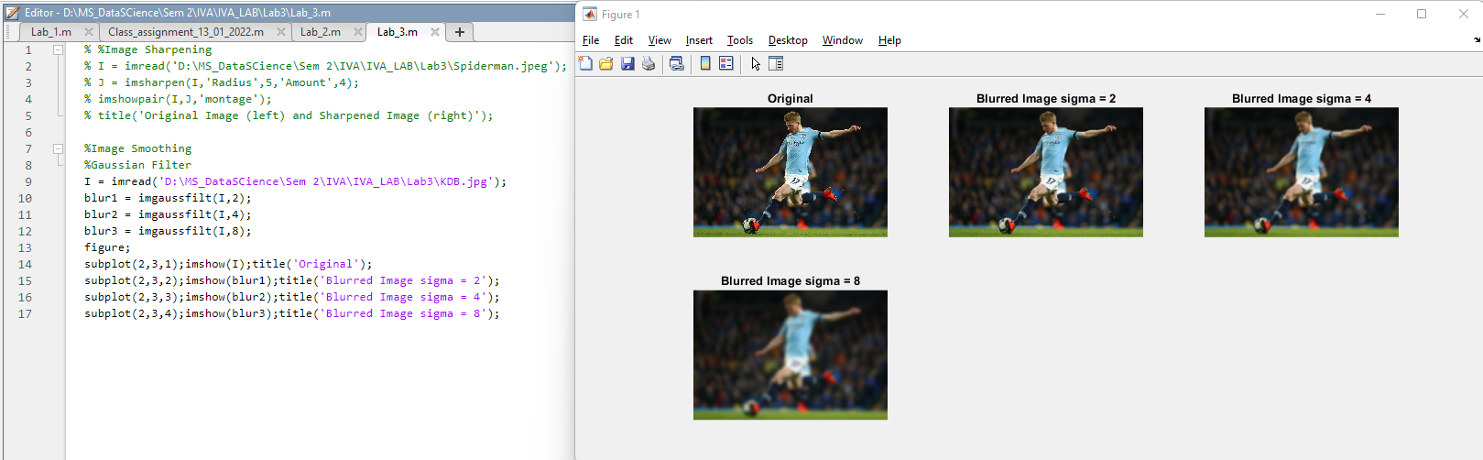

CODE(USER DEFINED):

%Image sharpening.

% Read the image in variable 'a'

a=imread("cameraman.tif");

% Defined the laplacian filter.

Lap=[0 1 0; 1 -4 1; 0 1 0];

% Convolve the image read

% in 'a' with Laplacian mask.

a1=conv2(a,Lap,'same');

% After convolution the intensity

% Values go beyond the range.

% Normalise the range of intensity.

a2=uint8(a1);

% Display the sharpened image.

imtool(abs(a-a2),[])

% Define strong laplacian filter

lap=[-1 -1 -1; -1 8 -1; -1 -1 -1];

% Apply filter on original image

a3=conv2(a,lap,'same');

% Normalise the resultant image.

a4=uint8(a3);

% Display the sharpened image.

imtool(abs(a+a4),[])

clear cam;

%Image Smoothening

% I = imread('D:\MS_DataSCience\Sem 2\IVA\IVA_LAB\Lab4\captain.jpg');

% grayImage = rgb2gray(I);

% subplot(1,2,1);

% imshow(grayImage);

% title('Original Image', 'FontSize', 15);

%

% windowSize = 16;

% kernel = ones(windowSize, windowSize) / windowSize ^ 2;

% filtimage= imfilter(grayImage, kernel, 'symmetric');

%

% subplot(1,2,2);

% imshow(filtimage);

% title('Blurred Image', 'FontSize', 15);

OUTPUT:

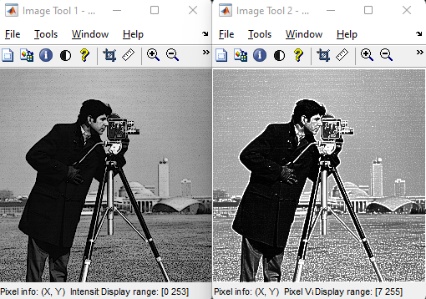



**2. Program to demonstrate Non linear filtering using Built-in and user defined functions with different size of kernels.**

**CODE(INBUILT):**

% built in function

B = ordfilt2(img,9,ones(3,3));

imshow(B);

**OUTPUT:**

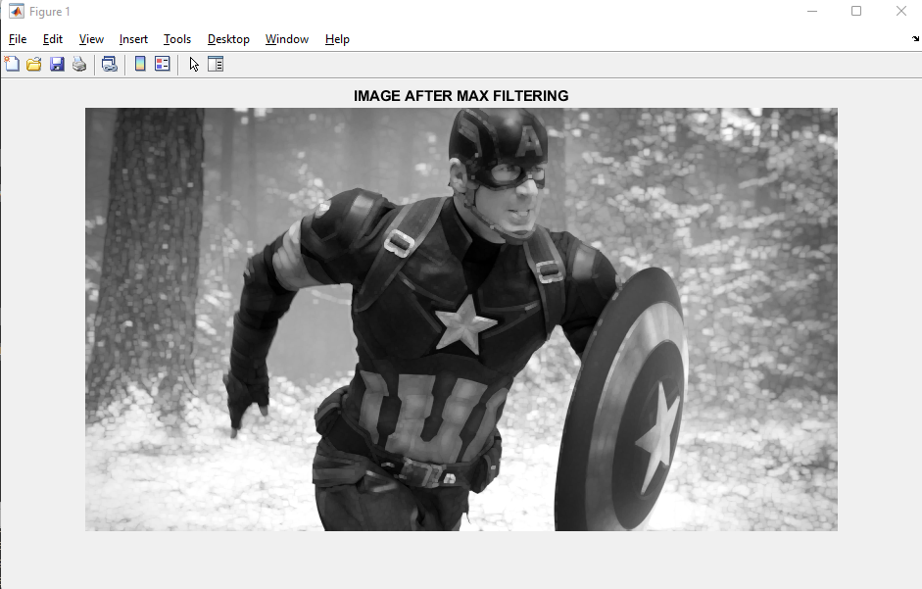

**CODE(USER DEFINED):**

im = imread('dog.jpg');

out_lm=zeros(size(im));

%PAD THE MATRIX A WITH ZEROS

padIm=padarray(im,[1 1]);

x=[1:3]';

y=[1:3]';

for i= 1:size(padIm,1)-2

for j=1:size(padIm,2)-2

%VECTORIZED METHOD

window=reshape(padIm(i+x-1,j+y-1),[],1);

%FIND THE MAXIMUM VALUE IN THE SELECTED WINDOW

out_lm(i,j) = max(window);

end

end

%CONVERT THE OUTPUT MATRIX TO 0-255 RANGE IMAGE TYPE

out_lm=uint8(out_lm);

figure,imshow(out_lm),title('IMAGE AFTER MAX FILTERING');

%convert the output into single array

output = out_lm(:);

**OUTPUT:**

