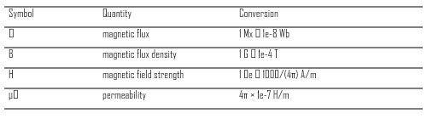
Rasterized Table Sample
Intro paragraph before the table.
TABLE I
UNITS FOR MAGNETIC PROPERTIES
Paragraph after the table, unrelated body text.

