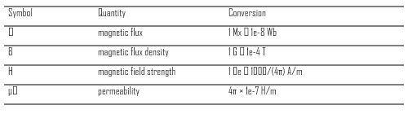
Rasterized Table Sample
Intro paragraph before the table.
TABLE I
UNITS FOR MAGNETIC PROPERTIES

