Home Page

Swades Foundation

Our Mission is to**empower 1 million rural Indians every 5-6 years**, creating a permanent, irreversible change for good. We believe in a **holistic 360-degree development** with a focus on four key verticals - **Health, Education, Water & Sanitation, and Economic Development.** This model empowers our communities with the capability of creating choices for themselves and their families, allowing them to transform their own lives and ensuring a permanent and irreversible change for good.

Smile Foundation

Smile Foundation believes that unless members of the civil society are involved proactively in the process of development, sustainable change will not happen. Following this model of Civic Driven Change, Smile Foundation sensitizes and engages the civil society, making it an active partner in all its welfare initiatives.

Care Foundation

We seek a world of hope, tolerance and social justice, where poverty has been overcome and people live in dignity and security. CARE India helps alleviate poverty and social exclusion by facilitating empowerment of women and girls from poor and marginalised communities.

Slider 1 –“We make a living by what we get,we make a life by what we give”

Slider 2- “We rise by lifting others”

Slider 3- “Giving opens the way for receiving.”

Women-Empowerment Page

Is just women education is women empowerment?

What do women do with higher education? How many of them actually pursue careers?  
General observations suggests that university education does not necessarily prepare women for any definite roles. Some women study while waiting to get married; several go in for higher studies to get better marriage partners. With the exception of few technical fields, no mechanism or procedure exists in Pakistan to help young women.

Not having been together as co-students men and women will find difficulty to accept each other as co-workers. By creating a women’s university that would be mainly a home economics university, we would be sex-stereotyping higher education for women. It is also important to look at and understand the political motives of those sections of the population which are demanding or opposing the establishment of women’s university.

We are emphatically of the view that a separate university for women should not be formed, because the ultimate aim of higher education for women in Pakistan(fot example) would be the integration of women into the various field of studying according to their abilities and talents. The formation of separate university for women could easily lead to a second-class status for women. The significance of this point needs to be fully appreciated. The matter should also be considered from the standpoint of emerging of competing claims in the distribution of scarce resources, services and facilities. “In Pakistan, where there are already quite a few bases for acquiring and rendering social justice, a women’s university would add to such bases, and thereby further complicate an already complex situation.”(319)

Such noble steps would help many little girls with dreams,become women with vision tomorrow .

The question is not who’s going to let her,its who is going to stop her!

Lets come together and help her to make her dreams alive.

Pray-For-Syria Page

What is happening in Eastern Ghouta, Syria?

Some of the worst violence we’ve seen over the course of the Syrian crisis is taking place right now in Syria’s Eastern Ghouta region, just northeast of the capital of Damascus. Each day, the situation grows more dire.

Despite a resolution from the United Nations Security Council demanding a cease-fire and the declaration of daily humanitarian pauses, we have barely seen a lull in violence.

**Punishment for No Reason**

In the past two weeks, escalating violence has left more than 1,000 people dead and at least 2,000 injured.

For more than a week now, families have been hiding in basements and underground shelters without proper ventilation, water or sanitation systems — many are digging their own underground shelters

Residents have little to no access to food, medicine or sanitary supplies. This year’s hard, cold winter has made conditions even worse.

**"This recent onslaught of violence comes on top of one of the worst hunger crises we have seen in the Syrian conflict," says Arnaud Quemin, Syria country director for Mercy Corps. "Bread prices are almost 22 times higher than the national average and the UN reports that 12 percent of Eastern Ghouta's children under the age of five are suffering from acute malnutrition."**

The Syrian conflict has created the worst humanitarian crisis of our time. Half the country’s pre-war population — more than 11 million people — have been killed or forced to flee their homes.

Families are struggling to survive inside Syria, or make a new home in neighboring countries. Others are risking their lives on the way to Europe, hoping to find acceptance and opportunity. And harsh winters and hot summers make life as a refugee even more difficult. At times, the effects of the conflict can seem overwhelming.

**A HEART PIERCING STORY(OPTIONAL-addition of the story could be done simply,but if we leave the option of reading it to the user, it would hv greater impact,hence initially story could be hidden,later on click ,could be made visible)**

At first glance, Douris in northern Lebanon's Bekaa Valley is a seemingly normal rural village. Poultry farms and cowsheds dot the landscape. But hidden from obvious view is a growing problem — Syrian refugees who have fewer and fewer safe places to live.

A look inside the poultry farms and the barns reveals a sad truth — **refugee families are now living where chickens and cows lived just a year ago**. In many cases, they are paying over $100 per month just to have a leaking roof over their heads and cow manure under their feet.

The Al Azab family is just one of thousands of Syrian refugee families who have resorted to living in unusual accommodations. Past several rows of former chicken coops (now inhabited by other refugees), the Al Azab family has turned a cowshed into their temporary home.

“My family name [Al Azab] means ‘scavenger’,” says the father Abid. **“We are suffering here and just trying to survive. It is a very hard life.”**

He and his wife and eight children share a single room that is about 10 feet by 12 feet in size. In the corner you can still see the trough where the cows used to feed — a stark reminder of their situation.

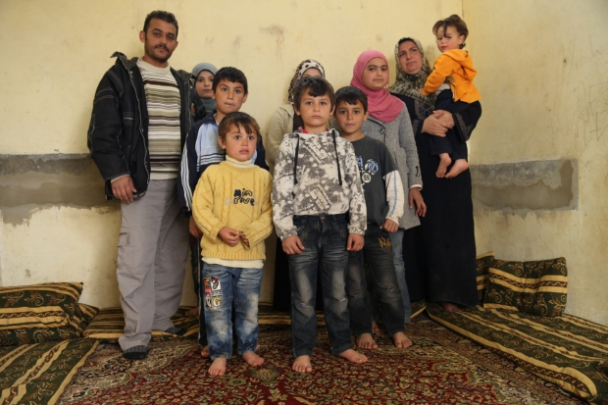  
Abid, his wife Khwada and their eight children all live in a single-room cowshed that has been recently repaired with help from Mercy Corps. They are just one of many families sheltering in barns and chicken coops.

Currently, Lebanon has the highest proportion of refugees of any country in the world — over one million in a country of just five million. That means that **one in five people in Lebanon is a Syrian refugee**, and the strain on the small country has become overwhelming.

The influx of new people has caused prices to skyrocket and increased competition for jobs as refugees try to find work. All of these factors contribute to tensions between refugees and their host communities.

And because there are no official refugee camps in Lebanon, Syrian families must find places to shelter on their own — places of last resort that others would never consider calling home. They end up in these barely habitable structures partly because they can’t afford to pay rent for proper living accommodations, and partly to avoid triggering negative reactions from local communities, which are severely strained by the refugee crisis.

For the Al Azab family’s cowshed, Mercy Corps was able to help by repairing and painting the walls, insulating the roof, and installing two water tanks and a sink.

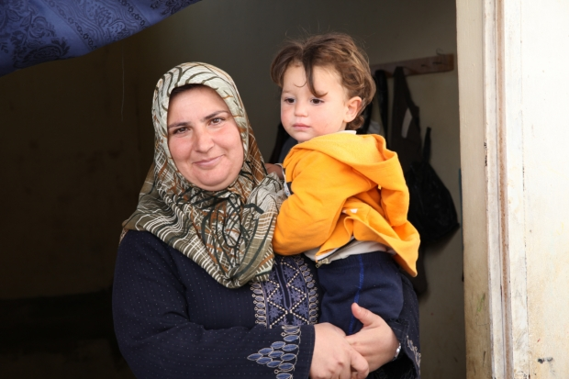  
Khwada and her youngest child, Salama. The family goes into winter with newly-painted walls, an insulated roof and a sink to help make the cowshed more livable.

Dealing with difficult living conditions is just the beginning of the challenges that refugee families face in Lebanon. Over half of the refugees from Syria are children. Most have witnessed horrific violence and many have seen their homes destroyed by bombs or have lost family members.

They arrive as refugees in a foreign country and typically do not have access to educational opportunities or even the chance to play or make friends. Currently, **68 percent of Syrian refugee children and adolescents are out of school**, and many have not seen the inside of a classroom in more than three years.

The Al-Azab children have not been able to attend school since arriving in Lebanon over a year ago. Before they fled Syria, violence forced them to move several times, and they missed an additional year and a half of school.

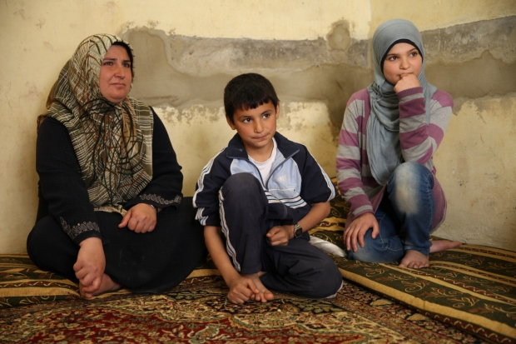  
Malek, 10, and Houda, 13, have been unable to attend school as refugees. Neither has been to a formal school in more than two years.

“I haven’t been to school in over two years,” says Houda, Abid’s 13-year-old daughter. **“I was a very good student in Syria. I loved my school and miss going to class and seeing friends.** Here my parents don’t let me do anything. I don’t have any freedom.”

Like hundreds of thousands of Syrian refugee girls, Houda is now forced to stay inside helping with chores. Her parents are afraid for her safety, since they now live in a place where they have few friends and no community ties.

For many refugee children, the pressure to generate income (for boys) or help with home chores (for girls) prevents them from pursuing their education goals. Girls, kept home by their families for safety reasons, have reported frightening levels of physical and social isolation.

## **WHAT CAN WE DO TO HELP THE PEOPLE OF SYRIA?**

* **Donate today.** Every single contribution helps us provide even more food, water, shelter and support to Syrian families and families in crisis around the world.
* **Tell your friends.** Share this story to post the infographic and spread the word about the millions who need us.
* **Start a campaign.** You can turn knowledge into action by **setting up a personal fundraising page** and asking your friends and family to contribute to our efforts to help Syrians fleeing the war.
* **Sign a petition.** Tell congress that we must continue to support Syrian refugees. **Add your name to the list** to stand in support with refugees.