System Requirements Statement (SRS) –

VaccAlert

Doc. Ref. : SRS_v0.4.doc

Version : 0.4

Status : Drafted

Created by :

Date : 17-June-2024

1. Introduction 3

2. Functional Requirements 4

2.1 Parent Module 5

2.2 Hospital Module 9

2.3 Admin Module 15

2.4 Use Case Diagram 18

THIS DOCUMENT CONTAINS 20 NUMBERED PAGES

# Introduction

This document explains the system requirements and scope for developing VaccAlert System.

VaccAlert System is a system design especially for child vaccination.

VaccAlert System could divide the three main parts, Parent part, Hospital part, Admin part.

This document specifically details the system requirements for the Account part of all the three parts.

# Functional Requirements

The Account part of VaccAlert System has three modules which are divided into 13 processes described as below.

|  |  |  |
| --- | --- | --- |
| **No** | **BRS requirement ID** | **Description** |
| **2.1** | **Parent Module** | |
| **2.1.1** | **F1** | **Account Creation Process** |
| **2.1.2** | **F2** | **Login Process** |
| **2.1.3** | **F3** | **Forgot Password Process** |
| **2.1.4** | **F4** | **Change Password Process** |
| **2.1.5** | **F5** | **Update Profile Process** |
| **2.1.6** | **F6** | **Book Vaccine** |
| **2.1.7** | **F7** | **Get** **Vaccination** **Reminders** |
| **2.1.8** | **F8** | **Cancel Booking** |
| **2.2** | **Hospital Module** | |
| **2.2.1** | **F09** | **Account Creation Process** |
| **2.2.2** | **F10** | **Login Process** |
| **2.2.3** | **F11** | **Forgot Password Process** |
| **2.2.4** | **F12** | **Change Password Process** |
| **2.2.5** | **F13** | **View Vaccination Appointment list** |
| **2.2.6** | **F14** | **Add Doctor** |
| **2.2.8** | **F16** | **View Vaccines** |
| **2.3 Admin Module** | | |
| **2.3.1** | **F17** | **Login Process** |
| **2.3.2** | **F18** | **Forgot Password Process** |
| **2.3.3** | **F19** | **Change Password Process** |
| **2.3.4** | **F20** | **Update Account Process** |
| **2.3.5** | **F22** | **Add Hospital** |
| **2.3.6** | **F** | **Add Vaccine** |
| **2.3.7** | **F21** | **View Registered Users** |

## 2.1 Parent Module

The Parent user of the VaccAlert System can perform the following functions:

1. View available vaccines.
2. Locate nearby hospitals that offer vaccinations.
3. Book appointments for vaccines.
4. Cancel vaccine bookings.

### Account Creation Process

* VaccAlert System requires users to create an account before using its features. Therefore, VaccAlert System should provide a sign-up function that allows parents to become users of the system.
* When a parent signs up for an account, the system requires the following information:

1. **Login information**

The updatable items as described below.

1. First Name
2. Last Name
3. E-mail address

**Note:** All items are required, but updates are optional.

* + UserName
* The UserName should be unique. If the UserName correspond with not case-sensitive to other which is previously registered, the UserName should not be registered as an account.
  + Password
* The Password has constrains which makes the Password consists of more than or equal 8 and less than or equal 16 characteristics including characters described as below.

1. Numeric figure (at least one)
2. Capital alphabet (A-Z)(at least one)
3. Small alphabet (a-z)(at least one)
4. Special character (#, $, %, &, etc.) (at least one)

* The Password is masked by dummy characters. The re-entering Password is demanded.
  + Email
* The email address must follow standard format rules:

It must contain exactly one '@' symbol

There must be at least one character before the '@' symbol.

There must be a valid domain name after the '@' symbol (e.g., gmail.com).

1. **The Security Question information**

The Security Question information is needed when parent lost their Password. This information consists of two items described as below.

1. Selected Question
2. Answer

**Note:** All items are required, but updates are optional.

* + - Some questions which are difficult to answer for anyone else are prepared in advance.
      * + E.g. which color do you like most?
    - A question should be selected from options by the parent, and the Answer is registered by the Parent.
* Login information should be entered on one screen, and then parent information and Security Question information should be entered on another screen.

### Login Process

* VaccAlert System always compels user authentication before using itself except when a new account is successfully created.
* The user authentication demands UserName and Password. The UserName and the Password should be checked in three ways.
  1. First, The UserName and the Password should be existed and correct.
* If The UserName and the Password are not equal to what the user has registered, the user authentication cannot be provided.
  1. Second, the User Type linked to the UserName should be present in "parent".
* When the User Type is "Parent", then user can be placed on “Parent Home”.
  1. Finally, UserName should be available.
* The Administrator can decide whether the UserName is available or suspended – Refer to the SRS of the Admin part.
* If parent is rejected, user authentication is not provided for system user.
* Only when the three checks are successfully completed, parent can be placed on respected page.
* **The “Parent Home” features**

1. A trigger to logout
2. A trigger to update Profile
3. A trigger to Search Vaccines
4. A trigger to Book Vaccine
5. A trigger to View Booking List

### Forgot Password Process

* When system user lost their Password, the recovery method should be provided by VaccAlert system.

The recovery method is described as below.

* 1. First, system user enters their Username for VaccAlert System.
  2. Next, VaccAlert System demands the Answer which has been registered since when the Account was created.
  3. Only when the Answer is correct, parent get the new function to enter new password and set the password.
* If the Answer is not correct, otherwise, the correct Answer is demanded for user again.
  1. In that case, Of course, parent couldn’t get the new password.

### Change Password Process

* When parent wants to change their Password, the measure should be provided by VaccAlert System.
* Therefore, VaccAlert System should provide the function which is available after getting the parent authentication.
* The function demands the current password and the new password.
  1. Of course, the new password should consist of more than or equal 8 and less than or equal 16 characteristics including at least a numeric figure, a capital alphabet, a small alphabet, and a special character.
  2. The current password and the new password are masked by using dummy characters.
  3. The new password is demanded to enter twice to avoid a typing error.
* Only when the current password is correct, parent could change their Password.
* When the current password is changed into new password, VaccAlert System compels user authentication again.

### Update Profile Process

* VaccAlert System should provide the function which makes the account updated for parent.
* The information parent could update is described below.

1. Child information
2. User Information
3. **The Child information**

The updatable items as described below.

1. First Name
2. Middle Name
3. Last Name
4. Mother Name
5. Date Of Birth
6. Address
7. Mobile Number
8. Blood Group
9. Weight
10. Gender

**Note:** All items are required, but updates are optional.

1. **The User information**

The updatable items as described below.

1. User Name
2. E-mail address

**Note:** All items are required, but updates are optional.

### 2.1.6 Book Vaccine Appointment

* The User can view Available vaccine and User can book for that vaccine

1. First Name
2. Last Name
3. Email

* Above data automatic generated by system using user information

1. Booking date
2. Time slot
3. Vaccine name
4. Hospital name

#### 2.2 Hospital Module

### 2.2.1 Account Creation Process

* Hospitals will contact admin for the account creation.
* The admin will create respective login credentials for the respective hospitals.
* Hospitals will use these credentials to log in and access their management systems.

Hospital Send Following information to the admin for account creation :

* Hospital Email
* Hospital Name
* Hospital Address
* Hospital Phone Number
* Hospital Web Site

Admin send following credential for login

* UserName
* Password

### 2.2.2 Login Process

* The user authentication demands UserName and Password. The UserName and the Password should be checked in three ways.
  1. First, The UserName and the Password should be existed and correct.
* If The UserName and the Password are not equal to what the user has registered, the user authentication cannot be provided.
  1. Second, the User Type linked to the UserName should be present in "parent".
* When the User Type is "Parent", then user can be placed on “Hospital Home”.
  1. Finally, UserName should be available.
* The Administrator can decide whether the UserName is available or suspended.
* If parent is rejected, user authentication is not provided for system user.
* Only when the three checks are successfully completed, Hospital can be placed on respected page.
* Only when the three checks are successfully completed, Wholesaler can be placed on respected page.
* The “Hospital Home” provides the some items described as below.
* A trigger to logout
* A trigger to Update Profile
* A trigger to View Vaccine
* A trigger to Add Doctor
* A trigger to View Doctors
* A trigger to View Vaccine Booking Details

### 2.2.2 Forgot Password Process

### 2.2.3 Change Password Process

### 2.2.4 **View Vaccination Appointment list**

Hospital can view the Vaccination Appointment list.

### 2.2.5 Add Doctor

* Vaccalert system provide a facility for hospital to add the doctor in hospital model.
* Following fields are required for add Doctors Details :
* First Name
* Last Name
* Qualification
* Vaccalert system also provide a facility for hospital to remove the doctor in hospital.

### 2.2.6 View Vaccines

Vaccalert system also provide a facility for hospital that can view the vaccies details.

#### 2.3 Admin Module

* The Admin Module of the Vaccination Alert System is made to help with administrative tasks.
* Admin Module will manage:

1. Users
2. Vaccination schedules
3. Notifications
4. System Settings

* This document describes what the Admin Module should do and what features it should have.

### 2.3.1 Login Process

* VaccAlert System always requires users to log in before using it, except when they are creating a new account.
* The user authentication demands UserID and Password. The UserID and the Password should be checked in three ways.
  1. First, The UserID and the Password should be existed and correct.
* If The UserID and the Password are not equal to what the admin has registered, the Admin authentication cannot be provided.
  1. Second, the User Type linked to the UserID should be "Admin".
* When the User Type is "Admin", user can be placed on “Admin Home”.
  1. Finally, UserID should be available.
* The Administrator has the authority to determine if a UserID is available or suspended.
* If user is rejected, user authentication is not provided for system user.
* The Admin account should remain active for the duration decided by the Administrator.
* Only when the three checks are successfully completed, Admin can be placed on respected page.
* **The “Admin Home” features:**

1. Trigger to Add Hospital.
2. Trigger to Add Vaccination.
3. Trigger to View Beneficiary Details.
4. Trigger to View Vaccine Details.
5. Trigger to Update Vaccine Details.

### 2.3.2 Forgot Password Process

* When Admin lost their Password, the recovery method should be provided by VaccAlert system.

The recovery method is described as below.

* 1. First, Admin enters their UserID for VaccAlert System.
  2. He will enter the email address associated with the account's creation
  3. Only if the email address is correct, the admin will receive a new password at the registered email address.
  4. The new password is automatically generated by VaccAlert System.
* Of course, the new password should consist of more than or equal 8 and less than or equal 16 characteristics including at least a numeric figure, a capital alphabet, a small alphabet, and a special character.
* As a consequence, The Admin could get the Admin authentication using the new password.
  1. Then, the admin should manually change the new password.

### 2.3.3 Change Password Process

* When the admin wants to change their password, VaccAlert System should provide the necessary steps.
* Therefore, VaccAlert System should provide a function that is accessible after the admin authentication is verified.
* The function demands the current password and the new password.
  1. Of course, the new password should consist of more than or equal 8 and less than or equal 16 characteristics including at least a numeric figure, a capital alphabet, a small alphabet, and a special character.
  2. The current password and the new password are masked by using dummy characters.
  3. The new password is demanded to enter twice to avoid a typing error.
* Only when the current password is correct, Admin could change his Password.
* When the current password is changed into new password, VaccAlert System compels user authentication again.

### 2.3.4 Update Account Process

* VaccAlert System should provide the function to update Admin accounts.
* The information Admin could update is described below.

1. Login information
2. User information

* **Login information**

The updatable items as described below.

1. First Name
2. Last Name
3. E-mail address

**Note:** All items are required, but updates are optional.

* **User information**

The updatable items as described below.

1. User Name
2. User Phone No
3. E-mail address
4. Permanent address

**Note**: All items are required, but updates are optional.

### 2.3.5 Add Hospital

* Admin Take Information from user i.e. mention in Hospital module.
* Using that information Admin create or add the Hospital account .
* After Successfully Account creation Admin send the login credential to the Hospital.
* Admin can also able to delete the registered hospital.

### 2.3.6 Add Vaccine

* Admin should able to add the vaccine.
* Following details are required to add the vaccine.
* Vaccine Name
* Description
* Dose
* Max Age
* Route
* Site
* When to give
* Stock
* Admin also able to delete and update the Vaccine.

### 2.3.6 View Registered Users

* Admin also able to view the registered user(Beneficiary) details.
* Also it can delete the user from system.

#### Use Case Diagram

### Parent:

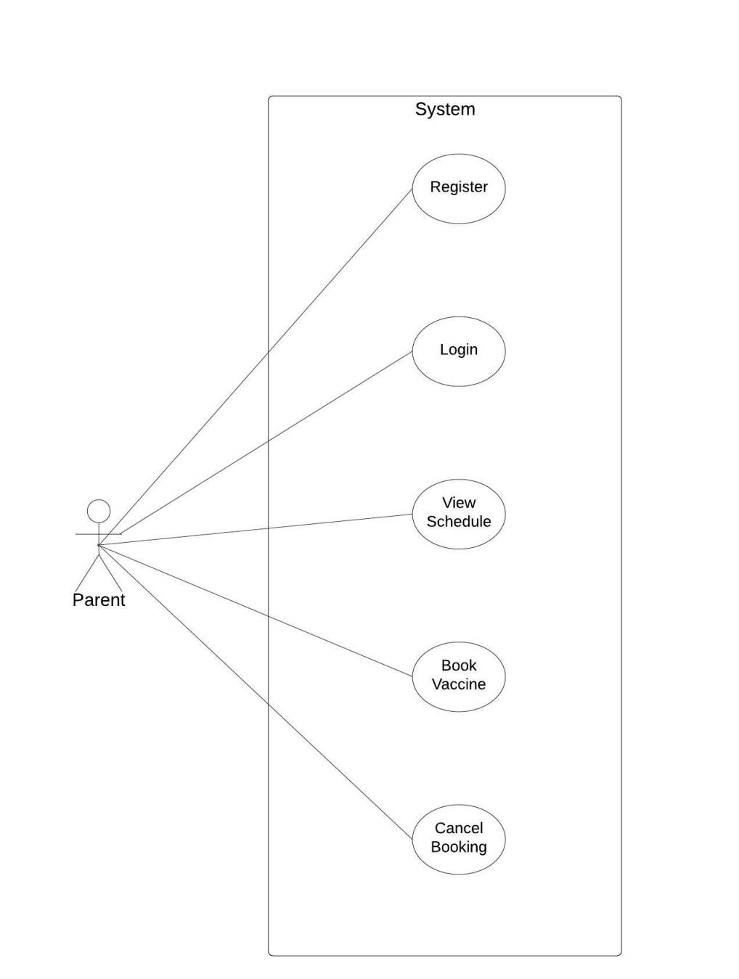

*Fig. Use case diagram for parent*

1. In Parent use case diagram Parent is the Actor.
2. Parent can handle following use cases:
3. Register
4. Login
5. View Schedule
6. Book Vaccine Appointment
7. Cancel Booking

#### Hospital:

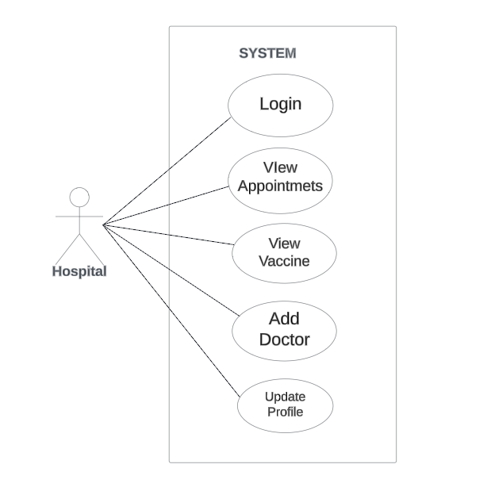

*Fig. Use case diagram for hospital*

1. In Hospital use case diagram Hospital is the Actor.
2. Hospital can handle following use cases:

* Login
* View Vaccine Appointment
* View vaccines
* Add Doctor
* Update Profile

#### Admin:

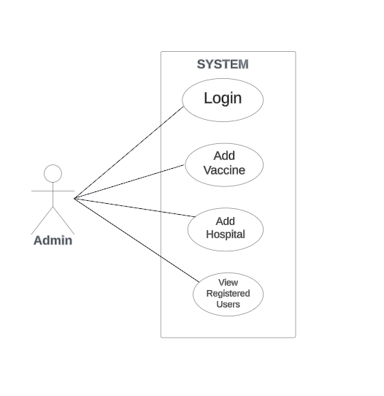

*Fig. Use case diagram for admin*

1. In Admin use case diagram Admin is the Actor.
2. Admin can handle following use cases:
3. Login
4. Add Vaccine
5. Add Hospital
6. View Registered users