2023-2027/CSE-DS/1/G15

AI-DRIVEN MULTIMODAL SENTIMENT ANALYSIS FOR MENTAL HEALTH MONITORING ON SOCIAL MEDIA
EXTENDED SYNOPSIS
(Research Design and Implementation: Progress Report for the Second Project Viva)
Submitted in Partial Fulfillment of the Requirements for the Degree of
Bachelor of Technology
in
Computer Science and Engineering
Session: 2023–2027
by
KARTIKEY TIWARI (2300271540063)
AKSHAT SHARMA (2300271540018)
KARAN SHARMA (2300271540062)
LALIT SHARMA (2300271540066)

Under the Supervision of
Dr. AVDHESH GUPTA
AJAY KUMAR GARG ENGINEERING COLLEGE, GHAZIABAD
DR. A.P.J. ABDUL KALAM TECHNICAL UNIVERSITY, LUCKNOW
Second Project Viva: 12–13 October 2026

CERTIFICATE OF REVIEW BY GUIDE
This is to certify that the Extended Synopsis entitled “AI-Driven Multimodal Sentiment Analysis for Mental Health Monitoring on Social Media”, containing the Research Design and Implementation progress of Group 15 (Session 2023–2027), B.Tech Computer Science and Engineering, Ajay Kumar Garg Engineering College, Ghaziabad, has been reviewed by me before the Second Project Viva held on 12–13 October 2026. The work reported here is an authentic record of the progress made by the group under my supervision.

Remarks of the Guide:
________________________________________________________________
________________________________________________________________
________________________________________________________________
________________________________________________________________

Signature of Guide: ______________________ Date: ____________
Dr. AVDHESH GUPTA
Department of Computer Science and Engineering
Ajay Kumar Garg Engineering College, Ghaziabad

Group Members
Name of Student | Roll Number | Signature
KARTIKEY TIWARI | 2300271540063
AKSHAT SHARMA | 2300271540018
KARAN SHARMA | 2300271540062
LALIT SHARMA | 2300271540066

ABSTRACT
Social-media posts usually combine text with an image, yet most sentiment and mental-health analysis systems read only the text. This project asks whether combining both modalities measurably improves sentiment classification, and under what conditions. The proposal stage (first viva) has now been carried through to a working, tested implementation. Following an experimental, comparative research design, we built two text models (TF-IDF + Logistic Regression; frozen DistilBERT), two image models (a from-scratch CNN; frozen ImageNet ResNet18), and two fusion strategies (feature-level concatenation with an MLP head; decision-level late fusion). All of them are trained and evaluated on identical splits with identical metrics, on CPU-only hardware.
Study 1 uses MVSA-Single (4,511 real Twitter text–image pairs, 3-class sentiment). Concatenation fusion reaches 64.4% accuracy / 56.3% macro-F1, ahead of the best text model (61.6% / 54.6%) and the best image model (52.7% / 42.8%). The gain is concentrated on posts where the text and image models disagree. Study 2 extends the work to Internet memes (Memotion, 3,500-sample stratified subset), where the text is rendered inside the image. A Gaussian-blur ablation, validated by a 99.9% drop in Laplacian sharpness, removes most of the fusion gain (−10.9 pp accuracy) while barely affecting the image-only model (−1.4 pp). This indicates that much of the apparent multimodal benefit on memes comes from the image encoder re-reading embedded text. A Streamlit demonstration application, a research dashboard, explainability (token saliency, Grad-CAM, modality ablation), 32 passing automated tests and an IEEE-format paper draft complete the implementation. The system is a non-clinical research tool and does not diagnose.
Keywords: Multimodal Sentiment Analysis, Feature Fusion, DistilBERT, ResNet18, MVSA-Single, Memotion, Modality Conflict, Embedded-Text Leakage, Mental Health Monitoring, Resource-Constrained ML

Contents
CERTIFICATE OF REVIEW BY GUIDE 2
ABSTRACT 3
1 Introduction and Research Progress 6
1.1 Problem Statement 6
1.2 Research Questions 6
1.3 Research Objectives 6
1.4 Progress Since the First Viva 7
1.5 Scope and Deviation from the Proposal 7
2 Literature Summary and Research Gap 8
2.1 Research Gap 8
3 Research Design 9
3.1 Research Approach and Justification 9
3.2 Datasets 9
3.3 System Architecture 10
3.4 Algorithms 10
3.5 Justification of Design Choices 11
3.6 Evaluation and Validation Design 11
4 Implementation 12
4.1 Tools, Platform and Environment 12
4.2 Modules Developed 12
4.3 Implementation Workflow 12
4.4 Demonstration Application 13
4.5 Testing 15
4.6 Technical Challenges Faced and Resolutions 15
5 Results and Validation 17
5.1 Study 1: MVSA-Single (Twitter photos) 17
5.2 Study 2: Memotion (memes): Embedded-Text Leakage 19
5.3 Validation Summary 20
6 Next Plan and Timeline 21
6.1 Work Remaining 21
6.2 Team Roles 21
7 Ethical Considerations 22
References 23

Chapter 1

1 Introduction and Research Progress

1.1 Problem Statement
Existing sentiment and mental-health analysis systems on social media rely mainly on text, and lose the emotional context carried by the images, memes and emoji that accompany it. Where multimodal systems do exist, they are rarely compared against text-only and image-only models under identical data, splits and metrics. When they are, the comparison is usually made on very small social-media samples or on GPU-scale infrastructure. This project builds and rigorously compares text-only, image-only and multimodal sentiment models on real social-media data, under a realistic CPU-only budget, and investigates when and why fusion helps.

1.2 Research Questions
Primary RQ: Can a multimodal framework combining textual and visual information improve sentiment classification of social-media posts compared with unimodal (text-only, image-only) approaches?
- RQ-a: How effectively can text alone classify the sentiment of social-media posts (traditional vs. transformer features)?
- RQ-b: What additional information does visual content provide (from-scratch CNN vs. pretrained ResNet18)?
- RQ-c: Does fusion help uniformly, or does the gain concentrate on posts where text and image disagree (modality conflict)?
- RQ-d (new, from Study 2): When the text is embedded in the image (memes), how much of the fusion gain is real visual signal and how much is the image encoder re-reading the text?

1.3 Research Objectives
- O1: Select and prepare a publicly available, adequately-sized multimodal social-media dataset with documented provenance.
- O2: Develop preprocessing pipelines for text (URL/mention normalisation, emoji demojization) and images.
- O3: Build text-only, image-only and multimodal (fusion) models, each with a baseline and a modern variant.
- O4: Evaluate all models on identical splits with accuracy, precision, recall, macro-F1 and confusion matrices.
- O5: Analyse errors, modality conflict and explainability, and deliver a non-clinical demo and dashboard.
- O6: Disseminate the work as a research manuscript.

1.4 Progress Since the First Viva
The table below maps each objective to its status and the evidence in the project repository.
Table 1.1: Objective-wise progress
Objective | Status | Evidence (repository)
O1 Dataset | Completed | MVSA-Single (4,511 pairs) + Memotion subset (3,500); DATASET_SELECTION.md
O2 Preprocessing | Completed | src/preprocessing/; unit-tested (tests/)
O3 Models | Completed | 6 variants (A1, A2, B1, B2, C-concat, C-late) + blur variants in Study 2
O4 Evaluation | Completed | results/*.json, research_paper_v2/results/*.json
O5 Analysis + demo | Completed | ERROR_ANALYSIS.md, MODALITY_CONFLICT_ANALYSIS.md, app/streamlit_app.py
O6 Dissemination | In progress | IEEE-format drafts: research_paper/ and research_paper_v2/
Robustness (multi-seed) | Pending | Planned for Oct–Nov 2026 (Chapter 6)

1.5 Scope and Deviation from the Proposal
The proposal named fine-grained emotional states (stress, anxiety, loneliness). The literature search found no publicly available, adequately-sized social-media dataset that pairs text, image and mental-health labels. We therefore use 3-class sentiment (positive/neutral/negative) as an established, non-clinical proxy, as the scope section of the proposal anticipated ("final dataset selection will depend on availability"). The framework does not depend on the label set and can be retrained if a mental-health-labelled multimodal corpus becomes available. The system remains a research and monitoring-support tool, not a diagnostic instrument.

Chapter 2

2 Literature Summary and Research Gap
A detailed literature review was submitted with the first synopsis (LITERATURE_REVIEW.md). The findings that drive the design are summarised below.
Table 2.1: Literature themes and their effect on the design
Theme | Key finding | Design consequence
Text (BERT, MentalBERT, DistilBERT) | Transformers dominate text sentiment; DistilBERT keeps ~97% of BERT's quality at ~60% of its cost | A2 uses frozen DistilBERT; TF-IDF kept as traditional baseline A1
Image (CNN, ViT, transfer learning) | ViTs need very large pre-training; transfer from pretrained CNNs beats training from scratch on thousands of images | B2 uses frozen ResNet18; B1 from-scratch CNN as baseline
Multimodal fusion surveys | Early, late and attention fusion are well studied; gains depend on modality complementarity | Concat (early) + late fusion; attention kept as a stretch goal
Memes / scene text (Memotion, Hateful Memes, TextVQA) | Meme meaning lives in the text–image interaction; reading in-image text is a distinct capability | Study 2 blur ablation isolates the embedded-text channel

2.1 Research Gap
- Few controlled, same-dataset, same-metric comparisons of text vs. image vs. multimodal models on adequately-sized real social-media data. The closest comparable work evaluates its social-media condition on about 100 pairs.
- Most multimodal studies assume GPU-scale resources. What is achievable on commodity CPU hardware is rarely reported.
- No located work quantifies how much of the fusion gain on memes comes from the image encoder reading embedded text rather than from independent visual cues.

Chapter 3

3 Research Design

3.1 Research Approach and Justification
The project follows an experimental, comparative research design. Every model (text, image and fusion) is trained on the same training split, tuned only on the same validation split, and evaluated once on the same untouched test split with the same metric code and a fixed random seed (42). Holding everything else constant lets us attribute any performance difference to the modality and the fusion strategy. That is exactly what the primary research question asks. A purely theoretical or survey-based approach could not answer it quantitatively. Building only a single multimodal system would leave the claim "fusion helps" without a baseline.

3.2 Datasets
Table 3.1: Datasets used
Property | Study 1: MVSA-Single | Study 2: Memotion (SemEval-2020 T8)
Content | Tweets with attached photographs | Internet memes (text rendered on image) + corrected OCR text
Size used | 4,511 pairs (3,611 / 450 / 450) | 3,500 stratified subset (2,800 / 350 / 350) of 6,992
Labels | 3-class sentiment | 5-class sentiment collapsed to 3-class
Class balance (train) | 59.5% pos, 30.1% neg, 10.4% neu | 59.3% pos, 31.5% neu, 9.3% neg
Split source | Published CLMLF (NAACL 2022) split, for comparability | Hugging Face mirror's splits, stratified subsample
Access | Official link dead (404); verified HF mirror | HF mirror Ahren09/MMSoc_Memotion

Because the classes are heavily imbalanced, macro-F1 is the primary metric. A majority-class predictor already reaches about 60% accuracy while scoring a very low macro-F1, so accuracy alone would be misleading.

3.3 System Architecture
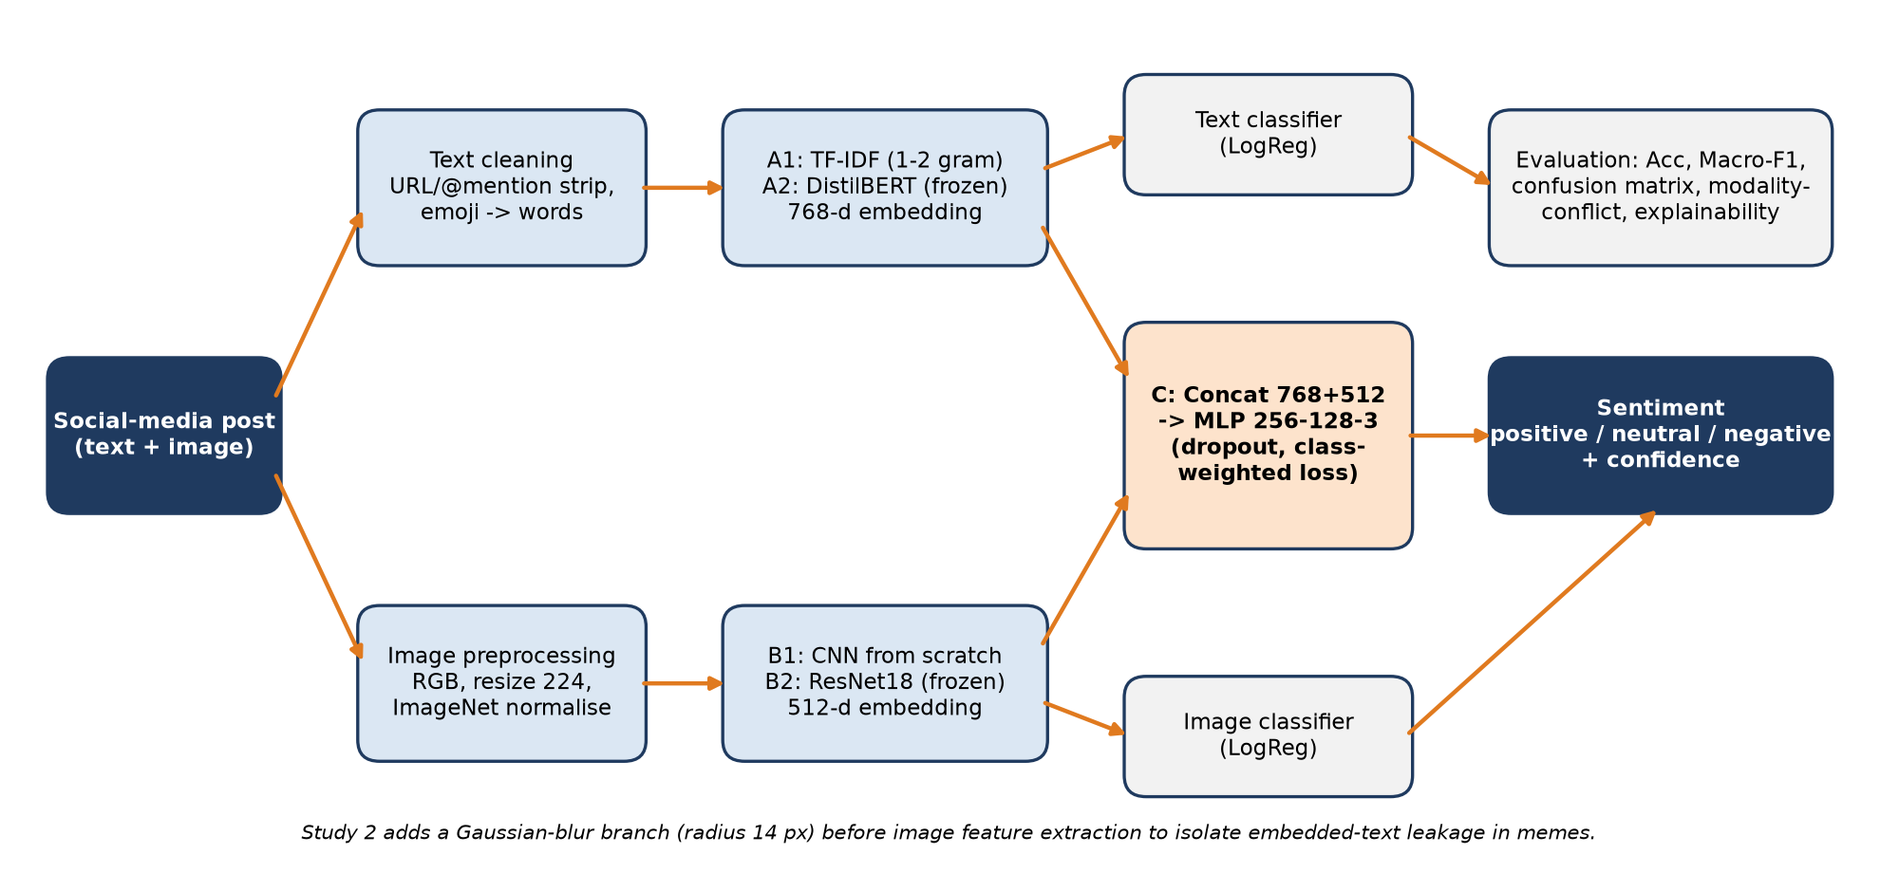
Figure 3.1: System architecture: text branch, image branch, fusion and evaluation
A post enters two independent branches. The text branch cleans the text and produces a TF-IDF vector (A1) or a 768-dimensional DistilBERT embedding (A2). The image branch normalises the image and produces either the prediction of a from-scratch CNN (B1) or a 512-dimensional ResNet18 penultimate-layer embedding (B2). Each branch has its own classifier, which gives the unimodal baselines. Model C concatenates the two embeddings (1,280 dimensions) and trains a joint MLP. Late fusion instead averages the probability outputs of the two unimodal classifiers. The same outputs feed the evaluation, explainability and dashboard modules.

3.4 Algorithms
Table 3.2: Models and configurations
ID | Modality | Algorithm / configuration
A1 | Text | TF-IDF (unigram+bigram, capped vocabulary) → class-weighted Logistic Regression
A2 | Text | distilbert-base-uncased, frozen; pooled 768-d embedding → class-weighted Logistic Regression
B1 | Image | 4-block CNN trained from scratch at 96×96 (reduced from 224 because of the CPU/RAM limit)
B2 | Image | ImageNet ResNet18, frozen; 512-d penultimate embedding → class-weighted Logistic Regression
C | Fusion (early) | [A2 ‖ B2] 1,280-d → MLP 256→128→3, dropout 0.4/0.3, Adam lr 1e-3, wd 1e-4, batch 32, ≤40 epochs, early stopping (patience 8) on validation macro-F1
C-late | Fusion (late) | Average of A2 and B2 class probabilities; simple average and validation-tuned weights
*-Blur | Ablation (Study 2) | Gaussian blur (radius 14 px at native resolution) applied before B2 features; B2 and C retrained identically

3.5 Justification of Design Choices
Table 3.3: Design decisions and justification
Choice | Alternative considered | Reason
Frozen encoders | End-to-end fine-tuning | CPU-only, 8 GB RAM: frozen extraction measured 46–71 ms/sample, while fine-tuning was impractical; frozen encoders also isolate the fusion effect
DistilBERT | BERT-base, MentalBERT | About 60% of BERT's compute for about 97% of its quality; MentalBERT targets clinical-style Reddit text, not tweets or memes
ResNet18 | ViT, ResNet50, EfficientNet | ViTs underperform without large-scale data; ResNet18 is the fastest robust CNN on CPU
Concat + MLP fusion | Cross-modal attention | Simple, interpretable and CPU-feasible; attention fusion is mainly validated on video/audio benchmarks and is kept as a stretch goal
Macro-F1 primary | Accuracy | Class imbalance (about 60% positive) makes accuracy misleading
Published split | Own random split | Comparability with prior work (CLMLF) and no tuning on the test set
Blur ablation | OCR text masking | Needs no OCR model and is objectively validated (Laplacian variance); OCR masking is planned as a follow-up

3.6 Evaluation and Validation Design
- Metrics: accuracy, macro and weighted precision/recall/F1, per-class F1, confusion matrices.
- Leakage audit: cross-split duplicate check (src/data/check_leakage.py, results/leakage_audit.txt).
- Modality-conflict analysis: the test set is split into posts where the text-only and image-only predictions agree or disagree, and each model is scored on both subsets.
- Explainability: gradient×input token saliency (text), Grad-CAM (image) and modality ablation (fusion).
- Blur validation: mean Laplacian variance on 150 test images, before and after blurring.

Chapter 4

4 Implementation

4.1 Tools, Platform and Environment
Table 4.1: Tools and environment
Category | Tools
Language / runtime | Python 3.13, virtual environment with pinned requirements (requirements.lock.txt)
Deep learning | PyTorch (CPU build), torchvision, Hugging Face Transformers
Classical ML | scikit-learn (TF-IDF, Logistic Regression, metrics)
Data | Hugging Face datasets, pandas, NumPy, Pillow, emoji
Application | Streamlit (demo + research dashboard)
Testing / QA | pytest (32 tests), Playwright (automated UI click-through)
Documentation | Markdown, ReportLab (IEEE PDF), python-pptx, python-docx, Git/GitHub
Hardware | Consumer laptop, CPU only (no GPU), 8 GB RAM, Windows 10

4.2 Modules Developed
Table 4.2: Implemented modules
Module (path) | Responsibility
src/data/ | Dataset download (MVSA, Memotion), manifest building, published-split loader, leakage check
src/preprocessing/ | Text cleaning (URL/mention normalisation, emoji demojization); image preprocessing
src/text_model/ | A1 TF-IDF baseline; DistilBERT embedding extraction and A2 classifier
src/image_model/ | B1 CNN from scratch (pixel cache); ResNet18 embedding extraction and B2 classifier
src/multimodal/ | C concatenation-fusion MLP; late (decision-level) fusion
src/evaluation/ | Shared metrics, test-set prediction export, result figures
src/explainability/ | Token saliency, Grad-CAM (hook-based), modality ablation examples
research_paper_v2/src/ | Study 2 pipeline 01–09: Memotion download, sharp/blur features, models, leakage and conflict analysis, figures
app/streamlit_app.py | Interactive demo (text + image → three model predictions with confidence) and dashboard
tests/ | Unit tests for seeding, text cleaning, image preprocessing, splits, metrics and the dataset loader

4.3 Implementation Workflow
- Step 1: Acquire data and verify its integrity (row counts, image decode check, label mapping).
- Step 2: Clean the text and preprocess the images; cache the expensive frozen-encoder embeddings to .npz/.npy files so that every classifier reads identical features.
- Step 3: Train each classifier on the training split, select it on validation macro-F1, and evaluate once on the test split. Results are written to JSON.
- Step 4: Run the analysis scripts (error analysis, modality conflict, blur leakage) and generate figures from the saved JSON. No numbers are typed in by hand.
- Step 5: Serve the trained models through the Streamlit application.

4.4 Demonstration Application
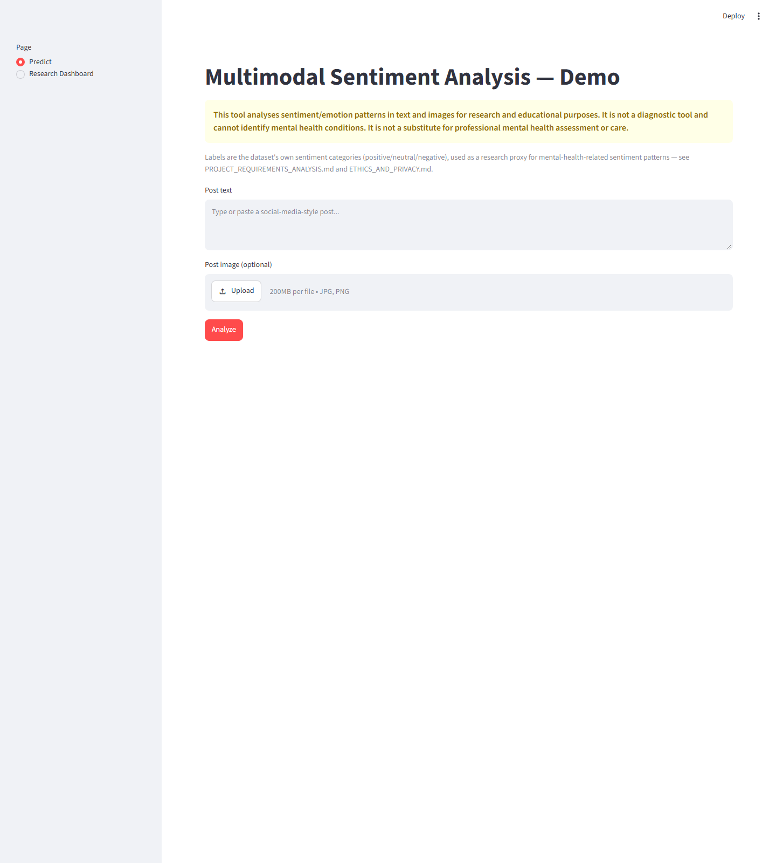
Figure 4.1: Demo application: input screen (post text + image upload)
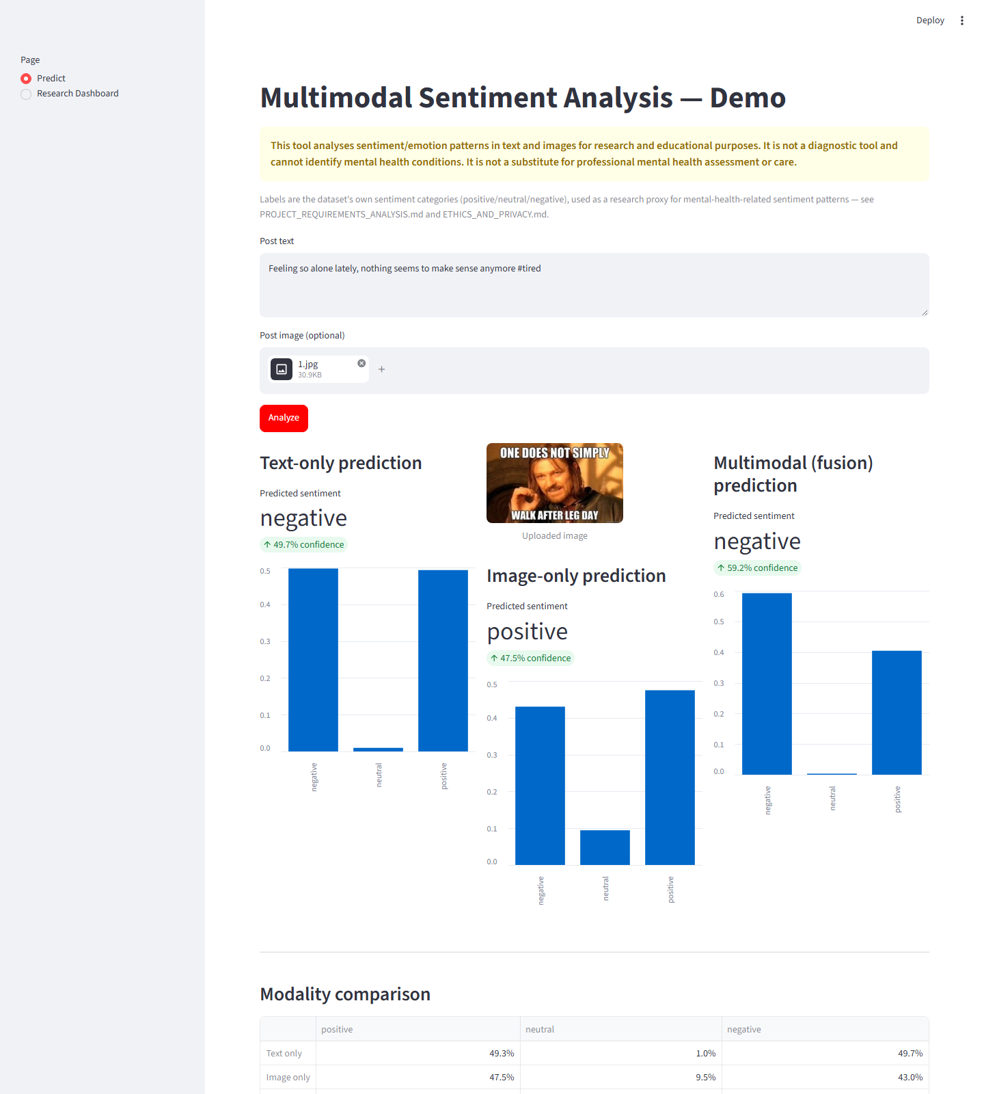
Figure 4.2: Text-only, image-only and fusion predictions with confidence, plus the non-clinical disclaimer
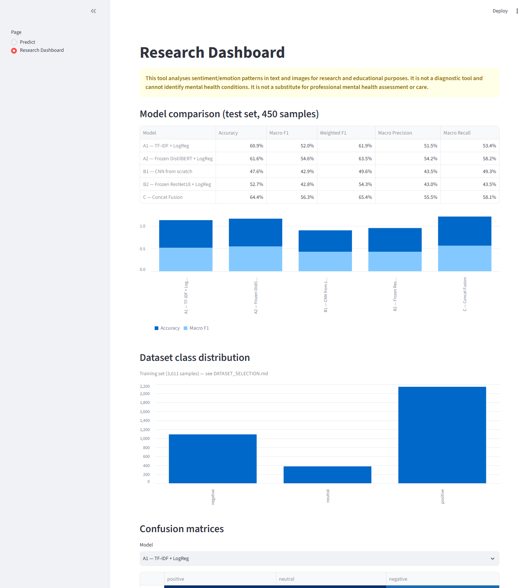
Figure 4.3: Research dashboard: model comparison, confusion matrices, class distribution

4.5 Testing
The automated test suite (pytest) contains 32 tests covering seed reproducibility, text cleaning, image preprocessing, stratified splitting, metric correctness and the dataset loader. All 32 tests pass (re-run on 12 Oct 2026). The demo was additionally exercised end to end with a Playwright click-through, which produced the screenshots above.

4.6 Technical Challenges Faced and Resolutions
Table 4.3: Technical challenges
Challenge | Resolution
Official MVSA OneDrive link returned 404 | Located a community Hugging Face mirror, verified its content, and adopted the published CLMLF split; all of this is disclosed
CNN from scratch: first full-scale run killed for running out of memory; second exceeded the time budget | Root-caused both failures; built a 96×96 pixel cache and limited training to 3 epochs; documented as a limitation
CPU-only compute for transformers | Frozen DistilBERT and ResNet18 feature extraction with cached embeddings (46–71 ms/sample)
Severe class imbalance (neutral ~10%) | Class-weighted losses, macro-F1 model selection, per-class reporting
About 1–2% cross-split duplicates (retweets) in the published split | Measured with a leakage audit and reported, not silently fixed, to stay comparable with prior work
Proving the blur actually removes text | Objective Laplacian-variance metric: 99.9% reduction on 150 images
No public multimodal mental-health-labelled dataset | Used sentiment as a non-clinical proxy; the framework does not depend on the label set

Chapter 5

5 Results and Validation

5.1 Study 1: MVSA-Single (Twitter photos)
Table 5.1: Test-set results, Study 1 (n = 450)
Model | Accuracy | Macro-F1 | Weighted-F1
A1: TF-IDF + Logistic Regression (text) | 60.9% | 52.0% | 61.9%
A2: Frozen DistilBERT + LogReg (text) | 61.6% | 54.6% | 63.5%
B1: CNN from scratch (image) | 47.6% | 42.9% | 49.6%
B2: Frozen ResNet18 + LogReg (image) | 52.7% | 42.8% | 54.3%
C-late: Late fusion, simple average | 63.8% | 54.6% | 65.0%
C-late: Late fusion, val-tuned weights | 64.0% | 56.4% | 65.6%
C: Concatenation fusion MLP (text + image) | 64.4% | 56.3% | 65.4%

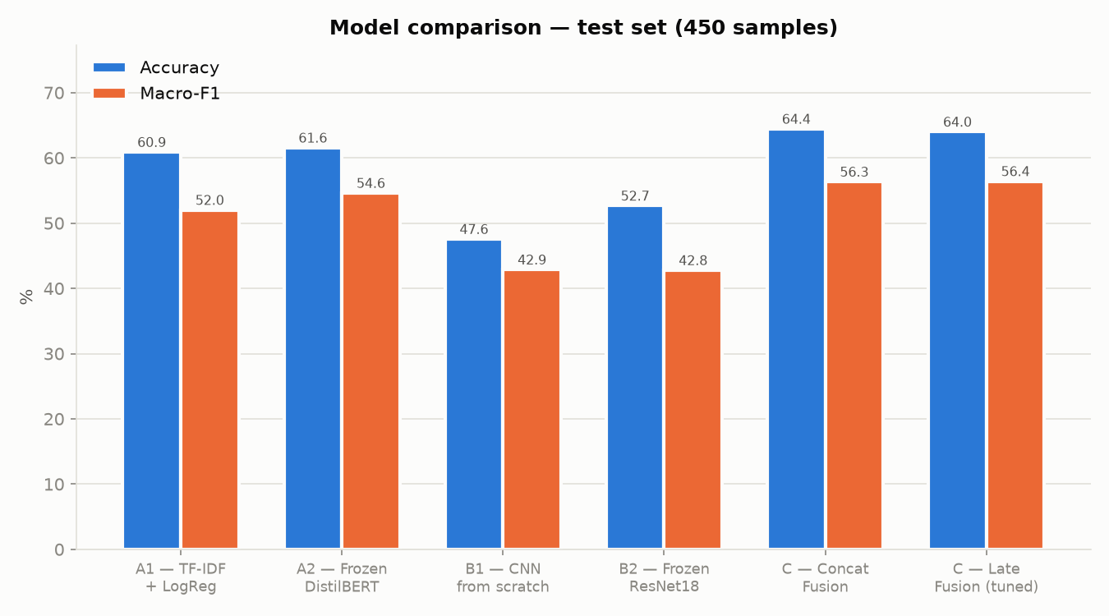
Figure 5.1: Model comparison (Study 1)
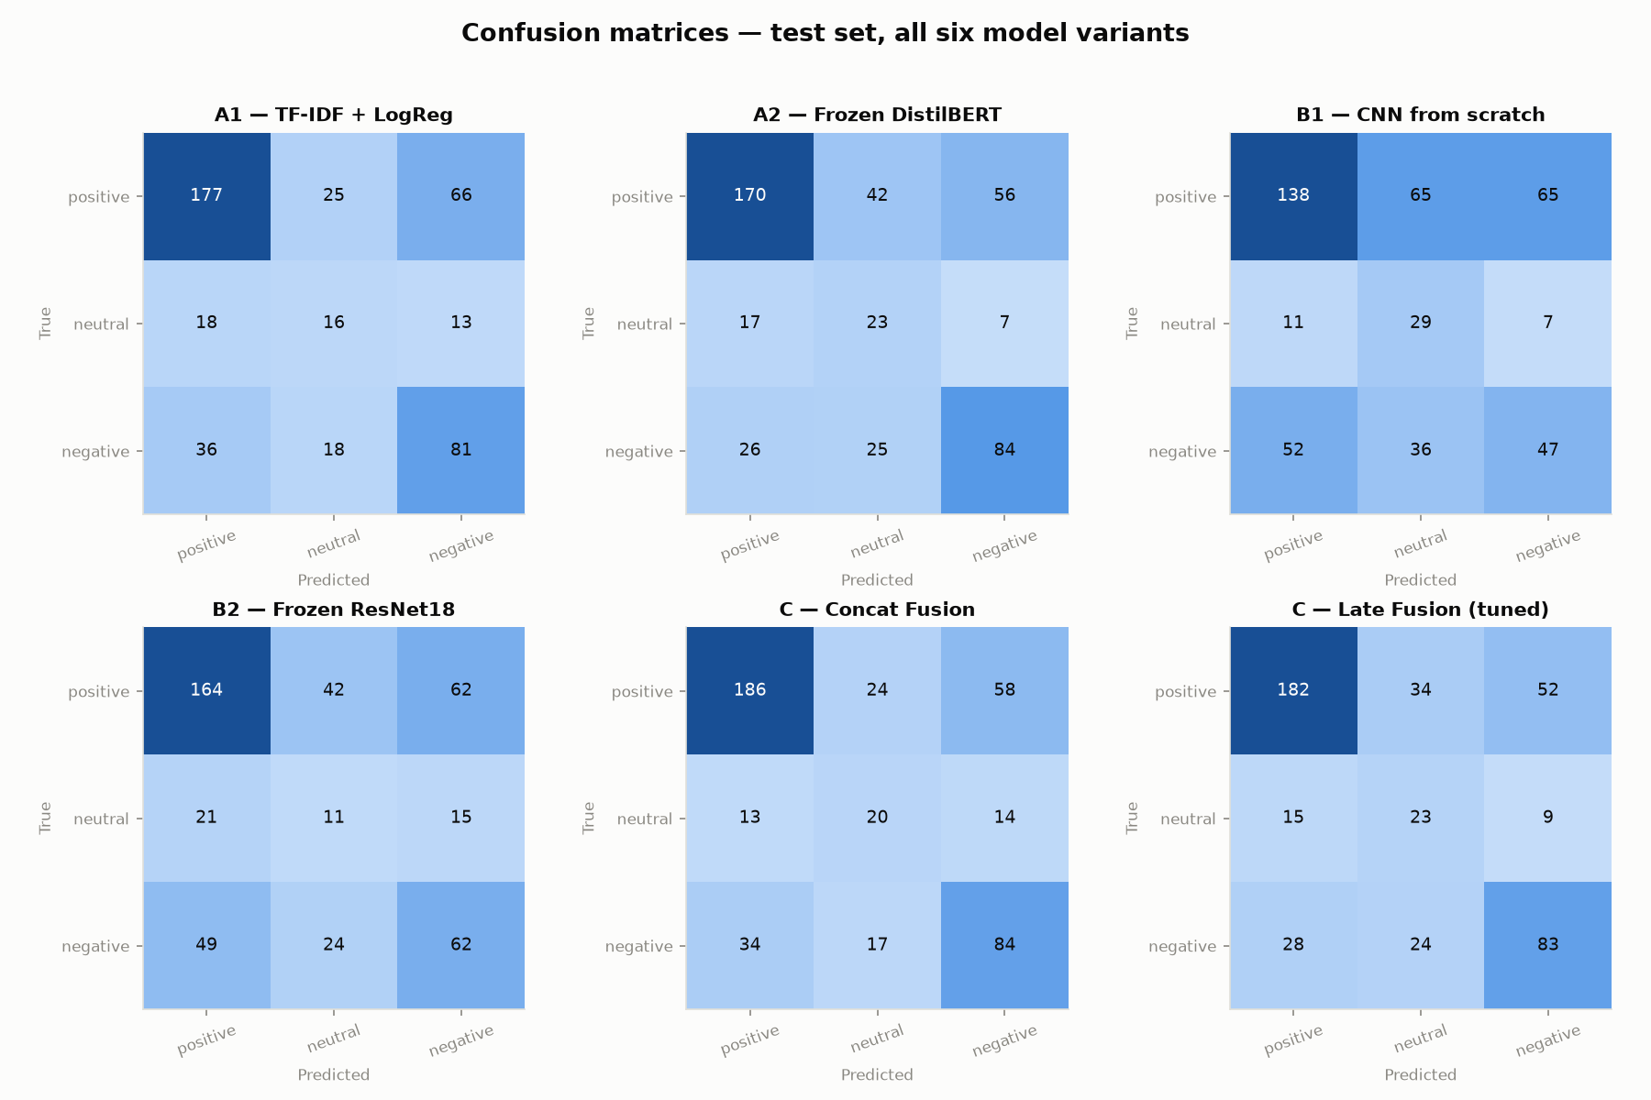
Figure 5.2: Confusion matrices (Study 1)

Observations
- Concatenation fusion is the best model on accuracy (64.4%) and improves macro-F1 by 1.7 pp over the best text model. Validation-tuned late fusion is essentially tied (64.0% accuracy, 56.4% macro-F1), so both fusion strategies beat every unimodal model.
- Text is the stronger single modality on tweets. The pretrained ResNet18 beats the from-scratch CNN on accuracy, which supports the transfer-learning choice.
- The text and image models disagree on 53.3% of test posts. On that subset fusion reaches 57.1%, against 50.0% (text) and 33.3% (image). On posts where they agree, fusion slightly regresses (72.9% vs. 74.8%). The fusion gain is therefore conditional and concentrated on modality conflict.
- Neutral is the hardest class (about 10% of the data, F1 about 0.37) for every model.
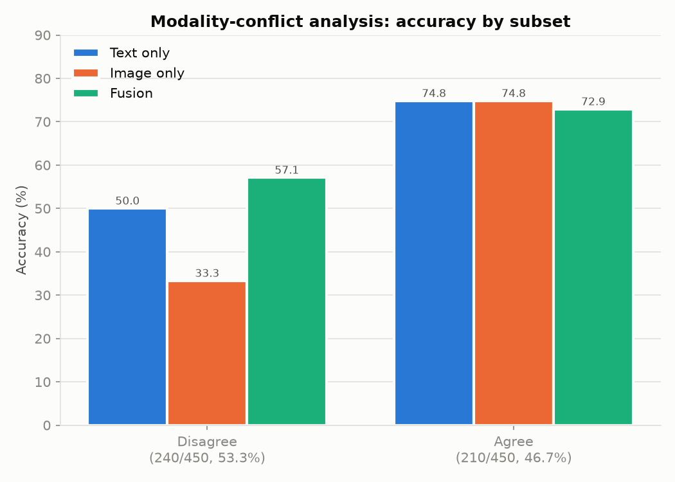
Figure 5.3: Accuracy on agreement vs. disagreement subsets (Study 1)

5.2 Study 2: Memotion (memes): Embedded-Text Leakage
Table 5.2: Test-set results, Study 2 (n = 350)
Model | Accuracy | Macro-F1 | Weighted-F1
A1: TF-IDF + LogReg (text) | 42.6% | 33.3% | 43.7%
A2: Frozen DistilBERT + LogReg (text) | 39.4% | 33.4% | 42.1%
B1: CNN from scratch (sharp image) | 61.1% | 25.3% | 46.4%
B2: Frozen ResNet18 + LogReg (sharp) | 38.6% | 31.0% | 42.2%
B2-Blur: Frozen ResNet18 + LogReg (blurred) | 37.1% | 30.7% | 39.6%
C: Concat fusion (text + sharp image) | 52.6% | 36.6% | 50.6%
C-Blur: Concat fusion (text + blurred image) | 41.7% | 33.0% | 44.4%

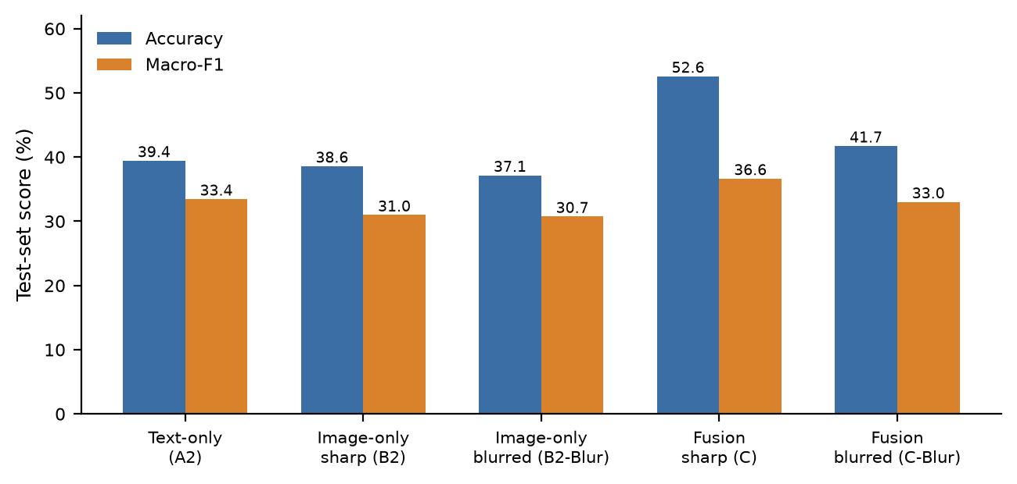
Figure 5.4: Effect of blurring the image on image-only and fusion models

Observations
- On sharp memes, fusion (52.6% / 36.6% macro-F1) clearly beats every unimodal model.
- Blurring (Laplacian variance 2022 → 1.5, a 99.9% reduction) barely changes the image-only model (−1.43 pp accuracy, −0.24 pp macro-F1) but removes most of the fusion gain (−10.86 pp accuracy, −3.63 pp macro-F1). C-Blur ends up within 2.3 pp of text-only accuracy.
- Interpretation: on memes, much of the fusion benefit comes from the image encoder's access to legible embedded text rather than from independent visual cues. Systems that treat a meme's image and text as independent evidence may overstate the multimodal benefit.
- Modality conflict replicates partly: models disagree on 63.1% of memes and fusion gains most there (51.6% vs. 37.1% text). Unlike Study 1, fusion also gains on the agreement subset.
- B1 reaches 61.1% accuracy but only 25.3% macro-F1 because it mostly predicts the majority class. This shows why accuracy alone is misleading here.
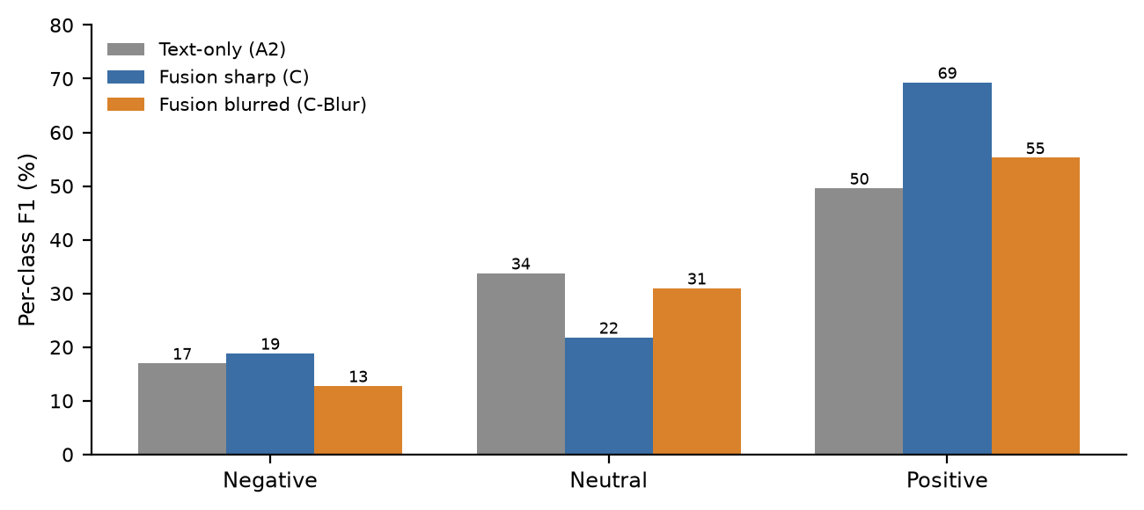
Figure 5.5: Per-class F1 (Study 2)

5.3 Validation Summary
- Same split, same seed and same metric code for every model; the test set is used once per model.
- All reported numbers are produced by scripts and saved as JSON; figures are generated from that JSON.
- A leakage audit quantifies the duplicates inherited from the published split.
- The blur ablation is validated objectively and is not assumed to work.
- Two independent datasets (photos vs. memes) show that the fusion benefit depends on the data. This is a stronger and more honest claim than "multimodal always wins".
- Known limitation: single seed and no significance tests yet. Both are scheduled first in the next plan.

Chapter 6

6 Next Plan and Timeline

6.1 Work Remaining
Table 6.1: Remaining work
# | Task | Purpose | Target
1 | Re-run fusion/CNN models over 5 seeds; report mean ± std; McNemar / bootstrap significance tests | Statistical robustness of the headline comparisons | Oct 2026
2 | OCR-based text-masking ablation and full 6,992-meme Memotion run | Confirm the blur finding with a text-specific ablation at full scale | Nov 2026
3 | Cross-modal (gated) attention fusion (stretch goal) | Compare a more expressive fusion method against concat/late fusion | Nov–Dec 2026
4 | Merge Studies 1 and 2 into one self-contained manuscript | External-reviewer readiness (remove repository-internal references) | Dec 2026
5 | Submission to a target venue (e.g. IEEE ICCCNT), chosen with the guide | Dissemination (objective O6) | Jan 2027
6 | Review response, final report, final demo polish | Project completion | Feb–Mar 2027

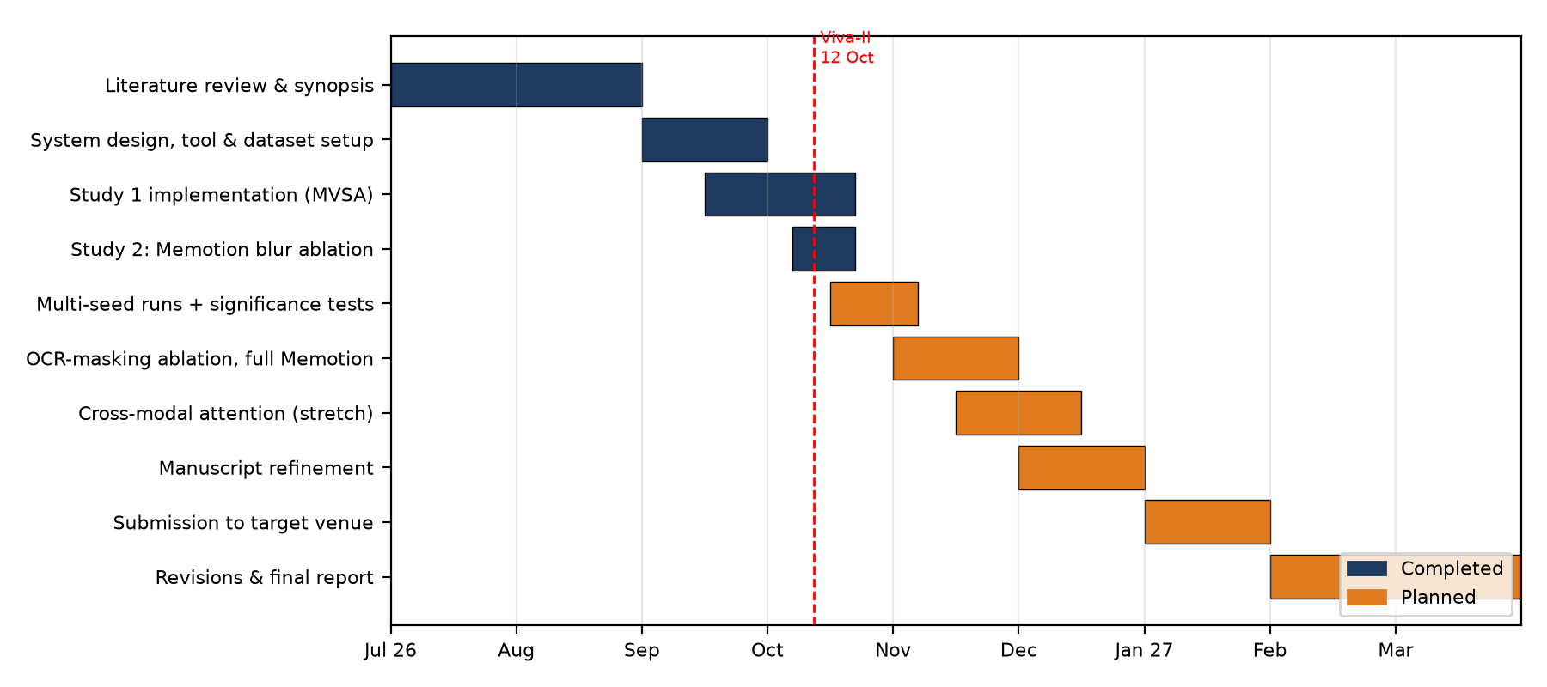
Figure 6.1: Timeline: completed work (blue) and planned work (orange)

6.2 Team Roles
Table 6.2: Team roles (as in the synopsis)
Member | Primary responsibility
Kartikey Tiwari | Literature, dataset acquisition and preparation, integration
Akshat Sharma | NLP preprocessing and text models (A1, A2)
Karan Sharma | Image models (B1, B2), multimodal fusion, evaluation
Lalit Sharma | Documentation, paper, presentation, testing

Chapter 7

7 Ethical Considerations
- Only public research datasets are used; no new user data is collected. Usernames and URLs are normalised during preprocessing.
- Labels are sentiment, not clinical states. Every screen of the application carries a non-clinical disclaimer, and the system must not be used to diagnose or profile individuals.
- Biases are disclosed: English-only, Twitter/meme-specific, 2015–2020-era data. Results may not transfer to other languages or platforms.

References
[1] J. Devlin, M.-W. Chang, K. Lee, and K. Toutanova, “BERT: Pre-training of deep bidirectional transformers for language understanding,” in Proc. NAACL-HLT, 2019, pp. 4171–4186.
[2] V. Sanh, L. Debut, J. Chaumond, and T. Wolf, “DistilBERT, a distilled version of BERT: smaller, faster, cheaper and lighter,” arXiv:1910.01108, 2019.
[3] K. He, X. Zhang, S. Ren, and J. Sun, “Deep residual learning for image recognition,” in Proc. IEEE CVPR, 2016.
[4] A. Dosovitskiy et al., “An image is worth 16x16 words: Transformers for image recognition at scale,” in Proc. ICLR, 2021.
[5] S. Ji et al., “MentalBERT: Publicly available pretrained language models for mental healthcare,” in Proc. LREC, 2022.
[6] T. Niu, S. Zhu, L. Pang, and A. El Saddik, “Sentiment analysis on multi-view social data,” in Proc. MMM, 2016.
[7] Z. Li, B. Xu, C. Zhu, and T. Zhao, “CLMLF: A contrastive learning and multi-layer fusion method for multimodal sentiment detection,” in Findings of NAACL, 2022, pp. 2282–2294.
[8] C. Sharma et al., “SemEval-2020 Task 8: Memotion analysis – the visuo-lingual metaphor!,” in Proc. SemEval, 2020.
[9] D. Kiela et al., “The Hateful Memes Challenge: Detecting hate speech in multimodal memes,” in Proc. NeurIPS, 2020.
[10] A. Singh et al., “Towards VQA models that can read,” in Proc. IEEE/CVF CVPR, 2019.
[11] A. Gandhi, K. Adhvaryu, S. Poria, E. Cambria, and A. Hussain, “Multimodal sentiment analysis: A systematic review of history, datasets, multimodal fusion methods, applications, challenges and future directions,” Information Fusion, vol. 91, pp. 424–444, 2023.
[12] R. Das and T. D. Singh, “Multimodal sentiment analysis: A survey of methods, trends, and challenges,” ACM Computing Surveys, vol. 55, no. 13s, 2023.
[13] R. R. Selvaraju et al., “Grad-CAM: Visual explanations from deep networks via gradient-based localization,” in Proc. IEEE ICCV, 2017.
[14] E. S. Agung, A. P. Rifai, and T. Wijayanto, “Image-based facial emotion recognition using convolutional neural network on emognition dataset,” Scientific Reports, vol. 14, 2024.

