|  |  |
| --- | --- |
| **Name:** | Kartikey dubey |
| **Roll No:** | 08 |
| **Class/Sem:** | SE/IV |
| **Experiment No.:** | 2B |
| **Title:** | Program for calculating factorial using assembly language |
| **Date of Performance:** |  |
| **Date of Submission:** |  |
| **Marks:** |  |
| **Sign of Faculty:** |  |

**Aim:** Program to calculate the Factorial of a number.

**Theory:**

To calculate the factorial of any number, we use MUL instruction. Here, initially, we initialize the first register by value 1. The second register is initialized by the value of the second register. After multiplication, decrement the value of the second register and repeat the multiplying step till the second register value becomes zero. The result is stored in the first register.

**Algorithm:**

1. Start.
2. Set AX=01H, and BX with the value whose factorial we want to find.
3. Multiply AX and BX.
4. Decrement BX=BX-1.
5. Repeat steps 3 and 4 till BX=0.
6. Stop.

**Flowchart:**

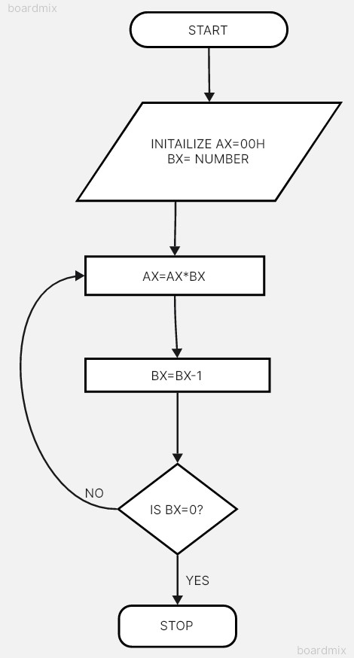

**Assembly Code:**



**Output:**



**Conclusion:**

1. Explain shift instructions.

Ans. Shift instructions are vital operations in computer architecture used to manipulate the binary representation of data by shifting its bits left or right. Here’s an explanation of these instructions:

1. Logical Shift Left (SHL): Shifts the bits of a binary number to the left by a specified number of positions, filling the vacant positions with zeros. This operation effectively multiplies the number by powers of 2.
2. Logical Shift Right (SHR): Shifts the bits of a binary number to the right by a specified number of positions, filling the vacant positions with zeros. This operation effectively divides the number by powers of 2.
3. Arithmetic Shift Left (SAL): Similar to logical shift left, but in arithmetic shift left, the most significant bit (MSB) is shifted into the carry flag, and the least significant bit (LSB) is set to zero. It preserves the sign of signed numbers.
4. Arithmetic Shift Right (SAR): Similar to logical shift right, but in arithmetic shift right, the MSB is shifted into the carry flag, and the vacant positions are filled with copies of the original MSB, preserving the sign of signed numbers.

Shift instructions are essential for operations such as multiplication and division by powers of 2, as well as for manipulating binary data in bitwise operations.

1. Explain rotate instructions.

Ans. Rotate instructions are essential operations in computer architecture that manipulate the binary representation of data by circularly shifting its bits left or right. Here’s an explanation of these instructions:

* 1. Rotate Left (ROL): Circularly shifts the bits of a binary number to the left by a specified number of positions. The shifted-out bits are rotated back to the rightmost positions. This operation is useful for creating circular patterns in binary data.
  2. Rotate Right (ROR): Circularly shifts the bits of a binary number to the right by a specified number of positions. The shifted-out bits are rotated back to the leftmost positions. This operation is helpful for circular buffer implementations and encryption algorithms.
  3. Rotate Through Carry Left (RCL): Similar to ROL, but includes the carry flag in the rotation. The carry flag is shifted into the least significant bit position, and the most significant bit is shifted into the carry flag.
  4. Rotate Through Carry Right (RCR): Similar to ROR, but includes the carry flag in the rotation. The carry flag is shifted into the most significant bit position, and the least significant bit is shifted into the carry flag.

Rotate instructions are versatile and find applications in various bitwise operations, data manipulation, and cryptographic algorithms.