**Blood cell images**

Blood cell images consisted of **white blood cells (**denoted by large purple shaded regions**), red blood cells, and platelets (**light purple-ish spots**)**.

**Usage**

Blood cell images assist in identifying different kinds of deficiencies and illnesses. Red Blood cells are responsible for carrying oxygen throughout the body, and their lack can cause Anemia. Depletion of platelets can cause excessive bleeding. White blood cells are responsible for the system's immunity, and their disorder can weaken the immune system and cause all hosts of infections.

**Model**

**Data Source**

The dataset was taken from the [BCCD dataset](https://github.com/Shenggan/BCCD_Dataset). The **image** folder consists of three subfolders - **TRAIN, TEST_SIMPLE, and TEST.** Each of the three folders is divided into four categories - **LYMPHOCYTE, MONOCYTE, NEUTROPHIL, and EOSINOPHIL.** The images in **the TRAIN and TEST** folders are augmented.

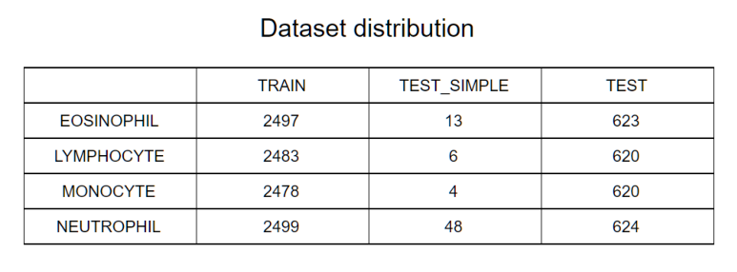

**Data Preprocessing**

The images were resized to size 128x128x3, and their mask was created by manually thresholding the pixel values. Then the masks were dilated using a 3x3 kernel. Below is the code,

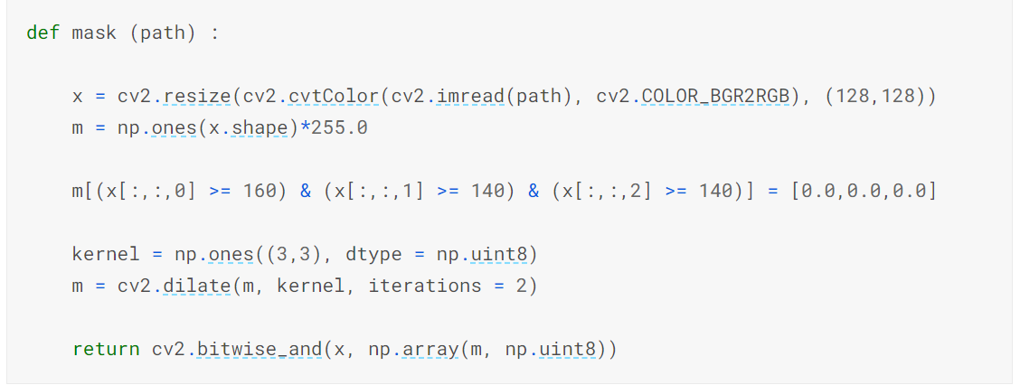

The output images,

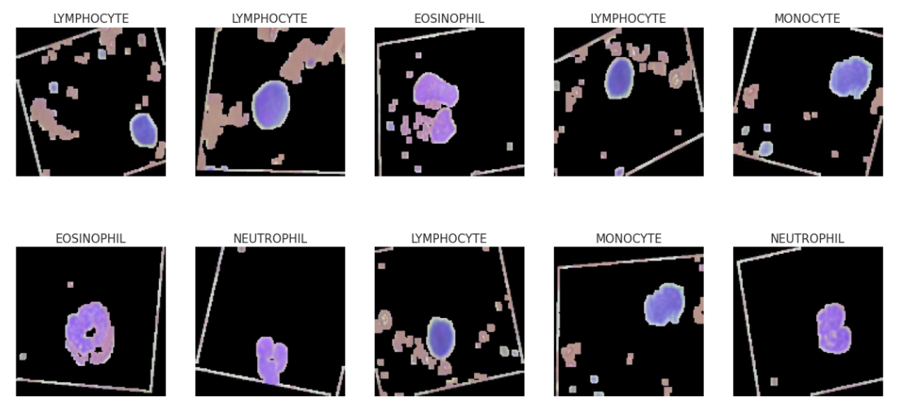

**Model**

The model is a Sequential network of Convolution and Fully connected layers. Dropout of 0.4 is added to the fully connected layer. And **weight regularization** is added to keep the weights small and generalize the model better. In addition, four **convolutional layers** were added with a 3x3 kernel size and strides of 1. And a **max-pooling layer** was added to reduce the image dimensions.

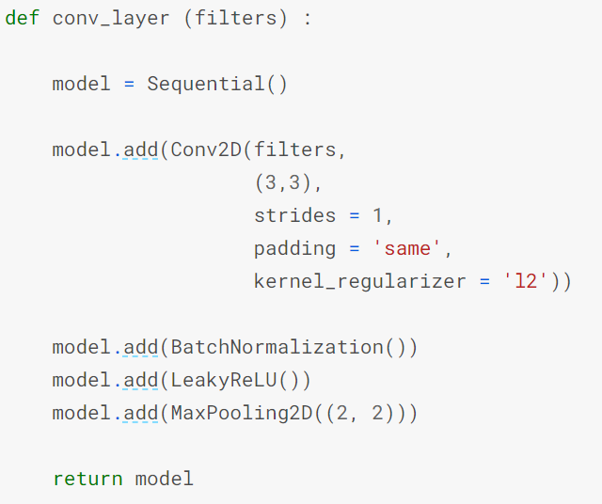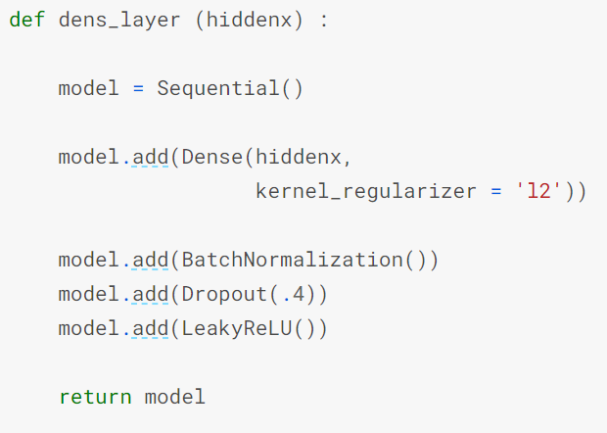

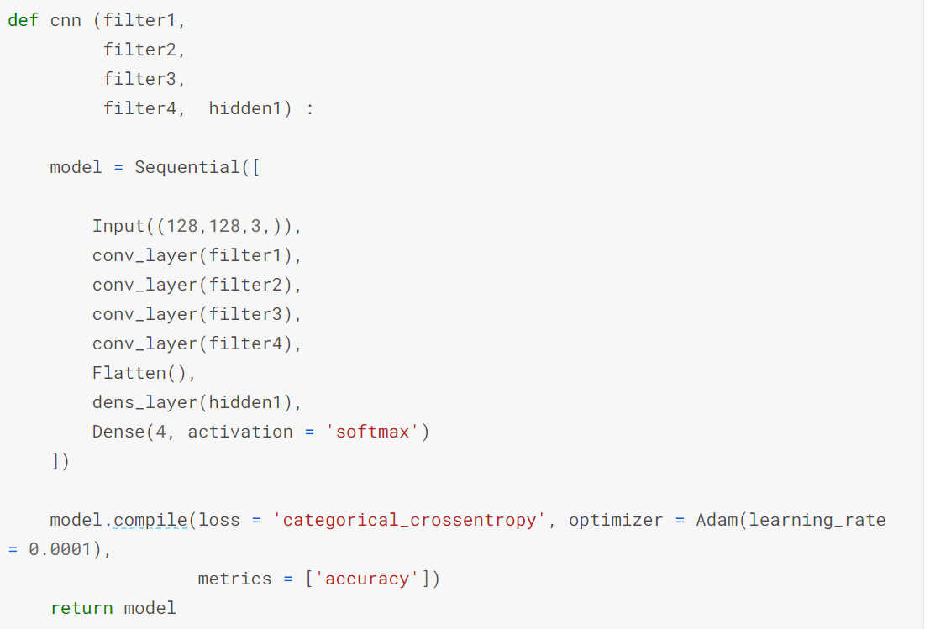

**Performance**

**Loss & accuracy with respect to Epochs**

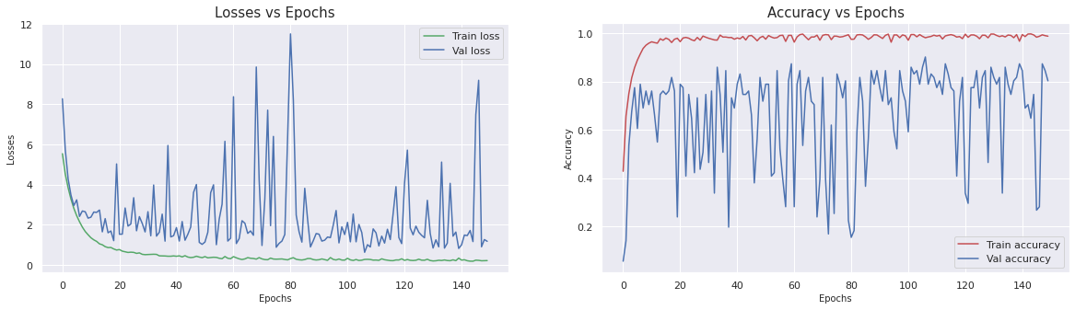

**Performance on Validation set**

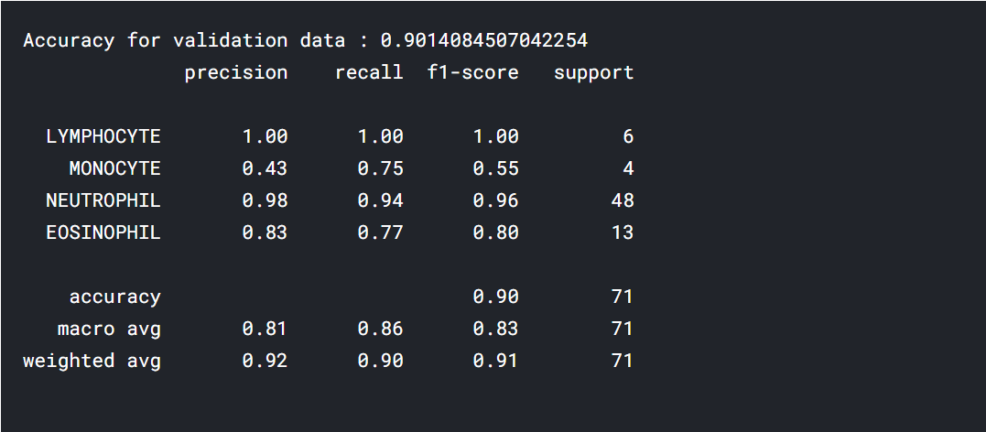

**Performance on testing set**

