**Pneumonia Detection**

Pneumonia is an infection in one or both lungs, caused by bacteria, virus or fungi. It involves inflammation of alveoli and causes difficulty in breathing. With Pneumonia, air sacs will be filled with fluid or pus. The disease can be life threatening, particularly to infants and people above the age of 65.

**Usage**

The model can be used in the Healthcare industry, especially in cases of medical emergencies where attention cannot be provided to each patient. In those cases, the chest X-rays of the individual can directly be given as input to the model and steps can be decided based on the results. Such models are already in experimental phases.

**Model**

**Data Source**

Data was taken from [Chest X-rays Dataset](https://www.kaggle.com/paultimothymooney/chest-xray-pneumonia) from kaggle. The dataset comprises three folders **train, test** and **val**, and these folders are subdivided into **PNEUMONIA** and **NORMAL** folders. These folders contain chest X-ray images of patients from Guangzhou Women and Children’s Medical Center, Guangzhou, China.

|  |  |  |
| --- | --- | --- |
| **Number of files** | NORMAL | PNEUMONIA |
| train | 1341 | 3875 |
| test | 234 | 390 |
| val | 8 | 8 |

**Data Preprocessing**

The training set was imbalanced as the number of NORMAL samples were less compared to PNEUMONIA ones. So [SMOTE](https://medium.com/swlh/how-to-use-smote-for-dealing-with-imbalanced-image-dataset-for-solving-classification-problems-3aba7d2b9cad#:~:text=By%20definition%20SMOTE%20is%20an,samples%20from%20the%20minority%20class.&text=SMOTE%20actually%20performs%20better%20than,when%20dealing%20with%20structured%20data.) was used for oversampling the minority samples. Further variations were added to the present images using [ImageDataGenerator](https://machinelearningmastery.com/how-to-configure-image-data-augmentation-when-training-deep-learning-neural-networks/). The new images were zoomed in between 0.85 to 1.00, and rotation of 5 degrees was added.

**Model**

Model has stacked CNN layers. There are three CNN layers with 128, 32, and 32 filters respectively. Each CNN block has a Conv2D layer with dropout and BatchNormalization, and MaxPooling layer.

**Conv2D layer** - Kernels or filters are applied on this layer, which are convolved with portions of images to capture specific features (some capture edges, others capture contrast, etc). This also assists in reducing image size. Filters can be considered as weights for images (which they are sort of).

**Dropout layer** - Assists in regularizing the weights by randomly deleting some units, so that the other nodes don't get too accustomed to the inputs and able to take variations into account.

**BatchNormalization** - It happens that the cost function curve may thin out at some axis. So this normalizes the Inputs for faster training.

**MaxPooling layer** - Move a window along the image to capture the dominant features in the image. Here the window size is (2,2).

More information about convolutional layers can be found [here](https://keras.io/api/layers/convolution_layers/).

**Performance**

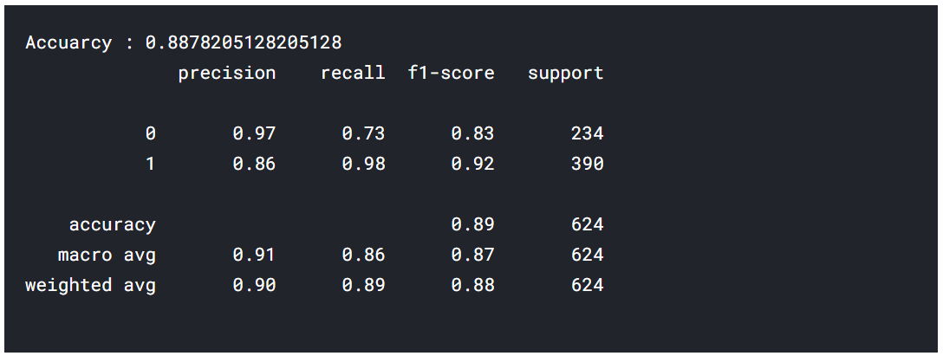

|  |  |
| --- | --- |
| 1 | **PNEUMONIA** |
| 0 | **NORMAL** |