**Retinal OCT Images**

Retinal Optical Coherence (or OCT) is an imaging technique used to capture high-resolution cross-sections of the retinas of living patients.

**Usage**

The model can be used in the healthcare sector to identify the defects in the retina without much significant human intervention.

**Model**

**Data Source**

The dataset was taken from [mendeley](https://data.mendeley.com/datasets/rscbjbr9sj/2). It contains three folders - train, test, and val, and each folder is subdivided into four subfolders - CNV, DME, DRUSEN, and NORMAL (disease types). The total number of images is approximately 84k. The images were obtained from Shiley Eye Institute of the University of California San Diego, the California Retinal Research Foundation, Medical Center Ophthalmology Associates, the Shanghai First People’s Hospital, and Beijing Tongren Eye Center between July 1, 2013, and March 1, 2017.

**Data Preprocessing**

The images were resized to 128x128 pixels and were scaled between 0 and 1. Only 5k images for each class were used for training (due to RAM constraints).

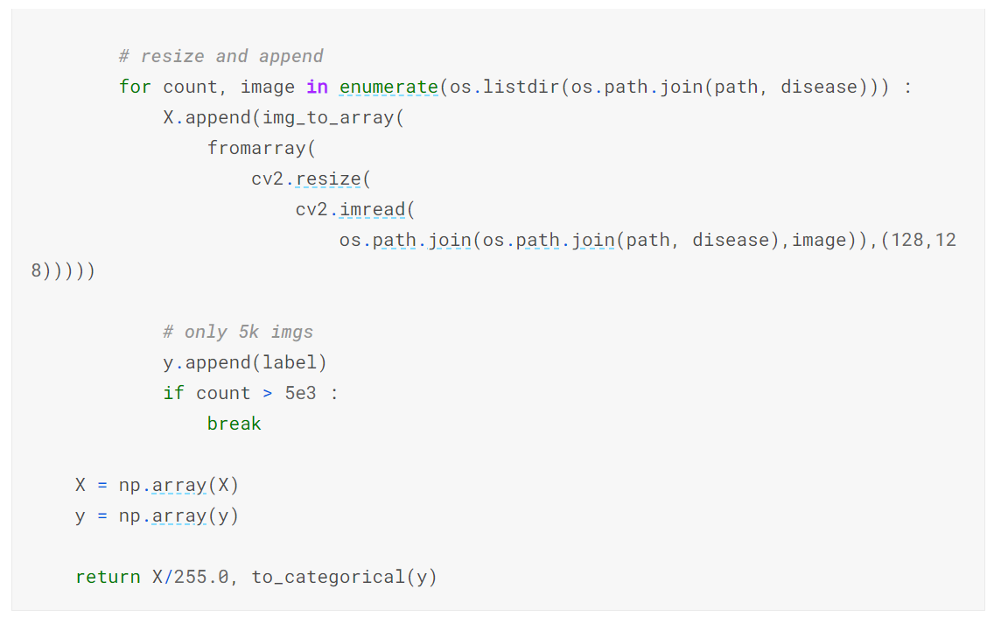

**Model**

The model comprised of Convolution blocks and Fully Connected Blocks, and each the layers were,

**Conv2D -** Convolution layers are the feature detectors for images. The filters move across the width and height of the image performing convolution operations and storing the values.

**MaxPooling2D -** Pooling layer with mode = ‘max’ is used to reduce the image and retain the dominant features in the region of the filter applied.

**BatchNormalization -** Normalize the hidden features to have zero mean and unit standard deviation. It helps in faster convergence and prevents internal covariate shift.

**LeakyReLU -** gives a small value for negative inputs instead of completely making them zero.

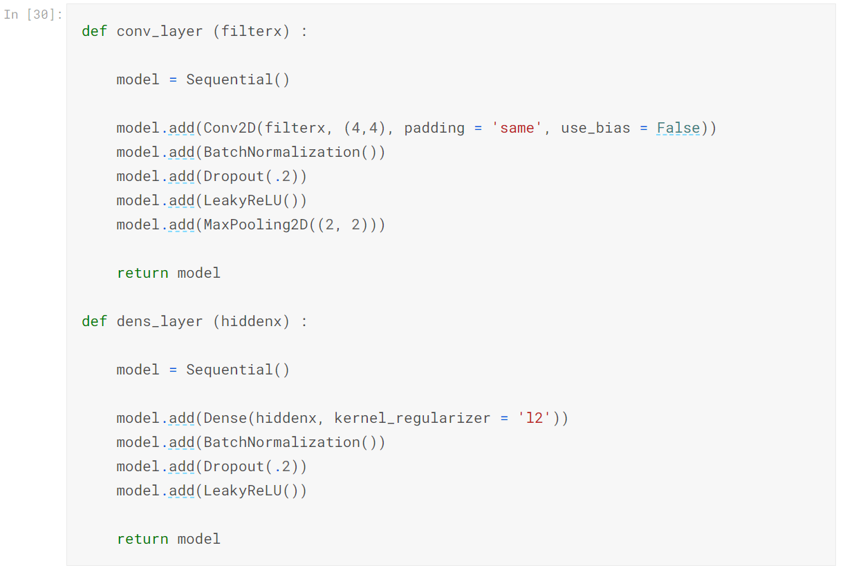

**Performance**

**Classification Report**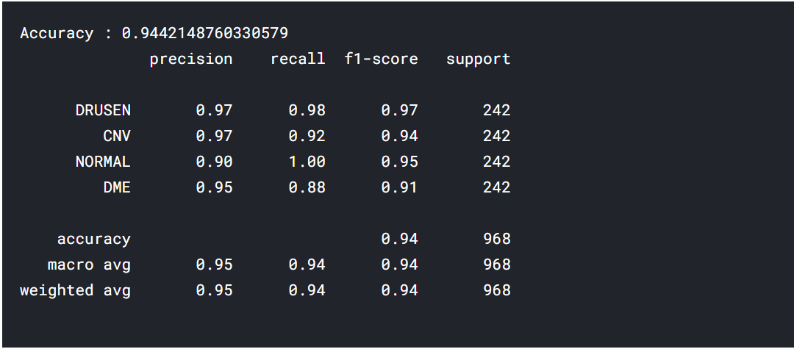

**Confusion Matrix**