Adaptive Data Science Language Model (ADSLM)
ABB Innovation Evaluation 2026

Problem Statement:-
The objective of this project is to design and evaluate an AI-powered Adaptive Data Science Language Model capable of automatically understanding datasets, identifying machine learning problem types, recommending suitable algorithms, generating explainable insights, and adapting outputs according to user expertise levels.
The System supports:
- Regression
- Classification
- Clustering
- Time-Series Forecasting
Dataset Inputs
- CSV datasets
- Numerical features
- Categorical features
- Datetime columns
- Missing values
- Duplicate records
- Outliers
User Inputs
- Dataset upload
- Optional target column
- User expertise level:
  - Beginner
  - Intermediate
  - Expert
System Inputs
- Dataset structure
- Feature distribution
- Dataset size
- Data quality metrics
- Industrial context
Technologies Use
Layer | Technology
Backend | Python, FastAPI
Frontend | Streamlit
ML Framework | Scikit-learn, XGBoost
Data Processing | Pandaas, Numpy
Visualization | Plotly
Reporting | ReportLab
Key Innovations
- Automatic ML task detection
- Adaptive model recommendation engine
- Automated preprocessing pipeline
- Explainable AI outputs
- User expertise-aware explanations
- Industrial predictive maintenance support
- End-to-end AutoML workflow automation

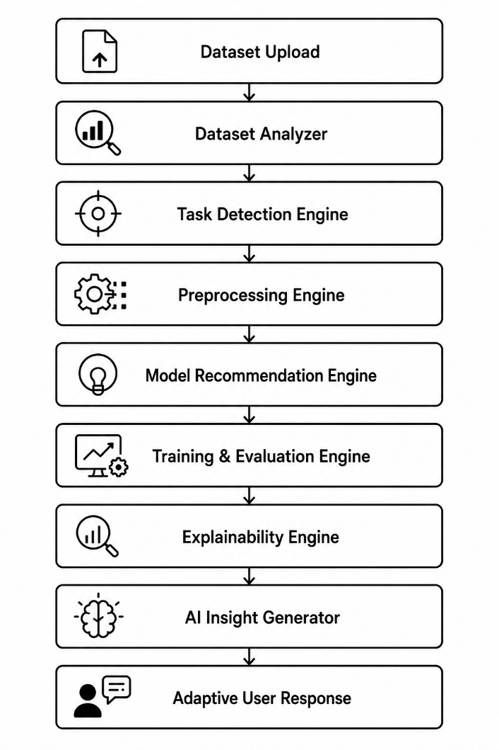
System Architecture
Core Modules
Module | Function
Dataset Analyzer | Detects dataset properties and structure
Task Detection Engine | Identifies ML problem type
Preprocessing Engine | Cleans and transforms data
Model Recommendation Engine | Suggests suitable algorithms
Training Engine | Trains multiple machine learning models
Evaluation Engine | Computes model performance metrics
Explainability Engine | Generates feature importance analysis
Insight Generator | Produces AI-generated insights
Expertise Adapter | Adapts explanations for different users

Adaptive Intelligence
The proposed system dynamically adapts based on:
- Dataset type
- Presence or absence of target variable
- Feature characteristics
- Data quality
- User expertise level
This enables the system to intelligently generate workflows suitable for multiple industrial and business use cases.

TECHNICAL IMPLEMENTATION & WORKFLOW
Step 1 — Dataset Profiling
The Dataset Analyzer performs:
- Shape detection
- Datatype identification
- Missing value analysis
- Duplicate detection
- Outlier detection
- Numerical/Categorical feature separation
Step 2 — Task Detection
Condition | Detected task
Numerical target column | Regression
Categorical target column | Classification
No target column | Clustering
Datetime features present | Time-Series Forecasting
Step 3 — Automated Preprocessing
The preprocessing engine automatically:
- Handles missing values
- Encodes categorical variables
- Normalizes/scales data
- Removes duplicates
- Splits train/test datasets
Step 4 — Model Recommendation
Supported Models
Task | Recommendation Models
Regression | Linear Regression, Random Forest Regressor
Classification | Logistic Regression, Random Forest, XGBoost
Clustering | KMeans, DBSCAN
Time-Series | ARIMA, Prophet
The recommendation engine selects models based on:
- Dataset size
- Feature types
- Data complexity
- Presence of nonlinear relationships
Step 5 — Evaluation Metrics
Task | Metrics
Regression | RMSE, MAE, R²
Classification | Accuracy, Precision, Recall, F1-score
Clustering | Silhouette Score
Time-Series | RMSE, MAE

INNOVATION, INDUSTRIAL RELEVANCE & SCALABILITY
Innovation & Originality
- The proposed solution introduces:
- AI-driven adaptive workflows
- Automated machine learning pipelines
- Explainable AI integration
- Expertise-based insight generation
- Industrial AutoML support
Unlike traditional ML pipelines, the system intelligently adapts itself according to both dataset characteristics and user requirements.
Industrial Relevance (ABB)
Predictive Maintenance
Detects machine faults using industrial sensor datasets.
Manufacturing Analytics
Improves production quality using AI-driven classification.
Energy Forecasting
Predicts energy consumption trends using time-series models.
Industrial Anomaly Detection
Identifies abnormal machine behavior using clustering techniques.
Scalability & Robustness
The architecture supports:
- Modular microservices
- Cloud deployment
- API-based integration
- Real-time analytics
- Large-scale datasets
- Future LLM integration
Technical Strengths
- Modular architecture
- Automated preprocessing
- Extensible model registry
- Production-ready FastAPI backend
- Explainable AI support
- Scalable workflow pipeline

EXPECTED OUTPUT
Expected System Outputs
Dataset Analysis Output
Dataset Shape: | 5000 rows × 24 columns
Missing Values Detected: | 3 columns
Categorical Features: | 5
Numerical Features: | 18
Outliers Detected: | Yes

Task Detection Output
Detected Task: Classification
Reason: Target column contains categorical labels representing machine fault types.

Recommended Model Output
Recommended Model: Random Forest Classifier
Reason: The dataset contains nonlinear relationships and mixed feature types.

Evaluation Output
Metric | Value
Accuracy | 94%
Precision | 93%
Recall | 91%
F1-Score | 92%

Explainable AI Output
Top Important Features
- Sensor Temperature
- Vibration Level
- Pressure Reading
- Machine Runtime
- Voltage Fluctuation

AI-Generated Insights
Beginner Mode
“The model predicts machine failures by learning patterns from previous sensor readings.”
Expert Mode
“Random Forest achieved superior F1-score due to strong nonlinear feature interaction handling and robustness against noisy industrial sensor data.”

Final Conclusion
ADSLM provides an intelligent, scalable, and industrially relevant AI-powered AutoML system capable of automating end-to-end data science workflows while dynamically adapting to varying datasets, machine learning tasks, and user expertise levels.
The proposed solution demonstrates strong innovation, technical implementation, scalability, robustness, and direct applicability to ABB industrial use cases such as predictive maintenance, manufacturing analytics, and anomaly detection.

