HEMVATI NANDAN BAHUGUNA GARHWAL UNIVERSITY

(A Central University)

Srinagar (Garhwal), Uttarakhand- 246174

School of Engineering and Technology

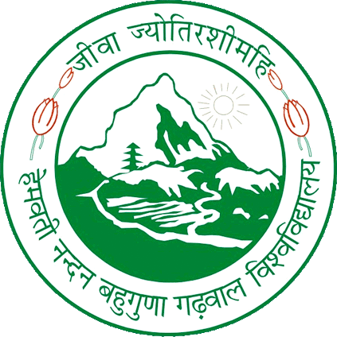

Session (2021 - 2022)

A PROJECT REPORT ON

# “OMR MCQ Automated Grading”

Submitted in Partial fulfillment for the award of the degree of Bachelor of Technology

In Computer Science and Engineering HNBGU, Srinagar Garhwal (Uttarakhand).

#### Guided by: - Submitted By: -

Mr. Rohan Verma Priyanka Chandra (18134501006)

Dept. of Computer Science and Engineering Kartikeya (18134503008)

Shivam (18134501029)

B.Tech. CSE 8th Sem