**Principals of Compiler Design**

(COCSC14 -III)



**Submitted By:**

Name – Kartikeya Agarwal

Roll No. – 2019UCO1692

Class – COE Section 3

**INDEX**

|  |  |  |
| --- | --- | --- |
| S.NO. | TOPIC | PAGE NO. |
| 1. | Implement Symbol Table in C/C++ | 3 |
| 2. | Write a Lex program to recognize the keywords and identifiers in the input C program. | 8 |
|  |  |  |
|  |  |  |
|  |  |  |
|  |  |  |
|  |  |  |
|  |  |  |
|  |  |  |
|  |  |  |
|  |  |  |
|  |  |  |
|  |  |  |
|  |  |  |
|  |  |  |
|  |  |  |
|  |  |  |
|  |  |  |

**PROGRAM 1: IMPLEMENT SYMBOL TABLE IN C/C++**

SYMBOL TABLE

#include <iostream>

#include<string>

using namespace std;

class Node{

public:

    string name;

    string scope;

    string type;

    string value;

    Node* next;

    Node(string name, string scope, string type, string value){

        this->name = name;

        this->scope = scope;

        this->type = type;

        this->value = value;

        next = NULL;

    }

    ~Node(){

        if(next)

            delete next;

    }

};

class SymbolTable{

private:

    Node** table;

    int cs;

    int ts;

    int hashFn(string key){

        int idx = 0;

        int p = 1;

        for(int j=0;j<key.length();j++){

            idx = idx+(key[j]*p)%ts;

            idx = idx%ts;

            p = (p*27)%ts;

        }

        return idx;

    }

    void rehash(){

        Node **old = table;

        ts = 2*ts;

        table = new Node*[ts];

        for(int i=0;i<ts;i++){

            table[i] = NULL;

        }

        cs = 0;

        for(int i=0;i<(ts/2);i++){

            Node*temp = old[i];

            while(temp!=NULL){

                insert(temp->name,temp->scope,temp->type,temp->value);

                temp=temp->next;

            }

            if(old[i]!=NULL){

                delete old[i];

            }

        }

        delete [] old;

    }

public:

    SymbolTable(int ts = 7){

        this->ts = ts;

        table = new Node*[ts];

        cs = 0;

        for(int i=0;i<ts;i++)

            table[i] = NULL;

    }

    void insert(string name, string scope, string type, string value){

        int idx = hashFn(name);

        Node *n = new Node(name, scope, type, value);

        n->next = table[idx];

        table[idx] = n;

        cs++;

        float lf = cs/(1.0*ts);

        if(lf>0.8){

            cout<<"***Auto Rehashing***\n";

            rehash();

        }

    }

    void print(){

        for(int i=0;i<ts;i++){

            cout<<"Table "<<i<<" --> ";

            Node *temp = table[i];

            while(temp!=NULL){

                cout<<temp->name<<" --> ";

                temp = temp->next;

            }

            cout<<endl;

        }

        cout<<endl;

    }

    Node* Search(string name, bool print = true){

        int idx = hashFn(name);

        Node *temp = table[idx];

        while(temp!=NULL){

            if(temp->name==name){

                if(print){

                    cout<<"Variable: "<<temp->name<<endl;

                    cout<<"Value: "<<temp->value<<endl;

                    cout<<"Type: "<<temp->type<<endl;

                    cout<<"Scope: "<<temp->scope<<endl;

                }

                return temp;

            }

            temp=temp->next;

        }

        return NULL;

    }

    void erase(string key){

        if(Search(key, false)!=NULL){

            int idx = hashFn(key);

            Node* temp = table[idx];

            if(temp->name == key){

                table[idx] = temp->next;

                delete temp;

                cs--;

                return;

            }

            while(temp->next!=NULL){

                if(temp->next->name==key)

                    break;

                temp=temp->next;

            }

            if(temp->next == NULL){

                Node* prev = temp;

                prev->next = NULL;

                temp = temp->next;

                delete temp;

                cs--;

                return;

            }

            Node* prev = temp;

            temp=temp->next;

            prev->next = temp->next;

            delete temp;

            cs--;

            return;

        }

    }

};

int main(int argc, char const *argv[]) {

    SymbolTable symb;

    symb.insert("a","local","string","Hello World");

    symb.insert("i","global","int","10");

    symb.insert("head","local","Node*","NULL");

    symb.insert("count","global","int","0");

    symb.insert("flag","local","bool","false");

    symb.print();

    Node* symbObj = symb.Search("a");

    if(symbObj==NULL){

        cout<<"Not Found";

    }

    cout<<"\n\n";

    cout<<"Erasing \"a\" from the symbol table\n";

    symb.erase("a");

    symb.insert("root","local","Node*","0x7ffe67fcdb24");

    symb.insert("counter","local","int","-1");

    symb.insert("check","local","bool","true");

    symb.insert("ch","global","char","g");

    symb.print();

    return 0;

}

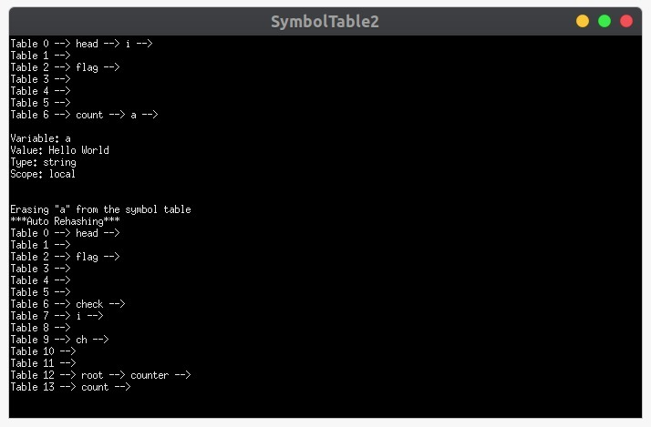

**PROGRAM 2: WRITE A LEX PROGRAM TO RECOGNIZE THE KEYWORDS AND IDENTIFIERS IN THE INPUT C PROGRAM.**

LEXICAL ANALYSIS

%{

#include<stdio.h>

#include<string.h>

int n = 0;

%}

%%

"while"|"if"|"else" {n++;printf("keywords: %s\n", yytext);}

"int"|"float" {n++;printf("keywords: %s\n", yytext);}

[a-zA-Z_][a-zA-Z0-9_]* {n++;printf("identifier: %s\n", yytext);}

"<="|"=="|"="|"++"|"-"|"*"|"+" {n++;printf("operator: %s\n", yytext);}

[(){}|,;]    {n++;printf("separator: %s\n", yytext);}

[0-9]*"."[0-9]+ {n++;printf("float: %s\n", yytext);}

[0-9]+ {n++;printf("integer: %s\n", yytext);}

.;

%%

int yywrap(void){}

int main(){

    yylex();

    {printf("Number of tokens: %d", n);}

    return 0;

}

